Statistics, Algorithms & AI (COMP7028)

Offine Open-Book Exam

Tuesday 9th February 2021, 1 PM – 4:30 PM

Attempt ALL questions
Question 1

Draw the graph represented by the following adjacency matrix.

 | A | B | C | D | E | F | G | H
A | 0 | 0 | 2 | 3 | 4 | 0 | 0 | 0
B | 0 | 0 | 3 | 0 | 0 | 6 | 2 | 0
C | 2 | 3 | 0 | 5 | 0 | 4 | 0 | 1
D | 3 | 0 | 5 | 0 | 0 | 0 | 0 | 0
E | 4 | 0 | 0 | 0 | 0 | 0 | 4 | 2
F | 0 | 6 | 4 | 0 | 0 | 0 | 2 | 0
G | 0 | 2 | 0 | 0 | 4 | 2 | 0 | 0
H | 0 | 0 | 1 | 0 | 2 | 0 | 0 | 0

Outline Kruskal’s algorithm and show how it can be used to construct a minimum spanning tree using the graph from above.

Outline Dijkstra’s algorithm and show how it can be used to calculate the shortest path from a given source vertex to all other reachable nodes in a graph using the graph from part above and vertex A as the source vertex.

Question 2

Outline the Ford-Fulkerson algorithm for computing the maximum flow in a flow network.

Does the algorithm always terminate? If so, after how many iterations?

Consider the following st-flow network and feasible flow f.
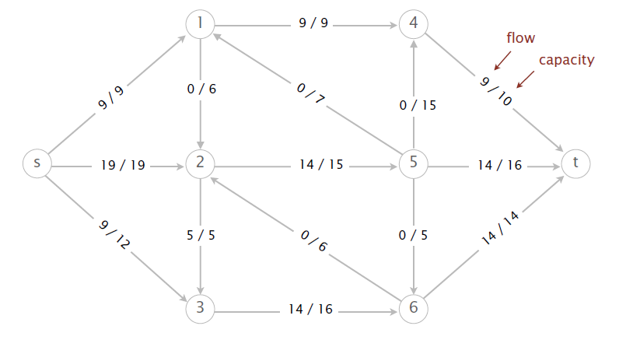
- What is the value of the flow f?

- Perform two iterations of the Ford-Fulkerson algorithm, starting from the flow f. Give the sequence of vertices on the augmenting path.

- What is the value of the maximum flow?

- List the vertices on the s side of the minimum cut.

- What is the capacity of the minimum cut?

Question 3

What does it mean to say that a problem is in P or in NP? What does it mean to say that a problem is NP-complete?

What does in mean for a problem to be intractable? What approaches can taken when faced with an intractable problem.

Question 4

Consider the following map:
36
122
43
40
45
61
80
112
36
32
102
32
31
52
20
31
M
B
D
E
G
H
I
J
F
C
K
A
L
Using the A* algorithm work out a route from town A to town M. Use the following cost functions:
- g(n) = The cost of each move as the distance between each town (shown on map)
- h(n) = The Straight Line Distance between any town and town M. These distances are given in the table below.

- Provide the search tree for your solution.
- Indicate the order in which you expanded the nodes and state the route you would take and the cost of that route.

Straight Line Distance to M
A | 223 |  | E | 165 |  | H | 111 |  | K | 32
B | 222 |  | F | 136 |  | I | 100 |  | L | 102
C | 166 |  | G | 122 |  | J | 60 |  | M | 0
D | 192

Question 5

For the operators and initial state description given below, explain how a regression planner searches for a plan to satisfy a goal, and give an example of a plan that achieves the goal On(b, a) ∧ On(c, b) ∧ OnTable(a)

- blocks are represented by constants: a, b, c, ... etc.
- states are described using the following predicates:

On(x, y) block x is on block y
OnTable(x) block x is on the table
Clear(x) there is no block on top of block x
Holding(x) the arm is holding block x
ArmEmpty the arm is not holding any block

- initial state: On(c, a) ∧ On(a, b) ∧ OnTable(b) ∧ ArmEmpty
- goal state: On(b, a) ∧ On(a, c) ∧ OnTable(c)
- operators:

[ Holding(x), Clear(y) ] STACK(x, y) [ On(x, y), ArmEmpty, ¬Holding(x), ¬Clear(y) ]

[ On(x, y), Clear(x), ArmEmpty ] UNSTACK(x, y) [Clear(y), Holding(x), ¬On(x, y), ¬ArmEmpty ]

[ OnTable(x), Clear(x), ArmEmpty ] PICKUP(x) [ Holding(x), ¬OnTable(x), ¬ArmEmpty, ]

[ Holding(x) ] PUTDOWN(x) [ OnTable(x), ArmEmpty, ¬Holding(x), ]

Question 6

You are a robot in a lumber yard, and must learn to discriminate Oak wood from Pine wood. You choose to learn a Decision Tree classifier. You are given the following examples:

Example | Density | Grain | Hardness | Class
1 | Heavy | Small | Hard | Oak
2 | Heavy | Large | Hard | Oak
3 | Heavy | Small | Hard | Oak
4 | Light | Large | Soft | Oak
5 | Light | Large | Hard | Pine
6 | Heavy | Small | Soft | Pine
7 | Heavy | Large | Soft | Pine
8 | Heavy | Small | Soft | Pine

- Draw the decision tree that would be constructed by recursively applying information gain to determine the most informative attribute.

- Classify these new examples as Oak or Pine using your decision tree above.

Density = Light, Grain = Small, Hardness = Hard
Density = Light, Grain = Small, Hardness = Soft

Question 7

For each of the truth tables below say whether it is possible for a perceptron to learn the required output.

In each case, explain the reason behind your decision.

i) | Input | 0 | 0 | 1 | 1
 | Input | 0 | 1 | 0 | 1
 | Required Output | 1 | 0 | 0 | 1
ii) | Input | 0 | 0 | 1 | 1
 | Input | 0 | 1 | 0 | 1
 | Required Output | 1 | 1 | 0 | 0
iii) | Input | 0 | 0 | 1 | 1
 | Input | 0 | 1 | 0 | 1
 | Required Output | 1 | 1 | 1 | 1

