# CSC 431 ToonDo System Architecture Specification (SAS)

# Version History

|  |  |  |  |
| --- | --- | --- | --- |
| Version | Date | Author(s) | Change Comments |
| 1 | 3/30/20 |  | Functional design and structural design |
|  |  |  |  |
|  |  |  |  |
|  |  |  |  |

# Table of Contents

1. System Analysis 6

1.1 System Overview 6

1.2 System Diagram 6

1.3 Actor Identification 6

1.4 Design Rationale 6

1.4.1 Architectural Style 6

1.4.2 Design Pattern(s) 6

1.4.3 Framework 6

2. Functional Design 7

2.1 Diagram Title 7

3. Structural Design 8

4. Behavioral Design 9

# Table of Tables

<Generate table here>

# Table of Figures

<Generate table here>

### System Analysis

#### System Overview

*<Describe the system in brief and your architecture choice>*

#### System Diagram

*<Insert System Diagram>*

#### Actor Identification

*<Identify all actors interacting with the system>*

#### Design Rationale

##### Architectural Style

*<Identify and briefly explain the architectural style e.g. 3-tier architecture>*

##### Design Pattern(s)

*<Identify the design pattern(s) you have deemed applicable to this architecture>*

##### Framework

*<Identify and briefly explain the frameworks you are using, if any. Also specify the rationale behind selecting this framework>*

### Functional Design

*<Identify all significant workflows as sequence diagrams using the following format>*

#### Sequence Diagram

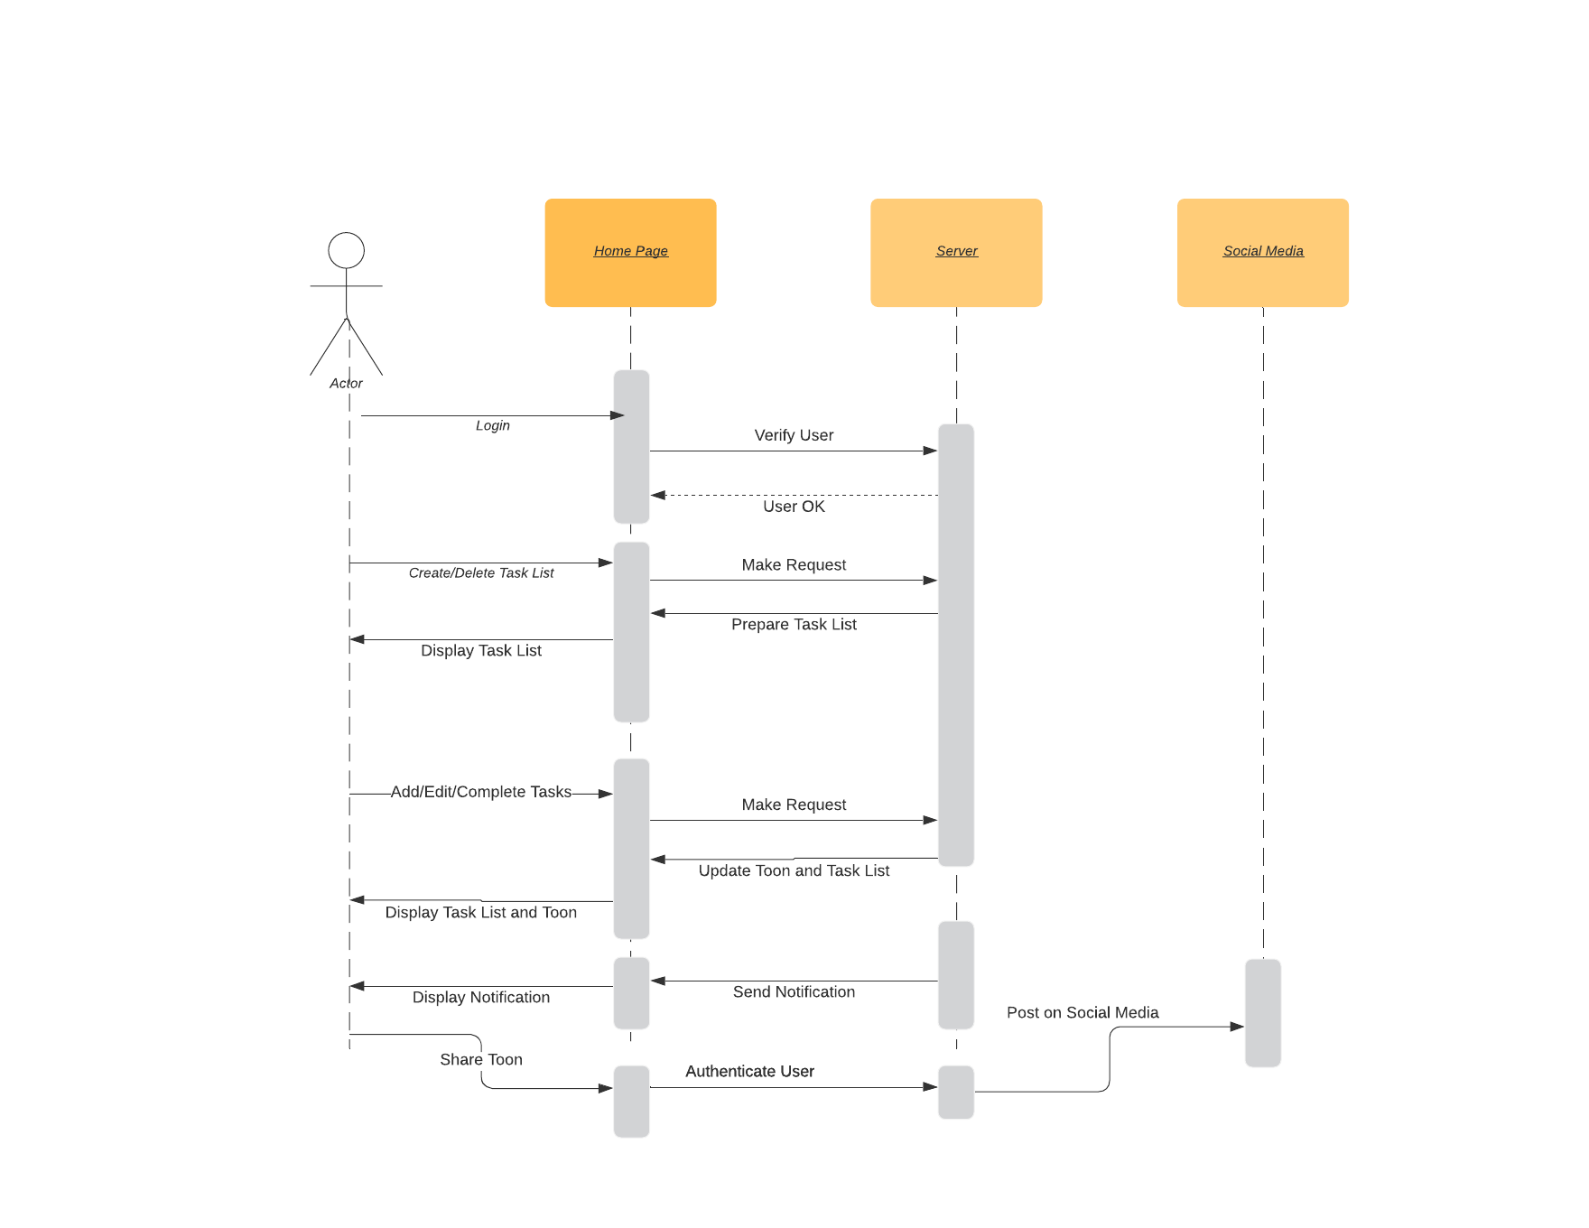

* When the user interacts with the web page by logging in, a request is sent to our web server/REST API to authenticate the user and pull up their stored information.
* When the user interacts with the web page to manage their task lists, tasks, and Toons, the request is again made to our web server/REST API to handle the writing and retrieval of data.
* When the user requests to share their Toon, the server will authenticate the user and then make the appropriate API calls to execute the post, which returns as a notification to the user.

**3 Structural Design**

The following class diagram represents an overview of the basic components in our system homepage.

Upon implementation of this project, the data retrieval from the database using REST API will be made more clear as more is known about it. However, this diagram gives an overview of the basic function of the app.