Part A: Writing to a memory mapped region which is PROT_READ and MAP_SHARED → SIGSEGV

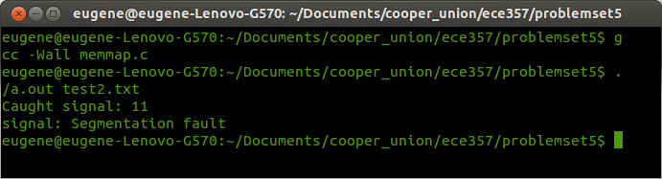
Part B: Write to memory mapped region which is MAP_SHARED → changes are visible immediately

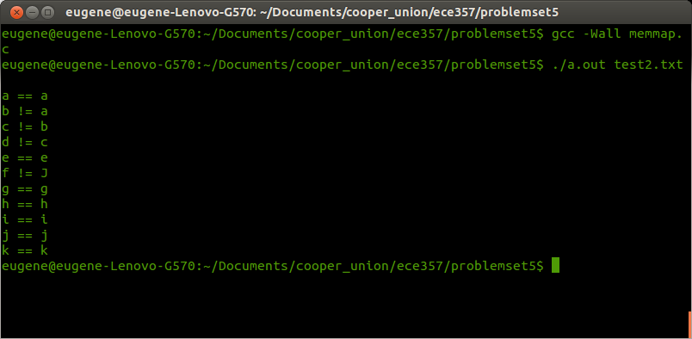
Part C: Write to memory mapped region which is MAP_PRIVATE → changes are not immediately as the memory region creates a copy of the contents of the file (COW) and write there

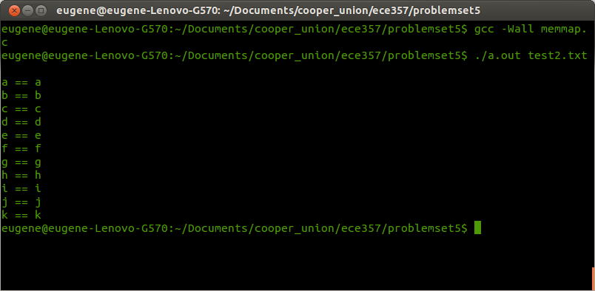

Part D: Write to one bytes past size of MAP_SHARED file → size does not change as the kernel does not know this change was done to the file as the change was made to the memory mapped region.

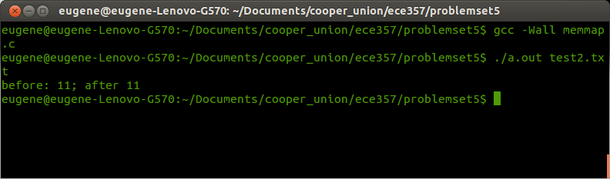
Part E: Create a 'hole' in the file → represented as '^@'
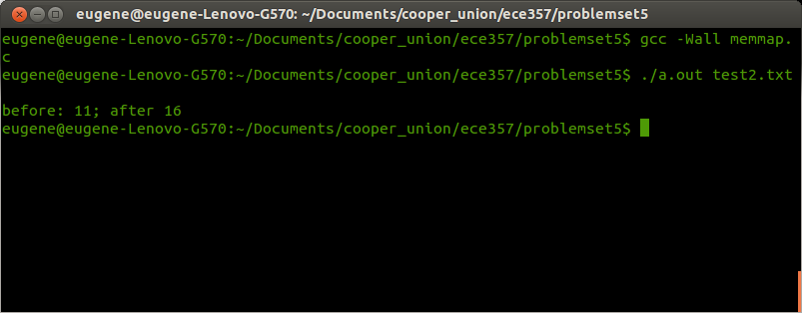
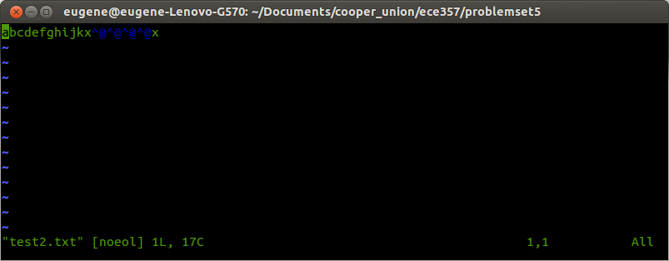
Part F: Map a small file to two pages long → able to write in first page, unable to write to second page

