Eugene Sokolov
ECE 357, pset 8

Problem 5:
100,000 iterations:
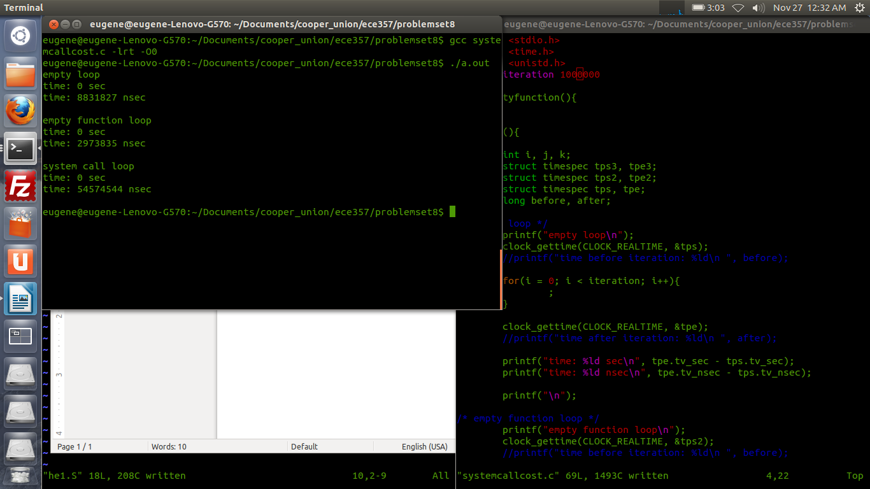

100000000

