**CPSC 2150: Week 8 Homework AVL Trees, Trees**

**Due: As indicated by submission link**

**Total Marks: 10**

**Instructions – PLEASE READ**

1. This work is to be done individually.
2. You should submit only one version via D2L. Check instructions from TA regarding what to submit (zip/just code). Code files must always be included.
3. Keep a copy of everything you submit in some online storage that is accessible by you only.

*Copying another student’s work or submitting anything that is not your own work will result in a zero for all parties involved. Academic alert may follow!*

# EXERCISES

***Problem 1 must be solved and submitted during lab***

1. AVL Tree analysis + Programming
   1. **For each question below, for each step of the process draw a tree to show the state of the tree at the end of that step.**

***Each leaf node’s height is 0***

***Balance factor calculation formula: rightSubTree’s height – leftSubTree’s height***

* + 1. Write the balance factors of each node in the tree shown below.

Height/bf

4/-2



3/-2 1/0

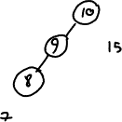

2/-1



1/0

* + 1. Rotate the sub-tree rooted at node containing 15 to the left by 1 in the tree shown below. Draw trees to show intermediate steps.

Height/bf

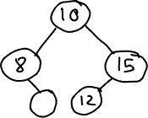

* + 1. Rotate the sub-tree rooted at node containing 10 to the right by 1 in the tree shown below. Draw trees to show intermediate steps.



The answer this page

* 1. **Download liangAVLTree.h from D2L -> Week 8 and complete the following exercises**
     1. Complete the following methods
        1. Search
        2. balancePath
        3. balanceFactor
        4. balanceRR
        5. balanceRL

1. AVL Tree analysis
   1. Convert the following bst into one that has an RR imbalance.



* 1. Convert the following bst into one that has an LR imbalance.



* 1. What type of imbalance does the bst shown below have at node containing 15? Give reasoning using balance factors.

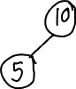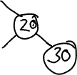

* 1. Fix the imbalance at node containing 15 in the bst shown below. Draw trees to show intermediate steps.

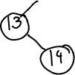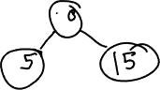

* 1. Fix the imbalance at node containing 15 in the bst shown below. Draw trees to show intermediate steps.



Answers are below

1. AVL Tree Coding
   1. Complete the remaining exercises in liangAVLTree.h