SUPPLEMENTARY MATERIAL

Title: Large-scale single-step all-breed GWAS for US dairy cattle

E. R. Carrara^{1*}; M. Bermann¹; J. M. Tabet¹; A. Legarra^{1,2}; J. B. Cole^{2,3,4,5}; I. Misztal¹; D. Lourenco¹

¹Department of Animal and Dairy Science, University of Georgia, Athens, GA 30602, USA
²Council on Dairy Cattle Breeding, Bowie, MD 20716, USA
³Department of Animal Science, North Carolina State University, Raleigh, NC 27607, USA
⁴Department of Animal Sciences, Donald Henry Barron Reproductive and Perinatal Biology Research Program, and the Genetics Institute, University of Florida, Gainesville, FL 32608, USA
⁵Centre for Genetic Improvement of Livestock, Department of Animal Biosciences, University of Guelph, Ontario N1G 2W1, Canada

SUPP. TABLES
Supplementary Table 1. Number of genotyped animals for single-breed analyses.
Breed¹ | AY |  | BS |  | GU |  | JE |  | HO
Trait² / Sex³ | M | F | M | F | M | F | M | F | M | F
MY, FY, PY | 810 | 1,130 | 1,876 | 8,541 | 644 | 3,130 | 7,599 | 308,120 | 39,790 | 1,734,310
CCR, HCR, DPR | 822 | 1,170 | 1,920 | 9,596 | 659 | 3,582 | 7,870 | 351,511 | 40,707 | 1,979,537
SCS | 807 | 1,093 | 1,869 | 8,367 | 642 | 3,083 | 7,562 | 304,285 | 39,438 | 1,701,582
PL | 788 | 886 | 1,779 | 7,635 | 601 | 2,794 | 7,169 | 265,075 | 38,262 | 1,493,247
LIV | 799 | 1,025 | 1,795 | 7,959 | 598 | 2,914 | 7,262 | 277,861 | 38,722 | 1,585,938
¹ AY = Ayrshire; BS = Brown Swiss; GU = Guernsey; JE = Jersey; HO = Holstein
² MY = milk yield; FY = fat yield; PY = protein yield; CCR = cow conception rate; HCR = heifer conception rate; DPR = daughter pregnancy rate; SCS = somatic cell score; PL = productive life; LIV = cow livability.
³ M = males; F = females

Supplementary Table 2. Number of males (M) and females (F) in core.
Breed¹ | AY |  | BS |  | GU |  | JE |  | HO
Trait² / Sex | M | F | M | F | M | F | M | F | M | F
MY, FY, PY | 113 | 938 | 319 | 4,792 | 115 | 3,158 | 2,162 | 14,375 | 4,653 | 14,375
CCR, HCR, DPR | 113 | 134 | 330 | 2,960 | 111 | 1,211 | 2,181 | 16,503 | 4,953 | 16,504
SCS | 109 | 585 | 312 | 4,870 | 113 | 2,949 | 3,024 | 14,608 | 4,539 | 14,608
PL | 109 | 582 | 320 | 4,999 | 112 | 2,555 | 1,973 | 14,999 | 4,353 | 14,998
LIV | 121 | 809 | 336 | 5,545 | 118 | 2,786 | 2,092 | 15,550 | 4,493 | 13,150
¹ AY = Ayrshire; BS = Brown Swiss; GU = Guernsey; JE = Jersey; HO = Holstein
² MY = milk yield; FY = fat yield; PY = protein yield; CCR = cow conception rate; HCR = heifer conception rate; DPR = daughter pregnancy rate; SCS = somatic cell score; PL = productive life; LIV = cow livability.

Supplementary Table 3. Significant markers for each trait, with chromosome, position, rs code (if available), and associated characteristics (if available). Blank entries indicate markers currently unavailable in Cattle Quantitative Trait Locus Database (QTLdb).

[Please, see the attached file “Supp_Table_3.xlsx”]

SUPP. FIGURES
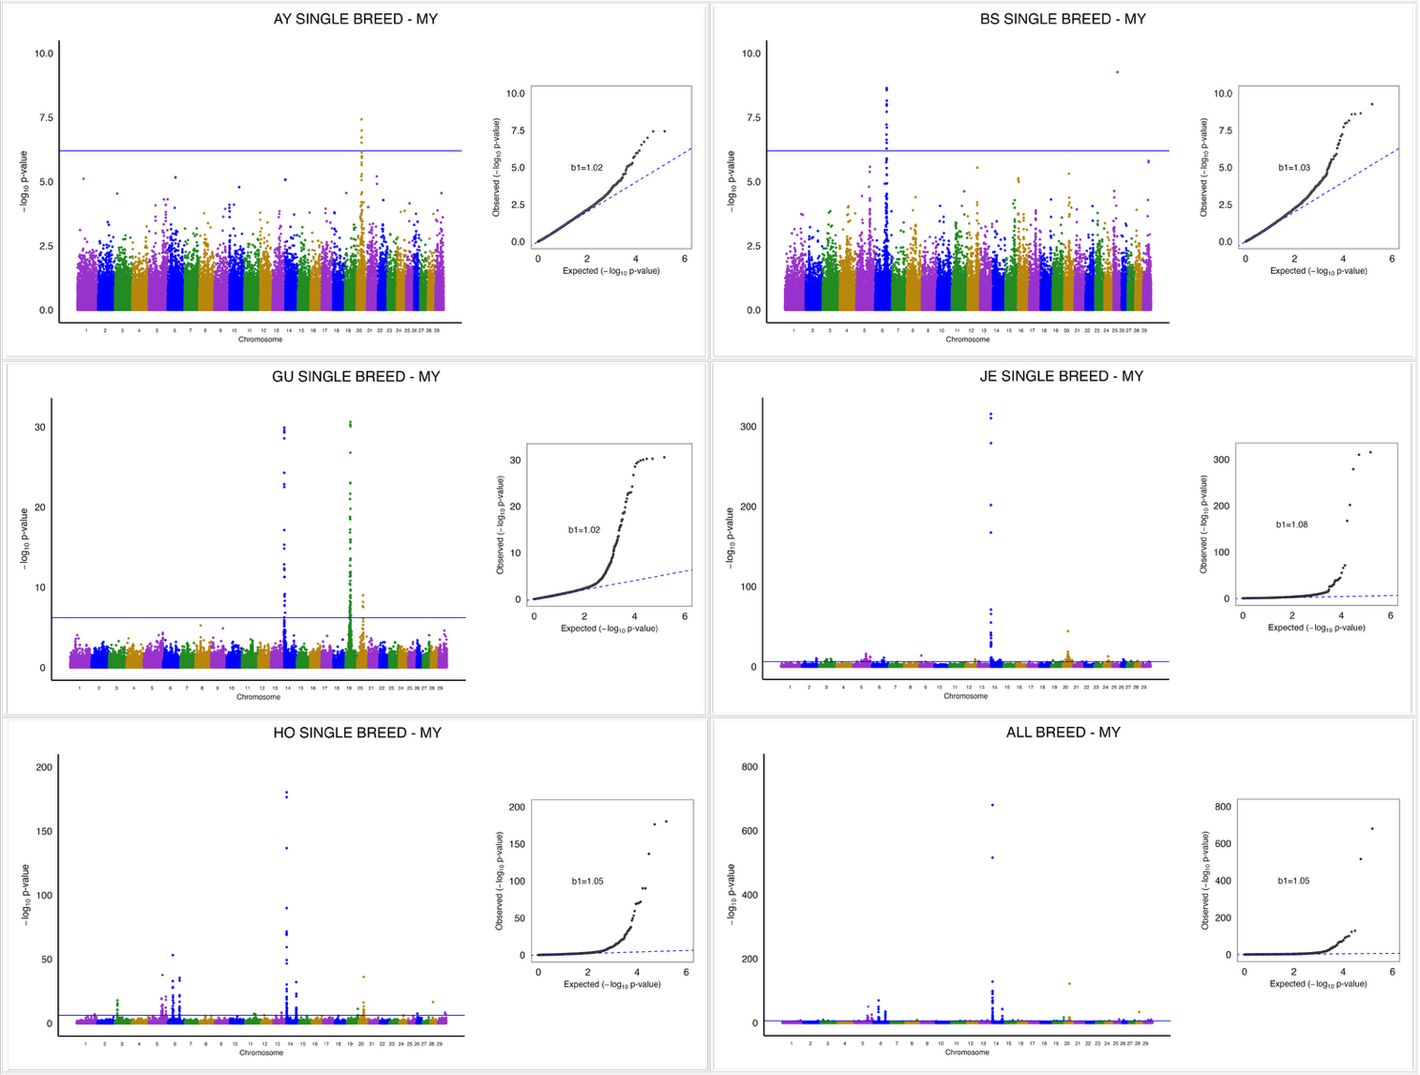
Supplementary Figure 1. Milk yield (MY) Manhattan plots for Ayrshire (AY), Brown Swiss (BS), Guernsey (GU), Jersey (JE), and Holstein (HO) single-breed analyses and all-breed analyses.
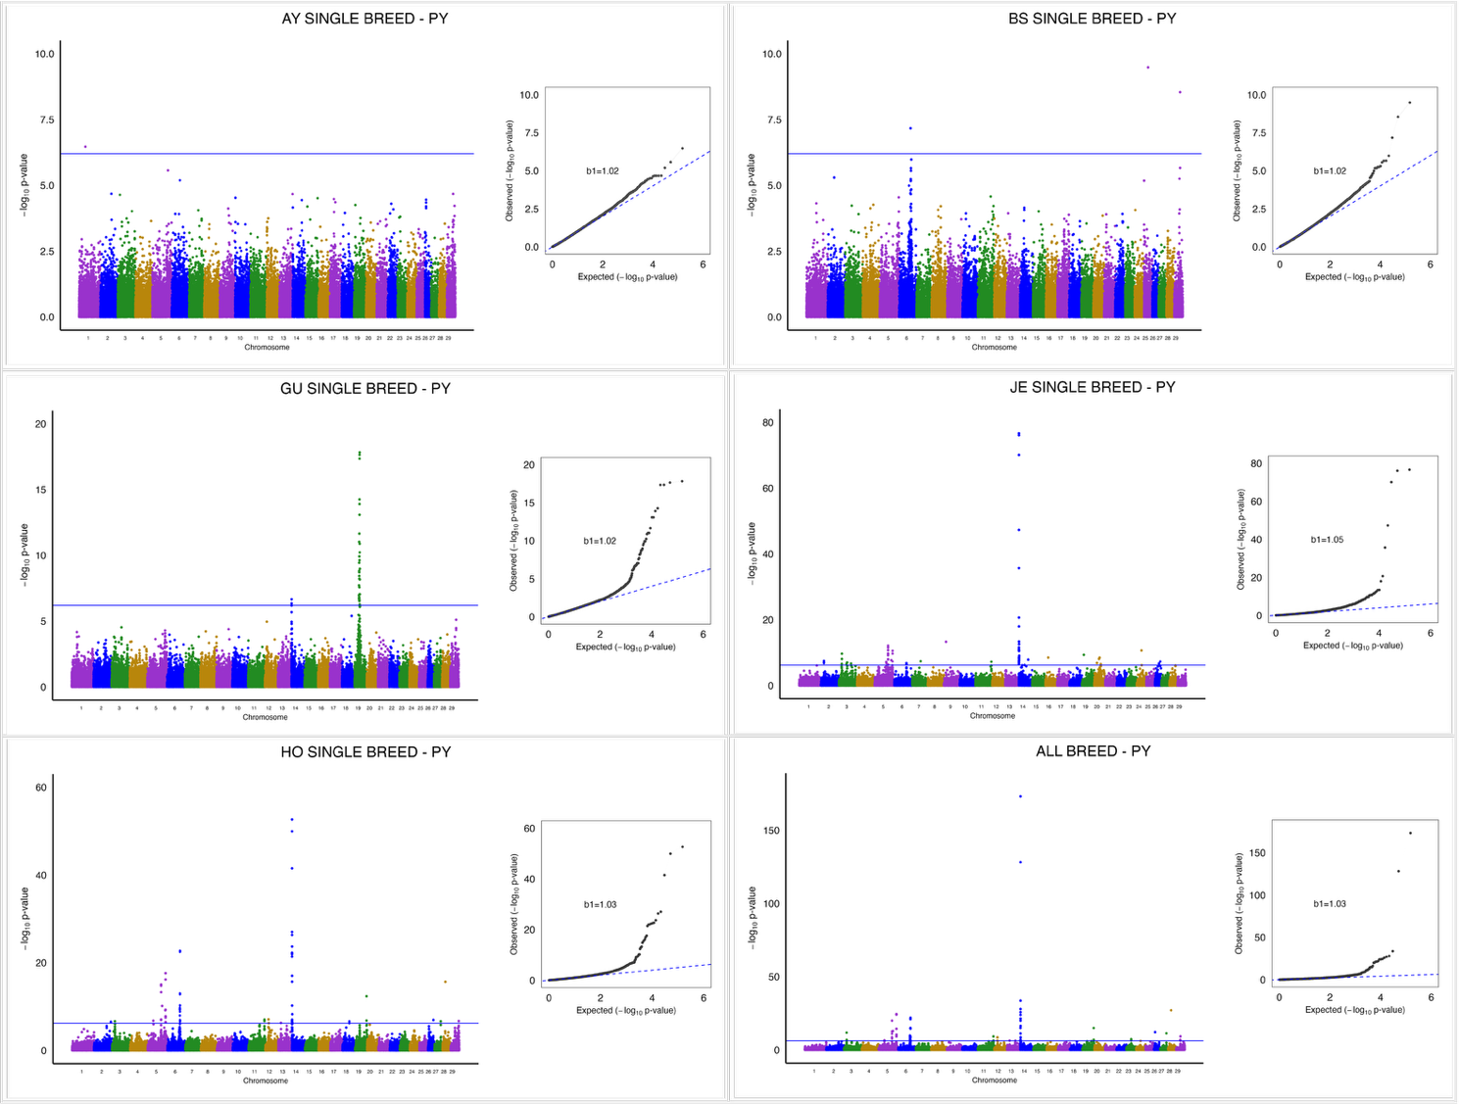
Supplementary Figure 2. Protein yield (PY) Manhattan plots for Ayrshire (AY), Brown Swiss (BS), Guernsey (GU), Jersey (JE), and Holstein (HO) single-breed analyses and all-breed analyses.

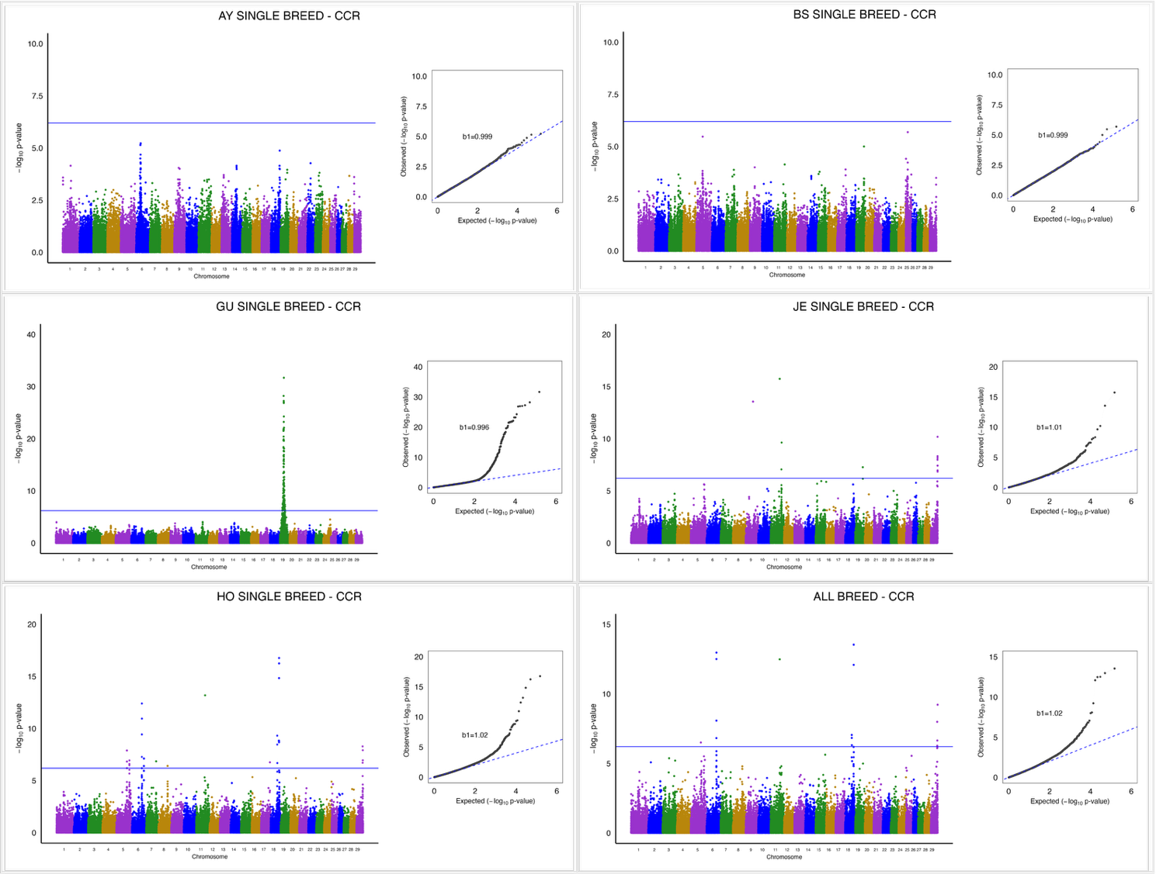
Supplementary Figure 3. Cow conception rate (CCR) Manhattan plots for Ayrshire (AY), Brown Swiss (BS), Guernsey (GU), Jersey (JE), and Holstein (HO) single-breed analyses and all-breed analyses.

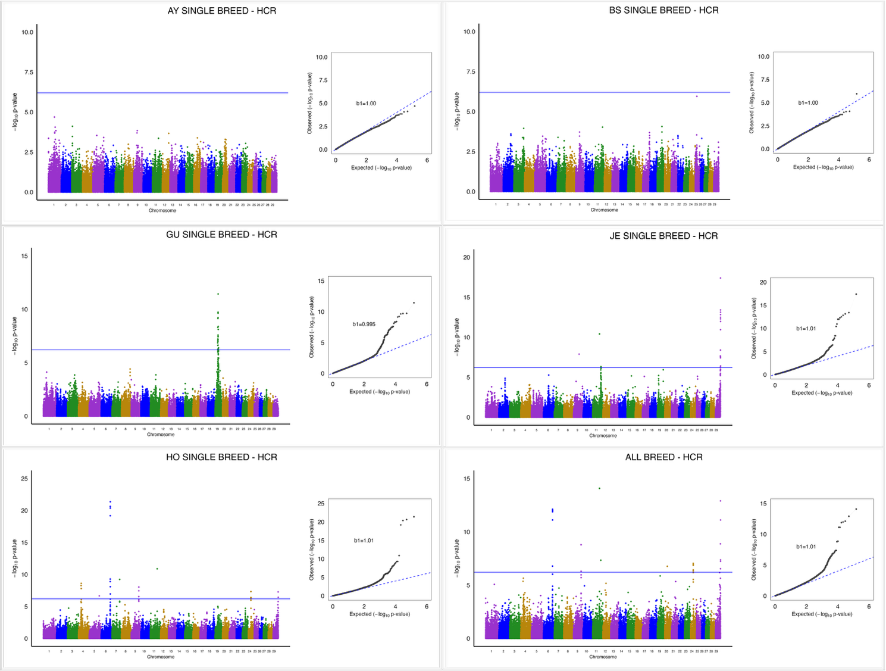
Supplementary Figure 4. Heifer conception rate (HCR) Manhattan plots for Ayrshire (AY), Brown Swiss (BS), Guernsey (GU), Jersey (JE), and Holstein (HO) single-breed analyses and all-breed analyses.

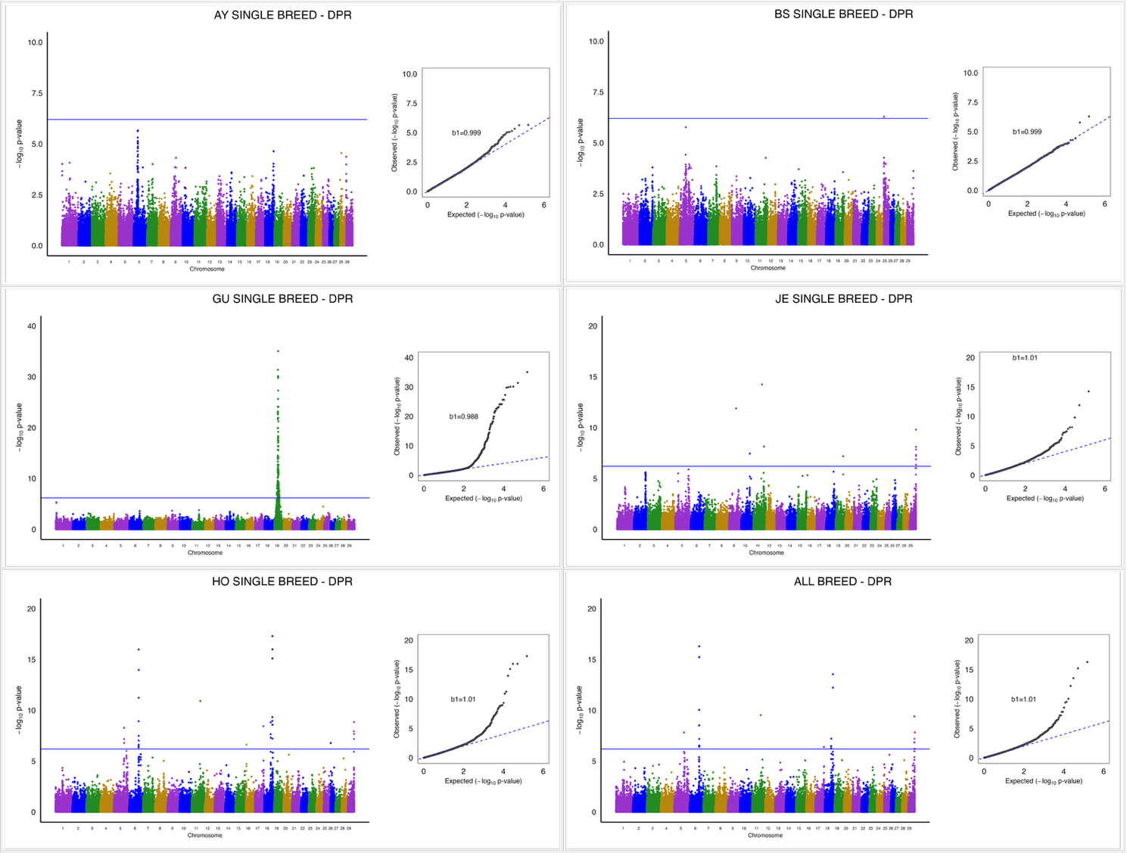
Supplementary Figure 5. Daughter pregnancy rate (DPR) Manhattan plots for Ayrshire (AY), Brown Swiss (BS), Guernsey (GU), Jersey (JE), and Holstein (HO) single-breed analyses and all-breed analyses.

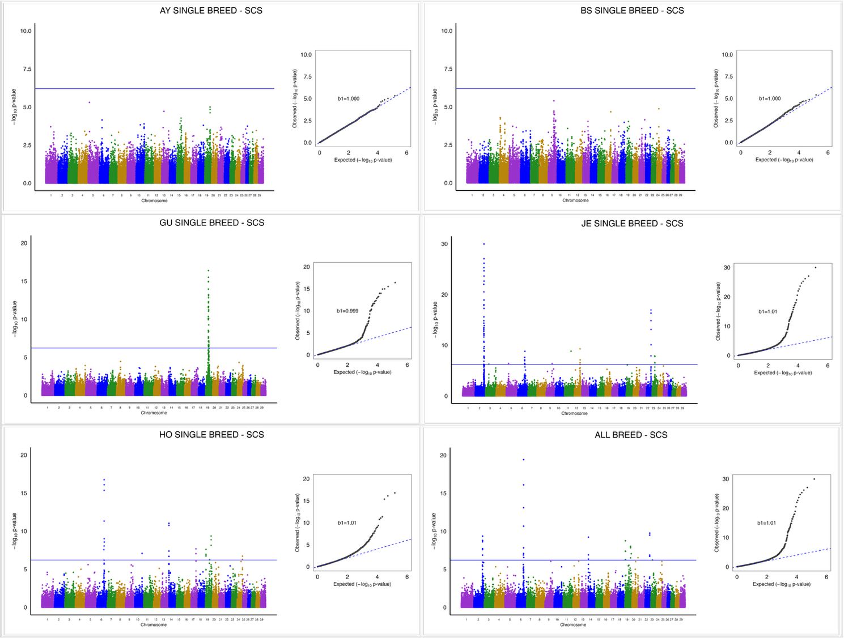
Supplementary Figure 6. Somatic cell score (SCS) Manhattan plots for Ayrshire (AY), Brown Swiss (BS), Guernsey (GU), Jersey (JE), and Holstein (HO) single-breed analyses and all-breed analyses.

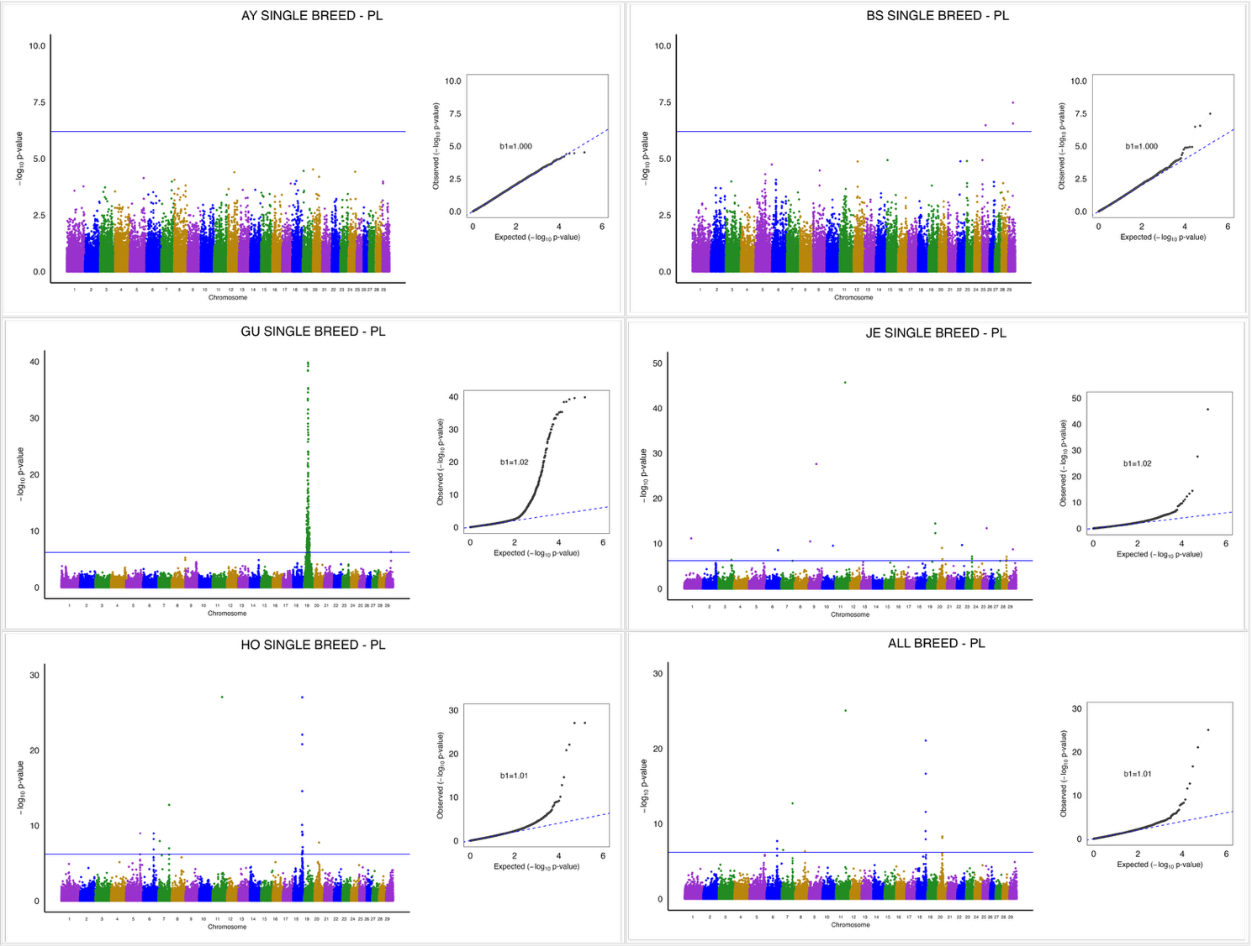
Supplementary Figure 7. Productive life (PL) Manhattan plots for Ayrshire (AY), Brown Swiss (BS), Guernsey (GU), Jersey (JE), and Holstein (HO) single-breed analyses and all-breed analyses.
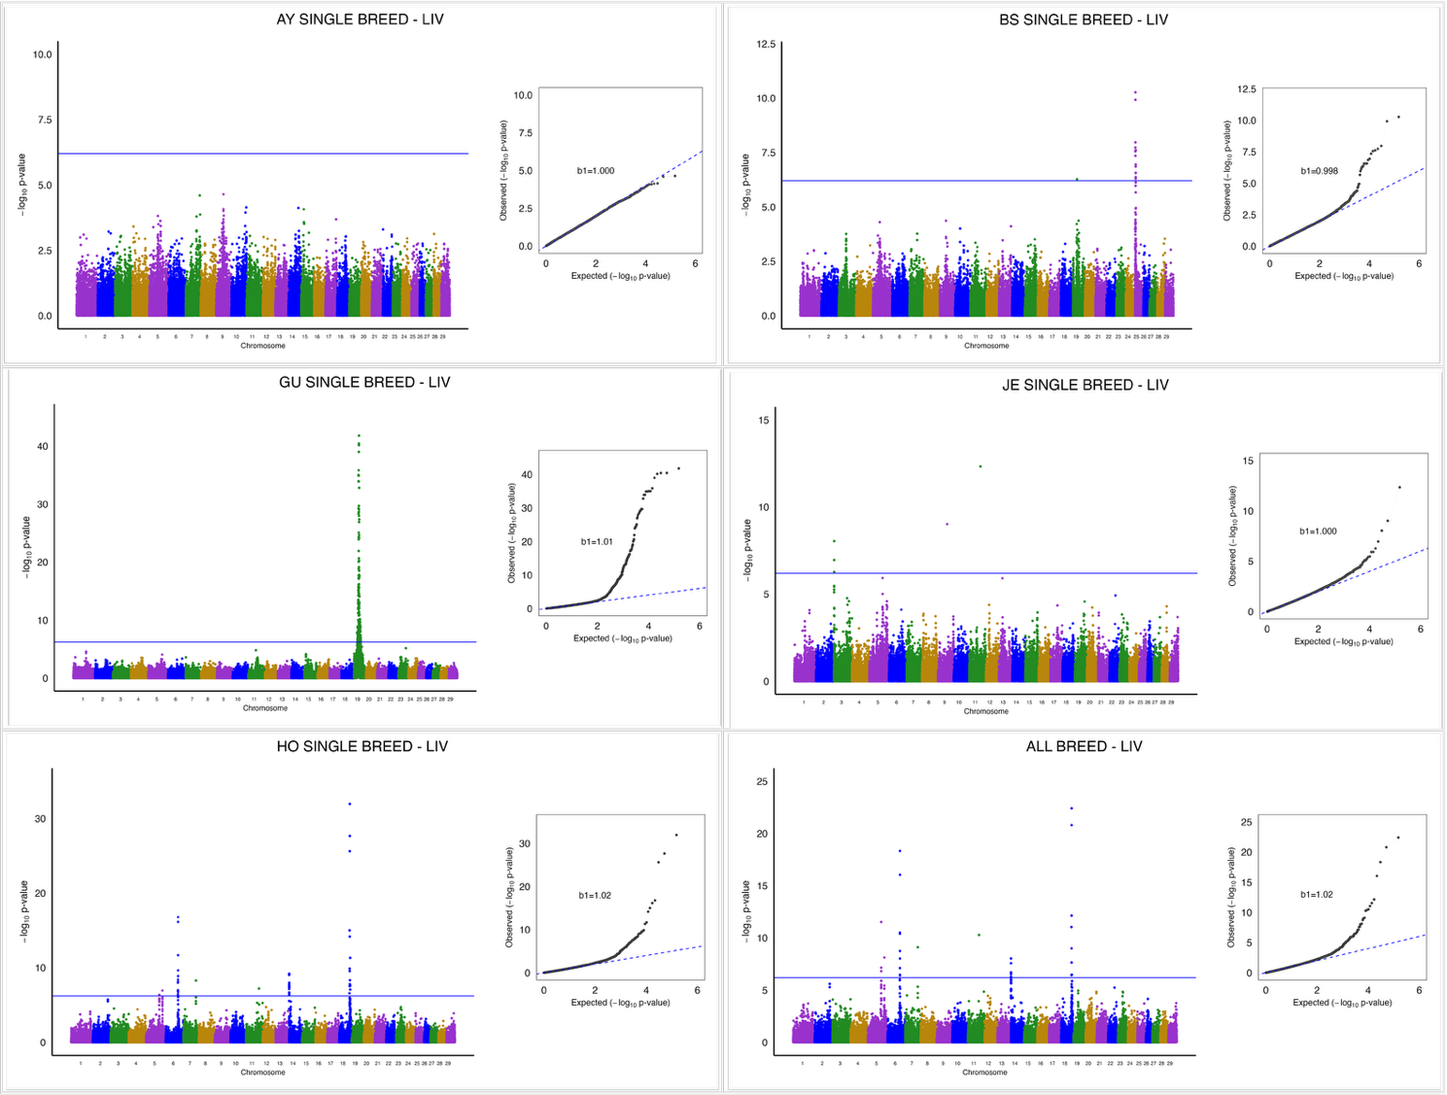

Supplementary Figure 8. Cow livability (LIV) Manhattan plots for Ayrshire (AY), Brown Swiss (BS), Guernsey (GU), Jersey (JE), and Holstein (HO) single-breed analyses and all-breed analyses.

