**PROGRAM - 1**

**AIM:**TO GENERATE EXPONENTIALLY RANDOM NUMBERS FROM UNIFORMLY DISTRIBUTED NUMBERS

clc;

clear;

uniX = rand(1,10000000);

subplot(3,1,1)

nbin = 5000;

hist(uniX,nbin);

title('uniformly distributed random numbers');

% generation of exp distribution

expY = -log(uniX);

subplot(3,1,2);

hist(expY,nbin);

title('exponentially distributed random numbers');

% generation of uniform from exp

uniX2 = exp(-expY);

subplot(3,1,3)

hist(uniX2,nbin);

title('uniform distribution using exponential');

**PROGRAM - 1**

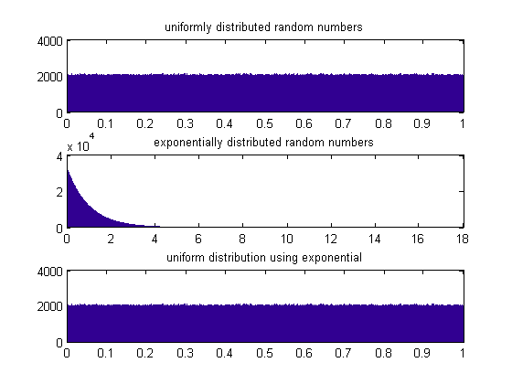

**PROGRAM - 2**

**AIM:** TO GENERATE AN AMPLITUDE MODULATED SIGNAL AND

ANALYSE THE CRITICAL, UNDER AND OVER

MODULATION

clc;

Clear;

fc = 1000000;

fm = 1000;

fs = 10000000; % sampling frequency

k = 0.5; % modulation index

Ac = 1/k; % assuming Am = 1

opt = -Ac;

t = 0:1/fs:(2/fm) - (1/fs);

x = cos(2*pi*fm*t);% + sin(2*pi*fm*t);

subplot(311)

plot(x);

title('Message Signal');

y = modulate(x,fc,fs,'amdsb-sc');

subplot(312)

plot(y);

title('Amplitude Modulation');

z = Ac*(1+k.*x).*cos(2*pi*fc*t);

subplot(313)

plot(z);

title('AM modulation');

**PROGRAM - 2**

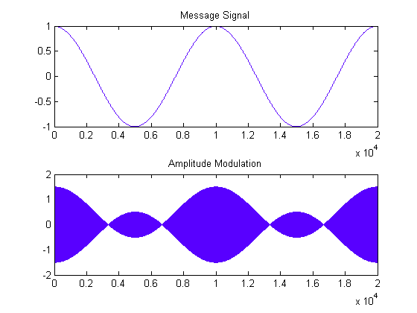

**OVER MODULATION**

**PROGRAM - 2**

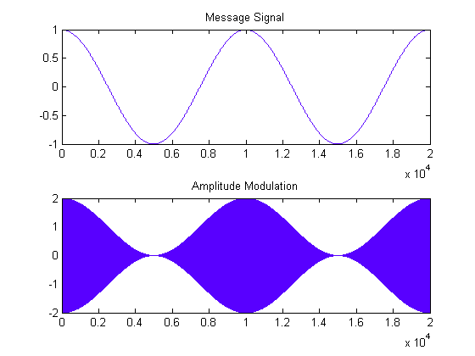

**CRITICAL MODULATION**

**PROGRAM - 2**

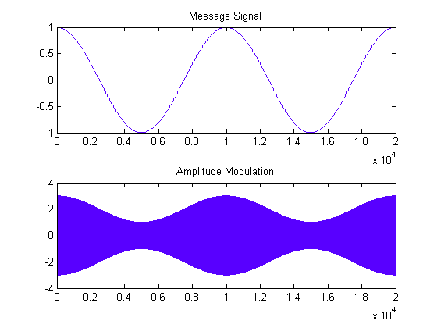

**UNDER MODULATION**

**PROGRAM - 3**

**AIM:** TO GENERATE RAYLEIGH DISTRIBUTION RANDOM NUMBERS FROM GAUSSIAN DISTRIBUTION

clc;

clear;

gaussX1 = randn(1,100000);

gaussX2 = randn(1,100000);

rayleighY = sqrt(gaussX1.^2 + gaussX2.^2);

nbins = 500;

subplot(3,1,1)

hist(gaussX1,nbins);

title('Gaussian');

subplot(3,1,2)

hist(gaussX2,nbins);

title('Gaussian');

subplot(3,1,3)

hist(rayleighY,nbins);

title('Rayleigh');

**PROGRAM - 3**

