1811ICT/2807ICT/7001ICT Programming Principles Workshop 4

School of Information and Communication Technology

Griffith University

| Goals | In this workshop we create interactive scripts that make decisions and/or loop. |
| --- | --- |
| When | Workshops from Friday 8 April to Thursday 21 April |
| Marks | 3 |
| Due | Pre-workshop questions before the start of the above mentioned workshops  Workshop programming problems by 11:59pm on 24 April |

# Before your workshop class:

* Read all of this document.
* Review the lecture notes sections 1 to 13.
* **Complete the pre-workshop questions (1 mark) posted on the course website and submit the answers for marking**.

# Workshop activities (2 marks)

At any stage, when you are stuck, *ask your tutor*!

## Problem 1

*Problem:* Write a program that reads whole numbers typed by the user until a zero is entered, then prints the number of positive numbers that were entered. Sample run:

Enter a number: 3

Enter a number: -2

Enter a number: 5

Enter a number: 6

Enter a number: -100

Enter a number: 70

Enter a number: 22

Enter a number: 68

Enter a number: 0   
6 positive numbers were entered.

*Answer*: Copy your code in the space given below and insert screenshots of your program output for two scenarios of your own choosing.

***Copy your code here***

***n=1***

***x=0***

***while n != 0:***

***n = int(input("Enter a number: "))***

***if n > 0 :***

***x+=1***

***print(x,"positive numbers were entered.")***

***Insert your screenshots here***

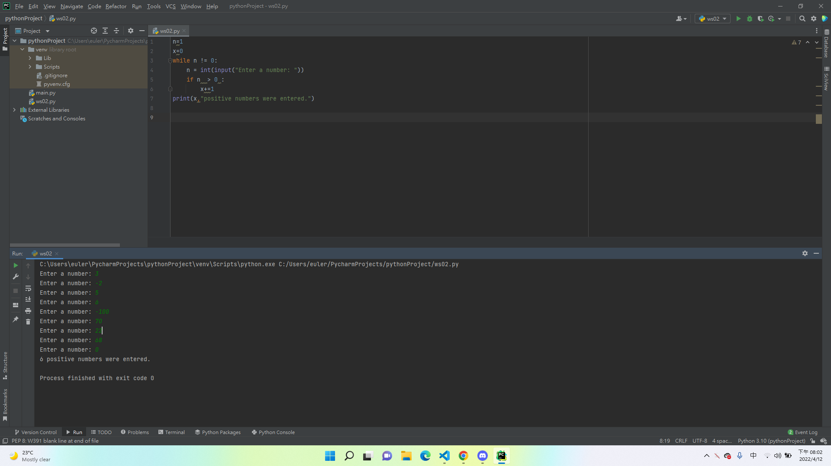

## Problem 2

*Problem:* In mathematics, the Fibonacci sequence is defined such that each Fibonacci number is the sum of the two preceding ones, starting from 0 and 1. That is, F1 = 0, F2 = 1, F3 = 1, F4 = 2, ..., Fn = F(n-1) + F(n-2). Write a program that given an input n, outputs the first n Fibonacci numbers. The format of output is that at most 4 numbers can be displayed in a row. Sample run:

| Enter a positive number: 6  0 1 1 2  3 5  Enter a positive number: 10  0 1 1 2  3 5 8 13  21 34 |
| --- |

*Answer*: Copy your code in the space given below and insert screenshots of your program output for the following two scenarios:

* Enter a positive number: 8
* Enter a positive number: 15

***Copy your code here***

*n=int(input("Enter a number:"))*

*x=0*

*y=1*

*c=x+y*

*if n!=0:*

*for i in range(0,n):*

*print(x, end = " " if i % 4 else "\n")*

*x=y*

*y=c*

*c=x+y*

***Insert your screenshots here***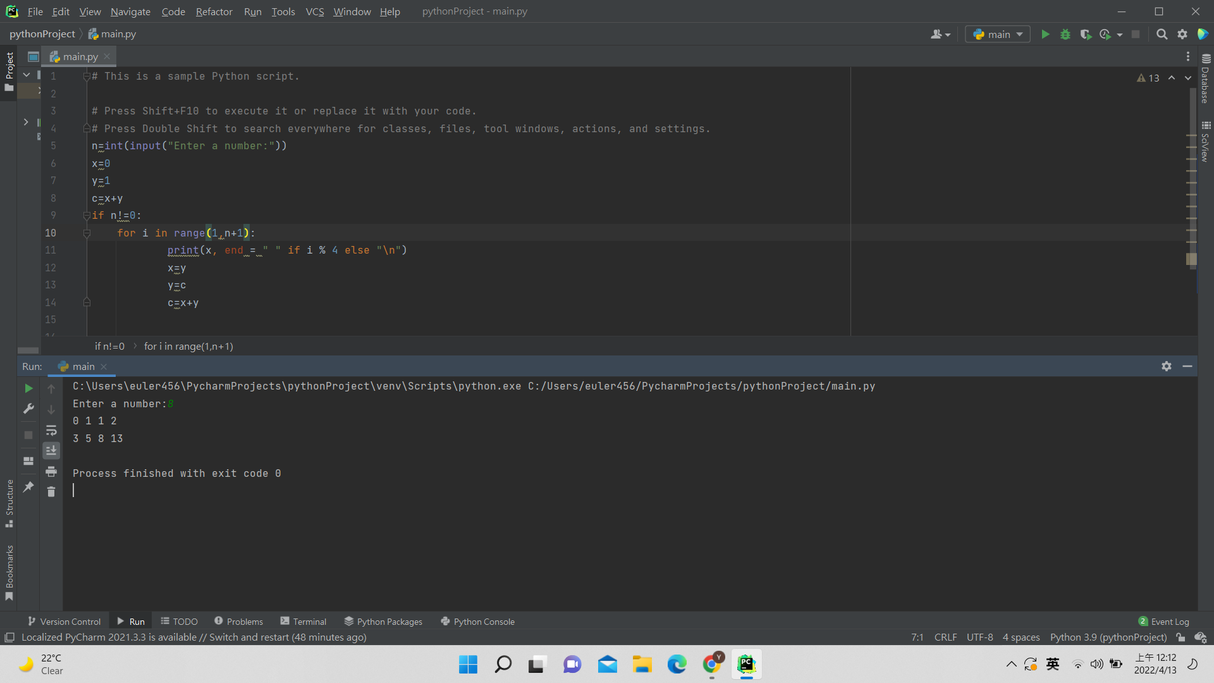

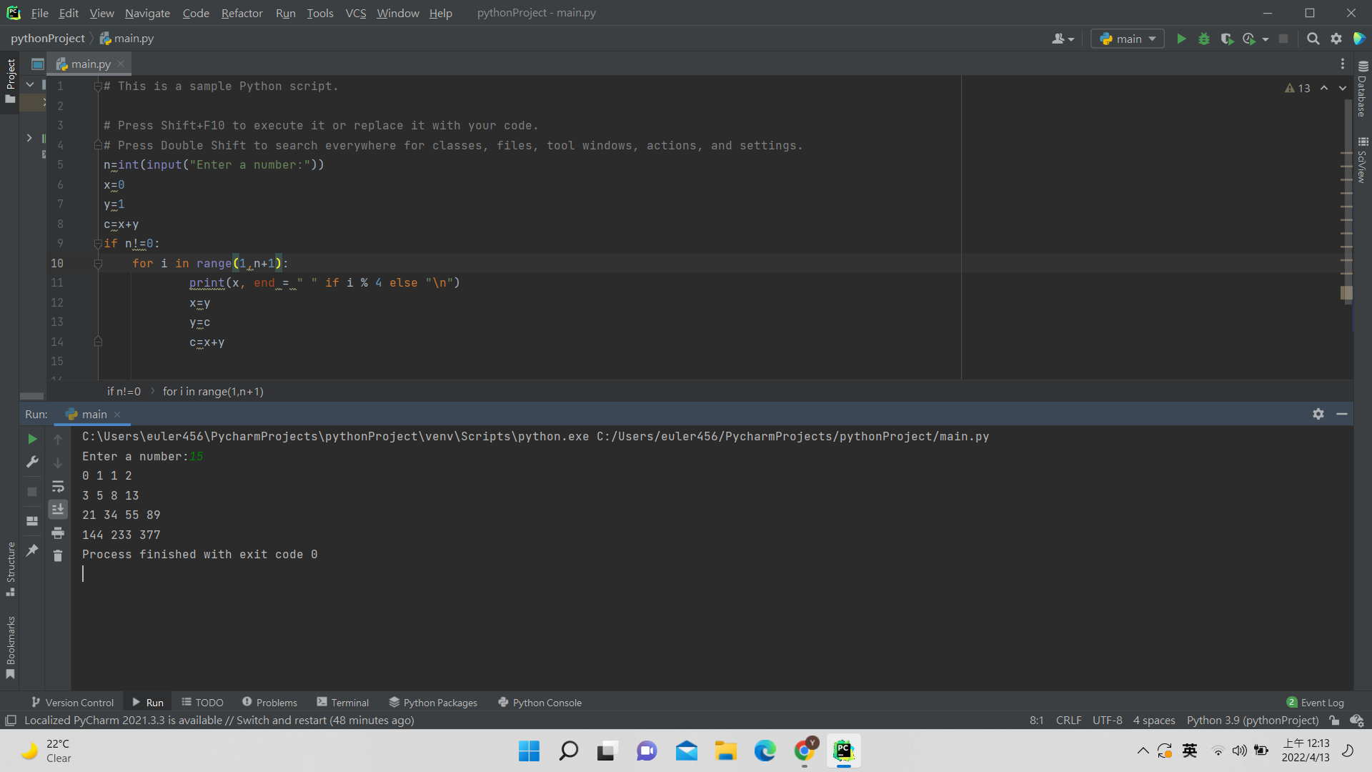

## Problem 3

*Problem:* Given an input number n, print a diamond shape with 2*n-1 rows.

Sample run:

| Enter a positive number: 3  xxx  xxxx  xxxxx  xxxx  xxx |
| --- |

*Answer*: Copy your code in the space given below and insert screenshots of your program output for the following two scenarios:

* Enter a positive number: 1
* Enter a positive number: 5

*n=int(input("Enter a positive number:"))*

*for i in range(n+1):*

*print(' '*(n-i)+'X'*(2*i-1))*

*for i in range(n-1,0,-1):*

*print(' '*(n-i)+'X'*(2*i-1))*

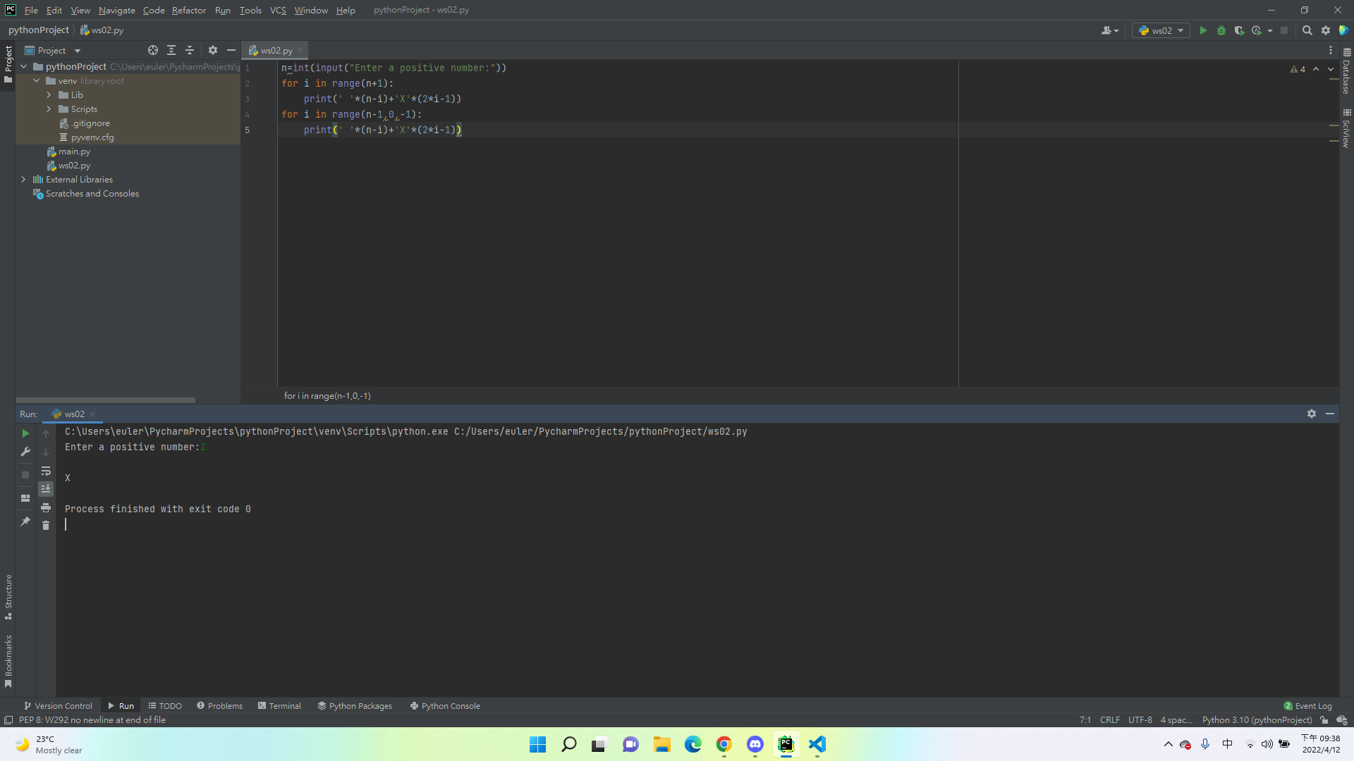

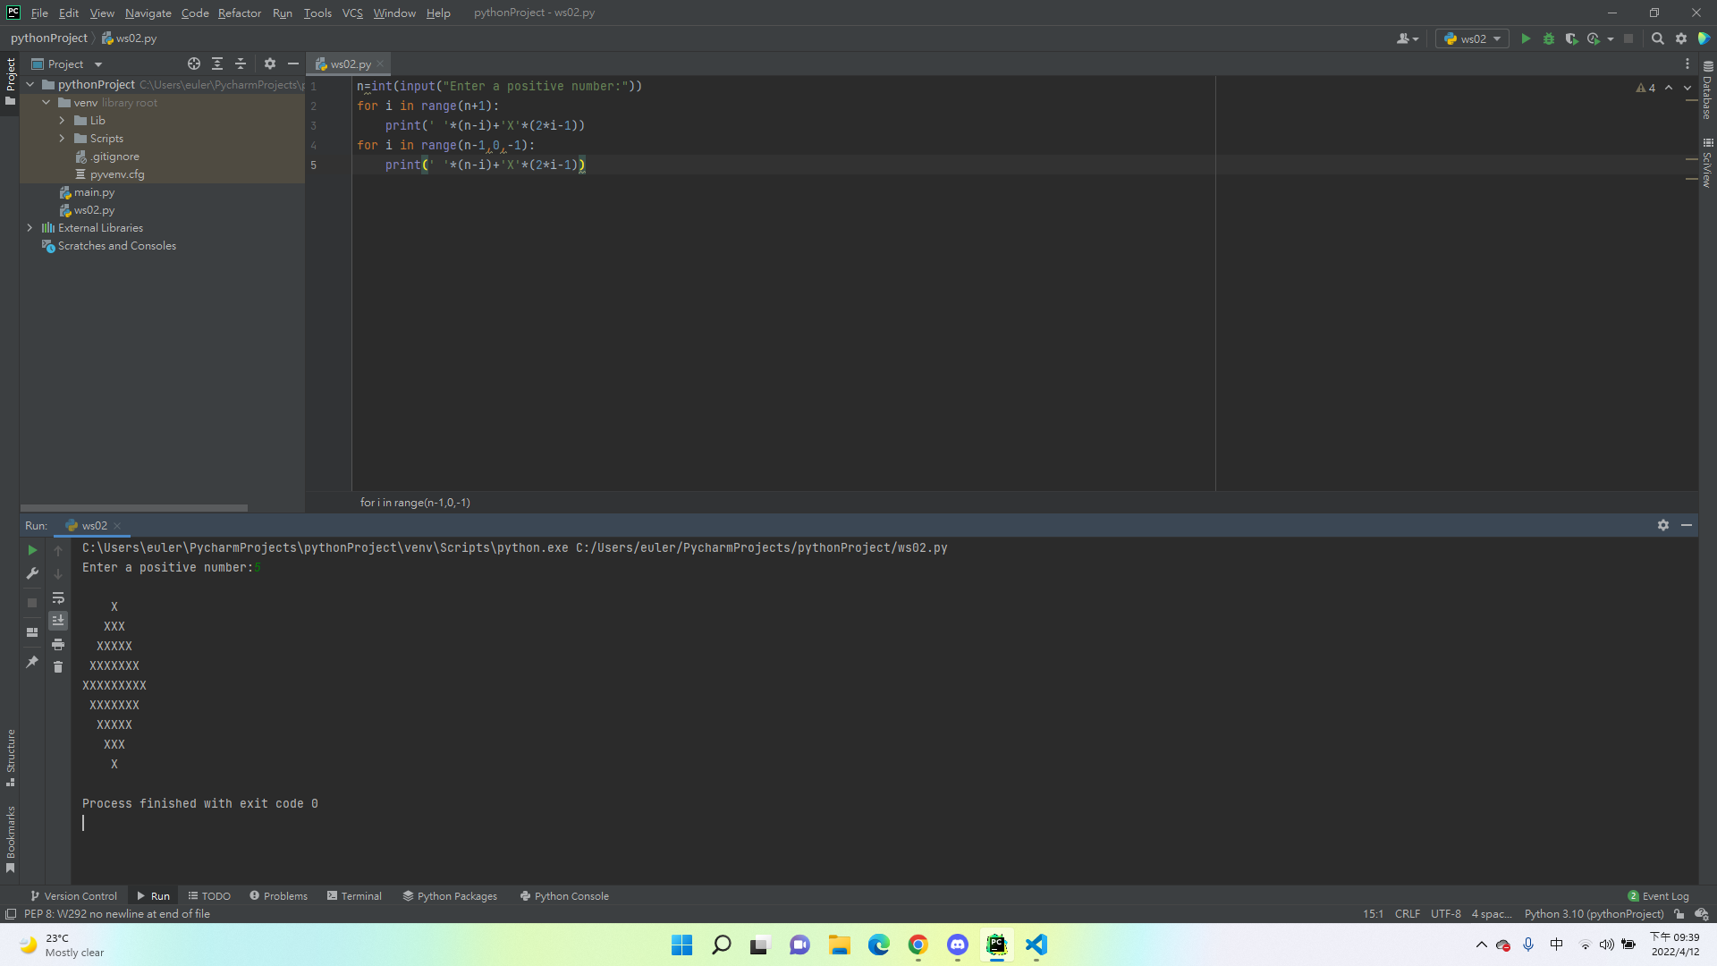

## Problem 4 (Optional, 1811ICT students are strongly encouraged to try)

*Problem:* A palindrome is a number or a text phrase that reads the same backwards as well as forwards. Examples of palindromes are 123321, 1234321, 55555, 22, 454, 1, 0. Write a program that reads in a positive integer number, and prints out whether or not that number is a palindrome. Sample run:

Enter a positive number: 12321

12321 is a palindrome

Enter a positive number: 1234

1234 is not a palindrome

*Answer*: Copy your code in the space given below and insert screenshots of your program output for the following two scenarios:

* Enter a positive number: 345543
* Enter a positive number: 92321

code:

n=int(input("Enter a positive number:"))

temp=n

f=n

s=0

i=0

while n !=0:

n= n//10

i += 1

for i in range(i,0,-1):

s = (temp % 10) * (10 ** (i-1)) + s

temp = temp // 10

if f==s:

print(f," is a palindrome")

else:

print(f," is not a palindrome")

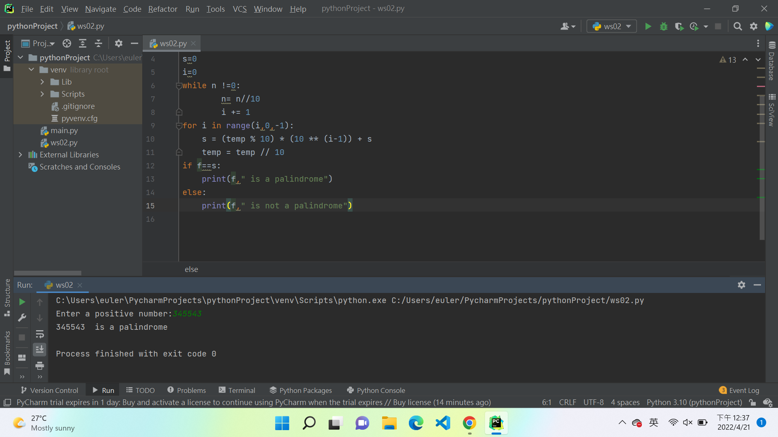

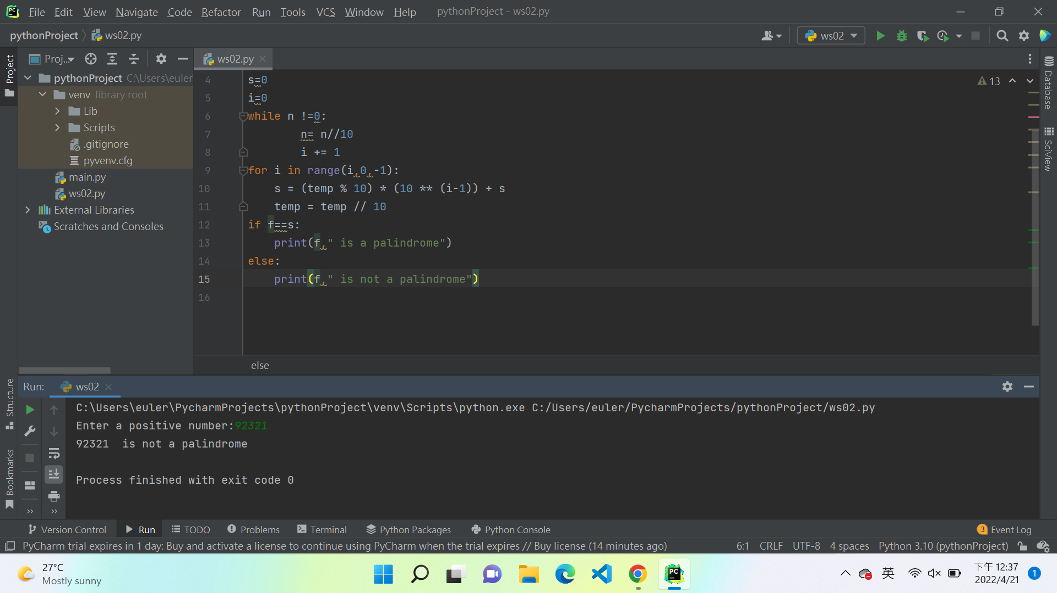

# Submission and marking

The pre-workshop can be accessed and submitted online using the provided link in the course website. Students get 1 mark if they get >50% in pre-workshop questions, or 0.5 mark if they get 0%-50% in pre-workshop questions, or 0 marks without any attempt.

For workshop tasks, please submit this document with copied codes and inserted screenshots using the provided submission link in the course website. Students get 2 marks if they complete two or more problems correctly, or 1 mark if they complete one problem correctly, or 0 marks without any attempt.