1811ICT/2807ICT/7001ICT Programming Principles Workshop 5

School of Information and Communication Technology

Griffith University

| Goals | In this workshop we practice programming with strings and functions |
| --- | --- |
| When | Workshops from Friday 22 April to Thursday 28 April |
| Marks | 3 |
| Due | Pre-workshop questions before the start of the above mentioned workshops  Workshop programming problems by 11:59pm on 1 May |

# Before your workshop class:

* Read all of this document.
* Review the lecture notes sections 1 to 11.
* **Complete the pre-workshop questions (1 mark) posted on the course website and submit the answers for marking**.

# Workshop activities (2 marks)

At any stage, when you are stuck, *ask your tutor*!

## Problem 1

*Problem:* Write a program that prompts for and reads strings until a string that starts with the letter “A” is entered (inclusive), then prints the longest string that was entered. Sample run:

Enter a string: Jaypher said, ’It’s safer

Enter a string: you’ve lemons in your head;

Enter a string: First to eat, a pound of meat,

Enter a string: Find then to go at once to bed.

Enter a string: Eating meat is half the battle,

Enter a string: Will you hear the Lemons rattle!

Enter a string: If you don’t, you’ll always moan,

Enter a string: In a Lemoncolly tone;

Enter a string: For there’s nothing half so dreadful,

Enter a string: As Lemons in your head.

Longest was: 'For there’s nothing half so dreadful,'

*Answer*: Copy your code in the space given below and insert screenshots of your program output for two scenarios:

Enter a string: The warmth of the sun,

* Enter a string: Faces all aglow.

Enter a string: It’s time for summer fun

Enter a string: As the happy faces show.

* Enter a string: He can’t afford a new red suit

Enter a string: With boots and matching belt,

Enter a string: But his smile is warmer than the sun

Enter a string: That can make the snow tops melt.

Enter a string: My dad would like to be Santa

Enter a string: And fill the world with glee

***Copy your code here***

y = ""

i = 0

while i == 0:

n = input(str("Enter a string:"))

if n[0] == "A":

if len(n) > len(y):

y = n

print("Longest was:", y)

i = 1

else:

print("Longest was:", y)

i = 1

else:

if len(n) > len(y):

y = n

***Insert your screenshots here***

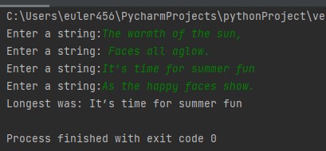

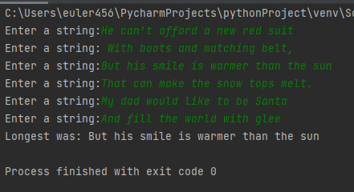

## Problem 2

*Problem:* Write a program with a **function** that converts all numerical digits in a string to underline.

Sample run:

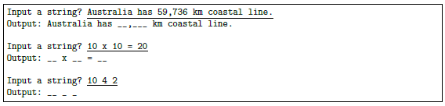

*Answer*: Copy your code in the space given below (you need to define a function in the code) and insert screenshots of your program output for two scenarios:

* Input a string? 7 is my lucky number
* Input a string? Students with a mark of 85 and above will achieve a grade of 7

***Copy your code here***

def converts():

n = str(input("Input a string?"))

for m in n:

if m.isdigit():

n=n.replace(m,'_')

print("Outputs: " + str(n))

converts();

***Insert your screenshots here***

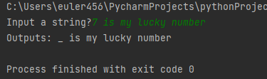

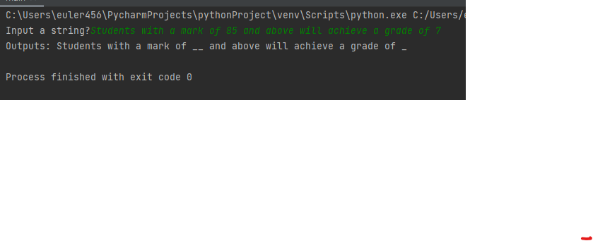

## Problem 3

*Problem:* Given starting and ending years, write a program with a **function** to calculate the number of days from starting year to ending year inclusive. Hints: Write a **function** to check leap year. Sample code is in the lecture notes of Section 10: Type Bool and Boolean Expressions. Sample run:

Year 1? 1980

Year 2? 2022

Number of days: 15706

*Answer*: Copy your code in the space given below (you need to define a function in the code) and insert screenshots of your program output for two scenarios:

* Year 1: 1988; Year 2: 2021
* Year 1: 1978; Year 2: 2008

***Copy your code here***

*def numofdays():*

*Y1 = int(input("Year 1?"))*

*Y2 = int(input("Year 2?"))*

*leap=0*

*total=0*

*if Y1%4==0:*

*leap=(Y2+1-Y1)//4+1*

*total=leap+(Y2+1-Y1)*365*

*else:*

*leap = (Y2 + 1 - Y1) // 4*

*total = leap + (Y2 + 1 - Y1) * 365*

*print("Number of days: ", total)*

*numofdays();*

***Insert your screenshots here***

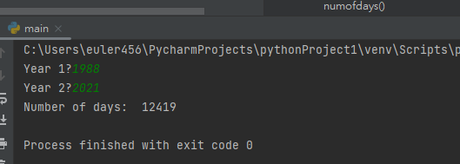

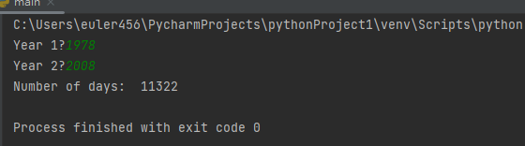

## Problem 4

*Problem:* Roll carpet comes in rolls 3.66 meters wide. Carpet is charged by the total number of **whole metres** that need to be cut from the roll. It may be laid in a rectangular room in a lengthways manner or widthways manner (see illustration below). Either way there might be some wastage. The length of a room is always its longer dimension and its width is always its shorter dimension.

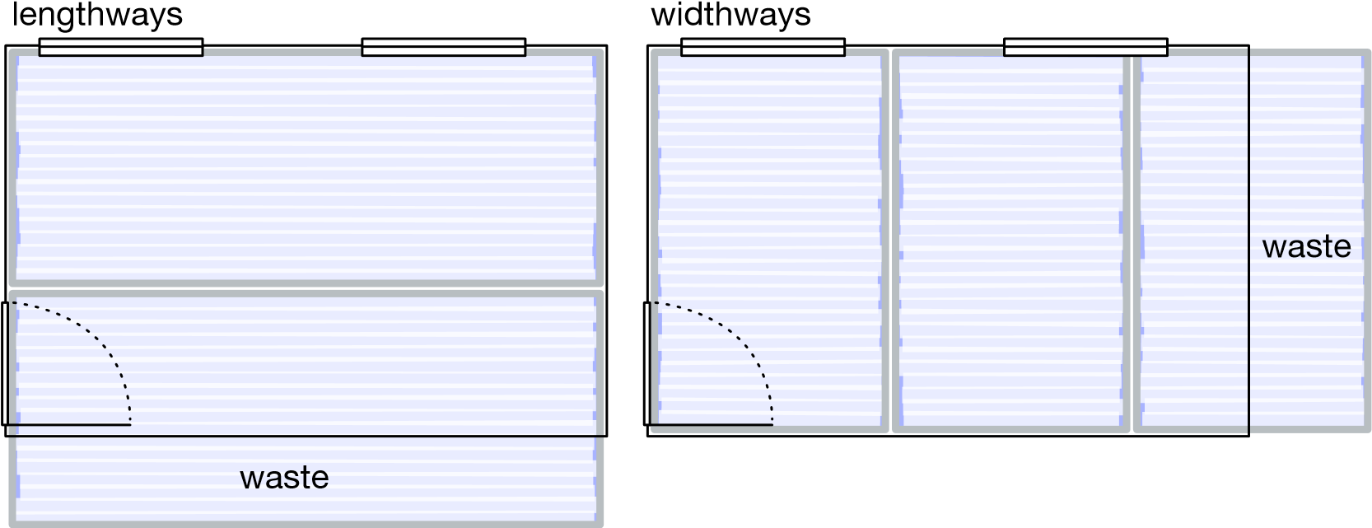

Write a program that repeatedly asks the user for room dimensions until either dimension entered is zero. For each room print the length and width (to the nearest millimetre), and the total length of carpet required in **whole metres**, to cover the room in two scenarios: lengthways manner and widthways manner. Hints: make good use of standard library functions; and simplify your program by writing a function to compute the total carpet length required given the room dimensions. Sample run:

Enter room dimension 1 (m): 2.5

Enter room dimension 2 (m): 5.5

Length of room = 5.500 m

Width of room = 2.500 m

Total carpet length required in lengthways manner = 6 m

Total carpet length required in widthways manner = 5 m

Enter room dimension 1 (m): 7.4

Enter room dimension 2 (m): 4.3

Length of room = 7.400 m

Width of room = 4.300 m

Total carpet length required in lengthways manner = 15 m

Total carpet length required in widthways manner = 13 m

Enter room dimension 1 (m): 0

Enter room dimension 2 (m): 0

*Answer*: Copy your code in the space given below and insert screenshots of your program output for two scenarios:

* Room dimensions 1: 3.2; Room dimensions 2: 10.3
* Room dimensions 1: 13.2; Room dimensions 2: 3.7

***Copy your code here***

import math

from re import L

roll=3.66

def calclenght(d1,d2):

x=d2

if d2 > d1:

d2=d1

d1 = x

print("Length of room = {:.3f}".format(d1),"m")

print("Width of room ={:.3f}".format(d2),"m")

D1=d1

D2=d2

d1=(math.ceil(D2/3.66)*D1)

d2=(math.ceil(D1/3.66)*D2)

print("Total carpet length required in lengthways manner =",math.ceil(d1),"m")

print("Total carpet length required in lengthways widthways =",math.ceil(d2),"m")

i=1

while i==1:

d1=float(input('Enter room dimension 1 (m):'))

d2=float(input('Enter room dimension 2 (m):'))

if d1!=0 and d2!=0:

calclenght(d1,d2)

else:

i=0

***Insert your screenshots here***

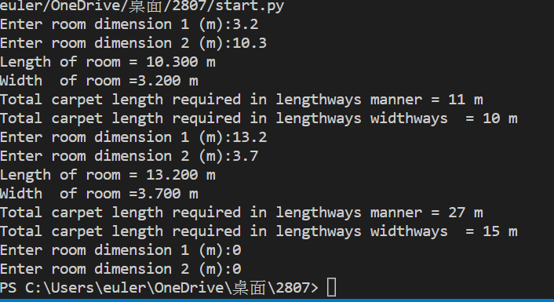

# Submission and marking

The pre-workshop can be accessed and submitted online using the provided link in the course website. Students get 1 mark if they get >50% in pre-workshop questions, or 0.5 mark if they get 0%-50% in pre-workshop questions, or 0 marks without any attempt.

For workshop tasks, please submit this document with copied codes and inserted screenshots using the provided submission link in the course website. Students get 2 marks if they complete three or more problems correctly, or 1 mark if they complete one or two problems correctly, or 0 marks without any attempt.