1811ICT/2807ICT/7001ICT Programming Principles Workshop 7

School of Information and Communication Technology

Griffith University

| *Goals* | This workshop focusses on everything in the course up to files. |
| --- | --- |
| When | Workshops from Friday 6 May to Thursday 12 May |
| Marks | 3 |
| Due | Pre-workshop questions before the start of the above mentioned workshops  Workshop programming problems by 11:59pm on 15 May |

# Before your workshop class:

* Read all of this document.
* Review the lecture notes sections 1 to 20.
* **Complete the pre-workshop questions (1 mark) posted on the course website and submit the answers for marking**.

# Workshop activities

At any stage, when you are stuck, *ask your tutor*!

## Problem 1

*Problem:* Write a program that prompts for the names of a source file to read and a target file to write, and copy the content of the source file to the target file, but with all empty lines removed, then output the number of empty lines removed.

| Source file name: string_doc.txt  Target file name: string_doc_nonempty.txt  Lines removed: 16 |
| --- |

*Answer*: Copy your code in the space given below and insert screenshots of your program output for the following two scenarios:

* Use the attached file P1_v1.txt as the source file to read. Use P1_v1_nonempty.txt as the target file name.
* Use the attached file P1_v2.txt as the source file to read. Use P1_v2_nonempty.txt as the target file name.

***Copy your code here***

*filename1=input("Source file name:")*

*filename2=input("Target file name:")*

*f1=open(filename1)*

*f2=open(filename2,mode='w')*

*counter=0*

*for line in f1:*

*if line !='\n':*

*f2.write(line)*

*else:*

*counter+=1*

*print("Lines removed:",counter)*

*f1.close()*

*f2.close()*

***Insert your screenshots here***

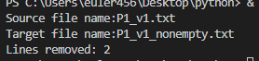

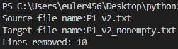

## Problem 2

*Problem:* Write a program that prompts for the name of a file, then prints the first two lines and the last two lines of the file.

| File name: yesterday.txt  Output:  Yesterday Once More  When I was young  I would sing to then  And I’d memorize each... |
| --- |

*Answer*: Copy your code in the space given below and insert screenshots of your program output for the following two scenarios:

* Use the attached file P2_v1.txt as the source file to read.
* Use the attached file P2_v2.txt as the source file to read.

***Copy your code here***

*filename1=input("File name: ")*

*f1=open(filename1)*

*f=f1.readlines()*

*print("Output")*

*for i in range(2):*

*print(f[i],end="")*

*for x in range(-2,0,1):*

*print(f[x],end="")*

*f1.close()*

***Insert your screenshots here***

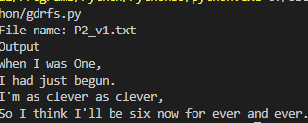

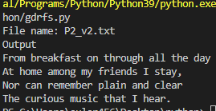

## Problem 3

*Problem:* Write a program that prompts for the name of a file containing numbers in each line, prints the average of each line. Assume each line contains numbers only and they are separated by spaces.

File name: scores.txt

The average of line 1 is 60.0

The average of line 2 is 91.75

The average of line 3 is 48.75

The average of line 4 is 56.25

*Answer*: Copy your code in the space given below and insert screenshots of your program output for the following two scenarios:

* Use the attached file P3_v1.txt as the source file to read.
* Use the attached file P3_v2.txt as the source file to read.

***Copy your code here***

*filename1=input("File name: ")*

*f1=open(filename1)*

*count=0*

*for line in f1:*

*sum=0*

*count+=1*

*lst=[int(x) for x in line.split()]*

*for x in lst:*

*sum=sum+x*

*print("The average of line",count,'is' ,sum/len(lst))*

*f1.close()*

***Insert your screenshots here***

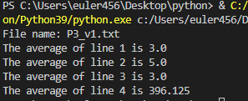

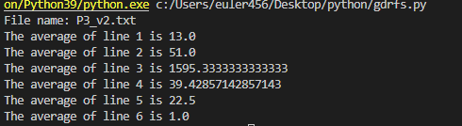

## Problem 4

*Problem:* The Unix tool wc counts the numbers of characters, words and lines in a file. Write your own version of wc that prompts for the name of the file to read, then prints the counts. Assume a word may contain letters, digits, symbols and their mixture, but not space. Hyphenated words, e.g. large-scale, shall be considered as one word.

| File name: python.txt  Characters: 1227  Words: 176  Lines: 10 |
| --- |

*Answer*: Copy your code in the space given below and insert screenshots of your program output for the following two scenarios:

* Use the attached file P4_v1.txt as the source file to read.
* Use the attached file P4_v2.txt as the source file to read.

***Copy your code here***

*filename1=input("enter the file 1 name")*

*f1=open(filename1)*

*l=0*

*c=0*

*w=0*

*for line in f1:*

*l=l+1*

*c=c+len(line)*

*w=w+len(line.split())*

*print("the number of line is",l)*

*print("the number of line is",c)*

*print("the number of line is",w)*

*f1.close()*

***Insert your screenshots here***

# Submission and marking

The pre-workshop can be accessed and submitted online using the provided link in the course website. Students get 1 mark if they get >50% in pre-workshop questions, or 0.5 mark if they get 0%-50% in pre-workshop questions, or 0 marks without any attempt.

For workshop tasks, please submit this document with copied codes and inserted screenshots using the provided submission link in the course website. Students get 2 marks if they complete three or more problems correctly, or 1 mark if they complete one or two problems correctly, or 0 marks without any attempt.