1811ICT/2807ICT/7001ICT Programming Principles Workshop 10

School of Information and Communication Technology

Griffith University

| Goals | This workshop focusses on everything in the course up to files. |
| --- | --- |
| When | Workshops from Friday 27 May to Thursday 2 June |
| Marks | 3 |
| Due | There are no pre-workshop tasks this week.  Workshop programming problems by 11:59pm on 5 June |

# Before your workshop class:

* Read all of this document.
* Review the lecture notes sections 1 to 25.
* **There are no pre-workshop tasks this week**.

# Workshop activities

## Class design

*Case study:* A Go Card account maintains a balance that may be spent on public transport. Users may request a statement that shows all transactions. The only transactions are to top up the account with some positive number of dollars, and to take a ride costing some dollars and cents.

The goal for this exercise is to develop a class for a Go Card Account. The class will be tested by a program that simulates transactions, like this:

| Creating account. Input initial balance: 100  ? r 3.50  ? r 10.90  ? b  Balance = $85.60  ? t 20  ? x gghhg  Bad command.  ? t  Bad command.  ? q  Statement:  event amount ($) balance ($)  Initial balance 100.00  Ride 3.50 96.50  Ride 10.90 85.60  Top up 20.00 105.60  Final balance 105.60 |
| --- |

where:

* r *number* simulates a ride costing *number* dollars;
* t *number* simulates a top up of *number* dollars;
* b requests the current balance; and
* q ends input and prints a statement.

Bad inputs are to be reported and ignored.

Let us consider the design for a class that represents a Go Card account. To design a class, we consider what services the object(s) must provide (its methods), and what data needs to be stored in the object(s) to support those services. Questions:

* What is a good name for a class that represents a Go Card account?
  + Be descriptive of what the class represents. Don’t include the word “class” in the name.
* What services should be provided?
  + A constructor (__init__) is required to set up the account with an initial balance.
  + It needs to record the amount each ride costs. A method that accepts the amount as a parameter is required.
  + It needs to record the amount for each top-up. A method that accepts the amount as a parameter is required.
  + It needs to be able to report the current balance at any time. A method that returns this is required.
  + A method is required print out a statement of all of the transactions.

We can see from the output of the proposed program that the class needs to store the details of every transaction in order.

* What data is required to be stored in the object to enable those services?
  + So that a method can return the current balance at any time, it would be useful have a field for the current balance.
  + So that the full statement can be printed, the object must store the amount of each transaction, in order. What data type can grow and keep multiple values in the order they are added?

## Problem 1

*Problem:* Implement the program described above, leaving out the printing of a full statement at the end.

*Answer:* Submit your code as problem1.py and insert a screenshot of your program output for the following scenario:

| Creating account. Input initial balance: 200  ? r 2.35  ? r 1.30  ? b  ? r 9.45  ? t 10  ? q |
| --- |

***Copy your code here***

*class GoCard():*

*# this function will get called once object of GoCard is created*

*def __init__(self):*

*self.bal = input('Creating Account. Input initial balance: ')*

*def receive_command(self):*

*while True:*

*# try and except block to handle exception*

*try:*

*s = input('? ')*

*# It will split the input using space as separator*

*# and create a list of string eg. r 3.50 become ['r','3.50']*

*s = s.split(' ')*

*# Now handle different input cases*

*if len(s)==2 and s[0]=='r':*

*self.bal = float(self.bal) - float(s[1])*

*elif len(s)==2 and s[0]=='t':*

*self.bal = float(self.bal) + float(s[1])*

*elif len(s)==1 and s[0]=='b':*

*# "%.2f" : used here to print upto two decimal places*

*print('Balance =','$'+str("%.2f" % self.bal))*

*elif len(s)==1 and s[0]=='q':*

*break*

*else:*

*print('Bad command.')*

*except:*

*print('Syntax error.')*

*#####################################*

*obj = GoCard() # create object*

*obj.receive_command() # call receive_command()*

*######################################*

*obj = GoCard()*

*obj.receive_command()*

***Insert your screenshots here***

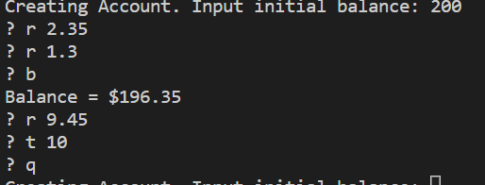

## Problem 2

*Problem:* Implement the program described above, including the printing of a full statement at the end.

*Answer:* Submit your code as problem2.py and insert a screenshot of your program output for the scenario described in Problem 1.

***Copy your code here***

*class GoCardAccount:*

*# onstructer method*

*def __init__(self, start_bal):*

*self.sb = start_bal*

*self.bal = self.sb*

*self.trans = []*

*# Method to take a ride*

*def takeRide(self, cost):*

*self.bal -= cost*

*self.trans.append(['Ride', cost, self.bal])*

*# Method to get the balance*

*def getBalance(self):*

*return self.bal*

*# Method to set the balance*

*def topUp(self, amount):*

*self.bal += amount*

*self.trans.append(['Top up', amount, self.bal])*

*# Method to print the statement*

*# Used format() printing method to print in tabular format*

*def printStatement(self):*

*print("\nStatement:")*

*print("=========================================================")*

*print("{:<25}{:<20}{}".format('event', 'amount ($)', 'balance ($)'))*

*print("=========================================================")*

*print("{:<45}{:11.2f}".format('Initial balance', self.sb))*

*for t in self.trans:*

*print("{:<25}{:10.2f}{:21.2f}".format(t[0],t[1],t[2]))*

*print("{:<45}{:11.2f}".format('Final Balance', self.bal))*

*print("=========================================================")*

*# Main Program*

*initial_bal = float(input("Creating account. Input initial balance: "))*

*# Creating object of the class*

*card1 = GoCardAccount(initial_bal)*

*# Loop to simulate the process*

*while True:*

*cmd = input('? ')*

*if cmd[0] in ['r','t','b','q']:*

*cmd = cmd.split(' ')*

*if cmd[0] in ['r','t']:*

*if len(cmd) <= 1:*

*print("Bad Entry")*

*continue*

*if float(cmd[1]) < 0:*

*print("Bad Entry")*

*continue*

*elif cmd[0] in ['b','q']:*

*if len(cmd) != 1:*

*print("Bad Entry")*

*continue*

*if cmd[0] == 'r':*

*if float(cmd[1]) > card1.getBalance():*

*print("Insufficeient funds!")*

*else:*

*card1.takeRide(float(cmd[1]))*

*elif cmd[0] == 'b':*

*print("Balance = ${:.2f}".format(card1.getBalance()))*

*elif cmd[0] == 't':*

*card1.topUp(float(cmd[1]))*

*elif cmd[0] == 'q':*

*card1.printStatement()*

*break*

*else:*

*print("Bad Entry")*

***Insert your screenshots here***

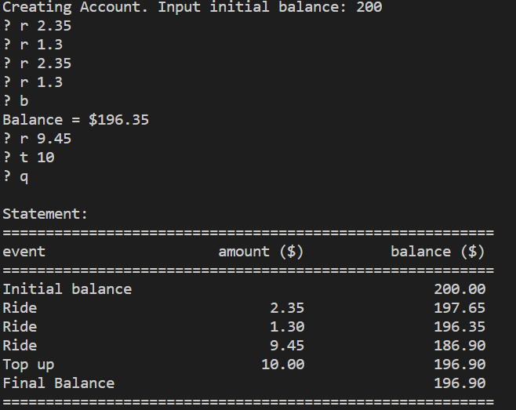

# Submission and marking

There are no pre-workshop tasks this week.

For workshop tasks, please submit this document with copied codes and inserted screenshots using the provided submission link in the course website. Students get 3 marks if they complete both problems correctly, or 2 marks if they complete problem 1 correctly, or 1 mark if they partially complete problem 1, or 0 marks without any attempt.