Screenshot of W3C Validation of HTML & CSS

Index.html

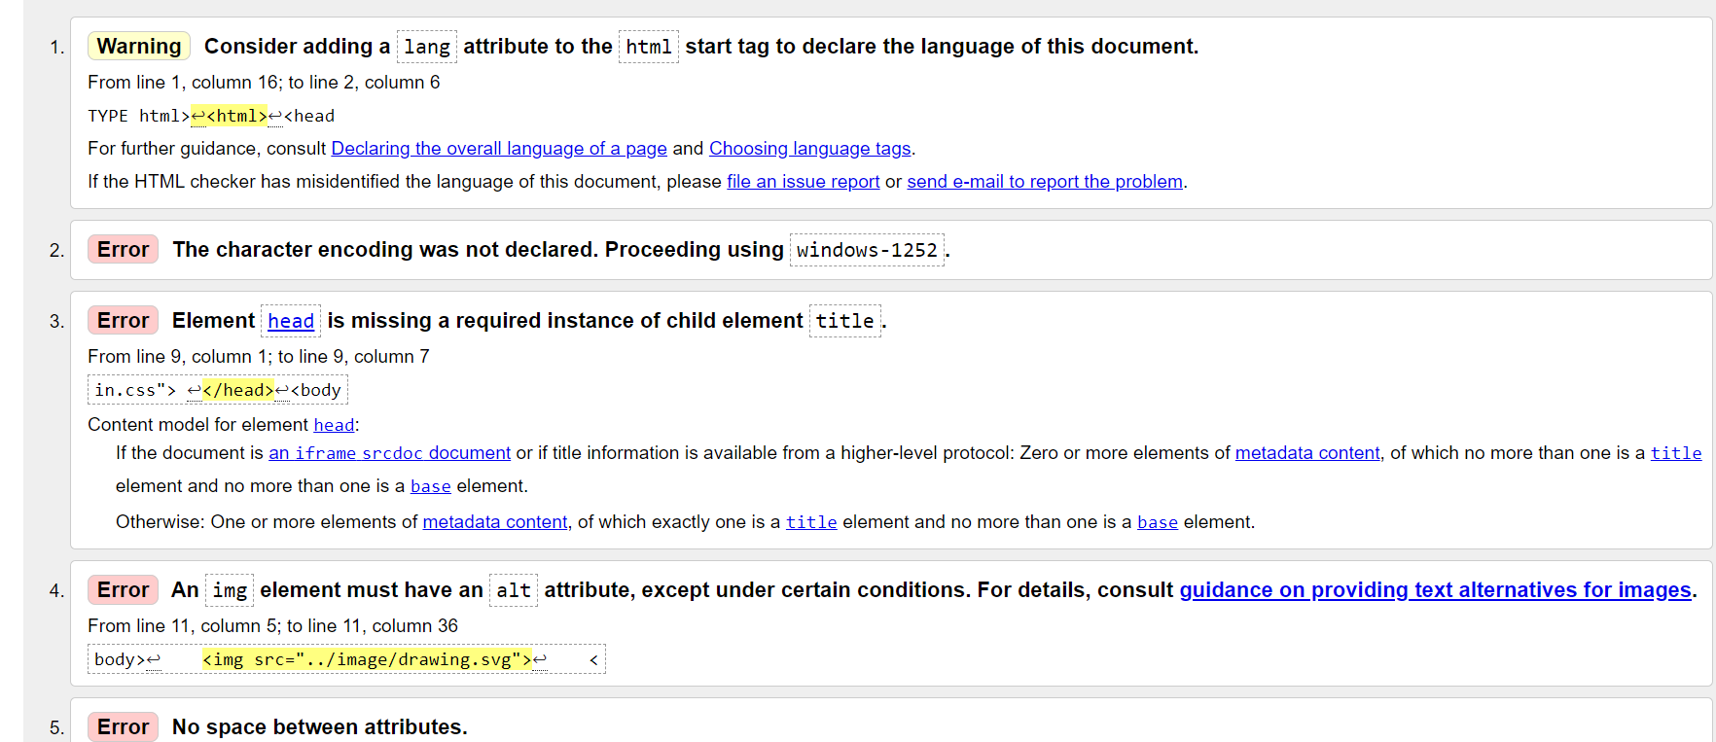

Css

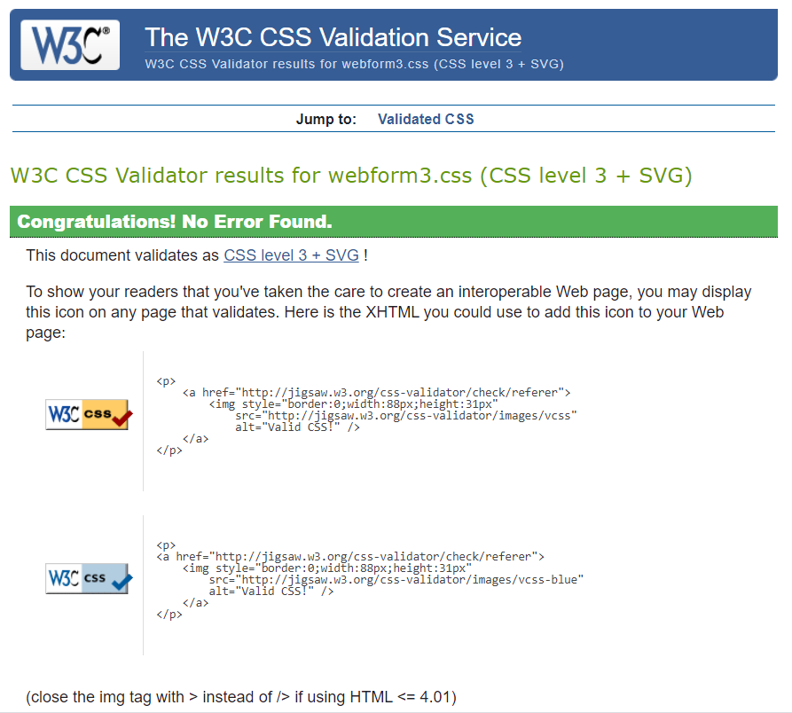

Correct Indentation of HTML CSS and JavaScript

Index.html

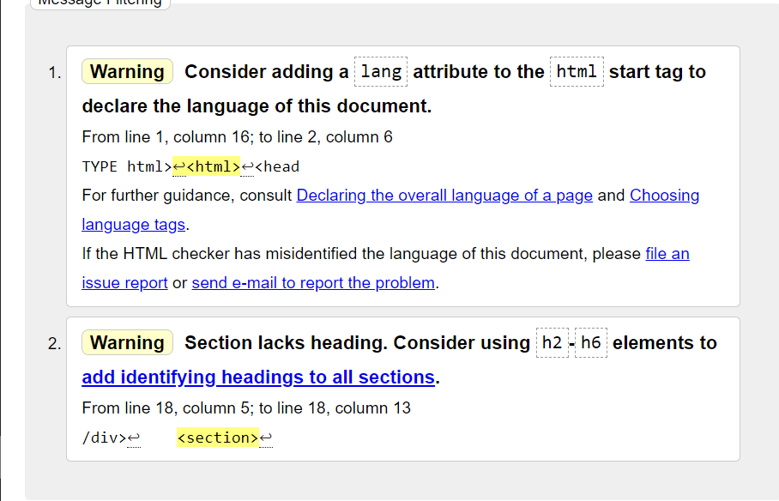

Css



Cross-Browser test three examples including mobile phone

Firefox:

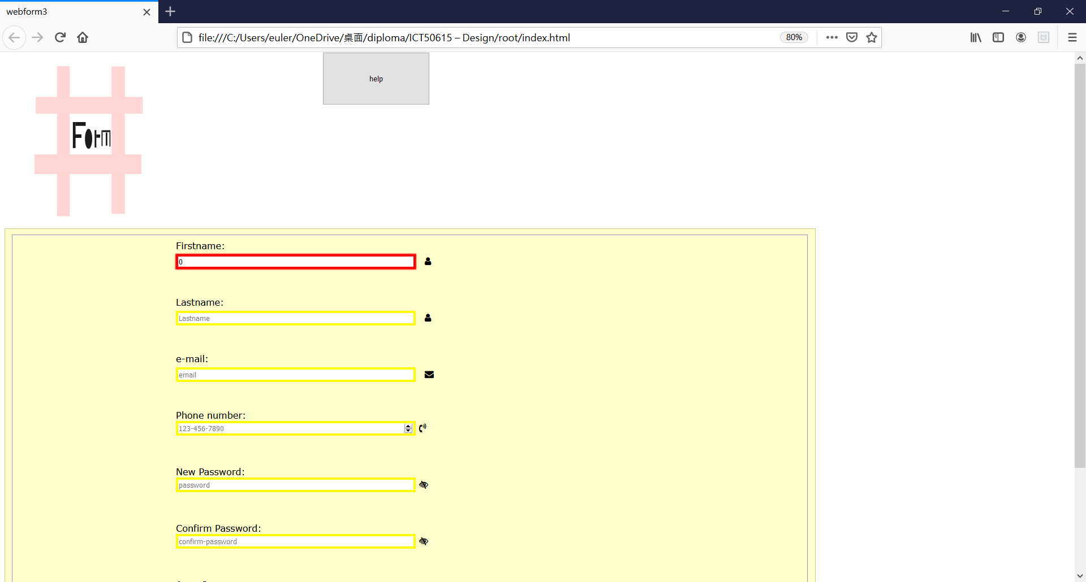 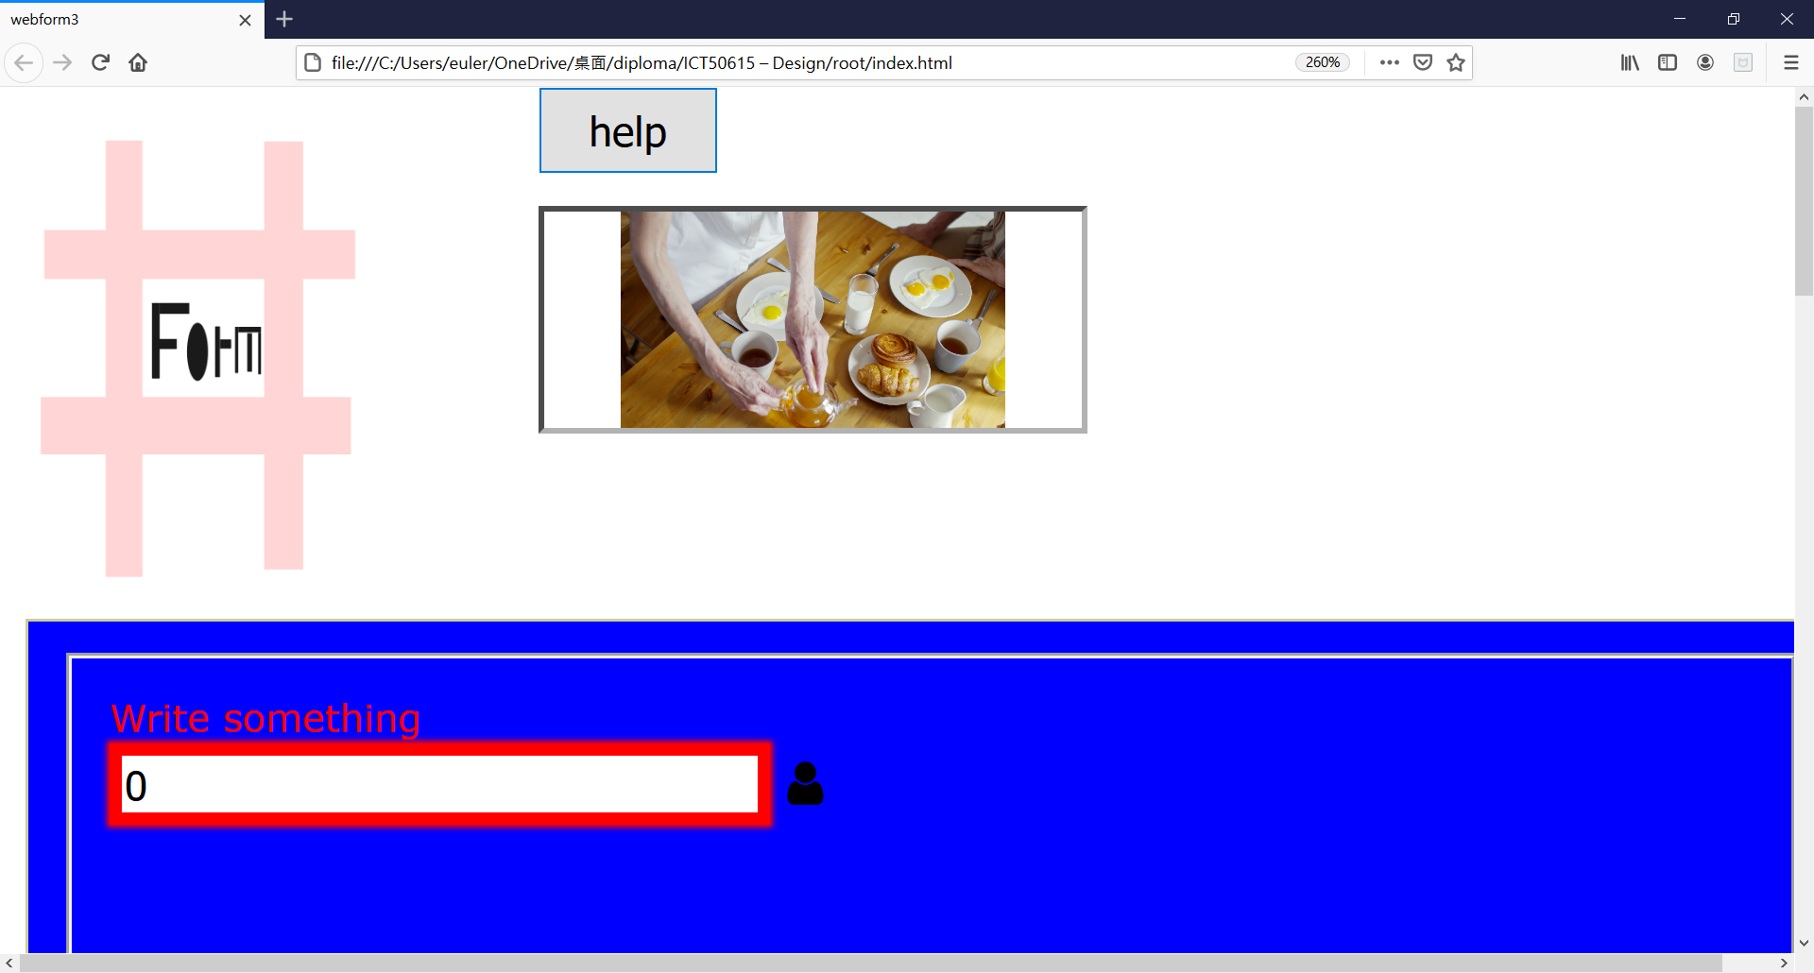

Google chrome:

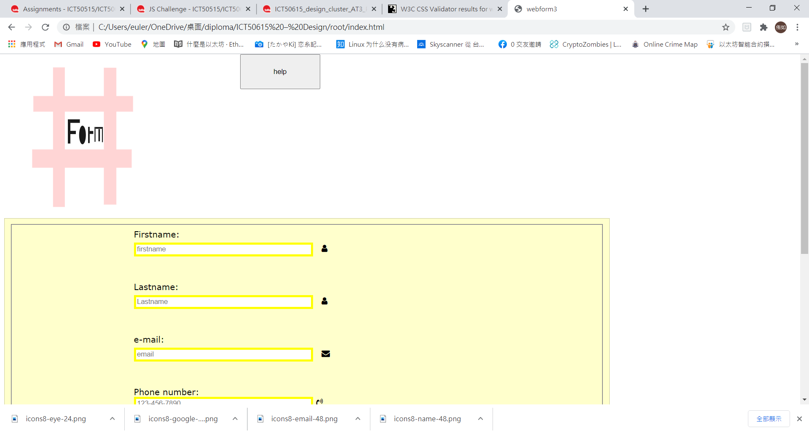 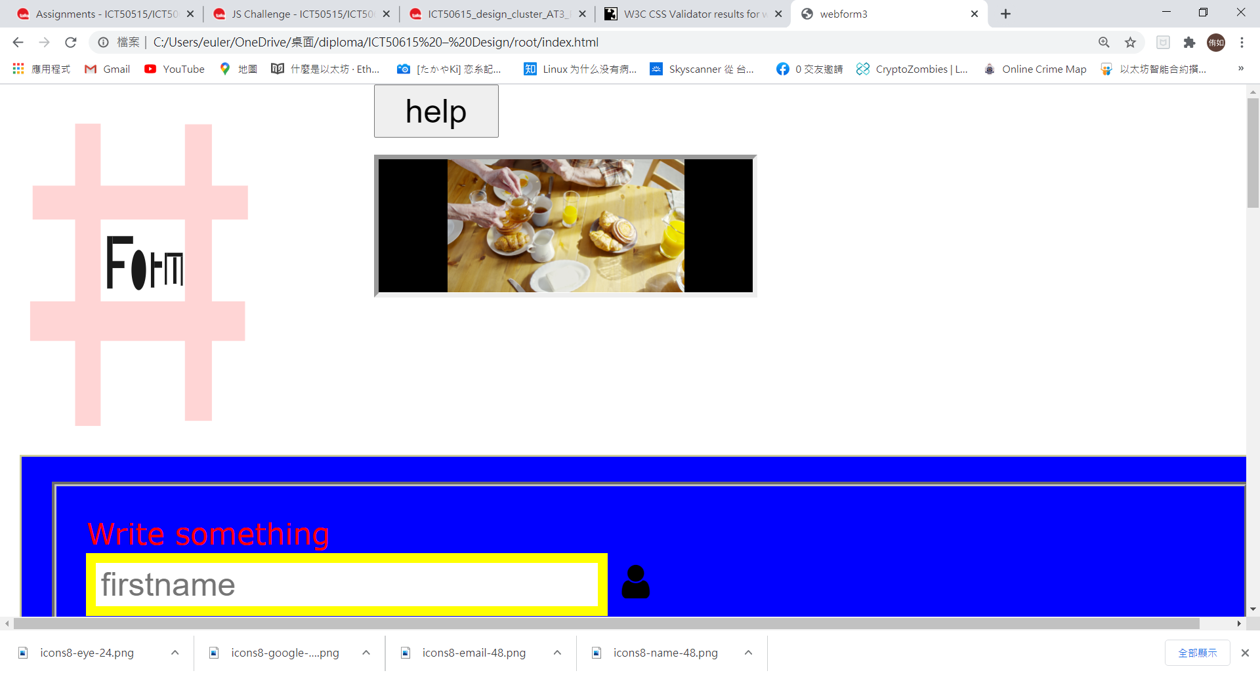

Opera:

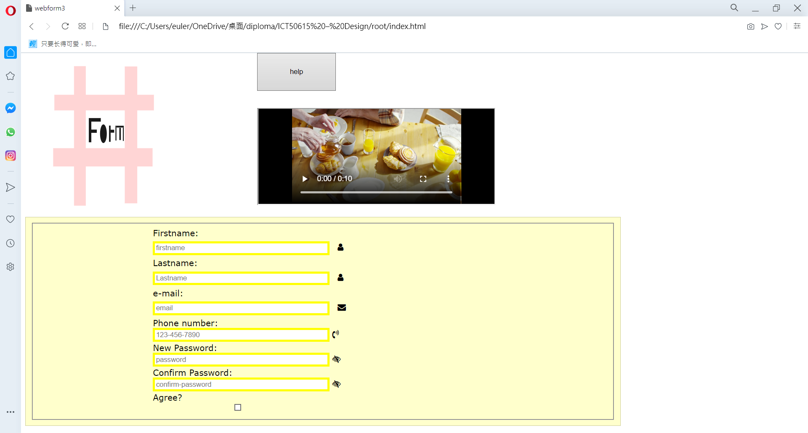 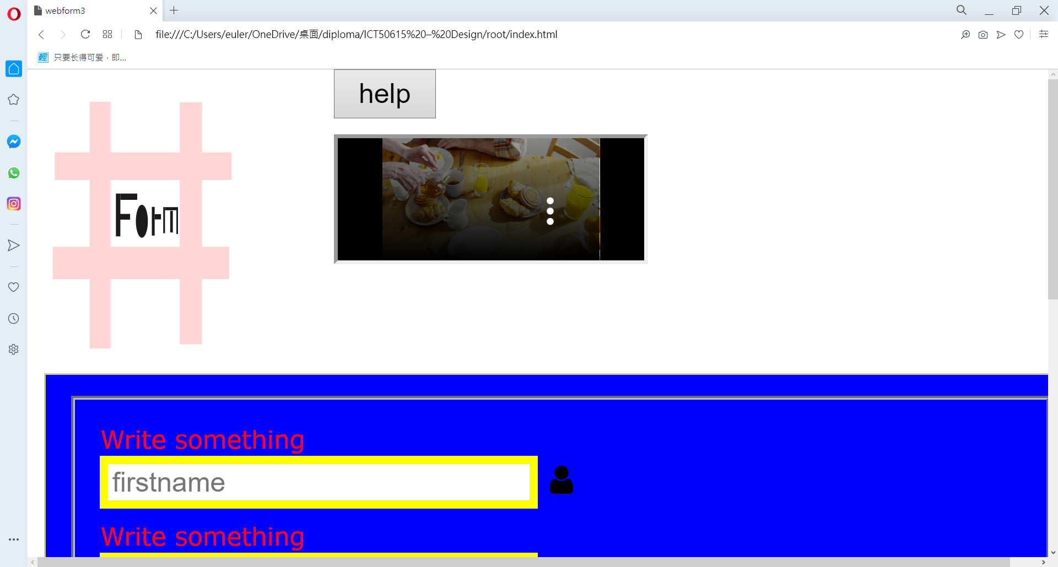

Prior to commencement of task, build a wireframe denoting location of all key elements:

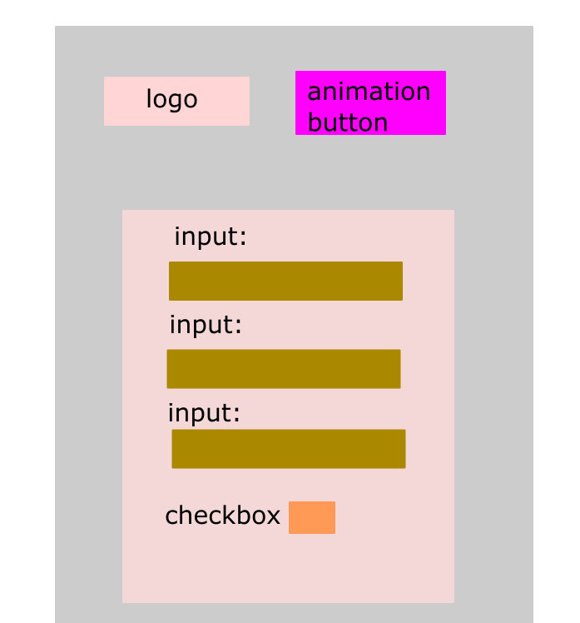

Confirm how icons chosen for each input are relevant to the type of input being sought:

Each input has its own specific type like phone number input must have an icon like relevant with the phone, and the password input have an eye icon.

What is it that you are trying to convey in the logo design created

I want to convey this is the form website ,so design the logo which look like “#” to let people know ,this is website is relative with the form input.

What WHS principles were followed while working on this project

Following the *Work Health and Safety Act 2011*

Employee need to take a rest for every 40mins ,and do not seat too long on the chair.