Finite Element Analysis Report

# Results Overview (Isometric View)

Deformed shape with displacement magnitude.

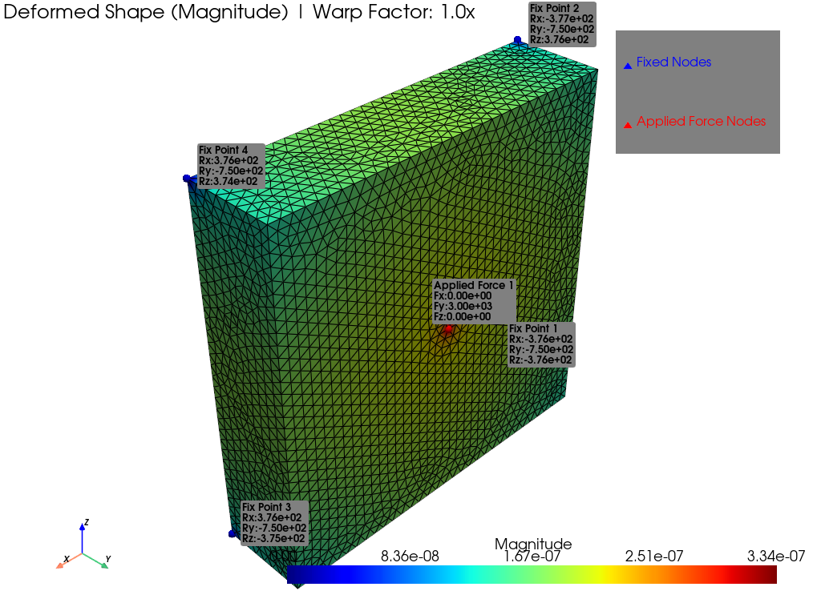

# Analysis Parameters

**Young's Modulus (E):** 2.00e+11 Pa  
**Poisson's Ratio (v):** 0.3

# Mesh Information

**Total Nodes:** 8856  
**Element Type:** 10-Node Quadratic Tetrahedron (Tetra10)  
**Total Elements:** 5195

# Boundary Conditions

## Applied Loads

**- Load 1:**  
 Force Vector (Fx, Fy, Fz): (0.0, 3000.0, 0.0) N  
 Application Point (x, y, z): (0.4, 0.2, 0.4) m

## Fixed Supports (Constraints)

- Fix Point 1 at (0.0, 0.0, 0.0): Constrained DOFs [X, Y, Z]

- Fix Point 2 at (0.0, 0.0, 0.8): Constrained DOFs [X, Y, Z]

- Fix Point 3 at (0.8, 0.0, 0.0): Constrained DOFs [X, Y, Z]

- Fix Point 4 at (0.8, 0.0, 0.8): Constrained DOFs [X, Y, Z]

# Mesh Quality Check

- All elements passed the Jacobian determinant check (all detJ > 0).

# Reaction Force Results

|  |  |  |  |  |
| --- | --- | --- | --- | --- |
| Fix Point | Node ID | Rx (N) | Ry (N) | Rz (N) |
| 1 | 1 | -3.7593e+02 | -7.5013e+02 | -3.7604e+02 |
| 2 | 2 | -3.7681e+02 | -7.4987e+02 | 3.7642e+02 |
| 3 | 3 | 3.7632e+02 | -7.4987e+02 | -3.7452e+02 |
| 4 | 4 | 3.7642e+02 | -7.5013e+02 | 3.7414e+02 |
| Total Reaction | | 1.9952e-11 | -3.0000e+03 | 1.2835e-10 |

Note: For static equilibrium, the 'Total Reaction' should be equal and opposite to the sum of applied forces.