Beam Analysis Report

Generated on: 2025-09-23 23:04:37

# 1. Input Parameters

**Mesh File:** frame.msh

Total Nodes: 5

Total Elements: 4

## Material Properties

Young's Modulus (E): 2e11 Pa

Poisson's Ratio (ν): 0.3

Density (ρ): 7800 kg/m³

## Section Assignments

**Group 'l_section':** I section with params: d=0.05, b=0.025, t_w=0.005, t_f=0.005, r=0.001

**Group 'c_section':** C section with params: d=0.05, b=0.025, t_f=0.005, t_w=0.005, r=0.001

## Boundary Conditions

**Group 'fix':** Fixed DOFs: X, Y, Z, RX, RY, RZ

**Group 'load_y':** Applied Force (N): (Fx=0.0, Fy=-3000.0, Fz=0.0)

# 2. Analysis Results

## Static Analysis

Maximum Displacement: 3.0047e-03 m at Node 4

Maximum Stress: 283.4407 MPa at Node 4

## Modal Analysis

|  |  |
| --- | --- |
| Mode | Natural Frequency (Hz) |
| 1 | 16.8448 |
| 2 | 33.4577 |
| 3 | 44.0366 |
| 4 | 104.8251 |
| 5 | 234.9084 |
| 6 | 305.0161 |
| 7 | 342.7343 |
| 8 | 363.8935 |
| 9 | 400.6217 |
| 10 | 644.5324 |

# 3. Analysis Plots

## Static Analysis Plot

Deformed shape (red) and stress contour plot.

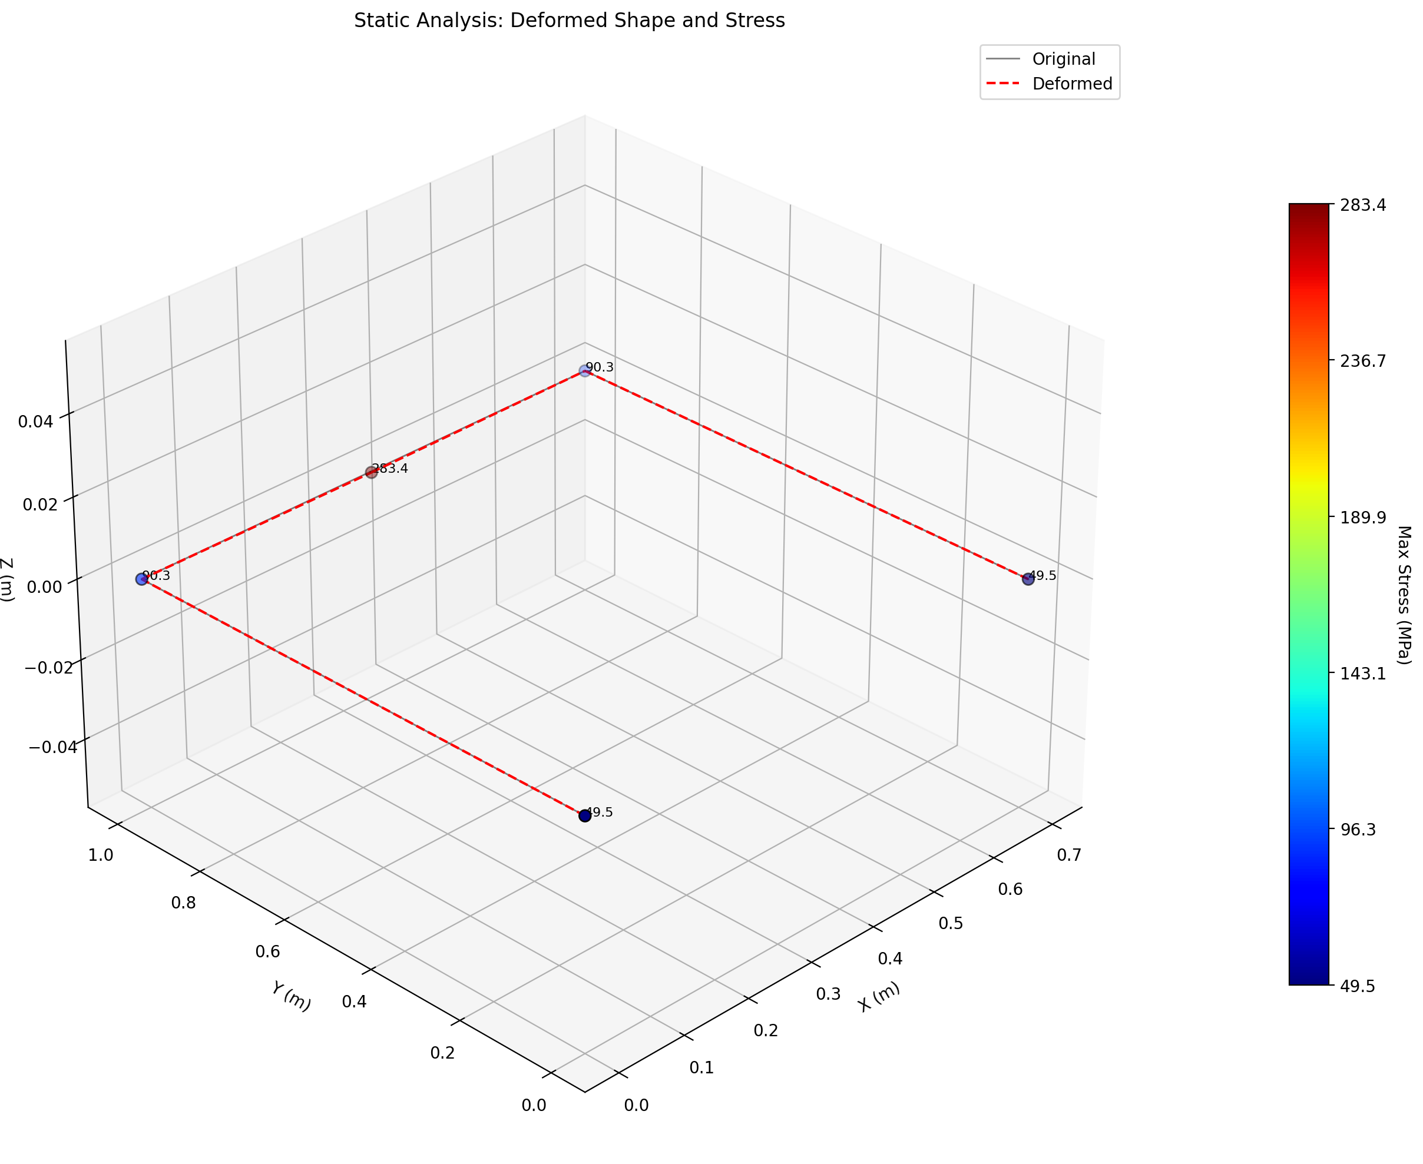

## Modal Analysis Plot

First 6 mode shapes and natural frequencies.

