Fire Eagle
usuario yahoo: ferreyraru

Clave: Udemm

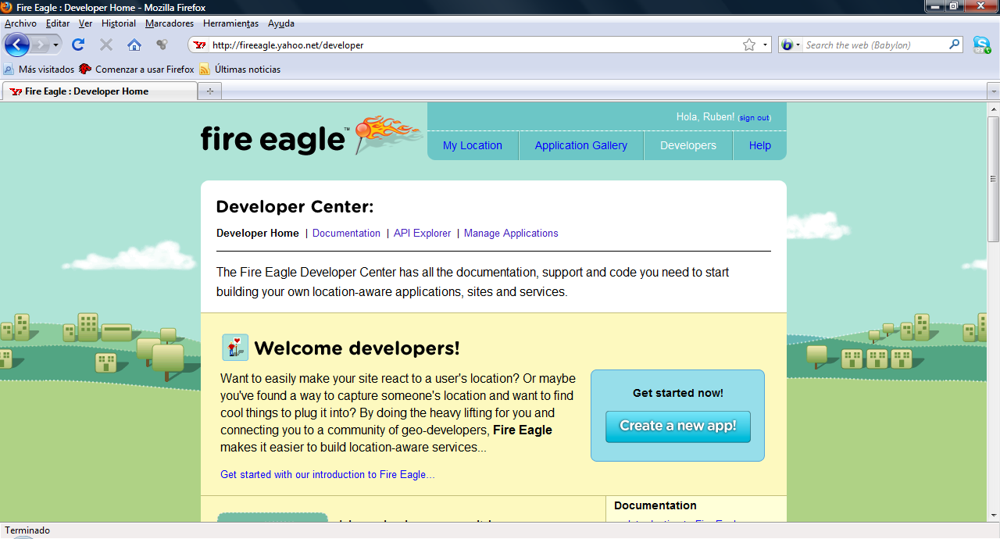

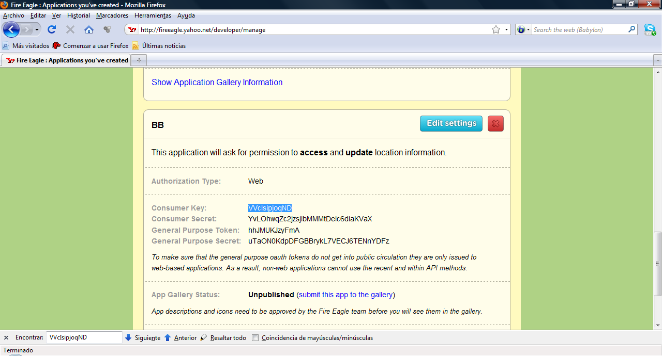

http://www.sonrisal.com.ar/dpanel

Usuario : w1401100@sonrisal.com.ar
Password : me90GEmone

Principio del formulario
Registration Complete
Congratulations, ferreyraru, your application is now registered! Yeah!
- Your application id is eGt2oD_IkY3Q9vWbSCktqjQBQ5R5Rcm.pno-
- Your shared secret is dd968ec5273455e94abc2611cea33e83
- For application entrypoint -> http://www.sonrisal.com.ar/
To view your current application ids, click here.
You may want to print this page for your records.
Here's what to do next.
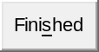
Final del formulario

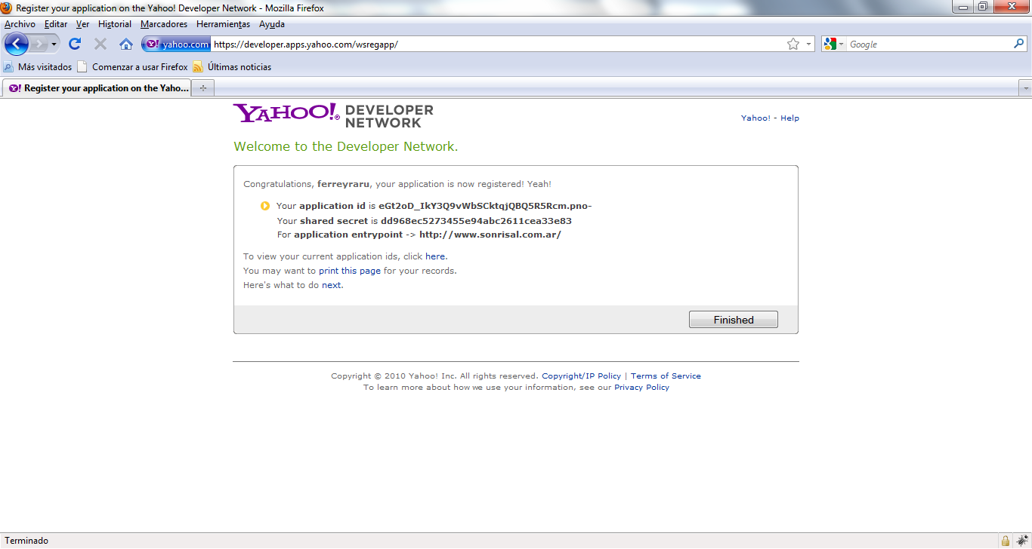

BBAuth URL: http://www.sonrisal.com.ar/
AppID: eGt2oD_IkY3Q9vWbSCktqjQBQ5R5Rcm.pno-
Shared Secret: dd968ec5273455e94abc2611cea33e83

