AI-based Reconstruction of Warning Masks from Meteorological Fields

In this document we present a compact demonstration of how artificial intelligence can learn to reconstruct warning polygons and mask fields from meteorological inputs such as wind and gust data. The method is designed as a prototype for rapid hazard detection and field-to-mask prediction tasks in a European weather forecasting context.
The overall workflow follows three steps:
- Polygon construction from synthetic fields: Synthetic wind and gust fields are generated, and connected hazard regions are detected and converted into polygon representations. Polygon to mask mappings for actual training.
- Neural network training: A neural network is trained to map complete input fields (wind and gust) to binary mask fields. The network learns spatial correlations and threshold behaviors implicitly from the training data
- Prediction and visualization: The trained network is applied to new input samples to predict masks, which are then compared to the original ones. Polygon contours are extracted and visualized for both cases.

1. Polygon Extraction and Mask Reconstruction
The figure below shows how synthetic wind and gust fields are used to define hazard regions. A mask is derived by applying simple threshold criteria and then transformed into polygons. These polygons can be re-converted to mask fields without losing significant spatial information.
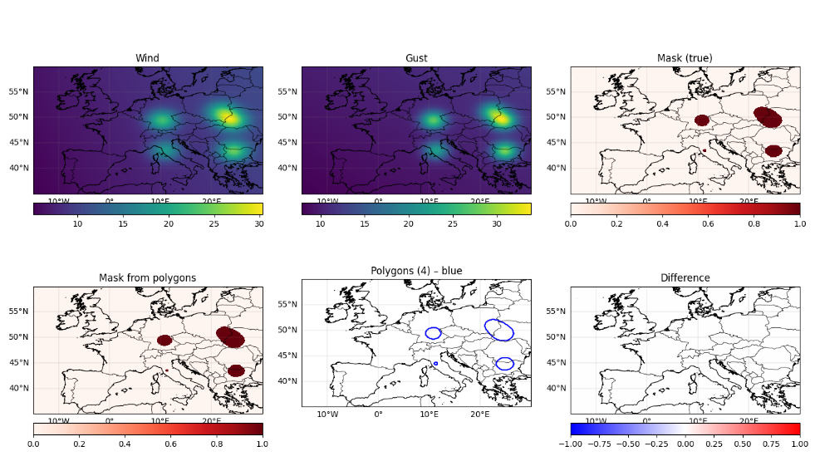
Figure 1: Fields, Polygons and Masks

2. Neural Network Training
A fully connected neural network (MLP) is trained to reconstruct the full spatial warning mask from the pair of input fields. Each sample represents a complete meteorological field on a fixed grid. The model learns a nonlinear mapping from two 2D input fields (wind, gust) to one 2D output mask. Training is performed over hundreds of epochs, minimizing the binary cross-entropy between predicted and true masks.
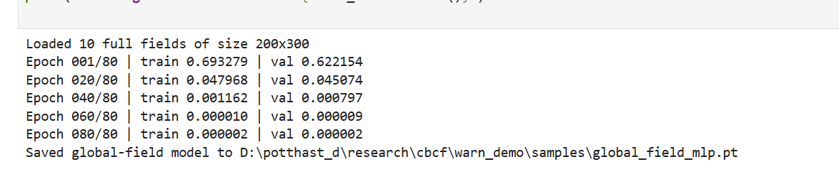 Figure 2: Training progress

3. Model Prediction and Polygon Comparison
The final step demonstrates the model’s predictive capability. For several test samples, the network output is compared to the original masks. Polygons derived from both predicted and true masks are plotted for visual comparison. The results illustrate that the model successfully reproduces the shape and extent of most hazard regions, allowing for a direct polygon-based verification.

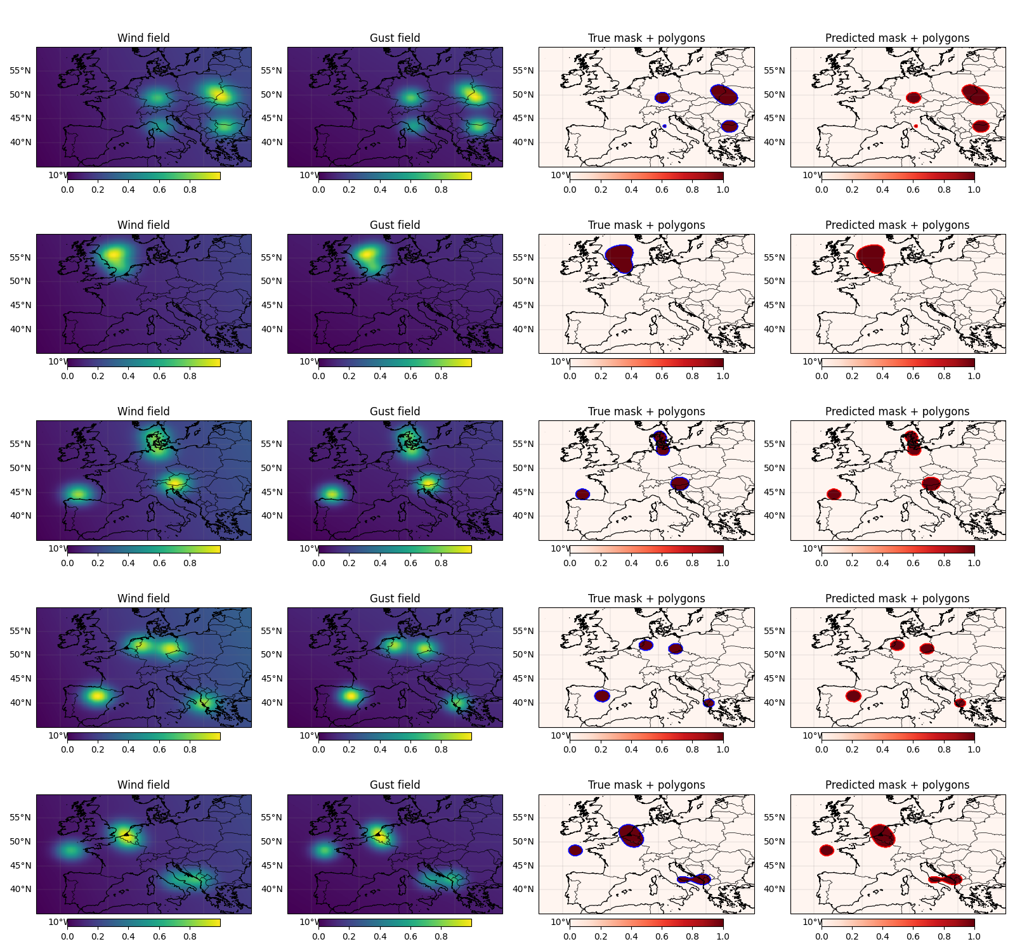Figure 3: Comparison of original and predicted polygons

Summary
This experiment illustrates the principle of field-to-mask learning: a neural network can infer threshold-like spatial structures directly from full meteorological fields. The technique forms the foundation for near-real-time warning systems, where AI predicts hazard regions based on multiple physical input variables. Further developments can integrate more predictors, temporal evolution, or real observational data.

