
Name : IGIRANEZA MUHORAKEYE EUNICE
Misis :M01100679
Program :AI and Data science
Github Repository : https://github.com/eunice-cell/CW2_CST1510_M01100679
1. Introduction
The Multi-Domain Intelligence Platform is a web-based application designed to help organizations manage and analyze data across multiple domains. In the one I created I have included cybersecurity, IT operations, and data science. The platform can provide users with secure access , integrate interactive dashboards, and supports AI-assisted data analysis from the ai_assistant page.
In multi-domain intelligence platform we have 3 words each having a meaning
Multi-domain : and area of knowledge like cybersecurity or datascience.
Intelligence : meaning that the system does more than just storing data.
Platform : which is a system including all user access ,dashboards ,ai assistance etc…
I chose to do all 3 domains cybersecurity,data science and it_operations .
for the cyber security domain which is the main focus of the system. Cybersecurity incidents are stored in the database cyber_incidents and displayed on the dashboard intelligence_platform where users can view details such as the incident type, status, description. Simple charts are used to show incident trends, such as the number of incidents by status. A machine learning model is also included to predict the severity level of incidents, which adds an advanced feature to the system.
For the Data Science domain which is used to manage datasets uploaded to the system. Information about each dataset, such as the dataset name,columns , rows, etc...is stored in the database and displayed on a dashboard allowing users to explore and understand data.
For the IT Operations domain which is focusing on handling IT support tickets. Tickets are stored in the database and displayed in a dashboard where users can keep tracking their status and priority.
2. how I built the system
2.1 security and database
To protect user information, all passwords are hashed using bcrypt, which means the real passwords are never stored in the database hashes are stored instead and once a passwored is hash there is no going back meaning that even if hackers got access to the db where hashes are they wouldn’t be able to encode them cause it’s impossible that’s why Users are authenticated through this hashed password mechanism it prevents unauthorized access.
Data is stored in SQL tables, and they are 4 : users, cyber_incidents, datasets and tickets. Each table is designed to hold structured data relevant to its domain which allows the system to retrieve and display it efficiently when requested by users with authorized access.
2.2 system structure
This is how the system works:

- When you run the code it takes you to the home page which takes u to the login page when u click on the login pager button .

- Users log in through the login page after successful login u can view all other pages .

- The system fetches data from the SQLite database table users which has a list of all names registered then they login .

- Data is processed and converted into Python objects (e.g.,Users, SecurityIncident, Dataset, ITTicket) for easy manipulation.

- Users can view dashboards, pie charts, and AI predictions through the Streamlit interface.
2.3 code organization
The system is organized using object-oriented programming.
- Classes implemented:
  - User – manages authentication and user roles.
  - SecurityIncident – represents each cybersecurity incident.
  - Dataset – represents uploaded datasets.
  - ITTicket – represents support tickets.
  - DatabaseManager – handles database connections and queries.
  - AuthManager – handles login and registration .
Each class has private variables as they have the __ and getter methods,it took me time to understand but it is worth it once u get the concept . it makes the code more secure and easier to maintain. Refactoring the code into classes helped me reduce repetition and organized functionalityin a more understandable way.

2.4 Key Features
- Dashboards
  - Cybersecurity incidents, IT tickets, and datasets are displayed in separate dashboards.
  - Pie charts show distribution by status or uploader.
The first one I sent is the uploader show which domain uploaded the most.
The second one is the ticket status distribution.
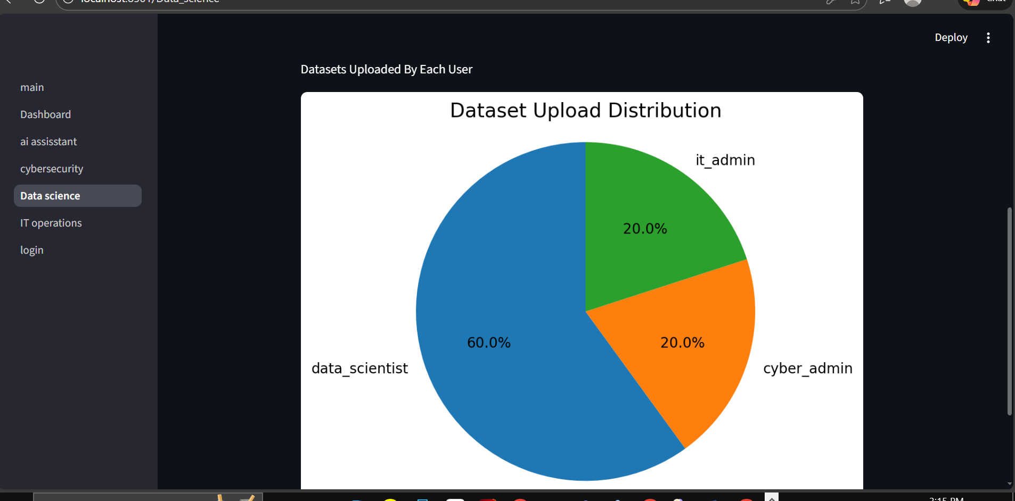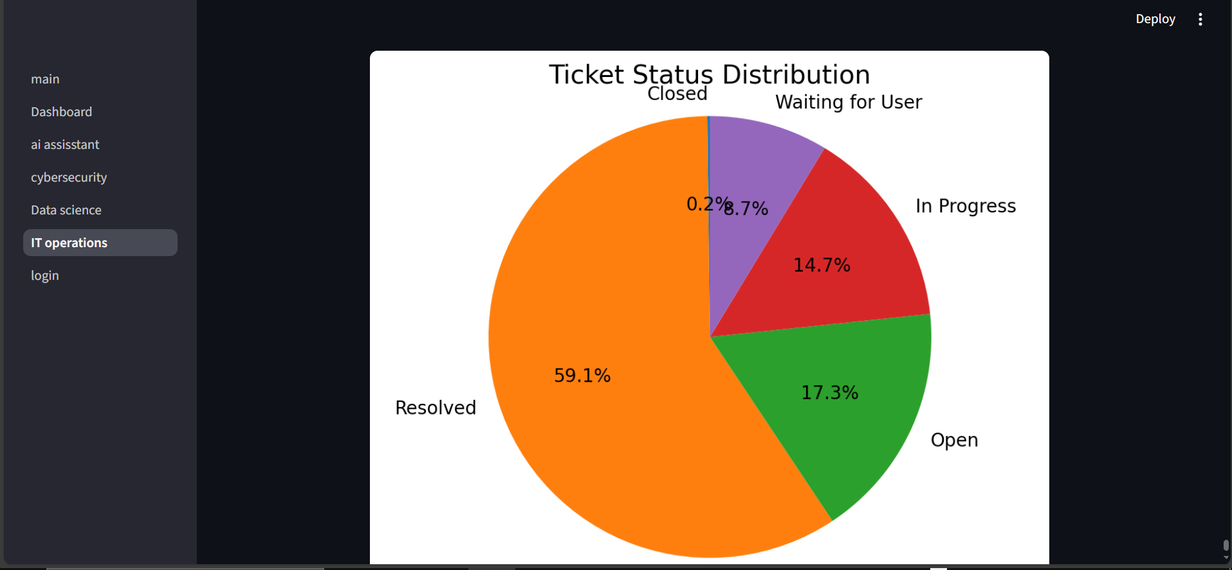

- Machine Learning
  - The system predicts incident types (i_type) using a K-Nearest Neighbors (KNN) model based on status, description, and reported_by.
  - Users can input new incidents to get predictions.
- 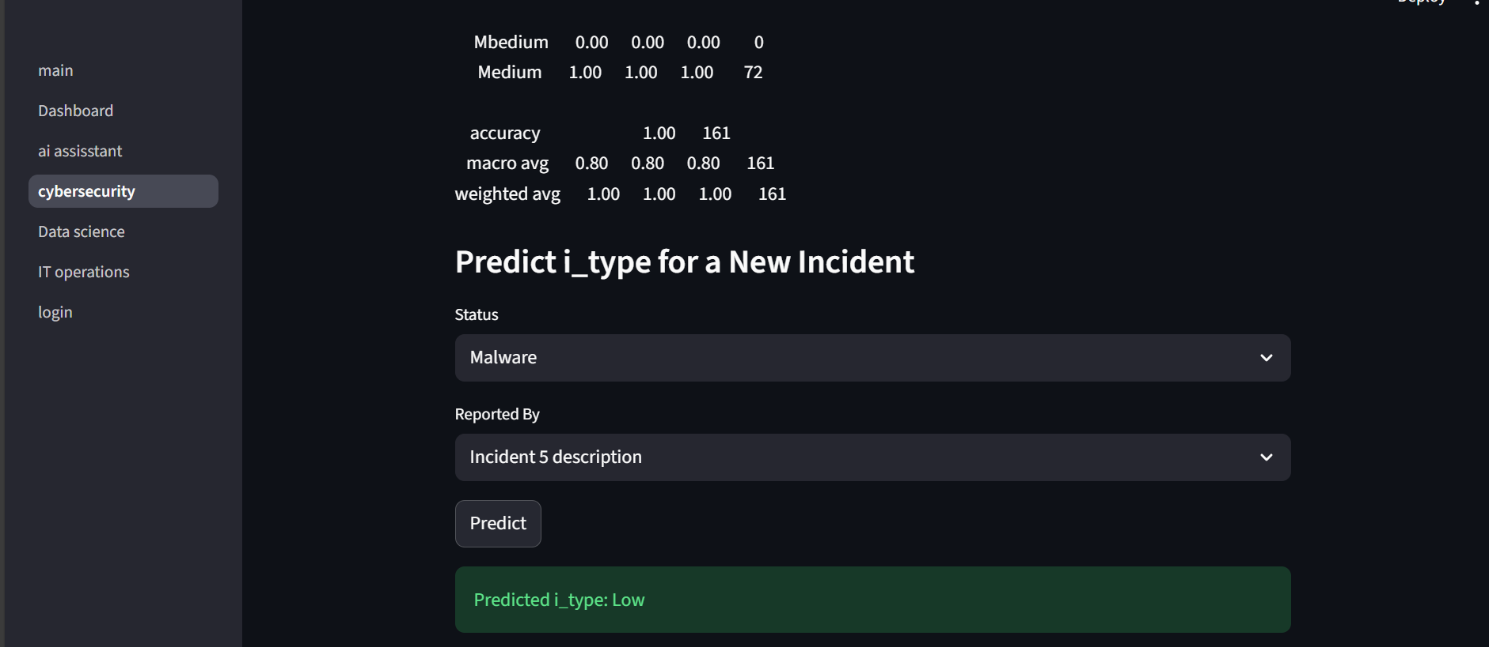
- AI Assistant
  - Users can interact with an AI chatbot to analyze datasets, incidents, and IT tickets.
  - Provides contextual guidance to interpret data as you can see down here .
- 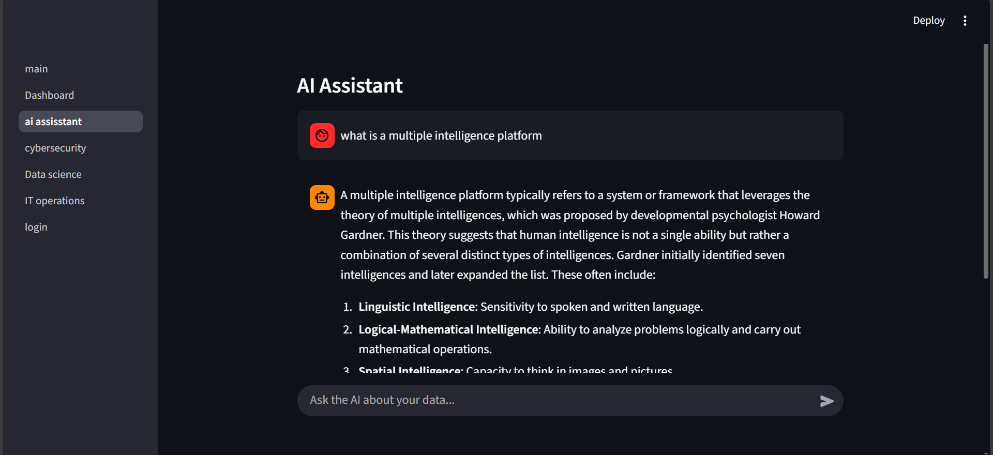

3. Reflection & Conclusion

3.1 what I learned
- Learned to use Streamlit for building interactive dashboards.
- Gained practical experience with object-oriented programming in Python and how they help in many things like :

1. Organizing your project into modules
models/
services/
pages/

3.Connecting to DB becomes easier

4.Adding AI assistant becomes easier

5. Loading datasets becomes easier

3.2 challnges I faced
I faced most of the challenge trying to refractor to create OOP stopping to store info of the new user registering from users.txt to the users database table directly I was not understanding the use of a lot of things until I start think of classes as the blueprint they do NOT change the visual interface.
Classes only change:
- how your code is organized; how clean, reusable, and professional it becomes;
- how easier it is to extend later how secure and scalable it becomes; NOT what the UI displays and NOT what the pages look like.

3.3 Conclusion
In conclusion, this project successfully implements the three-tier Multi-Domain Intelligence Platform. The user interface was built using Streamlit, which has provided clear and interactive dashboards for users. The logic was handled using Python classes and a simple machine learning model that I have learnt in my data science module (which is what we have been doing lately ), while the data layer was managed using a SQLite database to store and retrieve information securely.
The system also includes machine learning predictions for cybersecurity incident severity and an AI chatbot to support users with guidance and explanations. These features help make the platform more intelligent and useful.
If more time was available, the project could be improved by adding more ml cause now I only built one machine learning models, real-time alerts for incidents this time with reel data not the few we have in the .csv file , and more interactive visualizations. Overall, this project meets the requirements and demonstrates a strong understanding of multi-tier system design.

