Our cell counting pipeline is:

**Thresholding -> Erosion -> Erosion -> Erosion -> Dilution -> Dilution -> Dilution -> Region Counting (using flood fill)**

Step 1: Thresholding.

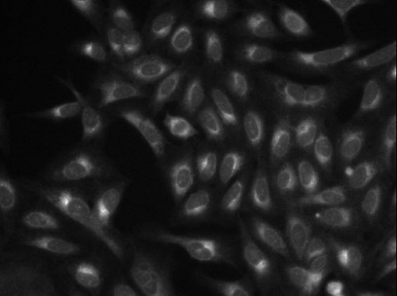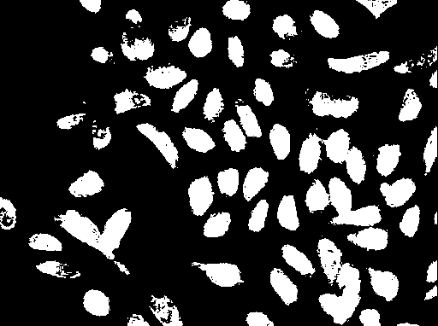Every image will have different good threshold value to be able to count the cells properly. To get the value of our threshold, we decided to use the mean value of the image’s pixel intensity and divide it by 2. We needed to divide the mean value by 2 because the mean value is affected by the pixels with unusual RGB value (outliers). The mean value itself would not be a good threshold value therefore to work around this problem, we divided by 2.

Step 2-3: Erosion and Dilution

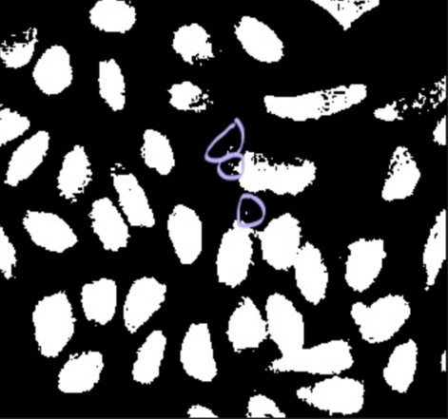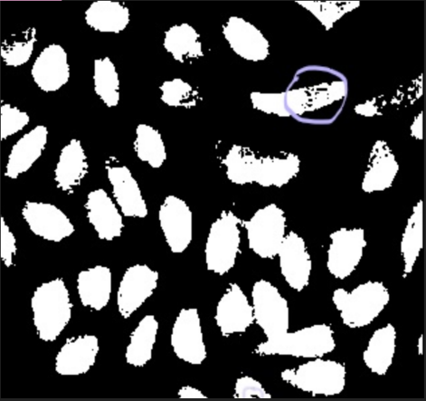After applying the thresholding filter, the images tend to have small foregrounds that are not cells or/and foreground with a lot of holes in it. To remove this, we use Erosion trice to the image. This mean shrinking the foreground (cells) trice, and then grow the foreground (cells) trice to return to the original size. This will remove the small foreground that are not cells. (see picture below). And will fill up the holes of the cells.

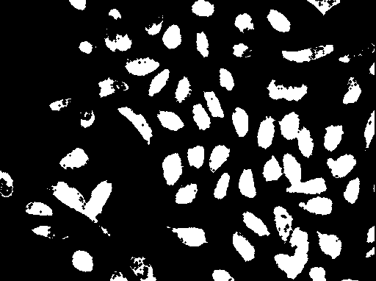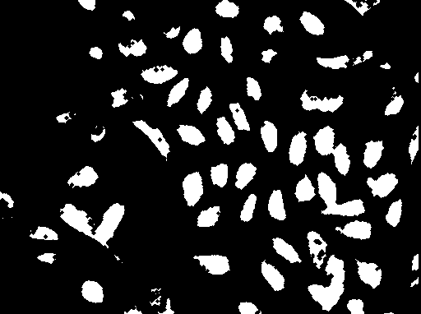3 Shrinking Images

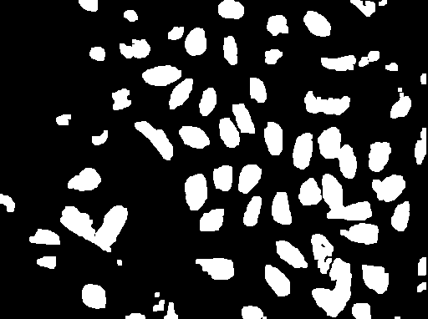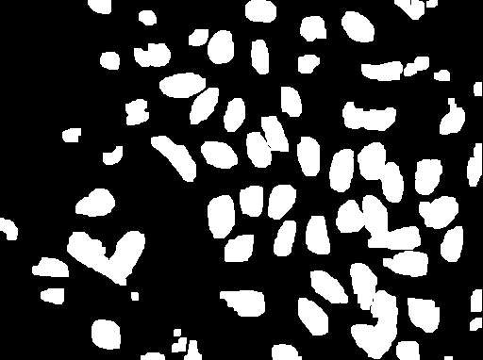3 Growing Images

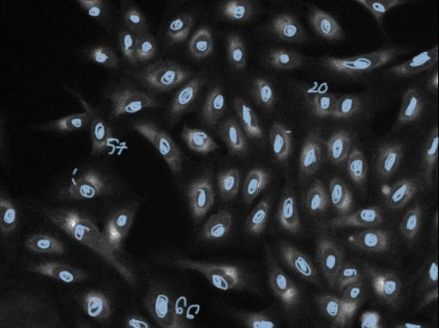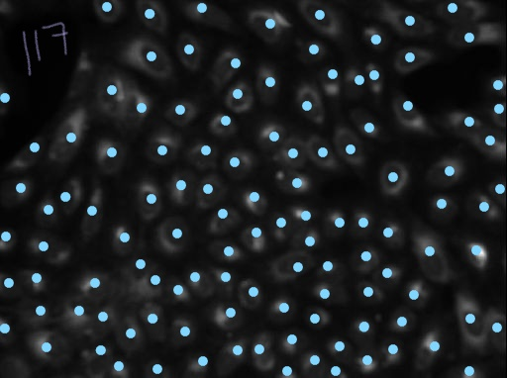Number of cells we counted:

Image (46075) – Cell Counted 117 Image (45799) – Cell Counted 66

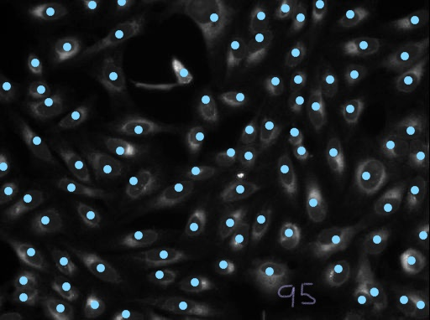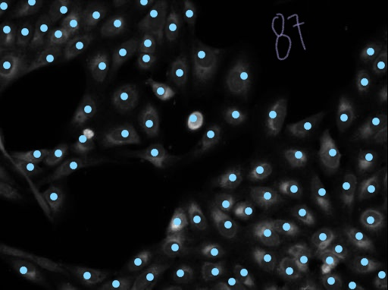

Image (46265) – Cell Counted 87 Image (45780) – Cell Counted 95