103.Does ML algorithm performance change over time?

Typically, when evaluating machine learning algorithms, researchers report the overall e.g. accuracy or RMSE. However, would results appear different when looking at time intervals? For instance, could it be that the overall results look like this:
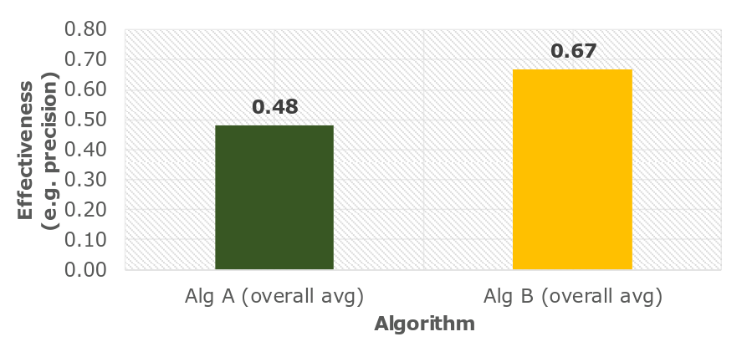
But when looking at time, results would look like this?

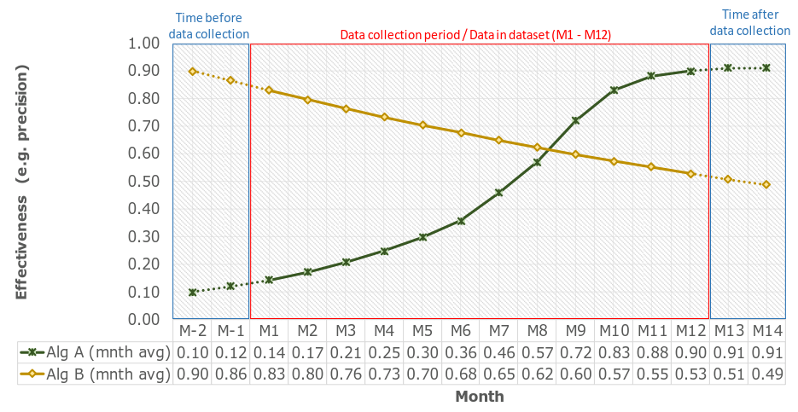

Keeping Your Machine Learning Models Up-To-Date
It’s more difficult, however, to find resources that show you how to maintain machine learning systems. How do you ensure your predictions continue to be accurate? How do you keep your models up-to-date with new training data?
Data is the most crucial component of a successful ML system. If you’ve found a data set that provides you with accurate predictions that’s a great start, but how long will that data continue to provide accurate predictions?
Let’s take the example of predicting house prices. House prices change all the time. The data you used to train a machine learning model that predicts house prices six months ago could provide terrible predictions today. For house prices, it’s imperative that you have up-to-date information to train your models.
When designing a machine learning system it is important to understand how your data is going to change over time. A well-architected system should take this into account, and a plan should be put in place for keeping your models updated.

Manual retraining
One way to maintain models with fresh data is to train and deploy your models using the same process you used to build your models in the first place. As you can imagine this process can be time-consuming. How often do you retrain your models? Weekly? Daily?
On the other hand, as you are manually retraining your models you may discover a new algorithm or a different set of features that provide improved accuracy.

Continuous learning
Another way to keep your models up-to-date is to have an automated system to continuously evaluate and retrain your models. This type of system is often referred to as continuous learning, and may look something like this:
- Save new training data as you receive it. For example, if you are receiving updated prices of houses on the market, save that information to a database.
- When you have enough new data, test its accuracy against your machine learning model.
- If you see the accuracy of your model degrading over time, use the new data, or a combination of the new data and old training data to build and deploy a new model.
The benefit to a continuous learning system is that it can be completely automated.
Machine Learning performance over long time frame:
https://www.business-school.ed.ac.uk/crc/wp-content/uploads/sites/55/2018/01/14-Yazhe_Li.pdf

Beware Steep Decline: Understanding Model Degradation in Machine Learning Models
Machine learning (ML) models are often designed to make predictions about future data. However, over time many models’ predictive performance decreases as a given model is tested on new datasets within rapidly evolving environments.
This is known as model degradation.
Model degradation is especially an issue in information security because malware is always changing and new malware is constantly emerging.
By understanding model degradation, we can determine how to optimize a model’s predictive performance.

Analysis of model degradation for prediction of customer preferences over time + ways to fix it:
https://blog.so1.ai/analysis-of-model-degradation/

Example of determining Ember model degradation:
https://www.endgame.com/blog/technical-blog/beware-steep-decline-understanding-model-degradation-machine-learning-models

Intro to time series

Time Series is generally data which is collected over time and is dependent on it.
CO2 level increases with respect to time, hence it is a time series.
Formal definition of Time Series: A series of data points collected in time order is known as a time series.
Most of businesses work on time series data to analyze sales number for the next year, website traffic, count of traffic, number of calls received, etc.
Data of a time series can be used for forecasting.
Some of the examples of time series are:
Stock price // Passenger count of an airline // temperature over time //number of visitors in a hotel

Components of a time series:
Trend : Trend is a general direction in which something is developing or changing i.e. increasing or decreasing
Seasonality : when the pattern repeats at regular time interval, this is known as the seasonality. Any predictable change or pattern in a time series that recurs or repeats over a specific time period can be said to be seasonality.
A time series problem is different from a regression problem in following ways:
- the main difference is that a time series is time dependent. So the basic assumption of a linear regression model that the observations are independent doesn’t hold in this case.
- Along with an increasing or decreasing trend, most Time Series have some form of seasonality trends,i.e. variations specific to a particular time frame
So, predicting a time series using regression techniques is not a good approach.
Time series forecasting is the use of a model to predict future values based on previously observed values.

Steps that we may follow to solve a problem at hand:

a) Understanding Data:

1) Hypothesis Generation

2) Getting the system ready and loading the data

3) Dataset Structure and Content

4) Feature Extraction

5) Exploratory Analysis

b) Forecasting using Multiple Modeling Techniques:

1) Splitting the data into training and validation part

2) Modeling techniques

3) Holt’s Linear Trend Model on daily time series

4) Holt Winter’s Model on daily time series

5) Introduction to ARIMA model

6) Parameter tuning for ARIMA model

7) SARIMAX model on daily time series

Extra articles/links:
https://towardsdatascience.com/keeping-your-production-model-fresh-9cf91e785630
https://blog.so1.ai/analysis-of-model-degradation/
https://machinelearningmastery.com/estimate-performance-machine-learning-algorithms-weka/
https://community.hitachivantara.com/community/products-and-solutions/pentaho/blog/2018/03/06/4-steps-to-machine-learning-model-management

Some more links on performance metrics:
https://towardsdatascience.com/metrics-to-evaluate-your-machine-learning-algorithm-f10ba6e38234

