**Group assignment of Capstone I**

**Deadline: 10/19/2016**

***BY: Namita Sehdev, Roger Frogoso & Eunjung Park***

1. **(*Logic reasoning*)**

**Justify the correctness of Huffman encoding algorithm:**

**In Huffman encoding algorithm (sort the symbols in order and merge the top two symbols iteratively until only one node is left), prove that for two symbols A and B with probabilities p(A) >= p(B), then (in the resultant representation sequence according to Huffman encoding procedure, )the length of symbol A is no longer than that of symbol B.**

**ANSWER:** Given symbol A and B s.t. Prob(A) >= Prob(B),

Show that len(A) <= len(B) in Hoffman enconding algorithm.

Prove by contradiction

Assume that len(A) > len(B) after finishing Hoffman encoding algorithm with A, B s.t. Prob(A) >= Prob(B).

* When there is only two symbols; A and B.

The assumption that len(A) > len(B) is not true because len(A) = len(B).

* When there's more than 2 symbols:

It doesn't matter if there is more ancestors or descendant beyond **between A and B** because we only care about A and B.

If len(A) > len(B) in Hoffman encoding algorithm, it means depth(A) > depth(B).

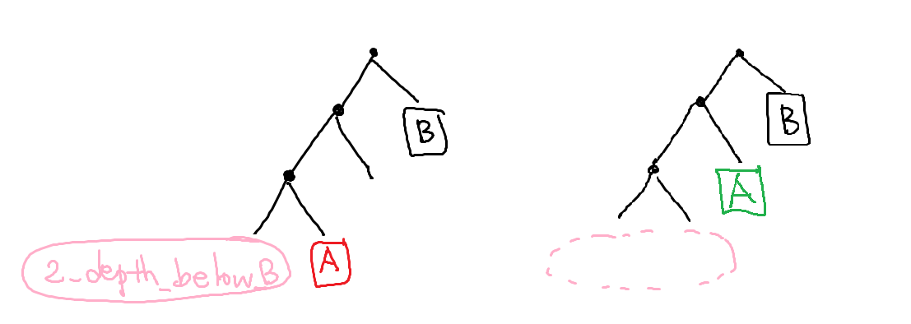

Case\_red\_A)

Prob(A) + Prob(2\_depth\_below\_B) <= Prob(B) in Hoffman tree. However, it contradicts to the condition of our assumption, Prob(A) >= Prob(B).

So, len(A) > len(B) s.t. Prob(A) >= Prob(B) is not true.

Case\_green\_B)

Prob(A) < Prob(B) as well to satisfy the green area based on the huffman code. It also contradict to the condition of our assumption, Prob(A) >= Prob(B).

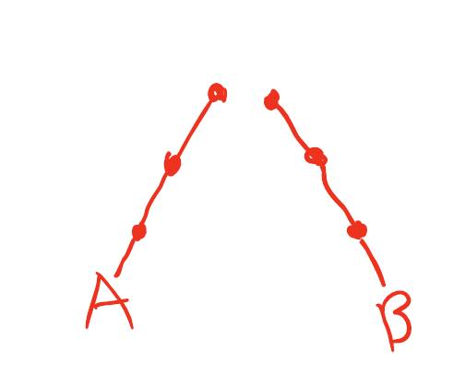So, len(A) > len(B) s.t. Prob(A) >= Prob(B) is not true.

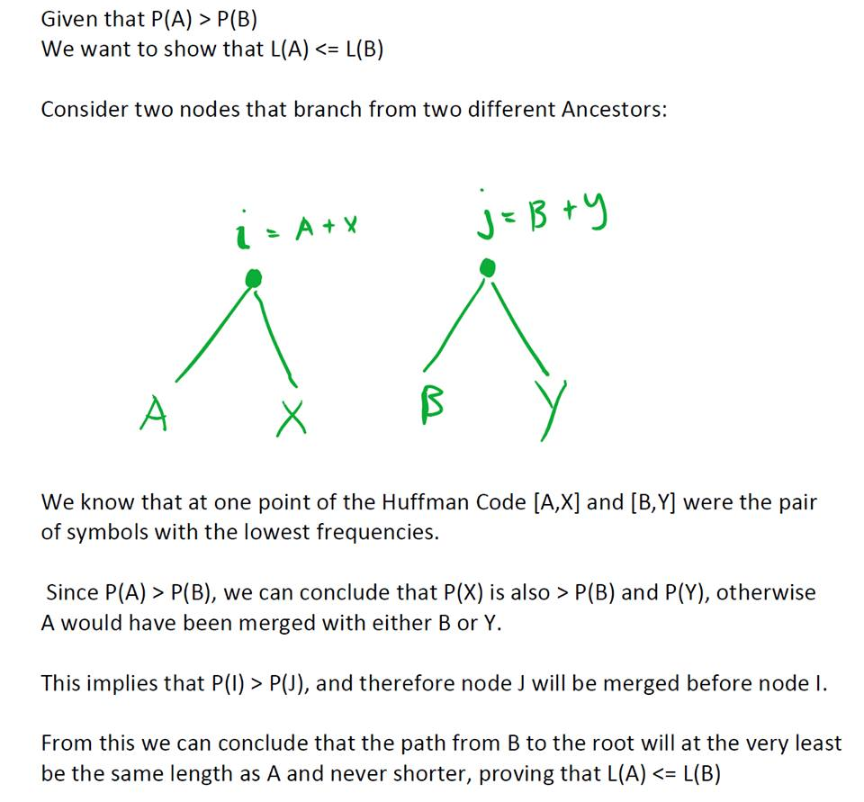

1. **(*Algorithm design and complexity analysis*)**

**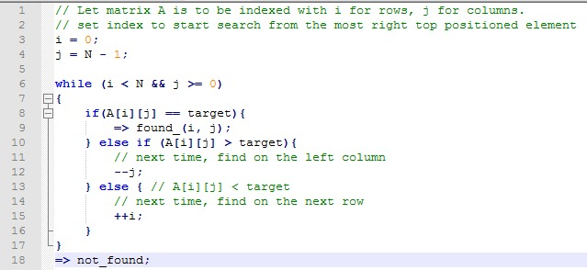For a square N x N matrix A, assume the elements are sorted in ascending order along the horizontal and vertical directions already, i.e., A[i][k] ≤ A[j][k] and A[k][i] ≤ A[k][j], where i<j. Develop an efficient algorithm to search for the query value v from A, return the location if found, None otherwise. Analyze the time complexity of your algorithm.**

**ANSWER:**

Time complexity- best and worst case

**Best**- if the target is the same spot supposedly O(1) constant

**Worst** – if the target doesn’t exist and it ends up to the bottom left square which means that there are several routes that go to the bottom square with the length of the path being 2n, which is O(n).

CODE- i = rows

J= columns

Starts from the top right element

N = size of length of columns and rows

When target value is less than the current elements value, the path to the target is shifted one element to the left and if the target values is greater than the current elements value, the path is shifted down 1 element. Rows and columns are ascending in element value.

This process will continue until it reaches its target value.

|  |  |  |  |  |
| --- | --- | --- | --- | --- |
| **1** | **7** | **12** | **15** | **20** |
| **3** | **9** | **14** | **17** | **21** |
| **8** | **11** | **16** | **18** | **26** |
| **22** | **23** | **25** | **27** | **30** |
| **28** | **29** | **30** | **32** | **35** |

1. **(*Double-blind testing*)**

**Use double-blind testing method to evaluate the performances of three search engines that you are free to choose.**

Web Results unprocessed data for Q1

|  |  |  |  |  |
| --- | --- | --- | --- | --- |
| **Search for** | **result** | **A** | **B** | **C** |
| Q1. What to do in Main? | 1 | [38 Awesome Things You Should Do When You Go To Maine](https://www.buzzfeed.com/mallorymcinnis/maine-is-the-best-state)  [https://www.buzzfeed.com/mallorymcinnis/**maine**-is-the-best-state](https://www.buzzfeed.com/mallorymcinnis/maine-is-the-best-state)  38 Awesome Things You Should **Do** When You Go To **Maine**. It's called Vacationland for a reason, people. posted on Aug. 12, 2015, at 9:14 a.m.. | [The Top 10 **Things to Do in Maine** - **TripAdvisor** - **Maine** ...](https://www.tripadvisor.com/Attractions-g28940-Activities-Maine.html)  [**www.tripadvisor.com**](http://www.tripadvisor.com) › [United States](https://www.tripadvisor.com/Tourism-g191-United_States-Vacations.html) › [**Maine** (ME)](https://www.tripadvisor.com/Tourism-g28940-Maine-Vacations.html)  **Things to Do in Maine**; **Things to Do in Maine** View Map Map. Satellite. Map updates are paused. Zoom in to see updated info. Reset zoom. Updating Map... Your filters ...  [Marginal Way](https://www.tripadvisor.com/Attraction_Review-g40790-d104969-Reviews-Marginal_Way-Ogunquit_Maine.html) · [Attractions Portland](https://www.tripadvisor.com/Attractions-g40827-Activities-Portland_Maine.html) | [The Top 10 Things to Do in Maine - TripAdvisor - ...](https://www.tripadvisor.com/Attractions-g28940-Activities-Maine.html)  [www.tripadvisor.com](http://www.tripadvisor.com)  **›**[United States](https://www.tripadvisor.com/Tourism-g191-United_States-Vacations.html)  **›**[Maine (ME)](https://www.tripadvisor.com/Tourism-g28940-Maine-Vacations.html)  Things to Do in Maine; Things to Do in Maine View Map Map. Satellite. Map updates are paused. Zoom in to see updated info. Reset zoom. Updating Map... Your filters ... |
|  | 2 | [The Top 10 Things to Do in Maine - TripAdvisor - Maine, United States ...](https://www.tripadvisor.com/Attractions-g28940-Activities-Maine.html)  [https://www.tripadvisor.com/Attractions-g28940-Activities-**Maine**.html](https://www.tripadvisor.com/Attractions-g28940-Activities-Maine.html)  Book your tickets online for the top things to **do in Maine**, United States on TripAdvisor: See 99186 traveler reviews and photos of Maine tourist attractions.  ‎[Maine](https://www.tripadvisor.com/Attractions-g28940-Activities-oa20-Maine.html) · ‎[Marginal Way](https://www.tripadvisor.com/Attraction_Review-g40790-d104969-Reviews-Marginal_Way-Ogunquit_Maine.html) · ‎[Portland Head Light](https://www.tripadvisor.com/Attraction_Review-g40554-d108101-Reviews-Portland_Head_Light-Cape_Elizabeth_Maine.html) · ‎[Mount Katahdin](https://www.tripadvisor.com/Attraction_Review-g40744-d145958-Reviews-Mount_Katahdin-Millinocket_Maine.html) | [The Top 10 **Things to Do in Portland** - **TripAdvisor** ...](https://www.tripadvisor.com/Attractions-g40827-Activities-Portland_Maine.html)  [**www.tripadvisor.com**](http://www.tripadvisor.com) › [United States](https://www.tripadvisor.com/Tourism-g191-United_States-Vacations.html) › [**Maine** (ME)](https://www.tripadvisor.com/Tourism-g28940-Maine-Vacations.html) › [Portland](https://www.tripadvisor.com/Tourism-g40827-Portland_Maine-Vacations.html)  Book your tickets online for the top **things to do in Portland**, **Maine** on **TripAdvisor**: ... #30 of 141 **things to do in Portland** . 110 reviews | [Things To Do | Visit Maine](https://visitmaine.com/things-to-do/)  visitmaine.com/things-to-do  Things To Do. Arts & Culture ... If you’re looking for what to do in Maine you’ve come to the right place – There are so many Maine attractions to explore and ... |
|  | 3 | [Things To Do | Visit Maine](https://visitmaine.com/things-to-do/)  [https://visit**maine**.com/things-to-**do**/](https://visitmaine.com/things-to-do/)  Explore all the activities Maine has to offer. ... If you're looking for **what to do in Maine** you've come to the right place – There are so many Maine attractions to ... | [Visit **Maine**](https://visitmaine.com/)  [https://visit**maine**.com](https://visitmaine.com)  Aroostook County **Maine**'s Lakes & Mountains DownEast & Acadia **Maine**'s MidCoast & Islands Greater Portland & **Casco Bay** The **Maine** Beaches The Kennebec Valley The**Maine** ... | [Maine Things To Do - Attractions & Must See -...](https://www.virtualtourist.com/travel/North_America/United_States_of_America/Maine/Things_To_Do-Maine-MISC-BR-1.html)  [www.virtualtourist.com/travel/North\_America/](http://www.virtualtourist.com/travel/North_America/)...  Maine Things To Do: 426 reviews and photos of things to see in Maine from real travelers and locals. ... There is a main loop, on the eastern island, ... |

Web Results processed to according to the rubric example

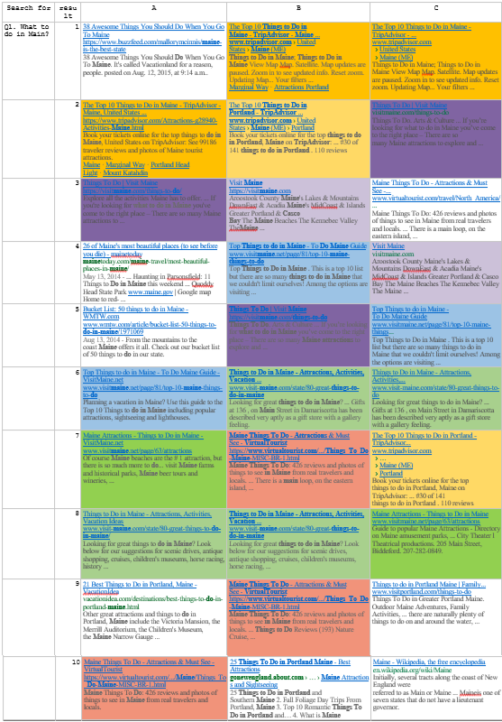

Image Search Results for Q1

|  |  |  |
| --- | --- | --- |
| Q1 | D | E |
| 1 | [Image result for What to do in Maine?](https://www.google.com/imgres?imgurl=https://img.buzzfeed.com/buzzfeed-static/static/2015-08/11/7/enhanced/webdr07/enhanced-2210-1439294384-1.jpg&imgrefurl=https://www.buzzfeed.com/mallorymcinnis/maine-is-the-best-state&docid=SK4JYfd9r80YfM&tbnid=D4oWXbvkFPW3xM:&w=625&h=1200&bih=901&biw=1920&ved=0ahUKEwi0kq3wmebPAhWCHD4KHZZPCl8QMwgeKAAwAA&iact=mrc&uact=8) | C:\C65A0EC5\90DFE58B-E23F-4A0C-AFAC-53B4CB9AD2B5_files\image002.jpg |
| 2 | Image result for What to do in Maine? | C:\C65A0EC5\90DFE58B-E23F-4A0C-AFAC-53B4CB9AD2B5_files\image004.jpg |
| 3 | Image result for What to do in Maine? | C:\C65A0EC5\90DFE58B-E23F-4A0C-AFAC-53B4CB9AD2B5_files\image006.jpg |

