《量子信息基础》2022.3.15随堂作业：

1. (1) Write down the indices of the following 9 crystal planes in the cubic lattice system.

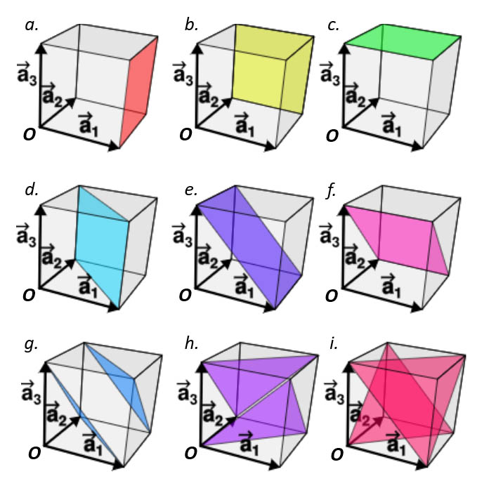

*a.* (1, 0, 0); *b.* (0, 1, 0); *c.* (0, 0, 1);

*d.* (1, 1, 0); *e.* (1, 0, 1); *f*. (0, 1, 1);

*g*. (1, 1, 1); *h.* ($\overline{1}$, 1, 1); *i.* (1, $\overline{1}$, 1).

以上每个写对给2分

(2) Write down the indices of the shortest lattice vector which starts from the point *O* and ends at the crystal planes with colors in the above figure.

*a.* (1, 0, 0); *b.* (0, 1, 0); *c.* (0, 0, 1);

*d.* (1, 1, 0); *e.* (1, 0, 1); *f*. (0, 1, 1);

*g*. ($\frac{1}{3}$, $\frac{1}{3}$, $\frac{1}{3}$); ($\frac{2}{3}$, $\frac{2}{3}$, $\frac{2}{3}$); *h.* ($-\frac{1}{3}$, $\frac{1}{3}$, $\frac{1}{3}$); (0, 0, 0); *i.* ($\frac{1}{3}$, $-\frac{1}{3}$, $\frac{1}{3}$); (0, 0, 0).

以上每个写对给2分

如果写成下面这样也算对

*g*. (1, 1, 1); *h.* ($\overline{1}$, 1, 1); *i.* (1, $\overline{1}$, 1).

1. (1) Write down the reciprocal vector $\overset{⃑}{G}$ of the 1D and 2D lattice of

$$\overset{⃑}{R}=u\overset{⃑}{a}$$

$$\overset{⃑}{R}=u{\overset{⃑}{a}}_{1}+v{\overset{⃑}{a}}_{2}$$

$${\overset{⃑}{b}}_{1}=2π∙\frac{{\overset{⃑}{a}}_{2}×{\overset{⃑}{a}}_{3}}{{\overset{⃑}{a}}_{1}∙\left({\overset{⃑}{a}}_{2}×{\overset{⃑}{a}}_{3}\right)}$$

在一维情况下，令 ${\overset{⃑}{a}}_{1}=a\overset{⃑}{i}$， ${\overset{⃑}{a}}_{2}=\overset{⃑}{j}$， ${\overset{⃑}{a}}_{3}=\overset{⃑}{k}$

$$\overset{⃑}{b}=\frac{2π}{a}\overset{⃑}{i}, \overset{⃑}{G}=u\overset{⃑}{b}$$

以上写对给10分

在二维情况下，令 ${\overset{⃑}{a}}_{1}=a_{1}\overset{⃑}{i}$， ${\overset{⃑}{a}}_{2}=a_{2}\overset{⃑}{j}$， ${\overset{⃑}{a}}_{3}=\overset{⃑}{k}$

$${\overset{⃑}{b}}_{1}=\frac{2π}{a_{1}}\overset{⃑}{i}$$

$${\overset{⃑}{b}}_{2}=\frac{2π}{a_{2}}\overset{⃑}{j}$$

$$\overset{⃑}{G}=u{\overset{⃑}{b}}_{1}+v{\overset{⃑}{b}}_{2}$$

以上写对给10分

(2) Prove that in the Bloch’s theorem, where $\overset{⃑}{G}$ is the 1D reciprocal vector.

$$u_{k}\left(x\right)=\sum_{h}{A_{h}e^{iGx}}$$

$$G=\frac{2π}{a}h, h=0, ±1, ±2, …$$

Comparing to,

$$\overset{⃑}{G}=u\frac{2π}{a}\overset{⃑}{i}$$

QED.

以上写对给10分

1. (Text book\* Problem 6.5)

Show that Equation 6.12 follows from Equation 6.11. Hint: First write $ψ\left(x\right)=e^{iqx}u\left(x\right)$, which is certainly true for some $u\left(x\right)$, and then show that $u\left(x\right)$ is necessarily a periodic function of *x*.

从6.11式出发

$$ψ_{q}\left(x-a\right)=e^{-iqa}ψ_{q}\left(x\right)$$

我们发现波矢为 $\overset{⃑}{q}$ 的平面波 $φ_{q}\left(x\right)=e^{iqx}$ 满足布洛赫定理:

$$φ_{q}\left(x-a\right)=e^{iq\left(x-a\right)}=e^{iqx}e^{-iqa}=e^{-iqa}φ_{q}\left(x\right)$$

写出平面波满足布洛赫定理给7分

我们还发现波矢为 $\overset{⃑}{q}+\overset{⃑}{G}$ 的平面波满足布洛赫定理，其中 $\overset{⃑}{G}=\frac{2π}{a}h,$ 是一维周期性晶格的倒格矢

$$φ_{q+G}\left(x-a\right)=e^{i\left(q+G\right)\left(x-a\right)}=e^{-i\left(q+G\right)a}φ_{q+G}\left(x\right)=e^{-iqa}φ_{q+G}\left(x\right)$$

写出倒格矢周期性叠加的平面波满足布洛赫定理给10分

令布洛赫波 $φ_{q}\left(x\right)$ 为平面波 $φ_{q+G}\left(x\right)=e^{i\left(q+G\right)x}$ 的线性叠加

$$ψ_{q}\left(x\right)=e^{iqx}u_{q}\left(x\right)=e^{iqx}\sum_{h}{A_{h}e^{iGx}}=\sum_{h}{A_{h}e^{i\left(q+G\right)x}}$$

写出关于u(x)的布洛赫定理给10分

其中

$$u_{q}\left(x\right)=\sum_{h}{A_{h}e^{iGx}}$$

写出关于u(x)的表达式给7分

\* David J. Griffiths, and Darrell F. Schroeter, Introduction to Quantum Mechanics (3rd Edition), Cambridge University Press (2018).