Vision and Scope Document

for

krizis2
Version 1.0 draft 1
Prepared by euphorion
The Crazy Group
28.05.2016
Table of Contents

Table of Contents ii
Revision History ii
1. Business Requirements 1
1.1. Background 1
1.2. Business Opportunity 1
1.3. Business Objectives 1
1.4. Success Metrics 1
1.5. Vision Statement 1
1.6. Business Risks 1
1.7. Business Assumptions and Dependencies 2
2. Scope and Limitations 2
2.1. Major Features 2
2.2. Scope of Initial Release 2
2.3. Scope of Subsequent Releases 2
2.4. Limitations and Exclusions 2
3. Business Context 2
3.1. Stakeholder Profiles 2
3.2. Project Priorities 3
3.3. Deployment Considerations 4

Revision History

Name | Date | Reason For Changes | Version
euphorion | 29/05/16 | Initial draft | 1.0 draft 1

Business Requirements
Krizis2 project improves shopping experience for discounted products.

Background
Finding discounted products with the best offer can take a lot of time. Krizis2 project can shorten it bringing together the best offers from supermarket web-pages. The krizis2 application should help to arrange shopping plans for discounted products.

Business Opportunity
There is kriisis.ee site, which has awkward design and no Android application. Our plan is to develop own replica of it offering better using experience along with the app.

Business Objectives
- BO-1: The project will list all up-to-date supermarket discounted products in food category.
- BO-2: The project will allow to search for a specific product category and compare prices from different supermarkets.
- BO-3: The project will grab and process pages with discounted products from supermarket web-pages.
- BO-4: The project will have an accompanying Android application for creating a shopping plan for discounted products.

Success Metrics
- SM-1: The website correctly lists discounted products from all major supermarket networks.
- SM-2: The website allows quick search and compare for the best discounted products.
- SM-3: The website works automatically or with small web-admin help to fill the discounted products database.
- SM-4: The website is more appealing than kriisis.ee and has good feedback from users.
- SM-5: The application runs smoothly and has users other than the creators.
- SM-6: The website earns itself money for hosting and domain name from advertising.

Vision Statement
For supermarket clients looking for discounted products, krizis2 website is an information system that will provide discounted products listings. The system will allow to search for specific products. This system will help users to eliminate necessity for searching discounted products themselves. Unlike the current reference sites the system be accompanied by an Android app to help organize shopping plans.

Business Risks
- RI-1: The discount import system will require too much effort/skills to make it work semi-automatically or will be error-prone.
- RI-2: Less than 10 users will use the system, reducing the return of investment and developers' satisfaction.

Business Assumptions and Dependencies

Scope and Limitations

Major Features
FE-1: Create, view, modify or delete discounts from the database.
FE-2: Show discounts in a web browser with a function to search and compare.
FE-3: Create a search robot to automatically fill the discounts database.
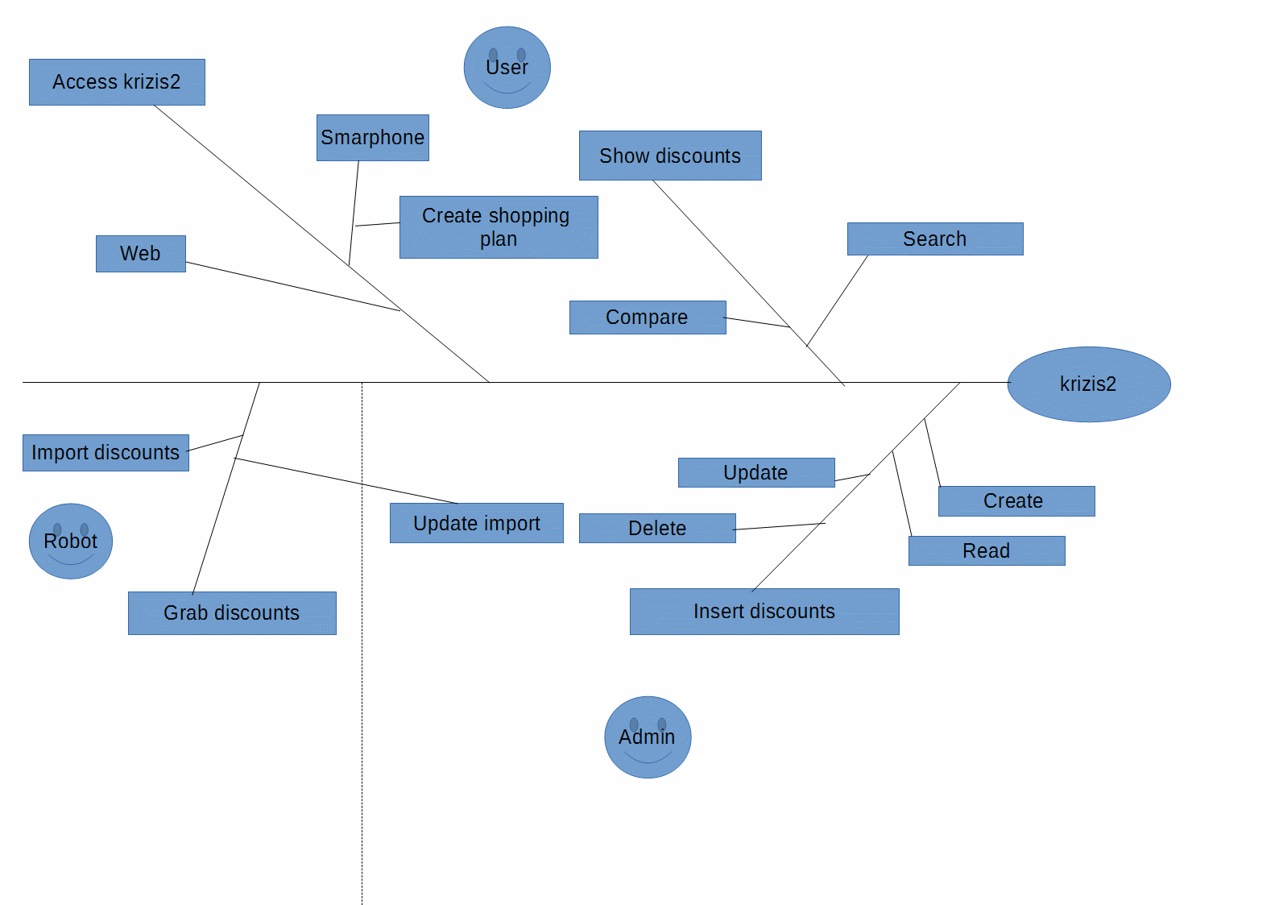
FE-4: Create an Android app for viewing discounts with a shopping plan creation function.

Scope of Initial Release

Scope of Subsequent Releases
Feature | Release 1 | Release 2 | Release 3
FE-1: Insert discounts | Implemented | Implemented | Implemented
FE-2: Show discounts | Implemented | Implemented | Implemented
FE-3: Grab discounts | Not Implemented | Implemented | Implemented
FE-4: Android App | Not implemented | Not Implemented | Implemented

Limitations and Exclusions

Business Context

Stakeholder Profiles

Stakeholder | Major Value | Attitudes | Major interests | Constraints
Users | Improved discounts accessibility
Buyers | Improved buying experience

Project Priorities

Dimension | Driver  (state objective) | Constraint  (state limits) | Degree of Freedom  (state allowable range)
Schedule | release 1.0 to be available by 01/06/2016, Features should be fully operational.  release 2.0 to be available by 08/06/2016  release 2.0 to be available by 22/06/2016
Features | All features scheduled for release 1.0 must be fully operational
Quality | 95% of user acceptance tests must pass; all security tests must pass
Staff
Cost

Deployment Considerations
The web server software will need to be upgraded to the latest version. An app will have to be developed for Android smartphones.

