**Component Polarities**

* **Diode:**

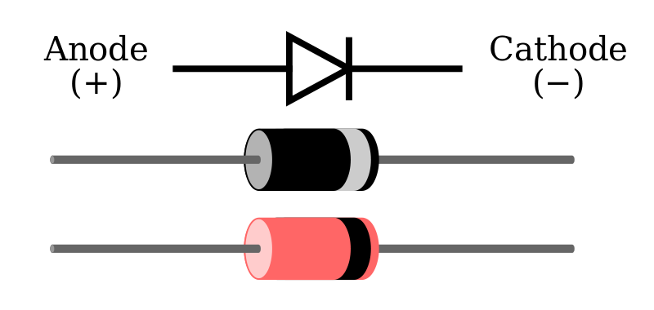

* **Capacitor:**

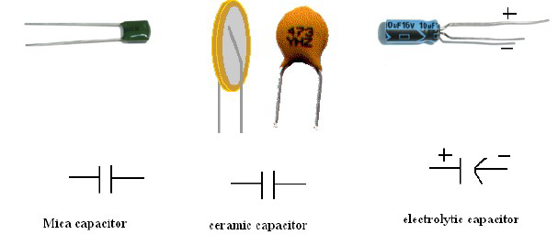

* **BJT:**

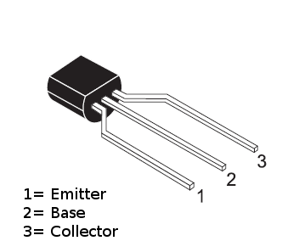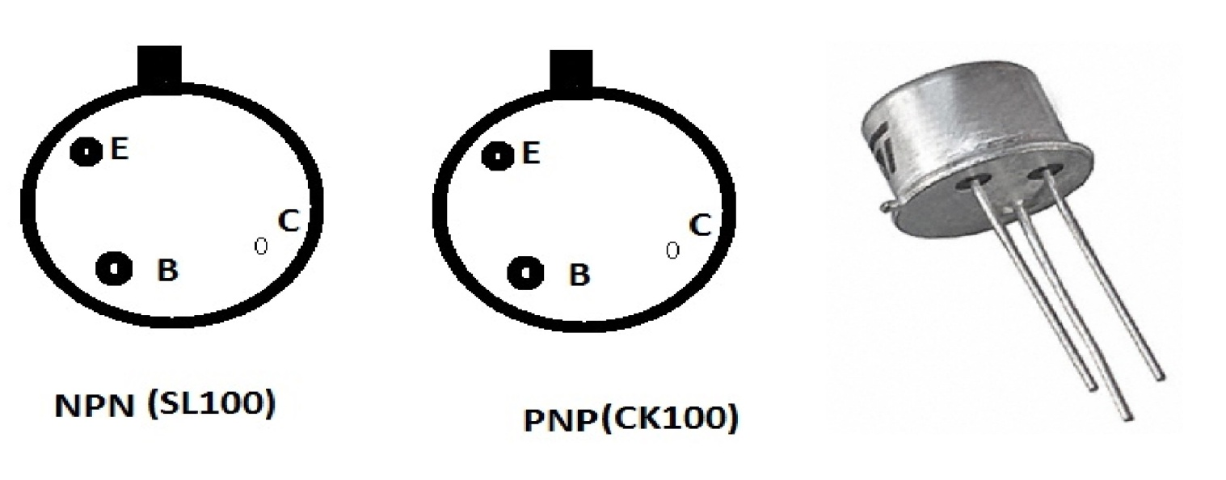

* **NMOS and PMOS**

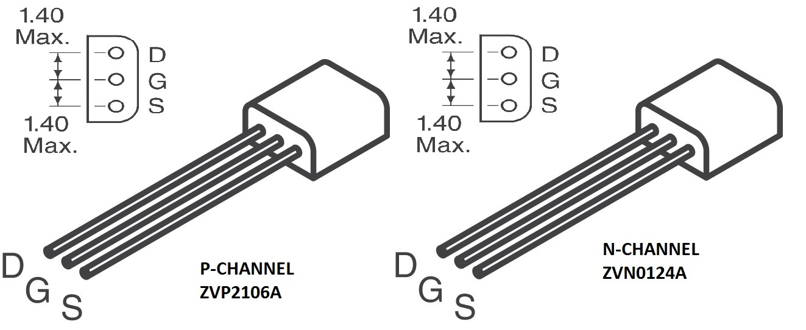

* **JFET:**

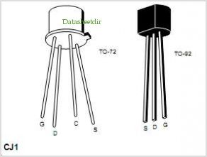

* **Op-Amp (IC741):**

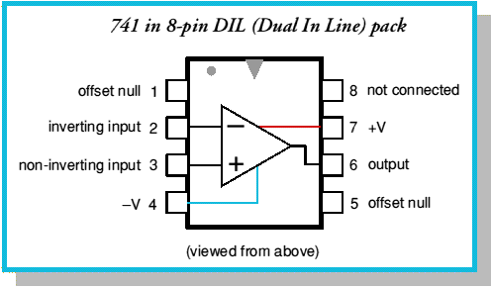

* **7404 - inverter**

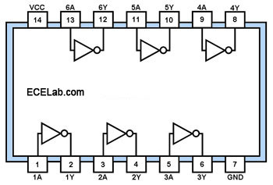

* **7408 - 2-input AND Gate**

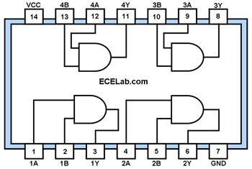

* **7400 - 2-input NAND Gate**

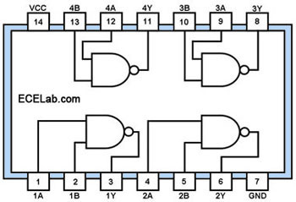

* **7410 - Triple 3-input NAND Gate**

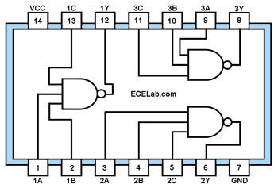

* **7432 - 2-input OR Gate**

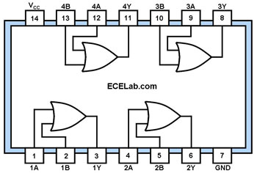

* **7402 - 2-input NOR Gate**

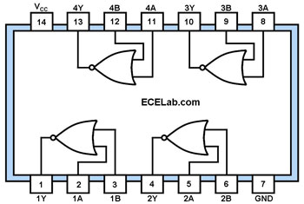

* **7427 - Triple 3-input NOR Gate**

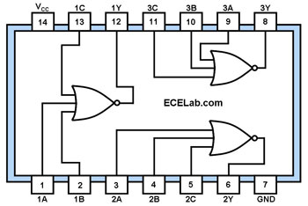

* **7486 - 2-input XOR Gate**

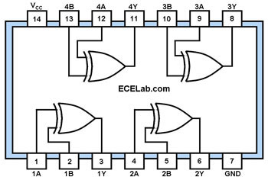

* **7483 – Adder**

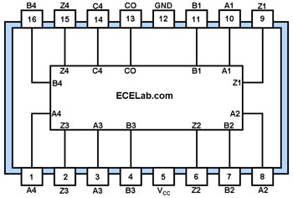

* **74HC175 – Quad D Flipflop**

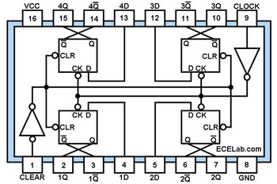

* **74HC112 – Dual JK Flipflop**

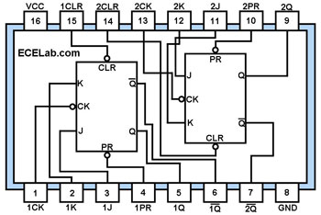

* **74HC138 - 3to8 Decoder**

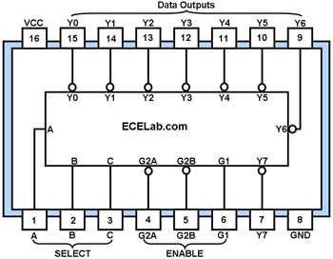

* **74LS469 – 8-Bit Up/Down Counter**

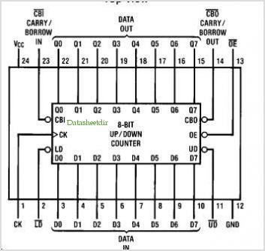

**Ref:** <http://www.ecelab.com/pin-outs/pin-outs.htm>

