**Input parameters for the KSTAR MSE (29 Apr. 2010)**

1. **The NBI (Units in mm and degrees)**
   1. The coordinates (in machine X-Y-Z coordinates) of the centre of the last grid of the NBI ion source.

>> Note X is in North direction in KSTAR building, Y is perpendicular, i.e., west direction.

>> 1st ion source (centered ion source): (12828.3, 4159.9, 0)

>> 2nd ion source (right beam, outboard direction, and 4-deg spaced apart from the center): (12518.9, 4785.6, 0)

>>3rd ion source (left beam, inboard direction, and also 4-deg space apart from the center): (13093.0, 3514.0, 0)

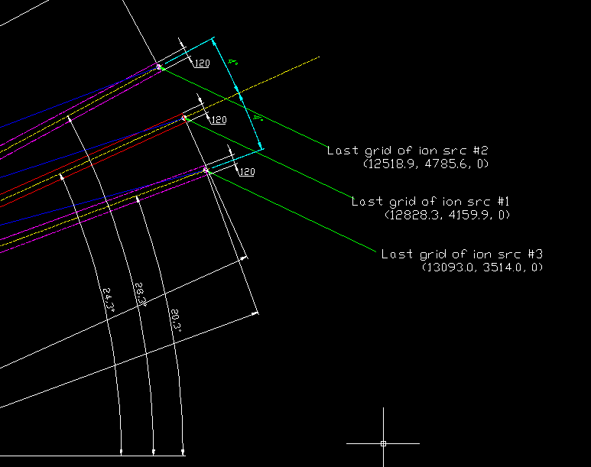

* 1. The angle of the beam axis with respect to the X-axis

>> 1st ion src. = 24.3 degrees

2nd ion src. = 28.3 degrees

3rd ion src. = 20.3 degrees

* 1. The angle of the beam axis with respect to the Z-axis (but i guess your beams are in the equatorial plane so this will just be 90 deg)

>> yes, all 90 degrees

* 1. The approximate beam width.

>> At the last grid? If so,

the approximate full beam width is 450 mm (vertical) x 120 mm (horizontal)

* 1. The vertical focal length of the beamlets, measured from the last grid of the NBI ion source.

>> 1000 mm

* 1. The horizontal focal length of the beamlets, measured from the last grid of the NBI ion source.

>> Same as the vertical focal length (1000 mm)

* 1. The coordinates (either in machine X-Y-Z coordinates or on the plane of the NBI ion source grid) of all beamlets of the NBI ion source.

>> I’m waiting for the answer from the NBI people on this. Send you soon.

* 1. The average divergence angle for the beamlets or the divergence angle for each beamlet. (indicate whether this is a FWHM or HWHM or 1/e or 1/e^2 ... angle)

>> 0.9 degrees, but I have to double check – I’ll let you know again soon.

* 1. The beam power in each of the 3 energy components of the beam as function of beam voltage

>> We will get the data of the beam power in each of the 3 energy components for 60 kV, 70 kV, 80 kV, 90 kV, and 100 kV during this campaign. Please wait.

1.10 If available the relative intensity or power profile over the beamlets (not strictly necessary).

>> We should rely on the BTR code simulation results on this. I will ask this to KAERI people who designed the NBI.

1. **K-STAR equilibrium at 1 time point (preferably in H-mode)**

The EFIT calculated 65 x 65 matrices. R_grid.xls and Z_grid.xls tell you the R-Z coordinate values at a certain point.

* 1. normalized flux psi_n as function of R and Z

>> see the NormalizedPsi.xls file

* 1. B_phi as function of R and Z

>> see the Bt.xls file. The blanks (no numbers indicated) are the region that cannot be calculated because there are no plasmas. And there are three groups of numbers in the screen. Here the middle one (looks a bit D-shaped) is from the plasma while the others (top and bottom) are not. It would be better to use only the numbers possibly in the beam path.

* 1. B_Z as function of R and Z

>> see the Bz.xls file.

* 1. B_R as function of R and Z

>> see the Br.xls file. Note that Br and Bz are proportional to the plasma current, Ip. And the Ip of shot#4333 is about 0.5MA. Here since the Ip target in 2014 will be 1.0-2.0MA, we have to consider that too. By multiply by 2 of the data we can expect 1.0MA case for instance.

* 1. T_e as function of R and Z. Or just as function of R (I assume the Thomson system is in the equatorial plane?)

>> Thomson is under commissioning. I will provide this after this campaign.

* 1. n_e as function of R and Z. Or just as function of R (I assume the Thomson system is in the equatorial plane?)

>> Thomson is under commissioning. I will provide this after this campaign.

* 1. Optionally (to apply electric field correction): T_i and v_i as function of R (from CXRS)

>> 4200_CXRS.xls

1. **MSE window (Units in mm and degrees)**
   1. The coordinates (in machine X-Y-Z coordinates) of the centre of MSE window in the M-bay.

>> (2572, 959, 0)

* 1. The angle of the "optical" axis with respect to the X-axis (with "optical" axis the line through the centre of the window and perpendicular to the window)

>> 69.5 degrees

* 1. The angle of the "optical" axis with respect to the Z-axis (but i guess your lines-of-sight are in the equatorial plane so this will just be 90 deg)

>> yes, 90 degrees

* 1. The diameter of the window

>> 96 mm

