**Legends:**

**UC = Upper Case U = Underscore ( _ ) NUM = Nonzero digits (1-9)**

**LC = Lower Case` Z = Zero (0)**

DFA Valid Identifier

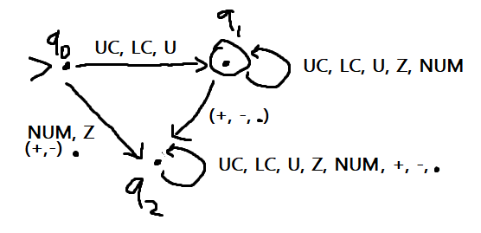

|  |  |  |  |  |  |  |  |
| --- | --- | --- | --- | --- | --- | --- | --- |
|  | UC | LC | U | Z | NUM | +,- | . |
| Q0 | Q1 | Q1 | Q1 | Q2 | Q2 | Q2 | Q2 |
| Q1 | Q1 | Q1 | Q1 | Q1 | Q1 | Q2 | Q2 |
| Q2 | Q2 | Q2 | Q2 | Q2 | Q2 | Q2 | Q2 |

DFA Valid Integer

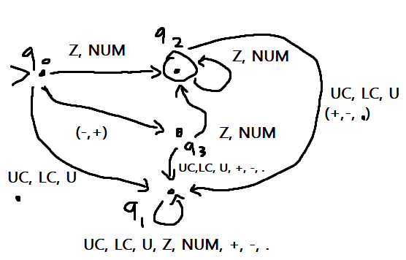

|  |  |  |  |  |  |  |  |
| --- | --- | --- | --- | --- | --- | --- | --- |
|  | UC | LC | U | Z | NUM | +,- | . |
| Q0 | Q1 | Q1 | Q1 | Q2 | Q2 | Q3 | Q1 |
| Q1 | Q1 | Q1 | Q1 | Q1 | Q1 | Q1 | Q1 |
| Q2 | Q1 | Q1 | Q1 | Q2 | Q2 | Q1 | Q1 |
| Q3 | Q1 | Q1 | Q1 | Q2 | Q2 | Q1 | Q1 |

DFA VALID FLOAT

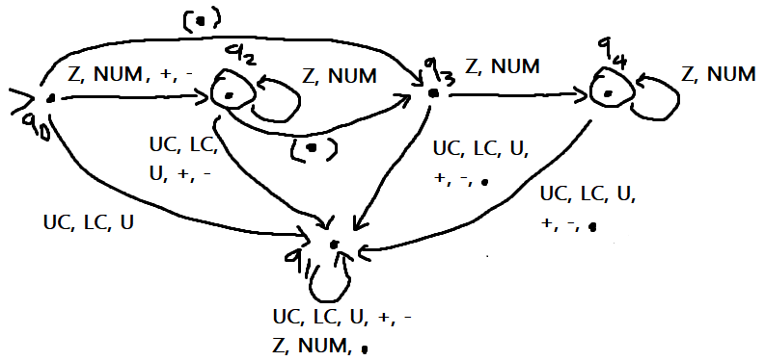

|  |  |  |  |  |  |  |  |
| --- | --- | --- | --- | --- | --- | --- | --- |
|  | UC | LC | U | Z | NUM | +,- | . |
| Q0 | Q1 | Q1 | Q1 | Q2 | Q2 | Q2 | Q3 |
| Q1 | Q1 | Q1 | Q1 | Q1 | Q1 | Q1 | Q1 |
| Q2 | Q1 | Q1 | Q1 | Q2 | Q2 | Q1 | Q3 |
| Q3 | Q1 | Q1 | Q1 | Q4 | Q4 | Q1 | Q1 |
| Q4 | Q1 | Q1 | Q1 | Q4 | Q4 | Q1 | Q1 |

DFA Version 2

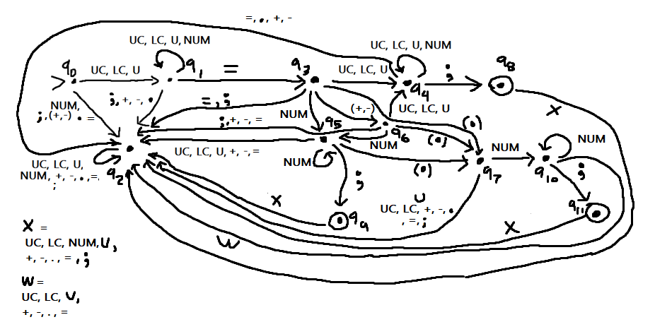

|  |  |  |  |  |  |  |  |  |  |
| --- | --- | --- | --- | --- | --- | --- | --- | --- | --- |
|  | UC | LC | U | NUM(0-9) | = | + | - | . | ; |
| Q0 | Q1 | Q1 | Q1 | Q2 | Q2 | Q2 | Q2 | Q2 | Q2 |
| Q1 | Q1 | Q1 | Q1 | Q1 | Q3 | Q2 | Q2 | Q2 | Q2 |
| Q2 | Q2 | Q2 | Q2 | Q2 | Q2 | Q2 | Q2 | Q2 | Q2 |
| Q3 | Q4 | Q4 | Q4 | Q5 | Q2 | Q6 | Q6 | Q7 | Q2 |
| Q4 | Q4 | Q4 | Q4 | Q4 | Q2 | Q2 | Q2 | Q2 | Q8 |
| Q5 | Q2 | Q2 | Q2 | Q5 | Q2 | Q2 | Q2 | Q7 | Q9 |
| Q6 | Q4 | Q4 | Q4 | Q5 | Q2 | Q2 | Q2 | Q7 | Q2 |
| Q7 | Q2 | Q2 | Q2 | Q10 | Q2 | Q2 | Q2 | Q2 | Q2 |
| Q8 | Q2 | Q2 | Q2 | Q2 | Q2 | Q2 | Q2 | Q2 | Q2 |
| Q9 | Q2 | Q2 | Q2 | Q2 | Q2 | Q2 | Q2 | Q2 | Q2 |
| Q10 | Q2 | Q2 | Q2 | Q10 | Q2 | Q2 | Q2 | Q2 | Q11 |
| Q11 | Q2 | Q2 | Q2 | Q2 | Q2 | Q2 | Q2 | Q2 | Q2 |