Argo data management

DOI: <http://dx.doi.org/...>

Implementation of Argo Real Time Quality Controls at Coriolis

Version 1.0

18th April 2017



**Implementation of Argo Real Time Quality Controls at Coriolis**

**Authors:** Jean-Philippe Rannou, Cécile Cabanes, Christine Coatanoan, Catherine Lagadec and Virginie Thierry

**How to cite this document**

Jean-Philippe Rannou, Cécile Cabanes, Christine Coatanoan, Catherine Lagadec and Virginie Thierry (2017). **Implementation of Argo Real Time Quality Controls at Coriolis** [**http://dx.doi.org/...**](http://dx.doi.org/...)

**Table of contents**

1. Introduction 7

2. Implementation of Argo Real-time Quality Control test procedures on vertical profiles 8

2.1. Description of implemented tests 8

2.1.1. Test #1: Platform identification test 8

2.1.2. Test #2: Impossible date test 8

2.1.3. Test #3: Impossible location test 8

2.1.4. Test #4: Position on land test 8

2.1.5. Test #5: Impossible speed test 8

2.1.6. Test #6: Global range test 8

2.1.7. Test #7: Regional range test 9

2.1.8. Test #8: Pressure increasing test 10

2.1.9. Test #9: Spike test 11

2.1.10. Test #10: Top and bottom spike test: obsolete 11

2.1.11. Test #11: Gradient test 11

2.1.12. Test #12: Digit rollover test 11

2.1.13. Test #13: Stuck value test 12

2.1.14. Test #14: Density inversion 12

2.1.15. Test #15: Grey list test 12

2.1.16. Test #16: Gross salinity or temperature sensor drift 12

2.1.17. Test #17: Visual QC 12

2.1.18. Test #18: Frozen profile test 12

2.1.19. Test #19: Deepest pressure test 12

2.1.20. Test #57: DOXY specific test 13

2.1.21. Test #58: CDOM specific test 13

2.1.22. Test #59: NITRATE specific test 13

2.1.23. Test #60: PAR specific test 13

2.1.24. Test #61: IRRADIANCE specific test 13

2.1.25. Test #62: BBP specific test 13

2.1.26. Test #63: CHLA specific test 13

2.2. Tests application order on vertical profiles 14

3. Implementation of Argo Real-time Quality Control test procedures on near-surface data of vertical profiles 15

3.1. Description of implemented tests 15

3.1.1. Test #21: Near-surface unpumped CTD salinity test 15

3.1.2. Test #22: Near-surface mixed air/water test 15

3.2. Tests application order on near-surface data of vertical profiles 15

4. Implementation of Argo Real-time Quality Control test procedures on trajectories 17

4.1. Description of implemented tests 17

4.1.1. Test #1: Platform identification test 17

4.1.2. Test #2: Impossible date test 17

4.1.3. Test #3: Impossible location test 17

4.1.4. Test #4: Position on land test 17

4.1.5. Test #5: Impossible speed test 17

4.1.6. Test #6: Global range test 17

4.1.7. Test #7: Regional range test 17

4.1.8. Test #15: Grey list test 17

4.1.9. Test #20: Questionable Argos position test 17

4.1.10. Test #57: DOXY specific test 17

4.1.11. Test #58: CDOM specific test 17

4.1.12. Test #59: NITRATE specific test 18

4.1.13. Test #60: PAR specific test 18

4.1.14. Test #61: IRRADIANCE specific test 18

4.1.15. Test #62: BBP specific test 18

4.1.16. Test #63: CHLA specific test 18

4.2. Tests application order on trajectories 18

4.3. Profile measurements reported in trajectories 18

5. Implementation of Argo Real-time Quality Control test procedures on in-air data of trajectories 19

5.1. Description of implemented tests 19

5.1.1. Test #21: Near-surface unpumped CTD salinity test 19

5.1.2. Test #22: Near-surface mixed air/water test 19

5.2. Tests application order on in-air data of trajectories 19

6. Passed/failed test traceability 20

7. Annex A: Example of Matlab implementation of the density inversion test 21

**History**

|  |  |
| --- | --- |
| **Date (dd/mmm/yyyy)** | **Comment** |
| 09/Feb/2016 | Creation of the document by Cecile, Jean-Philippe |
| 18/Apr/2017 | Update of the draft document to create its first version, Jean-Philippe |
|  |  |
|  |  |

**Reference Documents**

|  |  |  |
| --- | --- | --- |
| **Reference N°** | **Title** | **Link** |
| #RD1 | Argo Quality Control Manual for CTD and Trajectory Data | <http://dx.doi.org/10.13155/33951> |
| #RD2 | Argo quality control manual for biogeochemical data | <http://dx.doi.org/10.13155/40879> |
| #RD3 | Quality control manual for dissolved oxygen concentration | <http://dx.doi.org/10.13155/46542> |
| #RD4 | BGC Argo quality control manual for particles backscattering | TBD |
| #RD5 | Bio-Argo quality control manual for Chlorophyll-A concentration | <http://dx.doi.org/10.13155/35385> |
|  |  |  |
|  |  |  |
|  |  |  |

# Introduction

This document describes how the Real Time Quality Control (RTQC) tests are implemented at the Coriolis data Centre.

These tests are defined in the Argo quality control manuals (#RD1 and #RD2). The present document provides a detailed description of their implementation in the Matlab processing chain that produces Argo V3.1 format NetCDF files.

This document describes the tests implemented in **profile RTQC version 3.1** and **trajectory RTQC version 2.1** of the Coriolis **Matlab decoder version ‘010a’** (<http://doi.org/10.17882/45589>).

The implemented tests are defined for the following parameters:

* PRES ,
* TEMP,
* PSAL
* DOXY,
* TEMP_DOXY,
* CHLA,
* BBP700,
* BBP532.

# Implementation of Argo Real-time Quality Control test procedures on vertical profiles

## Description of implemented tests

### Test #1: Platform identification test

The Coriolis Matlab decoder cannot process a float without its WMO and associated PTT. Thus, nothing has been implemented for this test (it is always reported as successfully passed).

### Test #2: Impossible date test

At Coriolis the JULD value is checked to be later than January 1st 1997 (JULD ≥ 17167) and earlier than the date of the check (in UTC time).

The JULD_LOCATION is also checked with the same criteria and contributes (with test #3, #4 and #5) to the final value of POSITION_QC.

### Test #3: Impossible location test

At Coriolis the checked interval is [-90, 90] for latitudes and [-180, 180] for longitudes.

### Test #4: Position on land test

At Coriolis we use the ETOPO2 file (ETOPO2v2g_i2_MSB.bin version).

The detailed description of the test is the following: For a given position, the elevations are retrieved from the bathymetry file (1, 2 or 4 elevations depending on the position location on the ETOPO2 grid). The test fails if the average value of the retrieved elevations is ≥ 0.

### Test #5: Impossible speed test

At Coriolis, the profile position is defined according to DAC cookbook specifications (§2.2.2 of <http://dx.doi.org/10.13155/29824>), thus from a trajectory already checked by the JAMSTEC QC test. Consequently, this test is obsolete for Coriolis Argos floats and should be considered for Iridium floats only.

### Test #6: Global range test

At Coriolis the checked intervals are:

* PRES ≥ -5 dbars,
* TEMP in the interval [-2.5, 40] °C,
* PSAL in the interval [-2, 41] PSU,
* DOXY in the interval [−5, 600] micromoles/kg,
* TEMP_DOXY in the interval [-2.5, 40] °C,
* CHLA in the interval [−0.1, 50] mg/m3,
* BBP700 in the interval [−0.000025, 0.1] m-1,
* BBP532 in the interval [−0.000005, 0.1] m-1.

Values that fail this test are flagged ‘4’ except for BBP700 and BBP532 which are flagged ‘3’.

### Test #7: Regional range test

At Coriolis the regions are defined by rectangular areas.

For the Red Sea Region, 5 rectangular areas:

* 30N, 30E ; 25N, 35E,
* 30N, 35E ; 15N, 40E,
* 20N, 40E ; 15N, 45E,
* 15N, 40E ; 12.55N, 43E,
* 15N, 43E ; 13N, 43.5E.

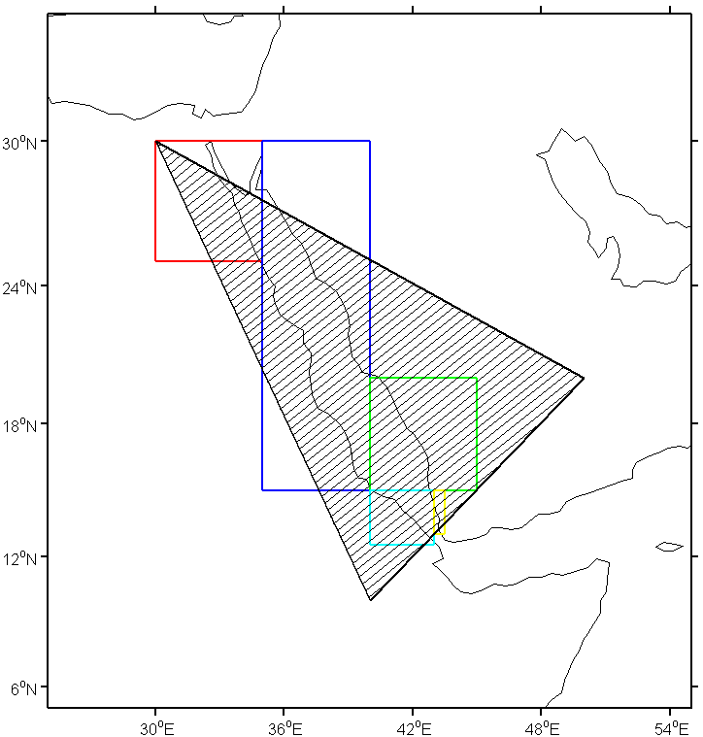

For the Mediterranean Sea region, 5 rectangular areas:

* 40N, 5W ; 30N, 40E,
* 45N, 0; 40N, 25E,
* 50N, 10E; 45N, 15E,
* 41N, 25E; 40N, 30E,
* 36.6N, 5.4W; 35.2N, 5W.

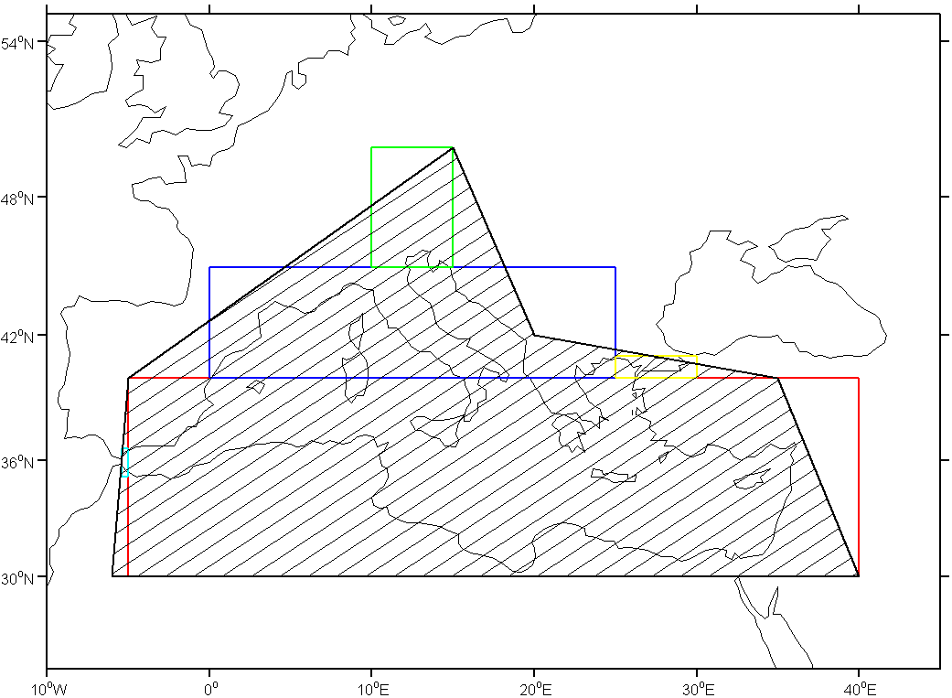

The borders are considered as part of the region.

The checked intervals are:

* TEMP and TEMP_DOXY in the interval [21.7, 40] °C in the Red Sea and [10, 40] °C in the Mediterranean Sea,
* PSAL in the interval [2, 41] PSU in the Red Sea and [2, 40] PSU in the Mediterranean Sea.

### Test #8: Pressure increasing test

Some BGC floats have the ability to transmit ‘raw’ sampled data, i.e. direct sensor output without any averaging or decimation of the measurements. Some parts of these ‘raw’ sampled profiles will probably be flagged as bad by this test (at the beginning and end parts of the profile).

As shown in the table below, the flagged data depend on the implementation (if we start the check from shallow values, from deep values or from the middle of the profile).

|  |  |  |  |
| --- | --- | --- | --- |
| **PRES** | **QC (start shallow)** | **QC (start deep)** | **QC (start middle)** |
| 0 | 1 | 1 | 1 |
| 1 | 1 | 4 | 4 |
| 2 | 1 | 4 | 4 |
| 1 | 4 | 1 | 1 |
| 2 | 4 | 4 | 4 |
| 3 | 1 | 4 | 4 |
| 4 | 1 | 4 | 4 |
| 3 | 4 | 4 | 4 |
| 2 | 4 | 1 | 1 |
| 3 | 4 | 4 | 4 |
| 3 | 4 | 1 | 1 |
| 4 | 4 | 1 | 1 |
| 5 | 1 | 1 | 1 |
| 6 | 1 | 4 | 4 |
| 7 | 1 | 4 | 4 |
| 8 | 1 | 4 | 4 |
| 9 | 1 | 4 | 4 |
| 10 | 1 | 4 | 4 |
| 9 | 4 | 4 | 4 |
| 8 | 4 | 4 | 4 |
| 7 | 4 | 4 | 4 |
| 6 | 4 | 1 | 1 |
| 7 | 4 | 1 | 1 |
| 8 | 4 | 1 | 1 |
| 9 | 4 | 1 | 1 |
| 10 | 4 | 1 | 1 |
| 11 | 1 | 1 | 1 |
| 12 | 1 | 1 | 1 |
| 13 | 1 | 1 | 1 |
| 14 | 1 | 1 | 1 |
| 15 | 1 | 1 | 1 |
| … | … | … | … |
| 1995 | 1 | 1 | 1 |
| 1996 | 1 | 1 | 1 |
| 1997 | 1 | 4 | 1 |
| 1998 | 1 | 4 | 1 |
| 1999 | 1 | 4 | 1 |
| 2000 | 1 | 4 | 1 |
| 2001 | 1 | 4 | 1 |
| 2002 | 1 | 4 | 1 |
| 2002 | 4 | 4 | 4 |
| 2001 | 4 | 4 | 4 |
| 2000 | 4 | 4 | 4 |
| 2000 | 4 | 4 | 4 |
| 1999 | 4 | 4 | 4 |
| 1998 | 4 | 4 | 4 |
| 1997 | 4 | 1 | 4 |

At Coriolis:

* For near-surface profiles, we start from the deepest measurement of the profile and check increasing pressures,
* For other profiles, we start from the middle of the profile and check increasing pressures to deep measurements and decreasing pressures to shallow measurements.

### Test #9: Spike test

This test is implemented for TEMP, PSAL, DOXY, TEMP_DOXY and CHLA according to Argo quality control manuals (#RD1 and #RD2).

**It is not implemented yet for BBP700 and BBP532.**

### Test #10: Top and bottom spike test: obsolete

### Test #11: Gradient test

This test is implemented for TEMP, PSAL, DOXY and TEMP_DOXY according to Argo quality control manuals (#RD1 and #RD2).

### Test #12: Digit rollover test

The test provides thresholds to detect a jump between two adjacent measurements of a parameter. It then specifies that the values that failed the test should be flagged as bad data. However, when a jump is detected, we cannot be sure in real time which part of the profile has rollover values

At Coriolis, when a jump is detected in a measured parameter (with the specified criteria) the ‘jumped values’ are flagged ‘4’ and all the remaining values of the profile for this parameter are flagged ‘3’.

This test is implemented for TEMP, PSAL and TEMP_DOXY.

### Test #13: Stuck value test

This test is implemented for TEMP, PSAL and TEMP_DOXY according to Argo quality control manuals (#RD1 and #RD2).

### Test #14: Density inversion

This test has been implemented thanks to Cécile Cabanes’s additional Matlab implementation example provided in Annex A of the present document.

### Test #15: Grey list test

This test is implemented according to Argo quality control manuals (#RD1 and #RD2).

### Test #16: Gross salinity or temperature sensor drift

In the Coriolis implementation of this test we search the previous good profile within the multi-profile file (thus from primary sampled profiles only) and within the profiles of the same direction as the checked profile.

This test is implemented for TEMP, PSAL and TEMP_DOXY.

However, this test is designed for floats that always profile from the same pressure and not for:

* Argos floats with multi-mission,
* Iridium floats with a mission that can be modified at sea.

**Consequently, we finally decided to not apply this test in Coriolis RTQC.**

### Test #17: Visual QC

This test is performed by Coriolis operators.

### Test #18: Frozen profile test

This test is implemented for TEMP, PSAL and TEMP_DOXY.

However, this test is designed for floats with constant cycle duration of ~10 days and not for:

* Argos float versions with different programmed cycle durations,
* Iridium floats with a mission that can be modified at sea.

**Consequently, we finally decided to not apply this test in Coriolis RTQC.**

### Test #19: Deepest pressure test

When PRES ≤ 1.1*CONFIG_ProfilePressure_dbar, this test will flag all profile parameters as good data. This is not acceptable for parameters that have no RTQC test already defined.

Consequently, at Coriolis, we decide to apply this test to parameters that already have at least one RTQC test defined; their associated ‘intermediate’ parameters are also flagged according to Argo quality control manuals (#RD1 and #RD2).

### Test #57: DOXY specific test

These tests are implemented according to the dedicated Argo quality control manual (#RD3).

### Test #58: CDOM specific test

**No test specific to CDOM parameter is implemented yet.**

### Test #59: NITRATE specific test

**No test specific to NITRATE parameter is implemented yet.**

### Test #60: PAR specific test

**No test specific to PAR parameter is implemented yet.**

### Test #61: IRRADIANCE specific test

**No test specific to IRRADIANCE parameter is implemented yet.**

### Test #62: BBP specific test

**Only “calibration test” is implemented at Coriolis**; “bad offset test” will be implemented as soon as the dedicated Argo quality control manual (#RD4) is available.

### Test #63: CHLA specific test

These tests are implemented according to the dedicated Argo quality control manual (#RD5).

## Tests application order on vertical profiles

At Coriolis, Argo real-time QC tests on vertical profiles are applied in the order described in the following table.

|  |  |  |
| --- | --- | --- |
| Order | Test number | Test name |
| 1 | 19 | Deepest pressure test |
| 2 | 1 | Platform identification |
| 3 | 2 | Impossible date test |
| 4 | 3 | Impossible location test |
| 5 | 4 | Position on land test |
| 6 | 5 | Impossible speed test |
| 7 | 6 | Global range test |
| 8 | 7 | Regional range test |
| 9 | 8 | Pressure increasing test |
| 10 | 9 | Spike test |
| 11 | 11 | Gradient test |
| 12 | 12 | Digit rollover test |
| 13 | 13 | Stuck value test |
| 14 | 14 | Density inversion test |
| 15 | 15 | Grey list test |
| not used | 16 | Gross salinity or temperature sensor drift test |
| not used | 18 | Frozen profile test |
| 16 | 23 | Real-time Quality Control flag scheme for float data deeper than 2000 dbar |
| - | 24 to 56 | Not used |
| 17 | 57 | DOXY specific test |
| not defined yet | 58 | CDOM specific test |
| not defined yet | 59 | NITRATE specific test |
| not defined yet | 60 | PAR specific test |
| not defined yet | 61 | IRRADIANCE specific test |
| 18 | 62 | BBP specific tests |
| 19 | 63 | CHLA specific tests |

# Implementation of Argo Real-time Quality Control test procedures on near-surface data of vertical profiles

## Description of implemented tests

All tests, listed in § 2.1 are implemented and applied on near-surface data of vertical profiles. Note that for “Test #8: Pressure increasing test”, the starting point is the deepest measurement and the check is performed on increasing pressures.

Two additional specific tests have been implemented for near-surface data of vertical profiles.

### Test #21: Near-surface unpumped CTD salinity test

This test is implemented for PSAL and DOXY according to Argo quality control manuals (#RD1 and #RD2).

### Test #22: Near-surface mixed air/water test

This test is implemented for TEMP and TEMP_DOXY according to Argo quality control manuals (#RD1 and #RD2).

## Tests application order on near-surface data of vertical profiles

At Coriolis, Argo real-time QC tests on near-surface data of vertical profiles are applied in the order described in the following table.

|  |  |  |
| --- | --- | --- |
| Order | Test number | Test name |
| 1 | 19 | Deepest pressure test |
| 2 | 1 | Platform identification |
| 3 | 2 | Impossible date test |
| 4 | 3 | Impossible location test |
| 5 | 4 | Position on land test |
| 6 | 5 | Impossible speed test |
| 7 | 21 | Near-surface unpumped CTD salinity test |
| 8 | 22 | Near-surface mixed air/water test |
| 9 | 6 | Global range test |
| 10 | 7 | Regional range test |
| 11 | 8 | Pressure increasing test |
| 12 | 9 | Spike test |
| 13 | 11 | Gradient test |
| 14 | 12 | Digit rollover test |
| not used | 13 | Stuck value test |
| not used | 14 | Density inversion test |
| 15 | 15 | Grey list test |
| not used | 16 | Gross salinity or temperature sensor drift test |
| not used | 18 | Frozen profile test |
| not used | 23 | Real-time Quality Control flag scheme for float data deeper than 2000 dbar |
| - | 24 to 56 | Not used |
| 16 | 57 | DOXY specific test |
| not defined yet | 58 | CDOM specific test |
| not defined yet | 59 | NITRATE specific test |
| not defined yet | 60 | PAR specific test |
| not defined yet | 61 | IRRADIANCE specific test |
| 17 | 62 | BBP specific tests |
| 18 | 63 | CHLA specific tests |

# Implementation of Argo Real-time Quality Control test procedures on trajectories

## Description of implemented tests

### Test #1: Platform identification test

See § 2.1.1.

### Test #2: Impossible date test

At Coriolis the JULD value is checked to be later than January 1st 1997 (JULD ≥ 17167) and earlier than the date of the check (in UTC time).

### Test #3: Impossible location test

See §2.1.3.

### Test #4: Position on land test

See §2.1.4.

### Test #5: Impossible speed test

**This test is not implemented at Coriolis; it has been replaced by test #20: Questionable Argos position test.**

### Test #6: Global range test

See §2.1.6.

### Test #7: Regional range test

See §2.1.7.

### Test #15: Grey list test

This test is implemented according to Argo quality control manuals (#RD1 and #RD2).

### Test #20: Questionable Argos position test

This test has been implemented according to Annex H of <http://dx.doi.org/10.13155/29824>.

### Test #57: DOXY specific test

These tests are implemented according to the dedicated Argo quality control manual (#RD3).

### Test #58: CDOM specific test

**No test specific to CDOM parameter is implemented yet.**

### Test #59: NITRATE specific test

**No test specific to NITRATE parameter is implemented yet.**

### Test #60: PAR specific test

**No test specific to PAR parameter is implemented yet.**

### Test #61: IRRADIANCE specific test

**No test specific to IRRADIANCE parameter is implemented yet.**

### Test #62: BBP specific test

See §2.1.25.

### Test #63: CHLA specific test

**The specified test is relevant for vertical profiles only.**

## Tests application order on trajectories

At Coriolis, Argo real-time QC tests on trajectories are applied in the order described in the following table.

|  |  |  |
| --- | --- | --- |
| Order | Test number | Test name |
| 1 | 1 | Platform identification |
| 2 | 2 | Impossible date test |
| 3 | 3 | Impossible location test |
| 4 | 4 | Position on land test |
| 5 | 20 | Questionable Argos position test |
| 6 | 6 | Global range test |
| 7 | 7 | Regional range test |
| 8 | 15 | Grey list test |
| 9 | 57 | DOXY specific test |
| not defined yet | 58 | CDOM specific test |
| not defined yet | 59 | NITRATE specific test |
| not defined yet | 60 | PAR specific test |
| not defined yet | 61 | IRRADIANCE specific test |
| 10 | 62 | BBP specific tests |
| no relevant for trajectories | 63 | CHLA specific tests |

## Profile measurements reported in trajectories

The following profile measurements are duplicated in the trajectories:

* The deepest measurement of the descending and ascending profiles (duplicated and stored with MC 203 and MC 503 respectively),
* The measurements of the dated levels of the profiles (duplicated, with their JULD, and stored with MC 190 (for descending profiles) or MC 590 (for ascending profiles).

These profile measurements are duplicated with their QCs set by RTQC tests on vertical profiles.

# Implementation of Argo Real-time Quality Control test procedures on in-air data of trajectories

Some Coriolis floats are able to sample in-air measurements which are stored in the trajectories with MC 1090.

## Description of implemented tests

All tests, listed in § 4.1 are implemented and applied on in-air data of trajectories.

Two additional specific tests have been implemented for in-air data of trajectories.

### Test #21: Near-surface unpumped CTD salinity test

See §3.1.1.

### Test #22: Near-surface mixed air/water test

See §3.1.2.

## Tests application order on in-air data of trajectories

At Coriolis, Argo real-time QC tests on in-air data of trajectories are applied in the order described in the following table.

|  |  |  |
| --- | --- | --- |
| Order | Test number | Test name |
| 1 | 1 | Platform identification |
| 2 | 2 | Impossible date test |
| 3 | 3 | Impossible location test |
| 4 | 4 | Position on land test |
| 5 | 20 | Questionable Argos position test |
| 6 | 6 | Global range test |
| 7 | 7 | Regional range test |
| 8 | 15 | Grey list test |
| 9 | 21 | Near-surface unpumped CTD salinity test |
| 10 | 22 | Near-surface mixed air/water test |
| 11 | 57 | DOXY specific test |
| not defined yet | 58 | CDOM specific test |
| not defined yet | 59 | NITRATE specific test |
| not defined yet | 60 | PAR specific test |
| not defined yet | 61 | IRRADIANCE specific test |
| 12 | 62 | BBP specific tests |
| no relevant for trajectories | 63 | CHLA specific tests |

# Passed/failed test traceability

Passed and failed test number lists are reported in the profile and trajectory files through the HISTORY_QCTEST variable.

At Coriolis:

* Tests # 1, 2, 3, 4, 5, 6, 7, 8, 9, 11, 12, 13, 14, 15, 19, 20, 21, 22 and 23 are reported in the C files (i.e. tests # 57, 62 and 63 are not),
* Tests # 1, 2, 3, 4, 5, 6, 7, 9, 11, 12, 13, 15, 19, 20, 21, 22, 23, 57, and 62 are reported in the B files (i.e. tests # 8 and 14 are not).

# Annex A: Example of Matlab implementation of the density inversion test

% [delta_upbot,delta_botup,is_inv_dens] = test_density14(P,T,S,threshold)

% INPUT:

% P(1,nlevel) pression (dB)

% T(1,nlevel) T in situ (°C)

% S(1,nlevel) S in situ (PSU)

% treshold : treshold used for detecting density inversion (0.03kg/m3)

% OUTPUT:

% delta_upbot (1,nlevel) : top to bottom test : if delta_upbot >= 0.03kg/m3 flag 4 of the level i

% delta_botup (1,nlevel) : bottom to top test: if delta_botup <= -0.03kg/m3 flag of the level i

% is_inv_dens (1,nlevel) : is_inv_dens=1 if level i should be flagued as bad (flag 4) ; ==0 otherwise

% You will need The ITS-90 version of the CSIRO SEAWATER library, which you can obtain from

% http://www.cmar.csiro.au/datacentre/ext_docs/seawater.htm. Version 3.3 22-Sep-2010

%

function [delta_upbot,delta_botup,is_inv_dens] = test_density14(P,T,S,treshold)

if size(P,1)> 1

P=P';

end

if size(T,1)> 1

T=T';

end

if size(S,1)> 1

S=S';

end

%%

% From top to bottom : two consecutive levels, i and i+1, are checked (Pi < Pi+1 )

%%

Pref = (P(1:end-1)+P(2:end))/2;

% rho_i(Pi, Ti, Si, Pref): potential density referenced to the mid-point Pref

rhop_i = sw_pden(S(1:end-1),T(1:end-1),P(1:end-1),Pref);

% rho_ip1(Pi+1, Ti+1, Si+1, Pref): potential density referenced to the mid-point Pref

rhop_ip1 = sw_pden(S(2:end),T(2:end),P(2:end),Pref);

delta_upbot = [rhop_i-rhop_ip1, NaN];

%%

% From bottom to top: two consecutive levels, i and i+1, are checked (Pi > Pi+1 )

%%

Pref = (P(2:end)+P(1:end-1))/2;

% rho_i(Pi, Ti, Si, Pref): potential density referenced to the mid-point Pref

rhop_i = sw_pden(S(2:end),T(2:end),P(2:end),Pref);

% rho_ip1(Pi+1, Ti+1, Si+1, Pref): potential density referenced to the mid-point Pref

rhop_ip1 = sw_pden(S(1:end-1),T(1:end-1),P(1:end-1),Pref);

delta_botup = [NaN, rhop_i-rhop_ip1];

% test if there is density inversion with the 0.03kgm-3 criterion

is_inv_dens = delta_upbot>=treshold | delta_botup<=-treshold;