Argo data management

DOI: <http://doi.org/xxx>

Positioning profiles in Coriolis Argo decoder

Version 1.0

April 19th 2022





**Positioning profiles in Coriolis Argo decoder**

**Authors:** Jean-Philippe Rannou, Catherine Schmechtig.

**How to cite this document**

*Coriolis Data Management (2017). Positioning profiles in Coriolis Argo decoder.* [***http://doi.org/xxx***](http://doi.org/xxx)

**Table of contents**

1. Introduction 5

2. Positioning profile strategy 6

2.1. For Argos or Iridium RUDICS transmission floats 6

2.1.1. Loop 1 6

2.1.2. Loop 2 6

2.1.3. Loop 3 7

2.1.4. Loop 4 7

2.2. For Iridium SBD transmission floats 8

2.2.1. Loop 1 8

2.2.2. Loop 2 8

2.2.3. Loop 3 8

2.2.4. Loop 4 9

2.2.5. Loop 5 (similar to loop 3) 9

2.2.6. Loop 6 9

2.2.7. Loop 7 10

3. Illustrated example 11

**History**

|  |  |
| --- | --- |
| **Date (dd/mm/yyyy)** | **Comment** |
| 19/04/2022 | Creation of the document by Jean-Philippe |
|  |  |

**Reference Documents**

|  |  |  |
| --- | --- | --- |
| **Reference N°** | **Title** | **Link** |
| #RD1 | Argo DAC Profile Cookbook. | http://dx.doi.org/10.13155/4115 |
|  |  |  |

# Introduction

This document explains the mechanism used in the Coriolis Argo decoder to set a position to the dated profiles.

The algorithms are designed so that **all the dated profiles are positioned**.

Three types of surface positioning systems are available in Coriolis floats:

* Argos: Argos fixes are computed by CLS from Argos transmission float data. Their accuracy is provided in location classes (from 250 m to 1 500 m).
* GPS: GPS fixes are obtained by a GPS receiver. Their accuracy is in the order of few tens of meters (~30 m).
* Iridium: Iridium fixes are computed by Iridium from Iridium SBD transmission floats data. Their accuracy is provided as “CEP_radius” given in km, so never better than 1 000 m. The Iridium fixes with a CEP_radius < 5 000 m are affected with a QC=1, the other ones with a QC=2.

For Argos transmission floats or Iridium RUDICS transmission floats the profile positioning strategy is similar. It is based on the unique source of fixes (Argos or GPS respectively).

For Iridium SBD transmission floats, the two types of fixes (GPS and Iridium) are used to improve the accuracy of the profile position.

# Positioning profile strategy

All the float profiles are processed at each received new set of data. Moreover, the status (extrapolated, interpolated or based on existing fix) of some profile locations may be modified by new received data.

The algorithm is iterative. The set of “positioned profiles” is first initialized with the float launch location (affected to POSITIONING_SYSTEM=”NONE”). The “not already positioned profiles” are then processed in loops, each profile positioned in a given loop is moved to the “positioned profiles” set.

## For Argos or Iridium RUDICS transmission floats

Up to four loops, performed on all dated profiles that must be positioned, can be used to position Argos or Iridium RUDICS transmission float profiles.

### Loop 1

If ARGOS/GPS fix(es) is(are) available, use it to locate the profile according to Argo rules (RD1).

In such case, set:

* POSITIONING_SYSTEM=”ARGOS/GPS”
* POSITION_QC=POSITION_ARGOS/GPS_QC
* LATITUDE=LATITUDE_ARGOS/GPS
* LONGITUDE=LONGITUDE_ARGOS/GPS

### Loop 2

If two “positioned profiles” are available before and after the current profile, use their interpolated location to position the profile.

In such case, set:

If this estimated position is based on one positioning system

* POSITIONING_SYSTEM=”ARGOS/GPS”
* POSITION_QC=8
* LATITUDE=interpolated latitude
* LONGITUDE=interpolated longitude

If this estimated position is based on two positioning system (remember that float launch location is part of the “positioned profiles” set)

* POSITIONING_SYSTEM=”NONE”
* POSITION_QC=8
* LATITUDE=interpolated latitude
* LONGITUDE=interpolated longitude

### Loop 3

If two “positioned profiles” are available before the current profile, use their extrapolated location to position the profile.

In such case, set:

If this estimated position is based on one positioning system

* POSITIONING_SYSTEM=”ARGOS/GPS”
* POSITION_QC=8
* LATITUDE=extrapolated latitude
* LONGITUDE= extrapolated longitude

If this estimated position is based on two positioning system (remember that float launch location is part of the “positioned profiles” set)

* POSITIONING_SYSTEM=”NONE”
* POSITION_QC=8
* LATITUDE= extrapolated latitude
* LONGITUDE= extrapolated longitude

### Loop 4

Use the float launch location to position the profile.

In such case, set:

* POSITIONING_SYSTEM=”NONE”
* POSITION_QC=3
* LATITUDE=LAUNCH_LATITUDE
* LONGITUDE=LAUNCH_LONGITUDE

## For Iridium SBD transmission floats

Up to seven loops, performed on all dated profiles that must be positioned, can be used to position Iridium SBD transmission float profiles.

### Loop 1

If GPS fix(es) is(are) available, use it to locate the profile according to Argo rules (RD1).

In such case, set:

* POSITIONING_SYSTEM=”GPS”
* POSITION_QC=POSITION_GPS_QC
* LATITUDE=LATITUDE_GPS
* LONGITUDE=LONGITUDE_GPS

### Loop 2

If Iridium fixe(s) with QC=1 is(are) available, compute the weighted average of such fixe(s), according to Annex B of Argo DAC Profile cookbook (RD1).

In such case, set:

* POSITIONING_SYSTEM=”IRIDIUM”
* POSITION_QC=1
* LATITUDE=sum(wi*lat_i)/sum(wi)
* LONGITUDE=sum(wi*lon_i)/sum(wi)

wi=sum(1/(AXES_ERROR_ELLIPSE_MAJOR_i)**2)

### Loop 3

If two “positioned profiles” are available before and after the current profile, use their interpolated location to position the profile.

In such case, set:

If this estimated position is based on one positioning system

* POSITIONING_SYSTEM=”GPS” or ”IRIDIUM”
* POSITION_QC=8
* LATITUDE=interpolated latitude
* LONGITUDE=interpolated longitude

If this estimated position is based on two positioning system

* POSITIONING_SYSTEM=”NONE”
* POSITION_QC=8
* LATITUDE=interpolated latitude
* LONGITUDE=interpolated longitude

### Loop 4

If Iridium fixe(s) with QC=2 is(are) available, compute the weighted average of fixe(s) assigned to the minimum value of CEP_radius, according to Annex B of Argo DAC Profile cookbook (RD1).

In such case, set:

* POSITIONING_SYSTEM=”IRIDIUM”
* POSITION_QC=2
* LATITUDE=sum(wi*lat_i)/sum(wi)
* LONGITUDE=sum(wi*lon_i)/sum(wi)

wi=sum(1/(AXES_ERROR_ELLIPSE_MAJOR_i)**2)

### Loop 5 (similar to loop 3)

If two “positioned profiles” are available before and after the current profile, use their interpolated location to position the profile.

In such case, set:

If this estimated position is based on one positioning system

* POSITIONING_SYSTEM=”GPS” or ”IRIDIUM”
* POSITION_QC=8
* LATITUDE=interpolated latitude
* LONGITUDE=interpolated longitude

If this estimated position is based on two positioning system

* POSITIONING_SYSTEM=”NONE”
* POSITION_QC=8
* LATITUDE=interpolated latitude
* LONGITUDE=interpolated longitude

### Loop 6

If two “positioned profiles” are available before the current profile, use their extrapolated location to position the profile.

In such case, set:

If this estimated position is based on one positioning system

* POSITIONING_SYSTEM=”GPS” or ”IRIDIUM”
* POSITION_QC=8
* LATITUDE=extrapolated latitude
* LONGITUDE= extrapolated longitude

If this estimated position is based on two positioning system

* POSITIONING_SYSTEM=”NONE”
* POSITION_QC=8
* LATITUDE= extrapolated latitude
* LONGITUDE= extrapolated longitude

### Loop 7

Use the float launch location to position the profile.

In such case, set:

* POSITIONING_SYSTEM=”NONE”
* POSITION_QC=3
* LATITUDE=LAUNCH_LATITUDE
* LONGITUDE=LAUNCH_LONGITUDE

# Illustrated example

The illustrated example is for Iridium SBD transmission

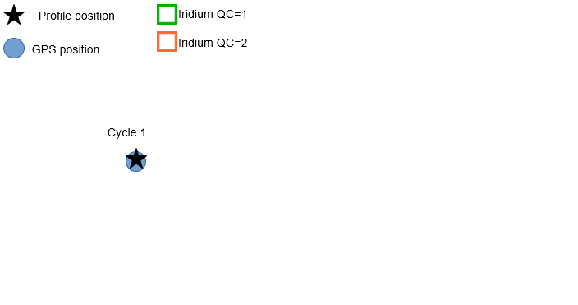

Figure 1. At Cycle 1, a GPS fix is available; use it to locate the profile of Cycle 1 (Loop1)

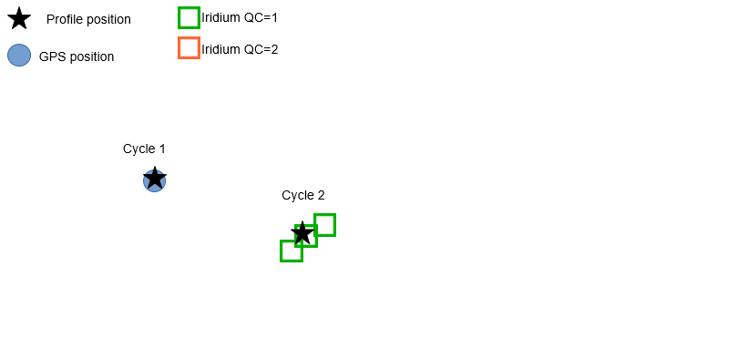

Figure 2. At Cycle 2, no GPS fix is available but Iridium fixes with QC=1 are available, compute the weighted average of such fixes, use it to locate the profile of Cycle 2 (Loop2)

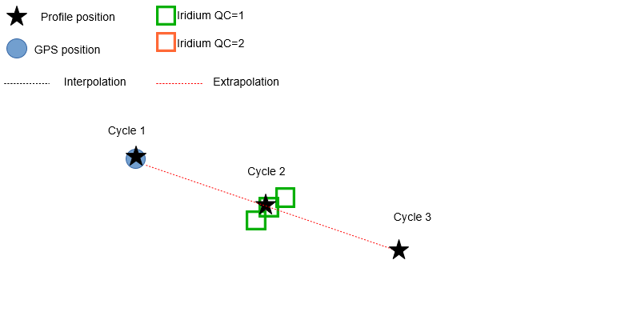

Figure 3. At Cycle 3, no GPS fixes nor Iridium fixes are available, two “positioned profiles” are available before the current profile, use their extrapolated location to position the profile of Cycle 3(Loop 6)

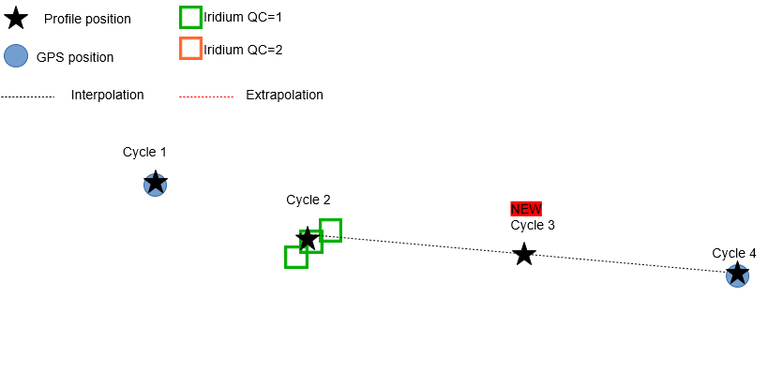

Figure 4. At Cycle 4, a GPS fix is available; use it to locate the profile of Cycle 4 (Loop1), then two “positioned profiles” are now available before and after the profile at Cycle 3, use their interpolated location to improve the position of the profile at Cycle 3 (Loop5).