Provor CTS5-USEA: anomaly on BGC Pres and Time

This note describes issues discovered on first versions of Provor CTS5-USEA floats and the correction methods used in the Coriolis decoder to adjust erroneous measurements.

# Anomalies

The so called “Provor CTS5-USEA” floats are Provor CTS5 floats equipped with two controller boards. The primary, called APMT, is in charge of vector functionalities including CTD sensor management and the secondary, called USEA, is in charge of BGC sensors management.

The anomalies mentioned here have been discovered on the 3 first versions of Provor CTS5-USEA managed at Coriolis:

* 7.11 Coriolis version, associated to float firmware version 1.07.024-1.00.0024 (for APMT-USEA respectively),
* 7.12 Coriolis version, associated to float firmware versions 1.08.005-1.01.005 and 1.08.004-1.01.004,
* 7.13 Coriolis version, associated to float firmware version 1.09.001–1.02.001.

At the date of the implementation (on February 7th 2022), 14 Provor CTS5-USEA floats are managed by the Coriolis DAC (see WMO list in Annex A).

Two types of anomalies have been discovered on float measurements, both concerning BGC sensors: pressure anomalies and timestamp anomalies.

## BGC pressure anomaly

CTD and BGC measurements can be performed during the drift phase at parking depth. When a BGC measurement is sampled, the associated pressure is added from the set of available CTD pressures (the timely closest one is used).

We discovered, from cycles where the float adjusted its buoyancy during the parking phase, that this report of the timely closest CTD pressure may fail.

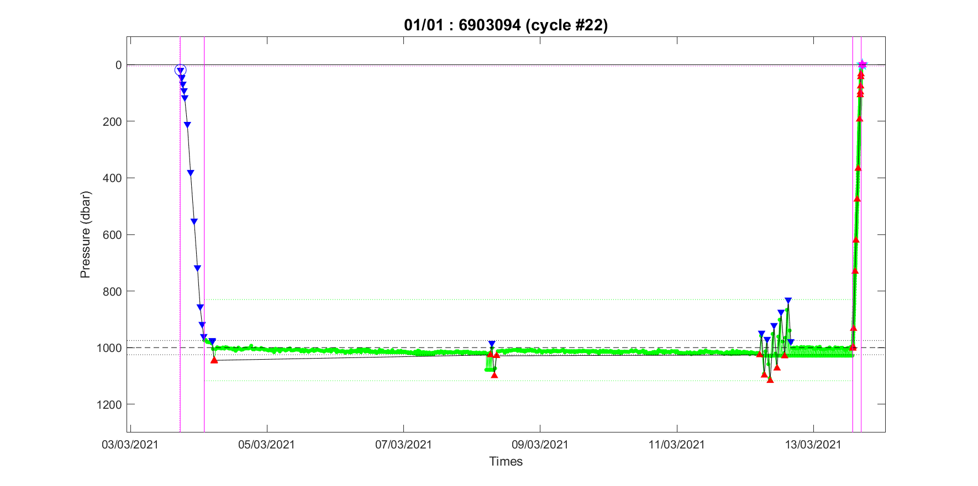

During cycle #22 of float 6903094, 3 buoyancy adjustments have been performed during the parking drift phase. Green dots are for pressure (CTD and BGC) measurements, blue/red triangles for valve/pump activations.

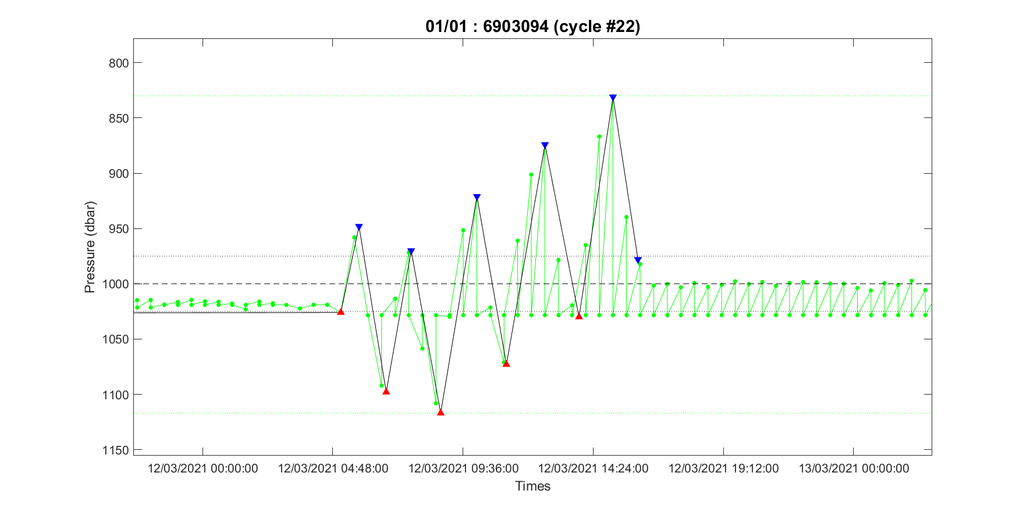

A zoom on the third buoyancy adjustment shows that, for (almost) all timestamps, 2 pressure samples are reported for the same time: the CTD ones that follow the buoyancy adjustments used to move the float drifting depth from ~1025 dbar to ~1000 dbar and the BGC ones (from the optode sensor in this case) that seem to stay stuck at ~1025 dbar.

## BGC time anomaly

BGC time anomalies have been discovered while looking carefully at the pressure measurements sampled during the ascending profile. It looks like the BGC pressures are not timely consistent with the CTD ones.



Extract of CTD and BGC Pressure measurements sampled during ascent profile of cycle #28 of float 6903094. Green cells concern CTD pressures, yellow ones SUNA pressures and blue ones other BGC sensor pressures.

## Edouard Leymarie’s analysis

Edouard Leymarie ([edouard.leymarie@imev-mer.fr](mailto:edouard.leymarie@imev-mer.fr)) analyzed the discovered BGC measurement anomalies. The report of this study is provided in Annex B.

The conclusions are the following:

* Concerning pressure anomalies: a bug on float firmware has been identified,
* Concerning time anomalies: except for SUNA sensor (see note below), the BGC pressures are correct but the issue concerns their associated timestamps. The difference seems to be due to an abnormal drift of the USEA board clock compared to the APMT one. This drift has been estimated to +3.4 seconds per day. This explains that the timely closest CTD pressure measurement doesn’t match the real BGC sensor pressure.

Note also that:

* The pressure provided with SUNA measurements is the CTD sample provided (together with its associated TEMP and PSAL) to the SUNA to compute the NITRATE measurement and not the timely closest CTD pressure measurement recovered just after BGC measurement as for other BGC sensors.
* The APMT and USEA controller board clocks are synchronized at the beginning of the cycle (whatever the surface was reached or not).
* When the surface is reached and the GPS time acquired, the APMT clock is set with this satellite time and the clock corrected offset available as technical information. However, this operation is performed **after** the clocks synchronization. This means that the USEA clock is not adjusted from this GPS time offset.

In the next release of the firmware:

* The bug on BGC pressures will be fixed,
* As the reason of abnormal USEA clock drift is presently unknown, the clocks will be synchronized at the beginning of each cycle phase (Descent start, Park start, Park end and Ascent start), and on a regular basis (daily ?) during de parking drift phase.

# Coriolis decoder adjustments

In the Coriolis decoder, BGC pressures and times are adjusted to try to cope with float firmware issues.

This specific code is implemented in the version ‘047a’ of the decoder.

## BGC time issue

### Profile BGC times

Profile BGC times are adjusted from an estimate of the offset between APMT and USEA clocks.

**Adjustment #1**

A first adjustment is performed on all BGC times to cope with the GPS time offset adjustment done on APMT clock only (see note above). We then first apply the same correction to all BGC times of the cycle: bgc_adjusted1_times = bgc_times – gps_clock_offset_of_previous_cycle.

**Adjustment #2**

A second adjustment is performed on BGC times which are corrected from an estimate of the APMT vs USEA clocks drift. The estimation is done from all BGC pressure measurements of the profile (except the SUNA ones), remember that we have a pressure axis per sensor:

* We linearly interpolate these BGC pressure measurements to the CTD pressure levels to get the theoretical corrected BGC times: bgc_time_interpolated,
* For each BGC measurement we then obtain a time offset between BGC time provided by the float (bgc_adjusted1_times) and BGC time interpolated from CTD pressures: bgc_time_offset = bgc_adjusted1_times – bgc_time_interpolated,
* The median value of the obtained data set is used as clock offset estimate: profile_clock_offset_estimate = median(bgc_time_offset),
* Finally, all BGC times (including SUNA ones) are adjusted with this estimated offset: bgc_adjusted2_times = bgc_adjusted1_times – profile_clock_offset_estimate.

**Adjustment #3**

Remember that a last adjustment, common to all Argo floats, is finally performed on all float times (APMT and USEA ones) to consider GPS time offset obtained at the end of the cycle when the APMT clock is set with GPS time: bgc_adjusted3_times = bgc_adjusted2_times – gps_clock_offset_of_current_cycle.

### Other BGC times

BGC sensor can also sample measurements during the drift phases at parking depth and at the surface.

**Adjustment #1 and adjustment #3**

The adjustments #1 and #3 previously described are also performed on these BGC measurement times.

**Adjustment #2**

We use the descending and ascending clock offset estimates as base points to linearly interpolate (subsurface drift measurement)/extrapolate (surface drift measurements) estimated clock offset for each “other” BGC measurements.

Note that:

* The middle time of each profile is used for time associated to base points,
* When no descending profile is performed, the descent profile clock offset estimate is set to 2.5 seconds (which is the median value of all descending profile clock offsets available from Coriolis Provor CTS5-USEA floats on February 7th 2022).

## BGC pressure issue

### Parking drift BGC pressure measurements

All BGC pressure sampled during the drift phase at parking drift are adjusted with the timely closest CTD pressure (adjusted times are used).

### Profile SUNA pressure measurements

As already mentioned, SUNA pressures are not associated with the NITRATE measurement but with the CTD (PRES, TEMP, PSAL) sample sent to the SUNA to compute the NITRATE.

We then adjust profile SUNA pressures with the timely closest CTD pressure to get a better estimate of the pressure at the time of the SUNA measurement.

## Adjustement reports

The estimated clock offsets of each cycle are available in the Argo auxiliary technical files:

* TECH_TIME_GpsTimeOffsetForBgcTimeAdj_seconds reports the GPS clock offset used in Adjustment #1
* TECH_TIME_Desc(Asc)ProfTimeOffsetForBgcTimeAdj_seconds report the USEA vs APMT clock offset estimated for descending (ascending) profile.

# Annex A: List of Coriolis Provor CTS5-USEA floats managed at the Coriolis

14 Provor CTS5-USEA floats concerned by this note were managed by the Coriolis DAC on February 7th 2022, their WMO numbers are:

* 4902602
* 6903069
* 6903095
* 6903096
* 6903124
* 6903125
* 6903126
* 6903127
* 6903706
* 6904116
* 6904117
* 6904139
* 6903093
* 6903094

# Annex B: Edouard Leymarie’s report

Problèmes de référencement temps/pression des données BGC sur CTS5

Position au 17/12/2021

Suite à différentes remontés, il a été identifié les problèmes suivants sur l’ensemble des CTS5_USEA à l’eau au 17/12/2021.

# En Parking : Différence de fréquence CTD vs BGC

**Origine** : En parking, si la fréquence CTD choisie par l’utilisateur est plus faible que la fréquence BGC, la pression BGC correspondra à la pression CTD la plus proche. Ce problème peut induire de grosses erreurs si on prend une fréquence CTD très faible et si le parking est instable. **Attention ce problème est commun au CTS4 !!**

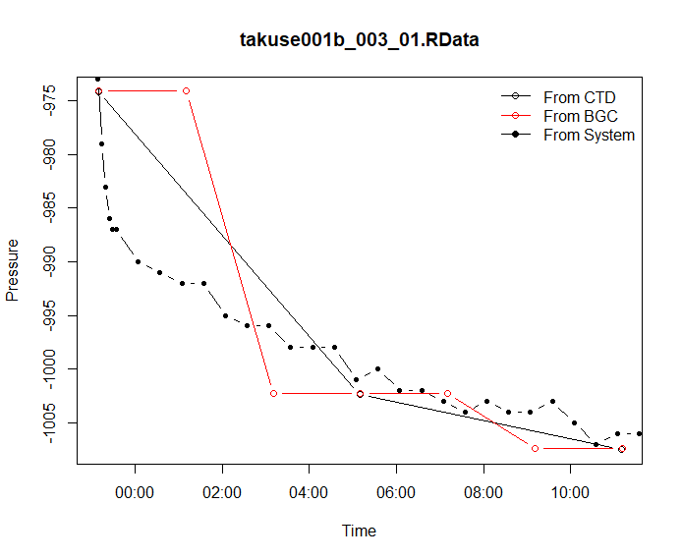

**Correction des données au niveau du DAC** : Pas de correction prévue.

**Correctifs logiciels prévus :**

* Message d’avertissement dans le GUI CTS5 si la fréquence CTD choisie est plus faible qu’une fréquence BGC.
* Si erreur de l’utilisateur prévoir un message/flag au niveau du DAC ?

# En Parking : Non rafraichissement de la pression BGC

En parking, on observe un blocage de la pression BGC. Des pistes sont possibles mais le problème n’est pas encore clairement identifié. La pression BGC peut se rafraîchir et se bloquer à nouveau. L’erreur sur la pression peut être très importante si le parking n’est pas stable.

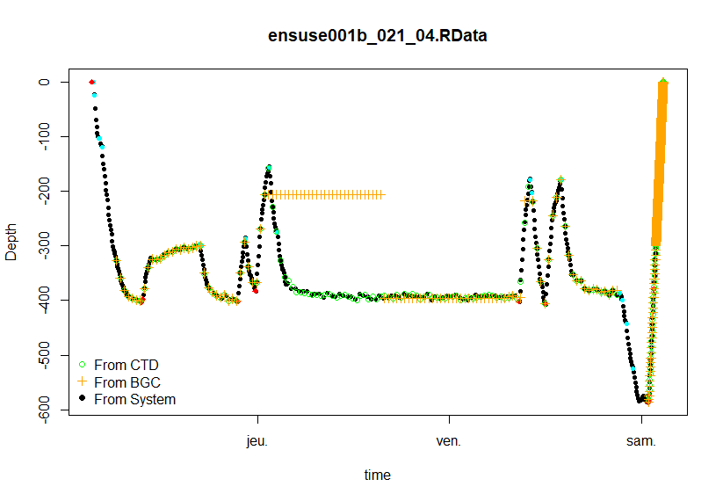

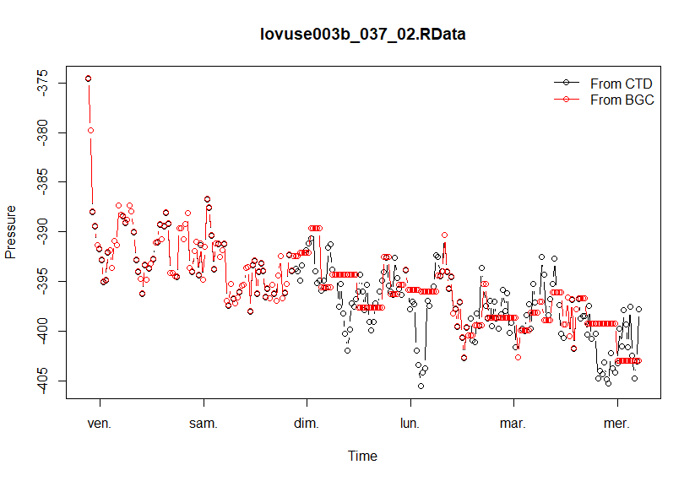

**Correction des données au niveau du DAC** : Une correction des données est surement à prévoir en interpolant les pressions CTD ?

**Correctifs logiciels prévus**: Un correctif logiciel est à prévoir quand le problème aura été identifié.

# En ASCENT : Désynchronisation du temps CTD vs BGC

Après un parking d’une dizaine de jours on observe pendant l’ascent, pour la même date, une différence entre pression CTD et pression BGC. Les tests sur banc montrent que les pressions CTD et BGC sont correctes mais que c’est le temps BGC qui n’est plus bon. On montre que le problème ressemble à une dérive de l’horloge USEA de 3.4s par jour (commun à l’ensemble des flotteur) et que la correction avec un offset de temps (constant en début d’Ascent) est très efficace.

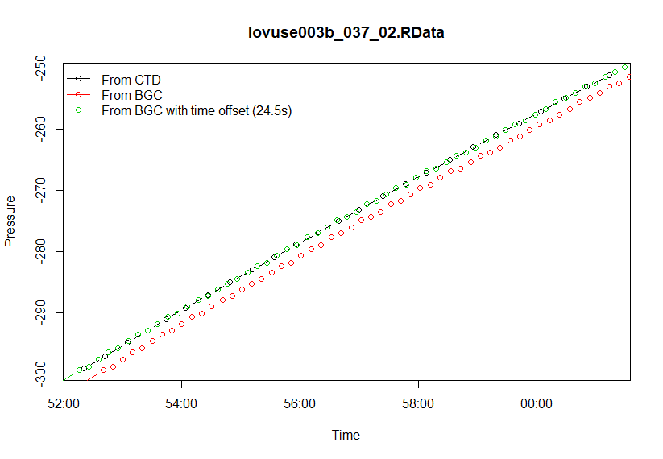

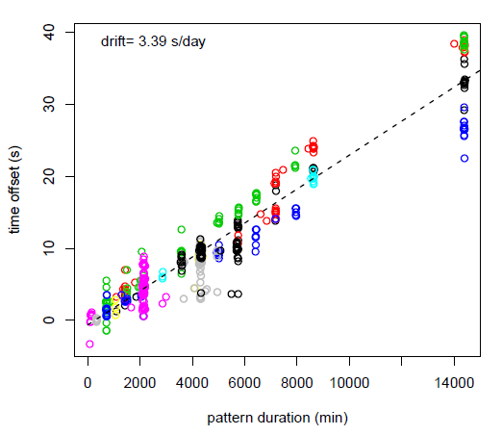

*Décalage en temps entre APMT et USEA pour l’ensemble des CTS5 en mer (couleur) en fonction de la durée du Pattern*

**Correction des données au niveau du DAC** : Une correction du temps BGC est probablement à prévoir. En particulier, il faut regarder les problèmes de post-traitement où l’on tient compte d’un décalage en temps (comme DO à priori).

**Correctifs logiciels prévus**: Le problème n’est pas encore clairement identifié mais un correctif logiciel est déjà à l’étude avec une resynchronisation des horloges avant chaque changement de phase de navigation et éventuellement aussi régulièrement en parking.