A guide to the DMQC-PCM quality assessment tool

Authors:
Kamila Walicka and Matthew McCormack
Contents
Useful documents 1
1 General introduction to Argo regional quality assessment in the Southern Ocean 2
2 Software preparation and usage 3
2.1 Download the code from github repository 3
2.2 Setup Python environment 4
2.2.1 Create the python virtual environment 4
2.2.2 Install poetry 4
2.3 Setting up the configuration of DMQC-PCM and pyOWC software 4
2.3.1 Setup configuration files 4
2.4 Run the DMQC-PCM analysis 7
2.5 Usage of DMQC-PCM for AUDIT 7
2.5.1 Generating a list of d-mode floats for Audit 7
2.5.2 Comparison of data from DMQC PCM software and output from already submitted D-mode float from GDAC 8

Useful documents

- SO_assesment tool: https://github.com/euroargodev/DMQC-PCM/tree/SO_assesment
- Profile Classification Model 1st version: https://github.com/euroargodev/DMQC-PCM
- DMQC processing of Argo floats in Matlab: https://github.com/ArgoDMQC/matlab_owc
- DMQC processing of Argo floats in Python: https://github.com/euroargodev/argodmqc_owc

General introduction to Argo regional quality assessment in the Southern Ocean
The quality assessment tool can be used by to perform the DMQC analysis of Argo floats for the first time for the specific floats (Role: ‘operational’) , but as also for auditing purpose (Role: ‘auditor’) to verify the quality of Argo floats which have been already analysed by DMQC operators from various DACs and submitted to GDAC.
A regular check of the quality of Argo float data in delayed mode is necessary to ensure the consistency of analysed salinity data within the basin. This is strongly linked with improve of the technology, new reference data and different experience leves of DMQC operators.

The general concept of performing the quality analysis using the DMQC PCM tool is to use in the traditional DMQC OWC analysis the beforehand classified Argo float and reference data belonging to similar water mass regimes. When performing the audit on already submitted floats, the result from DMQC PCM could be further to compare the result with already submitted to GDAC Argo floats in d-mode. This will allow comparing only those profiles which come from the same zone with specified characteristics avoiding noise from other zones which could be underrepresented and under/overestimating the proposed correction of drifted or offset floats.

The classification of data is performed using the Profile Classification Model (PCM). PCM is a scientific analysis approach based on vertical profiles classification that can be used in a variety of oceanographic problems (e.g. front detection, water mass identification, natural region contouring, reference profile selection for validation). It is being developed at Ifremer/LOPS in collaboration with IMT Atlantique since 2015. The PCM software is written in Python and is compatible with both Python and Matlab OWC software versions. The OWC toolbox includes routines for calibrating profiling float conductivity sensor drift.

Software workflow

Step 1:
The general workflow of the quality assessment method shows figure below. In the first step, the PCM code retrieves Argo float data from the GDAC FTP and generates the float_source matrix including all available profiles. Next, the DMQC PCM method is run using the reference data and configuration information which are the same as for the traditional OWC analysis. The code is running the analysis and selecting the most appropriate profiles, group them in classes. Then, the output from the DMQC PCM classification (Clasification labels) is read by the OWC software producing the suggested salinity correction outputs and associated diagnostic plots used to decide if the Argo float requires any salinity corrections.

Step 2:
In the second step is for Audit purpose. The output from the DMQC PCM +OWC analysis is compared with the adjusted salinity data submitted to GDAC by the DMQC operator. In this step, the code is comparing the differences between both outputs and generates the comparison plot and list of analysed floats and associated comments from the comparison.

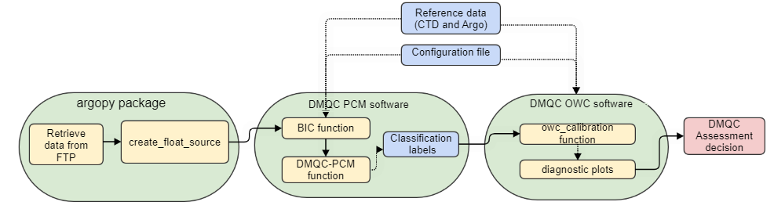

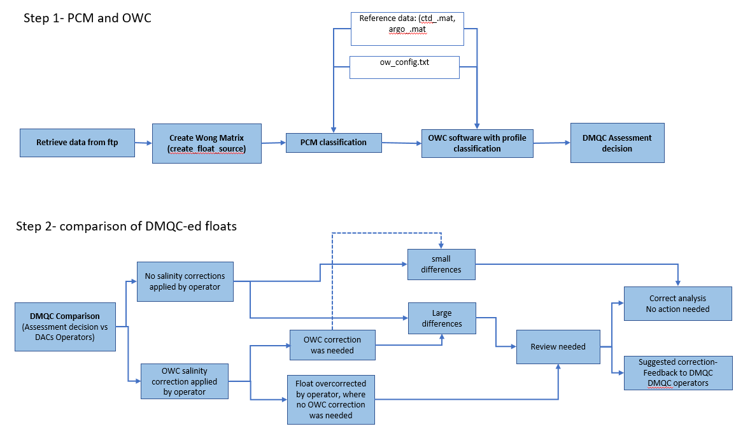

Software preparation and usage

The DMQC PCM quality assessment method operates using python. The software can be run on Windows or Linux machines.

Download the code from github repository
The DMQC-PCM software is located at https://github.com/euroargodev/DMQC-PCM/tree/SO_assesment. The code can be downloaded strait from this website by clicking on green “code ” button and selecting the Download ZIP option.

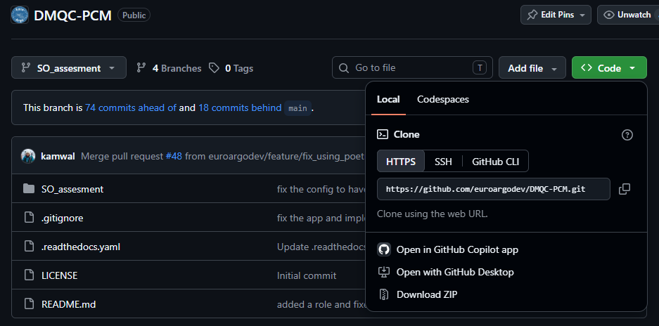

The second option is to clone the repository via your terminal using git:

Setup Python environment
Instead of manual module loading, this project uses Poetry to manage virtual environments and dependencies automatically.

Create the python virtual environment
Before working with the code, users should create and activate a Python virtual environment. This provides an isolated Python installation with all project-specific dependencies, ensuring the correct package versions are used and preventing conflicts with other Python projects or the system Python installation.
Linux/macOS users:
>Python3 -m venv venv
>source venv/bin/activate
Windows users:
- Command Prompt
>python -m venv venv
>venv\Scripts\activate.bat
- PowerSheel
>python -m venv venv
> venv\Scripts\Activate.ps1
- Git Bash
>python -m venv venv
> source venv/Scripts/activate

Install poetry
Poetry is a dependency management tool for Python that installs and manages the libraries required by a project, ensuring that all users work with the same package versions through the pyproject.toml and poetry.lock files.

>pip install poetry
>poetry install

Setting up the configuration of DMQC-PCM and pyOWC software

    - Setup configuration files
All necessary directories, constant values for PCM, and objective mapping parameters which are needed to run both PCM and OWC software can be set in one config file which is located in the code directory DMQC-PCM\SO_assesment\DMQC-PCM-Python:

    - pcm_ow_config.json

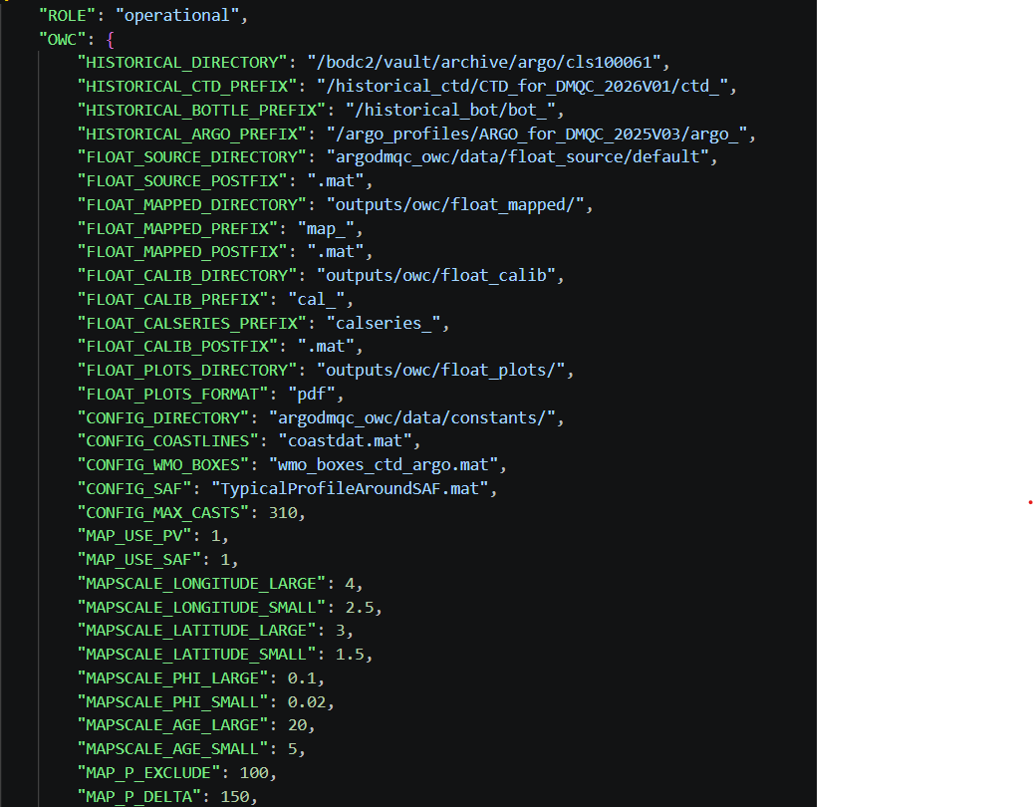

- 'ROLE' section
By default, it is set as 'operational'. The Operational role enabling automatic download all real time data from GDAC which can be used for the DMQC analysis. The other role can be 'auditor'. When you set the role to auditor, the app will retrieve adjusted and raw data which could be used for audit on the floats which already went through the DMQC analysis.
- ‘OWC’ section
  - ‘HISTORICAL_DIRECTORY’, ‘FLOAT_’, ‘CONFIG_’, ‘MAP_’, ‘MAPSCALE_’. These are the setting for the OWC part of analysis
  - Set calseries setups: Instead of making the changes inside the code, here the user can provide all its set calseries configuration requirements

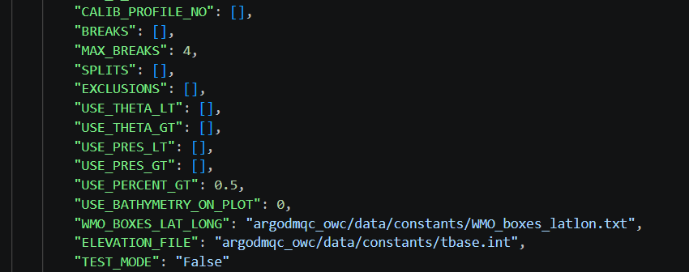

- ‘PCM’ section
  - ‘GDAC_MIRROR’- if you are keeping a copy of the GDAC data locally you can add it here. The code will used it to generate the source .m file for DMQC analysis. Otherwise the code will directly download data from GDAC.
  - ‘MAX_DEPTH’: 1000 (maximal Interpolation depth). The PCM cannot deal with “NaN” values, so the reference dataset is interpolated on standard depth levels and the profiles shallower than the MAX_DEPTH, defined above, are dropped out. A max depth of 1000 m can be enough; however, you should find a compromise between keeping a sufficient number of reference profiles and having a comprehensive representation of the oceanography in the region. You should also consider the depth of the float profiles: if they are shallower than the max depth, they will be dropped out, and they will not be classified by the PCM. In such cases, a lower value to be set as a max depth is recommended.
  - ‘CORR_DISTANCE’ = 50 (Correlation distance in km)
  - ‘NUMBER_RUNS’ = 10 (Number of runs in BIC for each K)
  - NK = 15 (Example Max number of classes to explore)
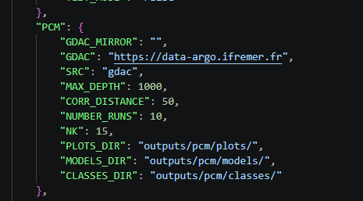

BIC (Bayesian Information Criteria) can be used to optimize the number of classes in the model, trying not to over-fit or under-fit the data. To compute this index, the model is fitted to the training dataset for a range of K values from 0 to 15. A minimum in the BIC curve will give you the optimal number of classes to be used. Moreover, for each K range run, a subset of the training dataset is randomly selected to use independent profiles. Indeed, the ocean exhibits spatial correlations that reduce the real information contained in the training dataset. This has to be considered. The dataset is sub-sampled into several subsets of uncorrelated profiles, finally allowing us to compute several times each K range run and hence to compute a standard deviation on the BIC metric.
K = is the number of classes
In default the BIC is calculated automatically by the code, however, if the user wishes to change the number of BIC, then it needs to be edited changed in the so_dmqc.py by commenting out the BIC, number_classes and setting the required value. Then comment in the applyBIC function.

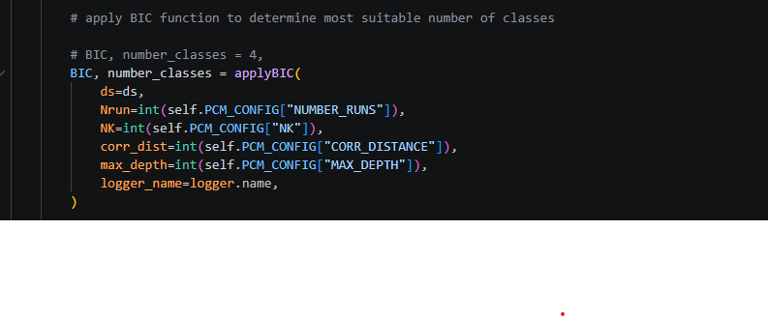
- ‘OUTPUT DIRECTORIES’- directories where the output from logs (time stamps of each processing steps) and from the audit comparisons (more info in the section below)
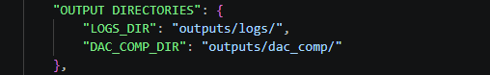

Run the DMQC-PCM analysis
The entire software workflow can be run by using the following command below. This function enables download data from GDAC and generates the source file; run DMQC PCM model and generate classes which are further used by the pyOWC software for DMQC analysis. You can specify the WMO float number without a need to opening and changing code itself. You can also implement more than one float number to run the code for multiple floats

> poetry run python so_dmqc.py <WMO>

e.g. > poetry run python so_dmqc.py 1902081
e.g. > poetry run python so_dmqc.py 1902081, 3900070

All the data outputs and plots from both pcm and owc analysis will be stored in the “outputs” folder.

Usage of DMQC-PCM for AUDIT
The software also allows you to run the audit of the preferred data region on the floats which already went through the DMQC analysis. As it was mentioned before this can be determined by setting the ‘ROLE’ as auditor. This function enables to automatically generate two the source matrix with the real-time and adjusted data. In the PCM DMQC code the real-time data will be used to calculate the output. The real-time output could be later compared with D-mode output in this software using the dac_comp.py (more details later in the text).

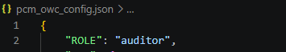

Generating a list of d-mode floats for Audit

The software package is enabling extracting the list of the floats in the required area. The list can be generated using the poetry run python argo_index_reader.py code. If you have a list of the floats for audit already you do not need to perform this step.

> poetry run python argo_index_reader.py

- This code requires prior downloading the ar_index_global_prof.txt file which could be downloaded from the GDAC: https://data-argo.ifremer.fr/
- In the next step the user need to manually in the code select the requested region from which the list of the floats will be extracted for audit. The current code is set to extract the list of the floats below 40S latitude.
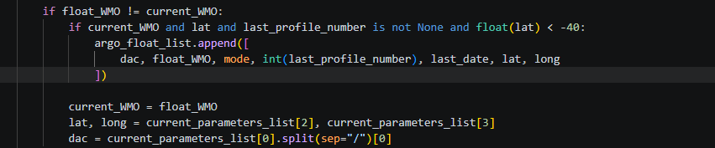
The output file is the excel argo_floats.xlsx and is located in the outputs folder. The file including the following information: DAC, float WMO number, mode, profile number, profile date, latitude and longitude. Use this list to choose the Argo floats from the region from which you are going to perform the audit analysis.

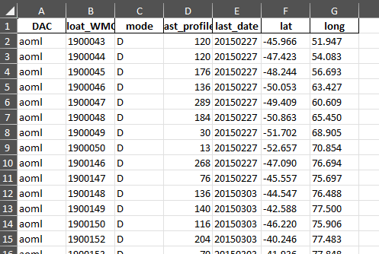

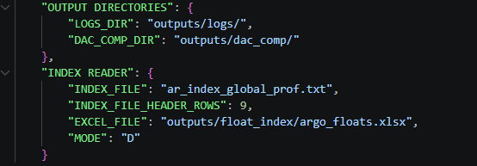

2.5.2 Comparison of data from DMQC PCM software and output from already submitted D-mode float from GDAC
In the next step the software enables you to compare the output obtained from the DMQC PCM assessment tool with the output from the float which is already DMQC-ed and submitted to GDAC. The comparison is done on the float source .m file previous generated during the data download in serring the ‘ROLE’ step. The comparison of data can be done running this command:
> poetry run python dac_comp.py

The output plot visualising the difference is presented in figure 4.1. Based on this output the user can assess the correctness of the D-mode files at GDAC.

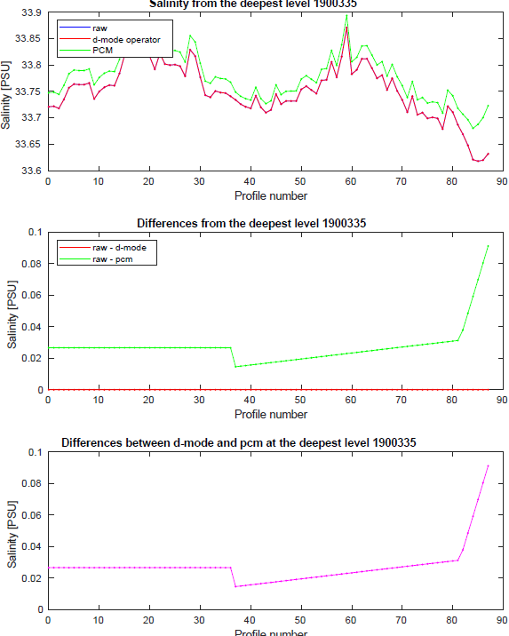
Figure 4.1: Comparison between the results from the quality assessment method of the floats in the Southern Ocean

