Recovering Argo floats
Since the launch of the Argo program in the late 90’s, over 16500 floats have been deployed. Today 12500 of them are inactive and according to Jcommops less than 200 of them have been recovered. While there are probably more un-notified recoveries at sea, we can accurately say that more than 12000 wrecked Argo floats are now lying on the seafloor.

Argo network was not designed to deploy recoverable profiling floats. However, Argo is now an internationally acclaimed and well recognized program that will probably run and continue to be maintained in the next decades. Should we allow 12000 more floats to be disposed on the seabed for the next 20 years or should we start to think of some float recovery means to try and minimize that number? The question of floats recoveries is raised at every Argo meeting and arise in almost all Argo communication to the public. Even if previous studies on environmental impact of Argo float have shown that it is relatively low and that Argo is far less pollutant than many other activities at sea, losing a high number of floats at sea still appears very questionable by the general public. It is thus our responsibility to think of the next step.

While one-way Argos telemetry previously used by the floats did not facilitate recovery at sea (poor positioning and unmanageable timing), two-way Iridium communication coupled to accurate GPS positioning now in use on the vast majority of floats, offers much better recovery options. On a carefully planned recovery operation, the float will be remotely programmed to shorter (e.g 24 hours) cycles a few days before the arrival of the ship in the recovery area so that its drift can be more accurately estimated. Then it will be driven to the surface a few hours before the ship’s ETA and will transmit its position at a suitable rate (e.g. every 5 min) in order to optimize the ship’s route and search time.

The grounds for a successful recovery depend on a number of factors:
-Careful and well anticipated planning that will possibly include meteorological routing
-A skilled team and an appropriate ship
-Compatible weather condition: a recovery will likely be complicated above 4-5 Beaufort
-Good communication either with a reactive team onshore or directly with the float
-An easy as possible float to spot and recover

Considering the above points, some efforts may still be necessary to improve float recoveries such as:
-Trained teams both for actual recovery operations but also for meteorological routing prior to recoveries
-Easy and efficient means of retrieving float’s position at sea
-Improvements on floats visibility and mechanical design for at sea handling
-Improvement on float’s secure handling (e.g pressure release or safe removal of the batteries)
-Improved float’s technical parameters monitoring such as precise battery state or GPS data

Experience on a few recoveries has shown that in an optimal meteorogical situation (i.e good visibility, calm sea and wind state) it can take less than one hour for a ship to recover a float. The latest recovery led by Euro-Argo in early 2020 in the Atlantic showed a recovery timeline of a Deep Arvor float from RV Thalassa in less than 30 min. This timeline includes the operations of slowing down to the recovery area, spotting the float, taking it on board and getting the ship back to its normal route.
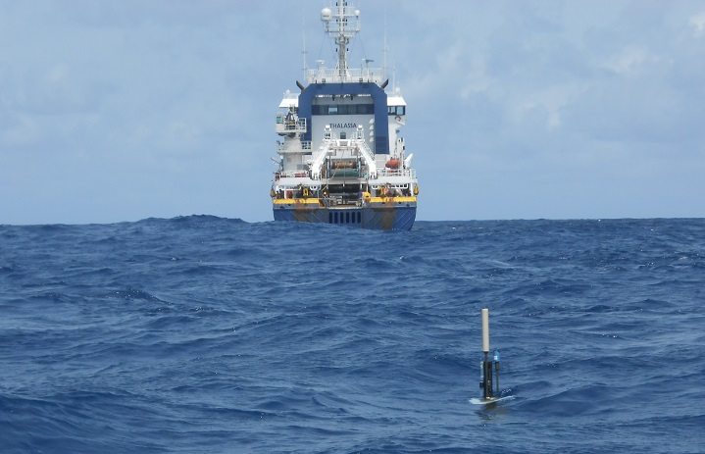
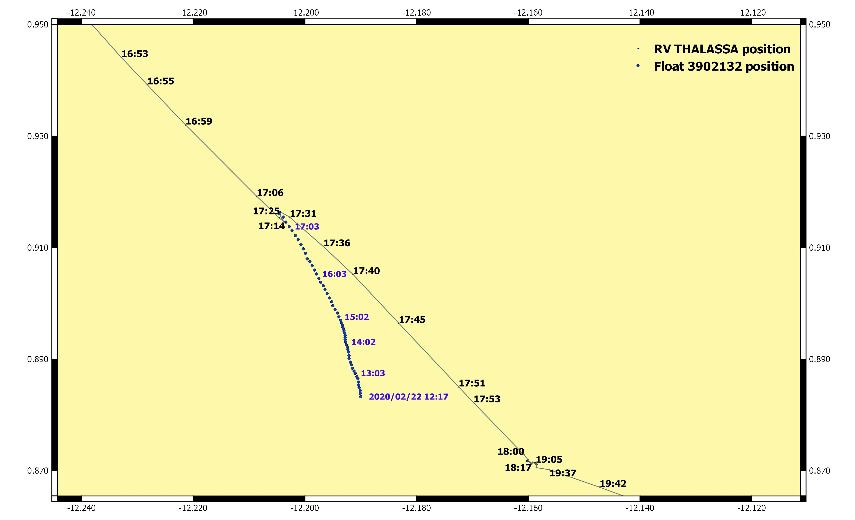

Recovery timeline of float WMO 3902132 by RV Thalassa in Feb. 2020

There are different aspects where recovering a float makes sense. Aside from the global reduction of Argo’s environmental impact, recovering a float because it is faulty or approaches the end of its battery life or is a prototype that needs to go back to the lab, might:
-Allow the sensors to be post-calibrated and provide valuable information for DMQC
-Give access to float’s internal memory with full HD profiles, sensors and tech data otherwise lost
-Provide technological feedback on the float and possibly help to anticipate or solve technological issues
-Provide spare parts if the full float is too damaged to refit

We believe that all of the above are not small details and could even lead to major improvements on float’s technology as a larger number of float recoveries will provide previously unknown insight into float’s full life technical behavior. And as far as BGC floats are concerned, recoveries may even be mandatory as the volume of data produced by some novel sensors is so high that it cannot be transmitted remotely. Therefore recovering float’s logged internal memory will be necessary for some studies. Finally new sensors and even standard sensors may be better understood and eventually corrected using post-calibration after recovery.
As Argo design was recently reviewed with a considerable increase of the Deep and BGC networks, that will rely on more recently designed float and sensors, the benefit of recoveries will be even more significant.

Now, there is obviously a legitimate question to ask regarding economic impacts of recoveries at sea: Is it worth it? Sending a high-sea research vessel in the open Ocean with the sole mean of recovering floats, even a large number of them, will hardly be valuable. But adding recovery operations to an already existing science cruise with a small impact on its planning is probably conceivable in many cases. Especially considering regular cruises deploying floats in specific areas on a year to year basis. Such cruises are quite common within the Argo program and using them for recoveries in addition to deployments might be an option to consider and we already have a few examples.

Another approach that we studied would be to use dedicated or semi-dedicated recovery cruises with sailing vessels. Sailing ships have indeed the huge advantages over the classical research vessels (or any suitable high-sea motor vessel) to be much cheaper to operate, typically in the range of $2000 to $5000 per day, and obviously much greener. While few floats were recovered using sailing vessels on a case to case basis, a dedicated sailing recovery expedition in a marginal sea such as the Mediterranean would prove the economic viability of such a model. Its extension to more open ocean area could then be discussed.
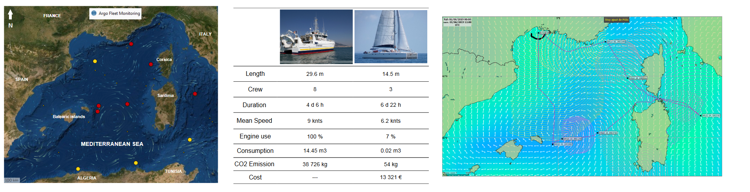
Case study of a one-week sailing cruise in the Mediterranean region with a target of 6 recoveries

While floats generally live for 4 to 6 years, their recovery might also provide the opportunity to refit them and put them back afterwards in the operational array. We estimated that a simple refit (change of batteries and critical components, cleaning and basic re-calibration of the sensors) would cost approximately 25% of the same new float. So one might think of recoveries as a way of reducing the global fleet price if the total recovery operation costs are less than the remaining 75% of the float’s price. On the above example of a one week sailing cruise in the Med with 6 targeted recoveries, if only a fraction of those floats are refitted, the whole operation would be quickly economically profitable. Furthermore, during the sailing cruise, other floats could be deployed, filling eventual gaps induced by recoveries.

Another economic indicator could be the cost per profile. Indeed recovering a good float before its expected end-of-life will mathematically increase the cost per profile. But the economic gain of refitting the float is such that the operation is still valuable even if the float is recovered well before the end of its expected lifetime. Extrapolating the study case of the one-week sailing cruise example in Mediterranean region leads to a cost per profile reduced by around 25% for a standard and almost 30% for a BGC float if recovered at 90% of its life expectancy.

Float type | Expected lifetime  (n° of cycles) | Unit price | Single profile cost  (no recovery) | Savings if recovered including cruise costs (Med case study) | Single profile cost if recovered and re-deployed including cruise costs  (Med case study) | Savings on single profile cost if recovered and re-deployed including cruise costs  (Med case study)
Standard Argo float | 250 | 20 000 € | 80 € | 12 780 € | 60 € | 24%
Full BGC float | 250 | 80 000 € | 320 € | 57 780 € | 227 € | 29%
Details of expected economic impact of a float recovery case-study on the cost per profile indicator

In conclusion we shouldn’t consider the recovery of floats as something anecdotic within Argo if they are conducted in a carefully planned and a sensible way. It would reduce the environmental impact of the Argo network and help on some scientific or technical issues. Recovery operations are already possible–and sometimes conducted- using existing research vessels but a pilot recovery sailing cruise would provide a valuable feedback for alternative solutions. In some cases, float recoveries could also lead to a substantial and positive economic impact on global Argo profile costs, at least for marginal seas. And it will allow the Argo community to finally be able to answer more positively the always-asked question of floats end-of-life at sea.

Noé POFFA, Argo-France operational Coordination, Ifremer
Martin Amice, R&D, Ifremer

From T. Le Bot et al poster presented at the Arvor/Provor Float Technical Workshop

