

**COMTEST testbed manual**

Vittorio Lippi

Institute of digitalization in medicine, Faculty of Medicine and Medical Center

University of Freiburg, Freiburg, Germany

**20/01/2022**



This project has received funding from the European Union’s Horizon 2020 research and innovation program under grant agreement No 779963

DOCUMENT HISTORY

|  |  |  |  |
| --- | --- | --- | --- |
| HISTORY OF CHANGES | | | |
| Version | Date | Author | Change |
| 0.1 | 19.01.2022 | Vittorio Lippi | 1st version with sinusoidal profile information |
| 0.2 | 20.01.2022 | Anthony Remazeilles | Version with Eurobench format |
|  |  |  |  |
|  |  |  |  |

Contents

1 Motivation and design criteria. 2

2 Materials and assembling 2

3 Available configurations 3

4 Testbed use 3

5 Software description 3

5.1 Human likeliness 3

5.2 Raised Cosine 4

5.3 Sinusoidal profile 4

6 Generating the CSV file from XSENSE input 4

# Motivation and design criteria.

Posture control and maintaining balance are fundamental elements of humanoid robot control and have a significant impact for the performance of robots. The evaluation of robotic performance, at the state of the art, is mostly evaluated at goal level, e.g. with robot competitions. While falling is a typical reason beyond the failure of the humanoid operation, the failure itself does not provide many details about the nature of the underlying problem that can be used to improve the control. In order to provide a more specific analysis of posture control and balance, this contribution presents a set of performance indicators, i.e. indexes that can be used to compare the performance of robots with the human control systems. The inspiration for the proposed tests and indicators comes from human experiments and particular emphasis is placed on human-robot comparison.

# Materials and assembling

In order to test the Humanoids it should be placed on the moving support surface (Figure 1) that provides a stimulus (disturbance) that produces a response (body sway). The body sway can be tracked using the tracking system provided by the subproject (XSENSE) or the one available at the facility. The platform smust be turned on and connected to the control PC.

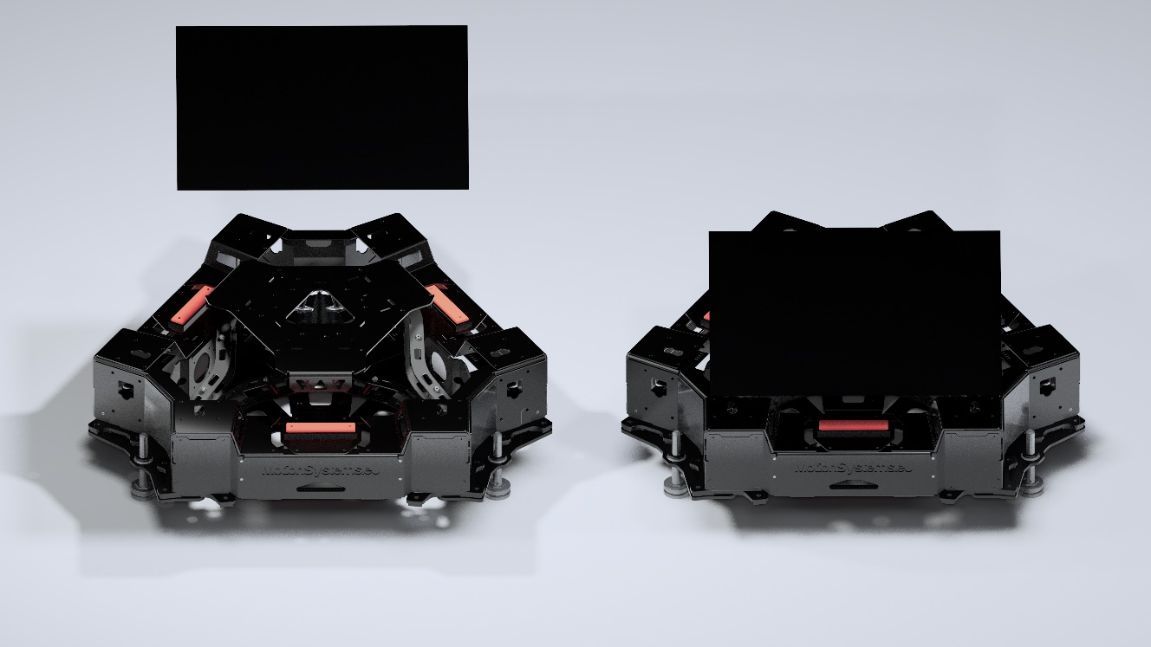

Figure 1 The moving support surface

# Available configurations

The control software provides the possibility to customize the input. In order to implement the PIs proposed in the Protocol files there are some input profiles specifically implemented to provide support surface tilt in the sagittal plane:

1) Raised cosine profile;

2) PRTS (*PseudoRandom Ternary Sequence*) profile.

Those can be selected from the interface in order to compute the PIs described in the section “Software Description”

# Testbed use

With the robot standing on the platform select the desired signal from the interface. The system will record the .cvs needed for the analysis.

# Software description

The analysis software works on offline data. The analysis is provided as an Octave Script.

## Human likeliness

The script to evaluate the human likeliness of a trial takes a recorded trial as input. A dataset of results from human experiments is provided as a reference for the benchmarking. The set includes healthy subjects and subjects with specific health conditions affecting sensorimotor control such as spasticity or vestibular loss. The experiments consisted in providing the subject with a stimulus consisting of a tilt or a translation of the support surface in the sagittal plane, while the recoded output was the body sway. The profile used for the stimulus is a pseudorandom ternary signal, PRTS. The comparison between different behaviours is defined in terms of the norm of the difference between frequency response functions on a set of relevant frequencies Such frequencies are defined by the structure of the PRTS power-spectrum P(f) that has a “comb” profile with peaks on those frequencies separated by ranges of frequencies with virtually no signal. Furthermore, the peaks of the PRTS power-spectrum have larger values at lower frequencies. This implies a better signal-to-noise ratio for the first components. A weighting proportional to P(fpeak ) is applied in the comparison. The distance between two FRFs is defined and the norm of the difference weighted by the precision matrix, i.e. the inverse of the covariance matrix , computed on the dataset of normal subjects, this together with the foretold weighting leads to the definition of the norm D=√(d^T SΣ^(-1) S d) , where S=diag(P(fpeak )) is the diagonal matrix representing the reweighting due to the power-spectrum, and d is the difference between the two FRFs.

Usage:   
 run_pi_PRTS.m <csv_filename> <result_dir>

This approach does not require model identification because it is performed on the basis of the data. The comparison can be performed between the tested robot and the average of the groups (healthy or with special deficient conditions) or between two single samples in order to quantify how much two robots differ from each other.

## Raised Cosine

A support surface movement, i.e. translation or tilt, with a velocity profile of a raised cosine represents a smooth version of a step function that can be used safely for humanoids and human subjects. In this way the transient response to external stimuli can be evaluated in terms of characteristics: (1)*rise time,* (2)*overshoot,* (3)*settling time,* (4)*peak time and* (5)*delay-time*.

Usage:   
 run_pi_RC.m <csv_filename> <result_dir>

## Sinusoidal profile

The humanoid is standing on a moving platform and commanded to stand upright. The platform moves with sinusoidal profile. The body sway is recorded and analysed in terms of response to the input sine wave. Specifically, it returns phase and gain of the body sway response respect to the input (support surface tilt) and a ratio between the power of the input and the output. It is different from the gain that is computed just on the pitch frequency. In particular

Usage:   
 run_pi_SIN.m <csv_filename> <result_dir>

# Generating the CSV file from XSENSE input

The Octave/Matlab utility xsens2COM.m converts the text format from xsense to csv files to be used with run_pi_PRTS.m, run_pi_SIN.m and run_pi_RC.m. The csv file contains time and COM sway from xsense angles. The function can be called with a single file as input so that the body-sway of the robot is identified by the pitch of a single xsense sensor, e.g.:

[BS] = XSENS2COM(OUTPUT_FILE,BS_FILE)

Or with two files, so that the COM position is reconstructed from the sway of the trunk (upper body) -sway and leg-sway:

[BS] = XSENS2COM(OUTPUT_FILE,LS_FILE,TS_FILE)

The script searches for the pitch angle in the file, it assumes the columns to be like:

PacketCounter,Roll,Pitch,Yaw