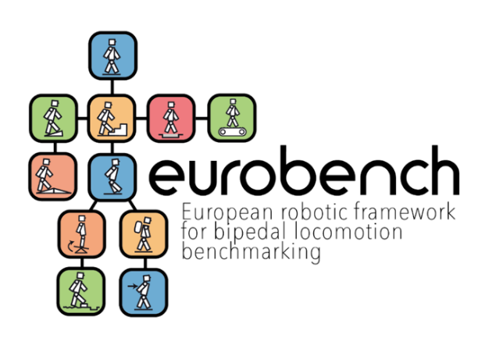

**Local Perceived Pressure Questionnaire**

**-**

**EXPERIMENTER GUIDE**



This project has received funding from the European Union’s Horizon 2020 research and innovation program under grant agreement No 779963

### Local Perceived Pressure Questionnaire Protocol Generalities

|  |  |  |
| --- | --- | --- |
| Generalities | Item | Template designer description |
| Name | The questionnaire measures the subjective evaluation of musculoskeletal pressure applied by the exoskeleton to the user. |
| Definition | The questionnaire measures the subjective evaluation of musculoskeletal pressure applied by the exoskeleton to the user. |
| Image |  |
| Keywords | Human factors; Comfort; Body pressure |
| Suitable Bipedal Systems | Lower-limbs exoskeletons |
| Associated PI Algo | LPP Algo |
| Estimated experimentation duration | ~5 min. |

### Local Perceived Pressure Questionnaire Protocol

|  |  |  |  |
| --- | --- | --- | --- |
| Protocol description | General description |  |  |
| Step | Description | Complementary information |
| 0 - Mandatory condition | The LPP Protocol has to be used after the participant has had the opportunity to try/use the exoskeleton. |  |
| 1 - Instruction | The experimenter provides instructions to the participant. | The instruction will be: “We show you a picture that reports a human body divided into nine parts. Please, could you judge the degree of discomfort you felt for each part?” |
| 2 - data collection | The participant answers the questionnaire’s items. | LPP consists of 14 items rated on a Likert-type scale ranging from 0 (no pressure at all/no discomfort at all) to 10 (extremely strong pressure/extreme discomfort, almost maximum). A discomfort level of little discomfort is defined as the cut-off point for the peak discomfort measure. Mean ratings of perceived pressure are computed for each target body area and/or across body areas. Both round numbers and decimals can be used (up to the experimenter). |

**Perceived Local Musculoskeletal Pressure (LPP)**

The Local Perceived Pressure method will be administered by the experimenter to the end-user after the completion of Single Task: Motor.

Also known as Localised Musculoskeletal Discomfort (LMD) method. It uses both numbers and verbal intensity descriptors to rate perceived musculoskeletal pressure (subjective evaluation of local discomfort). The ratings of localised perceived pressure indicate the levels of pressure that the device applies to the user. It can be related to a specific target body area (e.g., back, shoulders, upper legs, belly, hips, arms, chest, etc.).

Scoring: LPP is rated on a scale from 0 (no pressure at all/no discomfort at all) to 10 (extremely strong pressure/extreme discomfort, almost maximum). A discomfort level of little discomfort is defined as the cut-off point for the peak discomfort measure. Mean ratings of perceived pressure are computed for each target body area and/or across body areas. Both round numbers and decimals can be used (up to the experimenter).

LPP rated below 0.5 = extremely low pressure levels/extremely weak pressure/extremely little discomfort.

LPP rated below 2 = very low pressure levels/very weak pressure/minimal discomfort.

*LPP Method*

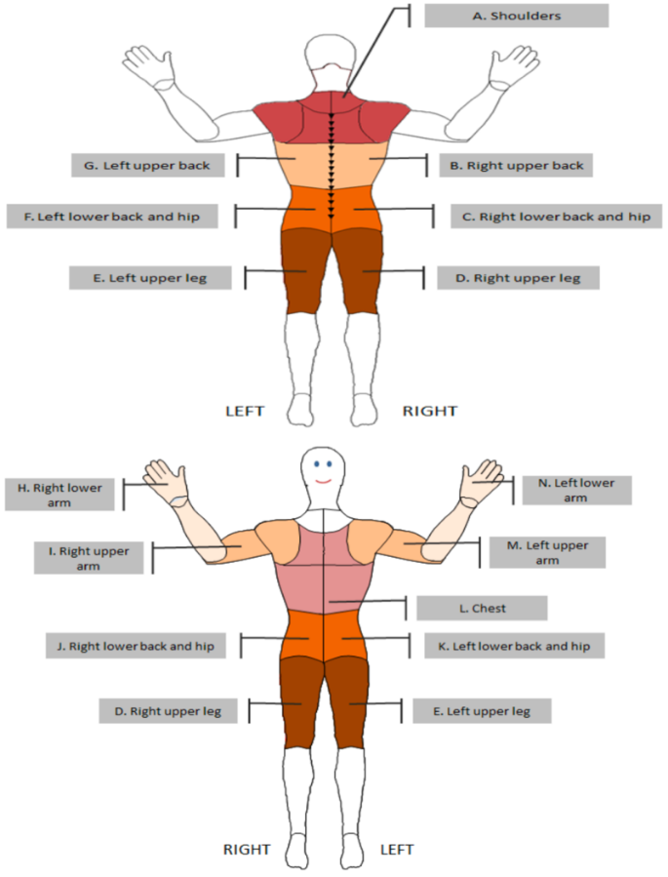

*LPP Method Scoring Algorithm*

Back/Shoulders = (A + B + C + F + G) / 5

Arm = (H + I + M + N) / 4

Chest = L / 1

Belly/Hips = (J + K) / 2

Legs = (D + E) / 2

*LPP benchmarking thresholds\**

Min. score = 0

Max. score = 10

0 < low pressure < 3

4 < medium pressure < 5

6 < high pressure < 10

*Thresholds are considered per each body area.