The Open-ALAQS GSE application

 | Version: 1.0  Date: 30 /06/2016

Coordinator: | ENVISA
Stavros Stromatas  +33 1 71 19 45 86  stavros.stromatas@env-isa.com | 22 rue Oberkampf  F-75011 Paris  France  www.env-isa.com

1. INTRODUCTION 4
2. GSE emissions in Open-ALAQS 5
3. Open-ALAQS GSE application 6
3.1 Interdependencies 6
3.2 Emission factors 6
4. Demonstration 8
4.1 Preparation of a GSE table 8
4.2 Calculate emissions 10

INTRODUCTION
GSE stands for Ground Support Equipment and includes the whole fleet of vehicles that are used to handle the aircraft during the turnaround at the stand: ground power units, air climate units, aircraft tugs, conveyer belts, passenger stairs, forklifts, tractors, cargo loaders, etc.
GSE may vary considerably from airport to airport. For example, the same type of equipment might be equipped with different engines (e.g. size and technology) depending on regional or national standards or local operational requirements. Moreover, GSE emission factors (EFs) are dependent on many different parameters (see Figure 1) such as fuel type, engine size, load factor, technology, age (or deterioration factor) etc. Therefore, GSE EFs are not uniform for all regions of the world.
Figure 1: Characterization of GSE operations. Taken from ICAO’s Airport Air Quality Manual (Doc. 9889)
In the context of local air quality studies, it is important to accurately assess GSE emissions. GSE EFs need to be separately calculated for each airport according to the type and number of GSE used.
The purpose of this document is to provide a detailed description of the new Open-ALAQS GSE application that was developed in the context of deliverable W16.06.03-D3 in order to enable the user to precisely define airport-specific GSE emissions factors. This new software can be used to estimate GSE and GPU EF’s from user-defined combinations of aircraft groups and gate types. The Open-ALAQS GSE application is based on the philosophy of the ALAQS-V2 GSE tool, which was also developed by ENVISA for ALAQS-V2 based on the ICAO doc 9889 (Appendix 2 to Chapter 3). It is an optional extension to Open-ALAQS that can also be used stand-alone.

GSE emissions in Open-ALAQS
In Open-ALAQS GSE emissions are added to Gate emissions. Three gates types are considered:
- CARGO (for air freight)
- PIER (gate next to the terminal)
- REMOTE (gate on the apron, far from the terminal)
Each gate can accommodate only specific types of aircrafts that need to be specified. Aircrafts are divided in the following categories:
- JET BUSINESS
- JET REGIONAL
- JET SMALL
- JET MEDIUM
- JET LARGE
- TURBOPROP
The first step to calculating GSE (or GPU) emissions is to extract the aircraft group information for each movement. Then depending on the source type (GSE or GPU) the appropriate emission factor is imported (in g/h). Depending on the type of operation (arrival or departure) and source an occupancy time (in min) is attributed to the specific aircraft group and gate type.
Table 1:Example of input data for GSE emissions in Open-ALAQS
Gate type | AC group | GSE/GPU | unit (time) | D  (time) | A  (time) | EF (unit) | CO | HC | NOx | SOx | PM10
CARGO | JET BUSINESS | GPU | min | 2 | 1 | g/h | 405 | 105 | 745 | 0 | 57
CARGO | JET BUSINESS | GSE | min | 50 | 50 | g/h | 24 | 6 | 45 | 0 | 3
CARGO | JET SMALL | GPU | min | 17 | 17 | g/h | 258 | 52 | 366 | 0 | 34
CARGO | JET SMALL | GSE | min | 64 | 36 | g/h | 209 | 33 | 226 | 0 | 19
The default GSE EFs in Open-ALAQS originate from the ALAQS v2 GSE application combined with airport data for operating times (from Zurich and Bucharest Warsaw). We note that the EFs for arrivals and departures is the same. However, this is not always realistic therefore in the new version of Open-ALAQS the aforementioned table is slightly modified as:
Gate type | AC group | GSE/GPU | unit (time) | op  (D/A) | time  (min) | EF (unit) | CO | HC | NOx | SOx | PM10
CARGO | JET BUSINESS | GPU | min | D | 2 | g/h | 405 | 105 | 745 | 0 | 57
CARGO | JET BUSINESS | GPU | min | A | 1 | g/h | 405 | 105 | 745 | 0 | 57
The reason behind this change is that using the new GSE application the user will be able to assign different operating times for arrivals and departures.

Open-ALAQS GSE application
In order to be more precise in the calculation of GSE emissions a new application was developed. Airport-specific GSE EFs are calculated as a function of the actual GSE that is used at the airport and the interdependencies between the equipment and other parameters such as operational procedures, airport stand properties and aircraft types.

Interdependencies
The Open-ALAQS GSE application have to take the following interdependencies into account:
- The amount and duration of GSE activity required for a cycle depends upon the aircraft type, in particular whether it is a narrow or wide body. The size of the aircraft influences the stand allocation and often the handling procedures (e.g. number, types and operating time) involving GSE.
- The stands themselves can exhibit considerable differences in terms of location and technical equipment available which influence the number and operations of GSE and thus emissions from this source. Stands may also differ for reasons of dedicated usage (e.g. whether a stand is used for cargo aircraft or for passenger aircraft).
- Operational procedures also determine the types and amounts of GSE services required. For example, different GSE types are required for servicing aircraft after landing than are used prior to departure and for servicing passenger and cargo operations.

Emission factors
In order to calculate GSE emissions, the following information is necessary for each piece of GSE used:
- Engine size (kW) and load factor (%)
- Emission factor per time (in g/kWh)
- Duration of operation (service time in minutes)
- Engine Deterioration factor (reflecting age and maintenance of GSE)
- Exhaust category (Stage II, III, IVi, IV, ...)
The list of available GSE as well as all necessary information is stored in two .csv files (default_gse.csv and default_emission_factors.csv). Figure 2 shows several GSE types that are included in the Open-ALAQS GSE database. All parameters for engines and service times can be easily modified simply by updating the appropriate file.
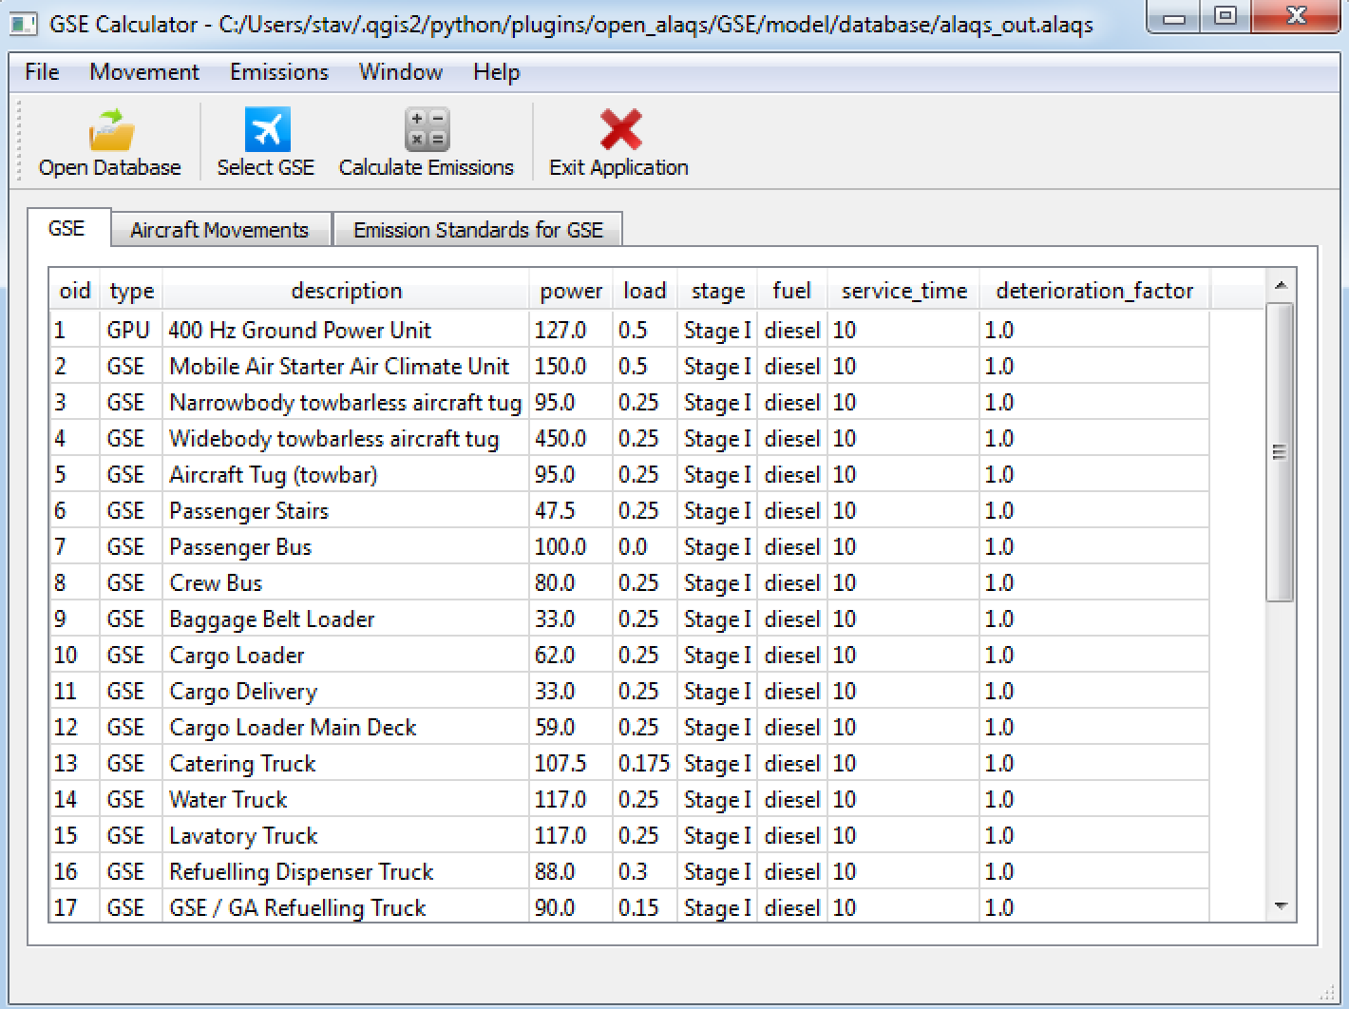
Figure 2: Typical ground support equipment in the Open-ALAQS GSE database.
The calculation of GSE emission factors in the Open-ALAQS GSE application is done by following the sophisticated approach as described in ICAO’s Doc 9889.
Under this approach, all GSE emissions are calculated for each individual aircraft operation (e.g. arrival, departure) as follows:
Emission_{Pollutant} [g] = power [kW] × load factor [%] × EF_{Pollutant} [g/kWh] × time_{A/C–Ops} [h] × DF
where:
- timeA/C–Ops [h] = average time for GSE unit operation, dependent on type of operation (arrival, departure or maintenance), stand property and aircraft size;
- DF = deterioration factor (reflecting age and maintenance of GSE).
By default, the deterioration factor is currently set to 1. It can be modified by the user if the exact value is known.
For example, a passenger stair is operated 10 minutes for a B-737 size aircraft at an open (e.g. remote) stand upon arrival. The stair has a 45-kW engine, operated at 25 per cent load, with an NOx EI of 6.0 g/kW-h and a deterioration factor of 3 per cent. The total NOx of this GSE operation is:
45 kW × 0.25 load factor × 6.0 g/kW-h × 1.03 deterioration factor × 10 min × 1-hr/60min = 11.61 g NOx.

Demonstration
The use of the application for an LAQ with Open-ALAQS is optional. By default, an Open-ALAQS output file contains all necessary information to calculate GSE emissions based on default values as described in the previous section. The GSE application can be used to derive airport-specific EFs provided that the user has good knowledge of the GSE used at the airport as well of the service time for each GSE piece.
In this case, the initial “default_gate_profiles” contained in the Open-ALAQS output file table will be automatically updated with the new values at the end of the procedure.

Preparation of a GSE table
The first step consists in selecting an Open-ALAQS output file (.alaqs) by clicking on the “Open Database” button.
When the database is loaded, click on “Define Movements”. A new window will appear where the user can select all GSE/GPU pieces per aircraft group and stand type (Figure 3) from the list of available units.
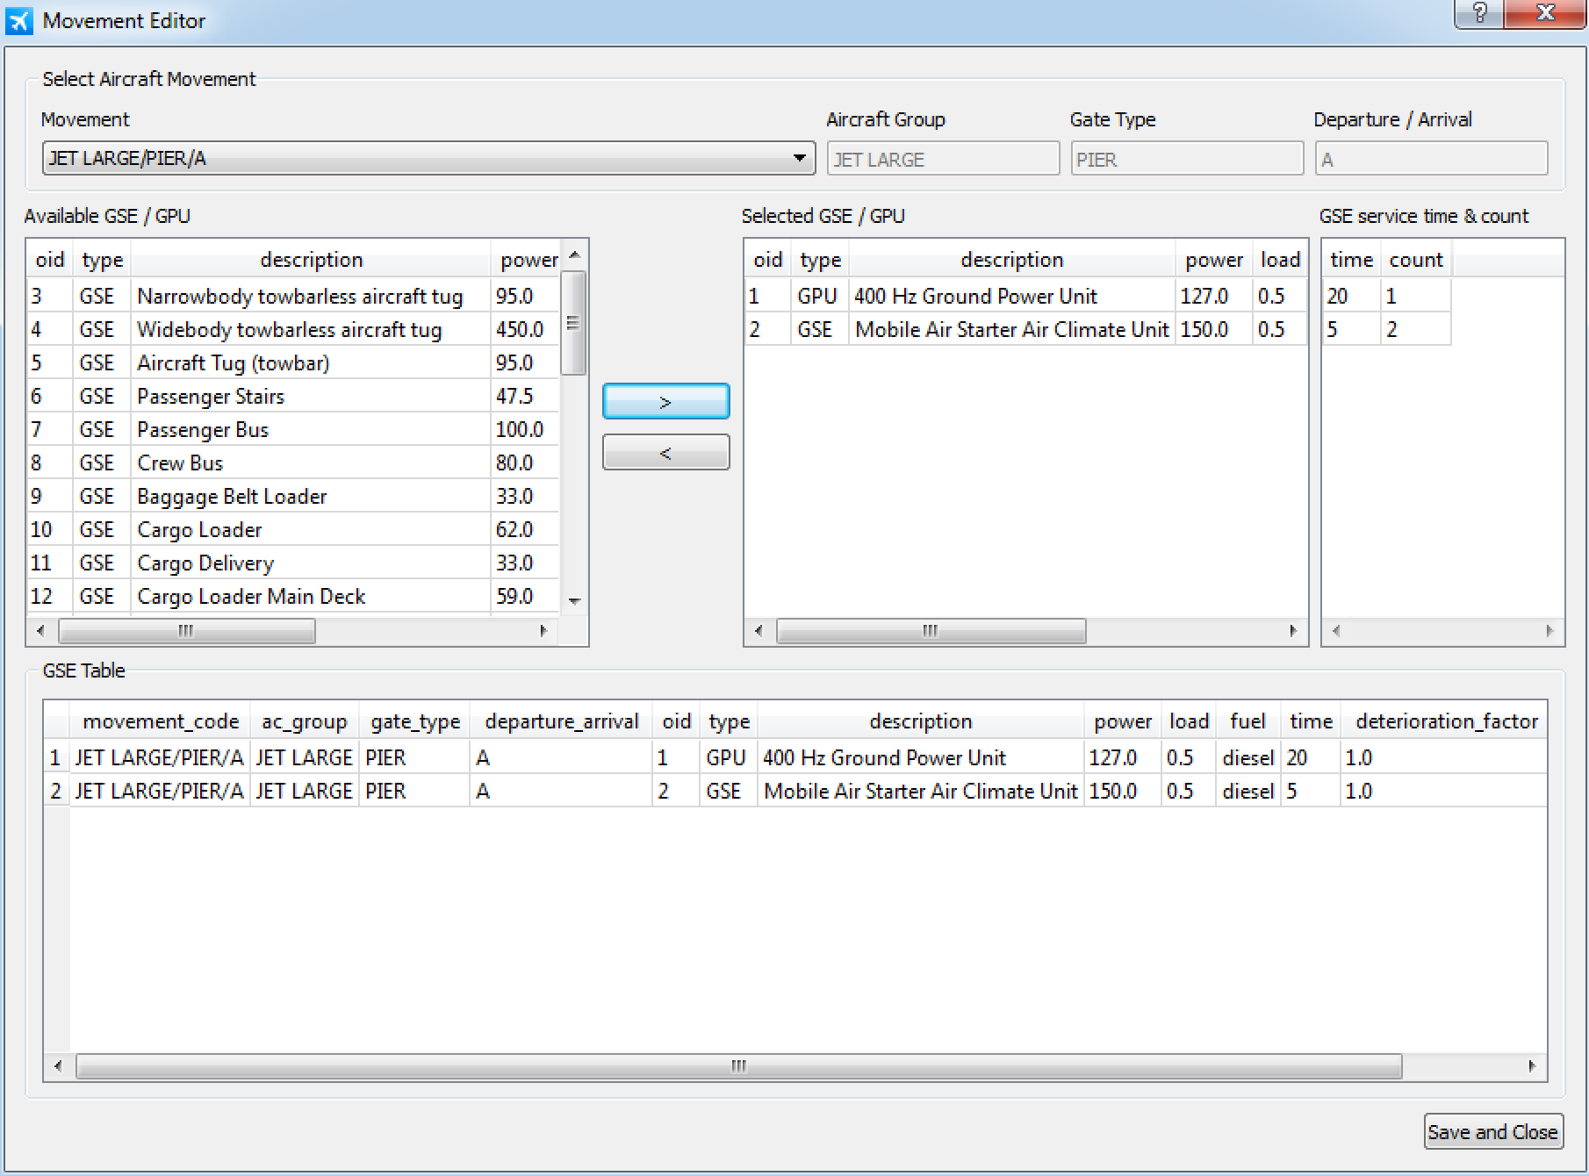
Figure 3: Available and selected GSE/GPU pieces per aircraft group and stand type.
The equipment allocation per Gate Type / Aircraft Group combination is visible on the bottom of the window. Every time a new unit is added the table is updated automatically.
The characteristics of each individual GSE/GPU piece can be modified by the user in the .csv file. The operating times and number of units used can be defined directly in the application (“time” and “count” parameters). Once the allocation of GSE/GPU units is finished, click on “Save and Close” to finalise this step.

Calculate emissions
In order to calculate the emissions for the selected GSE/GPU pieces, click on “Calculate emissions”. The list of all imported GSE/GPU per aircraft group and stand type is listed on the top (“GSE list by Movement”). Click on the button “Calculate emissions” to calculate the EFs for all pollutants. The results should be visible at the bottom (“Output Emissions”) as shown in Figure 5.

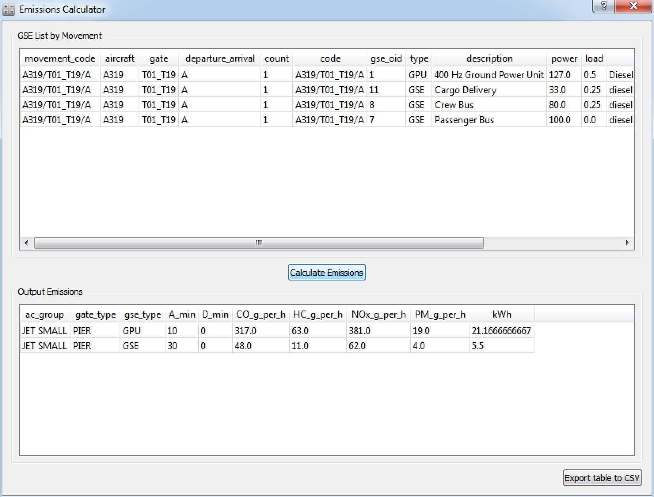
Figure 5: Emissions Calculator for the selected GSE/GPU pieces

The Open-ALAQS file is automatically updated and can be used to calculate movement emissions according to the new airport-specific values for GSE/GPU. Moreover, the results can be saved as a .csv file by clicking on “Export table to CSV”.

