Dublinevents.com Map App

Project Description:

Dublinevents.com does not have an app would like to have their own Map App to promote tourism in Ireland for all tourists and visitors. A simple map app of the City of Dublin to which it shows the location of important places around Dublin such as places to stay, places to eat and place of interest. This app will be a guide for tourists to go around Dublin.

Target Audience

The target audience for this app are tourists to help them find their way around Dublin City Centre.

Specifications

Functionalities:

* Able to zoom in and out of the map.
* Enable Scrollable
* Enable Drag
* Custom image of the Dublinevents Map
* The app should have left and right hand side bars

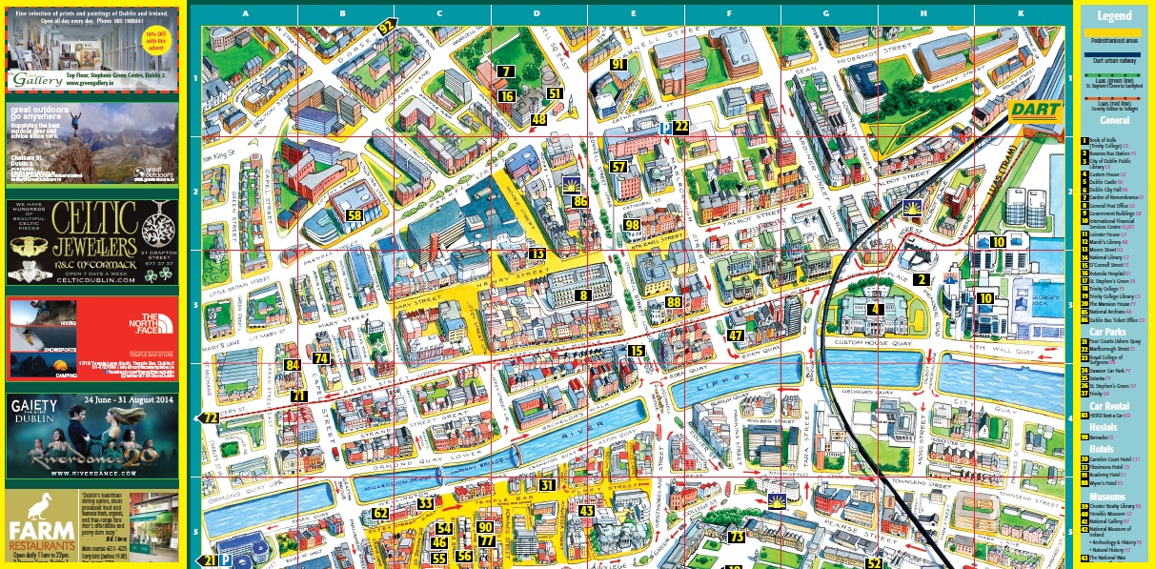

* Should have a complete lists of legends
  + Places of interests
  + Car Parks
  + Car Rental
  + Hostels
  + Hotels
  + Museums
  + Exhibitions
  + Theatres
  + Cinemas
  + Language Colleges
  + Churches
  + Menswear
  + Shopping
  + Restaurants
  + Universities
  + Garda stations
* Each Legends should be shown on the Map identified with the corresponding numbers. For instance Book of Kells is labelled by 1 on the map the number 1 should appear at the location of Book of Kells.

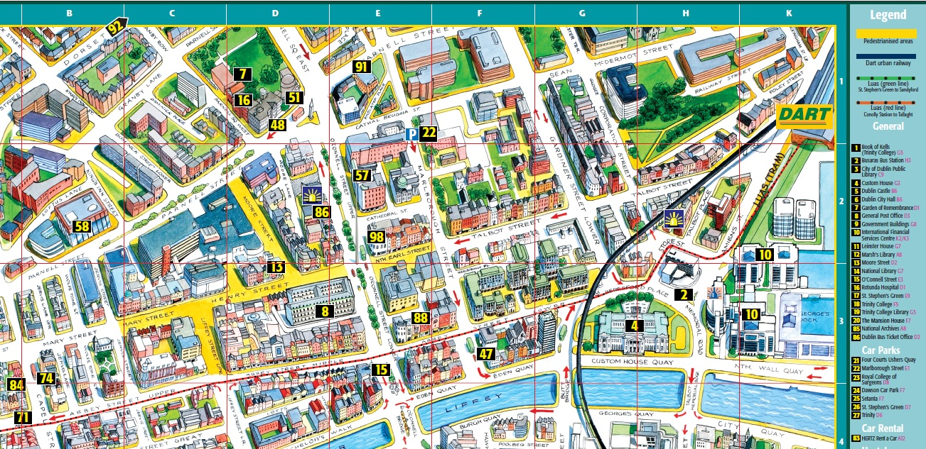

* If the user click the number a pop up should appear showing following details about the place:
  + Name of the place
  + Website URL (If they have one, should be linked to Dublinevents.com mini-webpage)
  + Address
  + Phone Number
  + Fax Number
  + Opening times
  + Short summary
* The app should have lists of important contact numbers on the side bar:
  + Emergency Contact Number
  + Aware Depression Support
  + Child line
  + Drugs/HIV Helpline
  + Rape Crisis
  + Samaritans
  + Victim Support
  + Women’s Aid