Hitler Intervention
22
MILITARY
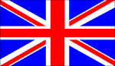
2nd BRIT
AIR POWER
+1 1st CAN; -1 Supply
RESOURCES
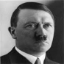
Gain 1
Hitler redeploys a pz div (players choice) and attacks the 2nd British Army (*ignore if player passes Hitler roll)
ORDERS: 0/2 Actions*
+1 DRM 2nd BRIT ARMY
Hitler often displayed his tendency to issue detailed orders far below the strategic level, and he divided responsibility for military operations among the land, air, and naval commanders, who would answer not to a theatre commander but ultimately to himself. Such interference and rigid control contributed to the military debacle of the Normandy campaign in June-August 1944.

