Operation Totalize
33
MILITARY
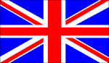
2nd BRIT 1ST CAN
AIR POWER
Jabos: +1 1st Can; -1 Supply; Carpet Bombing; +2 Montgomery
RESOURCES
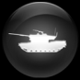
2 x FlaK 88mm Anti Tanks Units*
*immediately deployable at
1 action per unit or can be left in reserve box

ORDERS: 3 Actions
-1 DRM 1st CAN
Operation Totalize was an offensive launched by Allied troops of the First Canadian Army from August 8 to August 13, 1944. The intention was to break through the German defences south of Caen on the eastern flank of the Allied positions in Normandy and exploit success by driving south to capture the high ground north of the city of Falaise. The overall goal was to precipitate the collapse of the entire German front, and cut off the retreat of German forces fighting further west.

