Patton
37
MILITARY
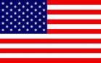
1st US 3rd US
AIR POWER
Jabos: +1 3rd US; -1 Reinforcements; +2 Patton available 3rd US Army
RESOURCES

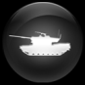
2 x Nebelwerfers*
*immediately deployable for 1 action or can be left in reserve box

ORDERS: 2 Actions
+1 DRM 3rd US ARMY
Following the Normandy invasion, Patton was placed in command of the U.S. Third Army, which was on the extreme right (west) of the Allied land forces. Beginning at noon on August 1, 1944, he led this army during the late stages of Operation Cobra, the breakout from earlier slow fighting in the Normandy hedgerows. The Third Army simultaneously attacked west (into Brittany), south, east towards the Seine, and north, assisting in trapping several hundred thousand German soldiers in the Chambois pocket, between Falaise and Argentan.

