Price Quotation AI assistant

1. New site visit
2. Upload bill of quantities

Remove the titles and keep the buttons, compare the examples with the competitors.

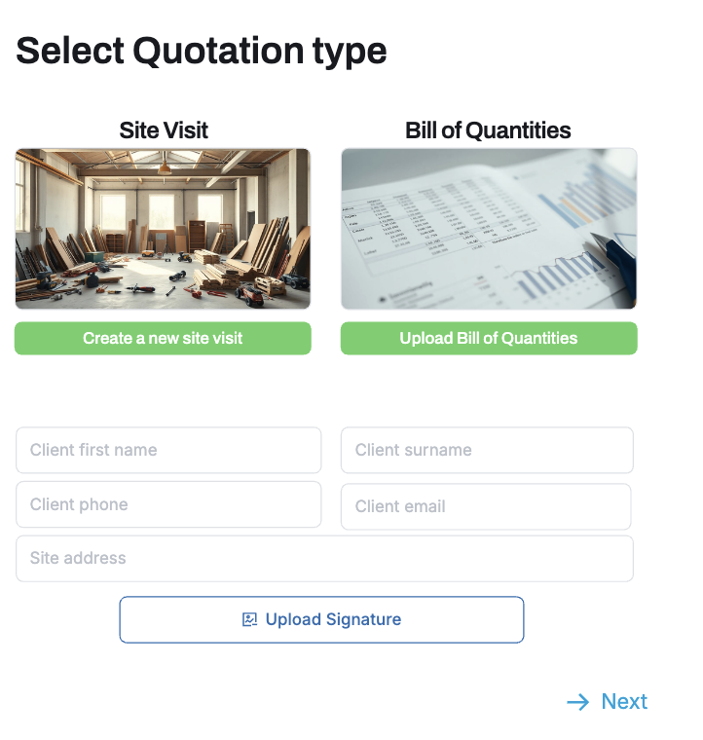

**Upload Bill of Quantities**

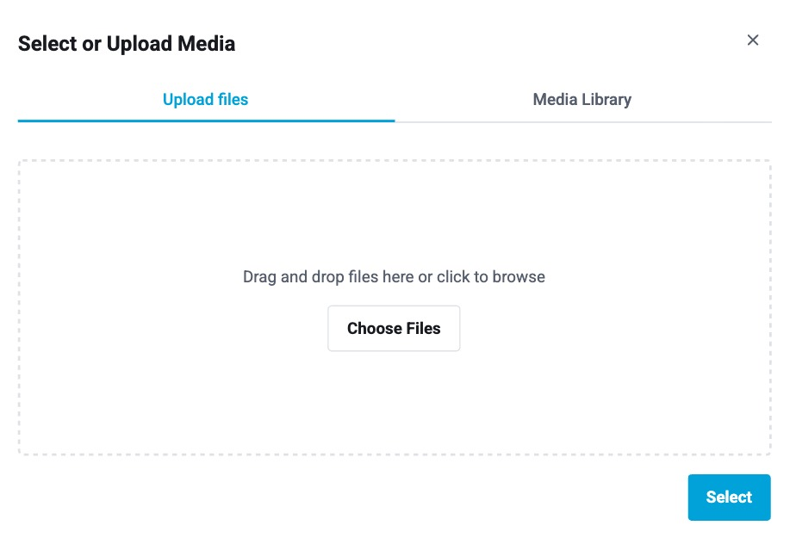

and check Computo Metrico, add popups for selecting.

Step For starting with Computo Metrico, upload files

Value for the client- make quotation fast from existing Bill of Quantities

Media Library- only for EdilManager

Site Visit

Edit from scratch with the good UX

Site area name underlined, and biggered

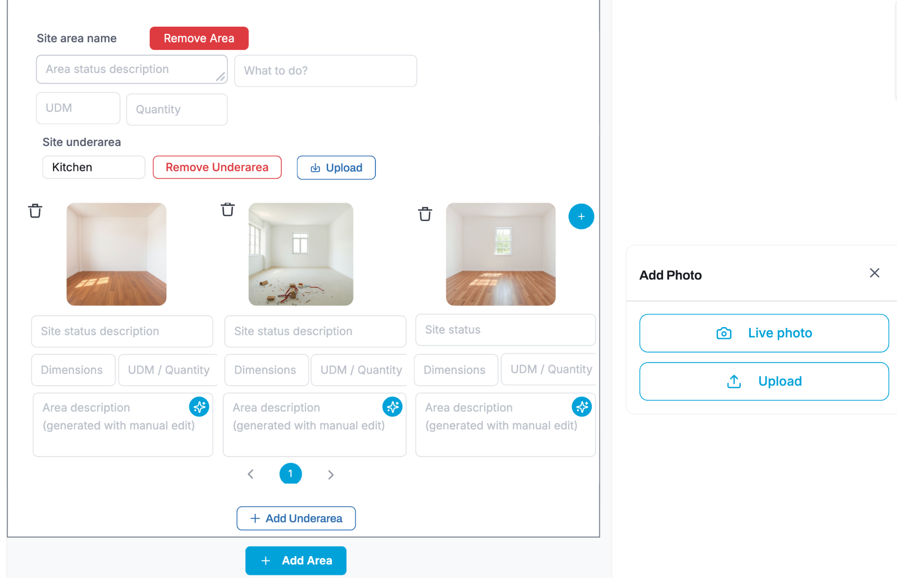

Site area status description, dimensions, quantity UDM and what to do is for the planning the site activities and get prices per each floor. Site underarea is for estimating work for the each room to get enough details from images and notes for Computo Metrico. Notes are generated and editable that describes and finds missing information to be added.

Value: adding all required details to make a quotation, site status, information about rooms, measures and quantities, description about the work requirements.

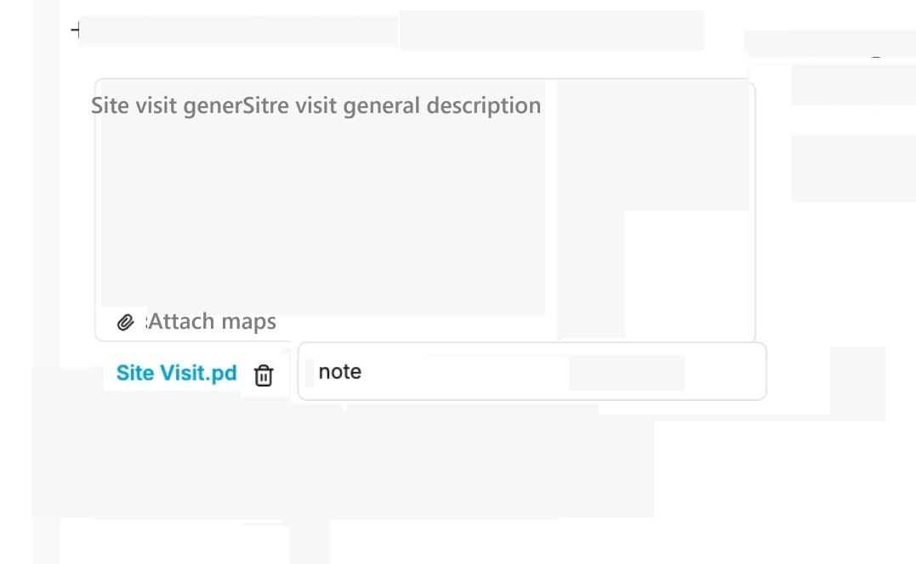

General notes and attachment is for understanding AI what is in attachment and how to process it with the other information about the site. Client details are for the quotation intro

Value: Add additional attachments and everything that can be useful in quotation.

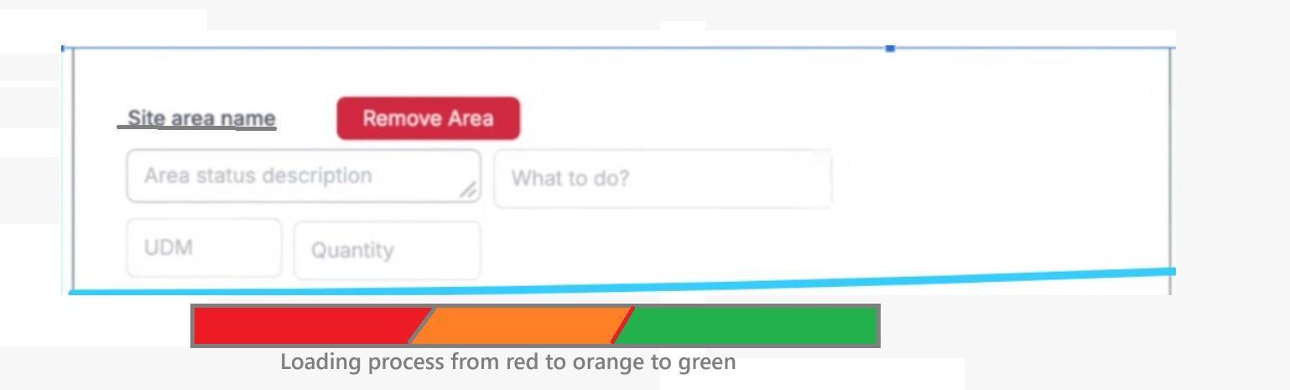

After uploading site visit next step is Adding missing details from the previous step. For the Computo Metrico upload this step is skipped.

Value: Understanding what has to be done and what is missing to create a full and precise quotation, help AI understand the requirements to make evaluation correct from engineering point of view.

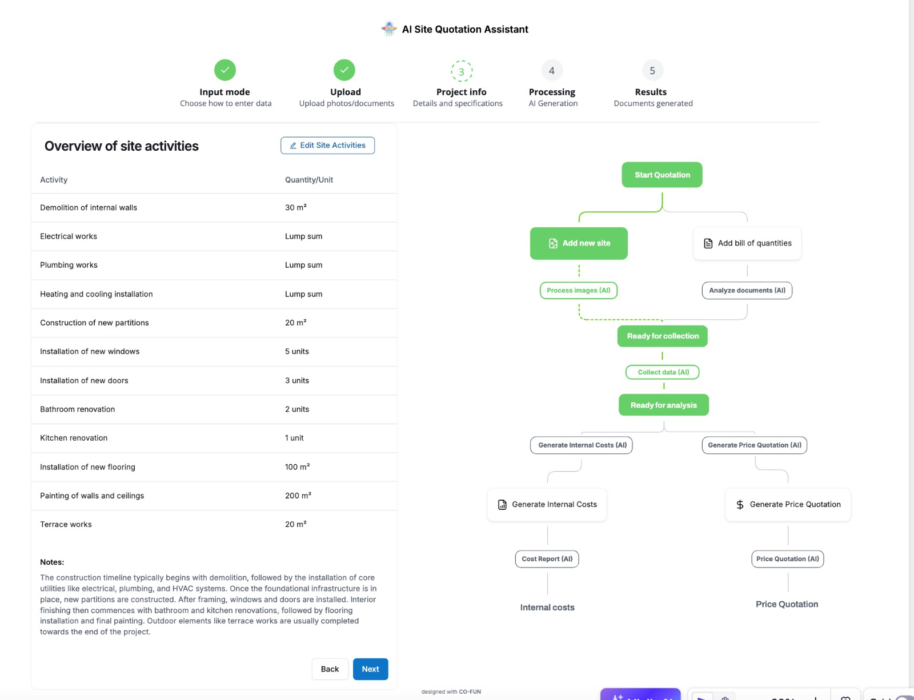

Work activity catogeries

Sum of the the total measures should be for each area / floor.

This is the editable table next that is the same for both scenarios- site visit or Computo metrico.

Value: overview the site activities generated by AI and edit quantities and description if something is not correct or remove the activity.

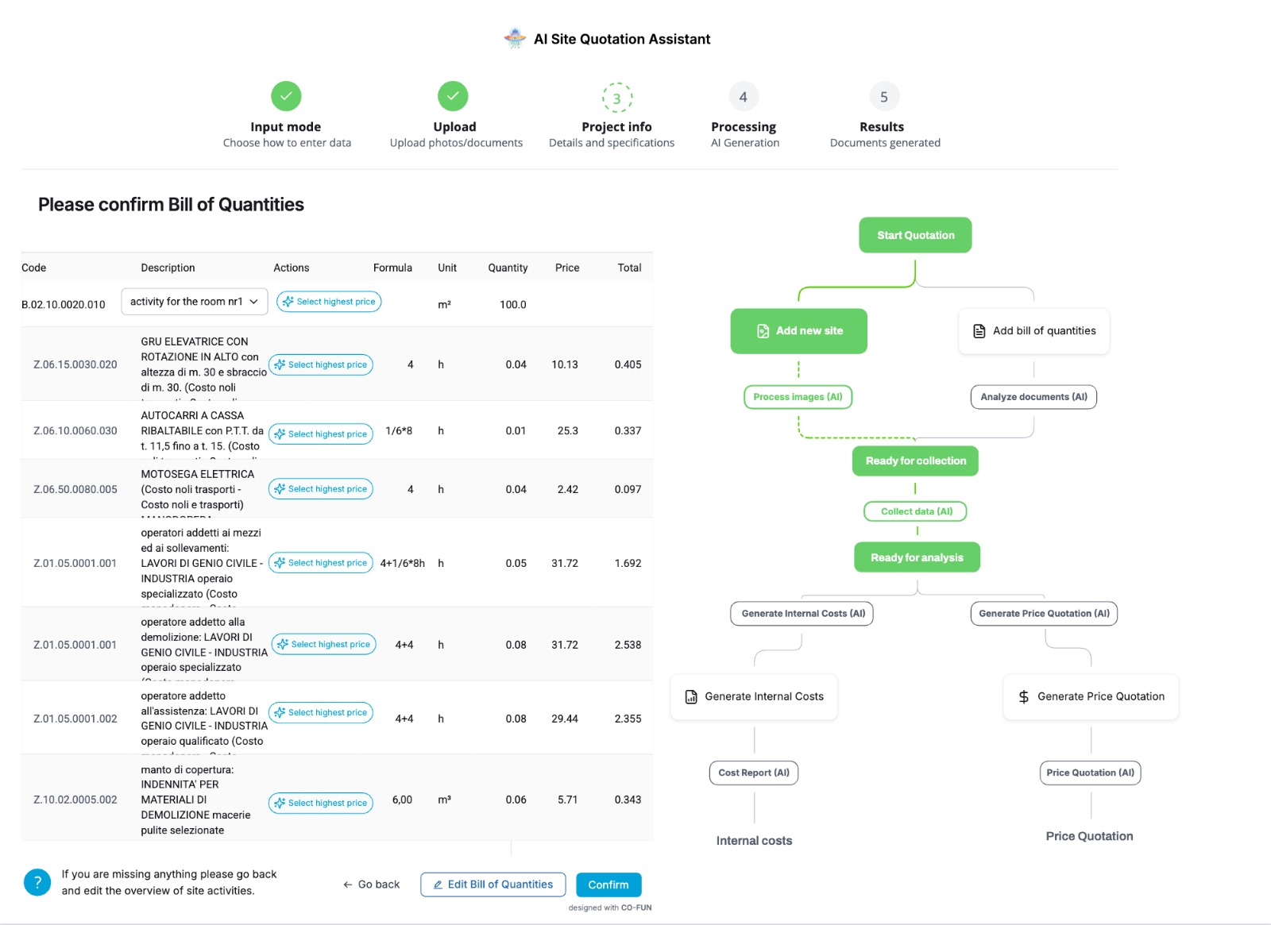

Next confirm the Computo Metrico- possible options change the activity from selecting from the drop down and button to select the highest price.

Value: select the highest price from the regions or specify the type of the activity that aligns best with the planned work. This edit is for the use of AI to adjust prices quickly for the client.

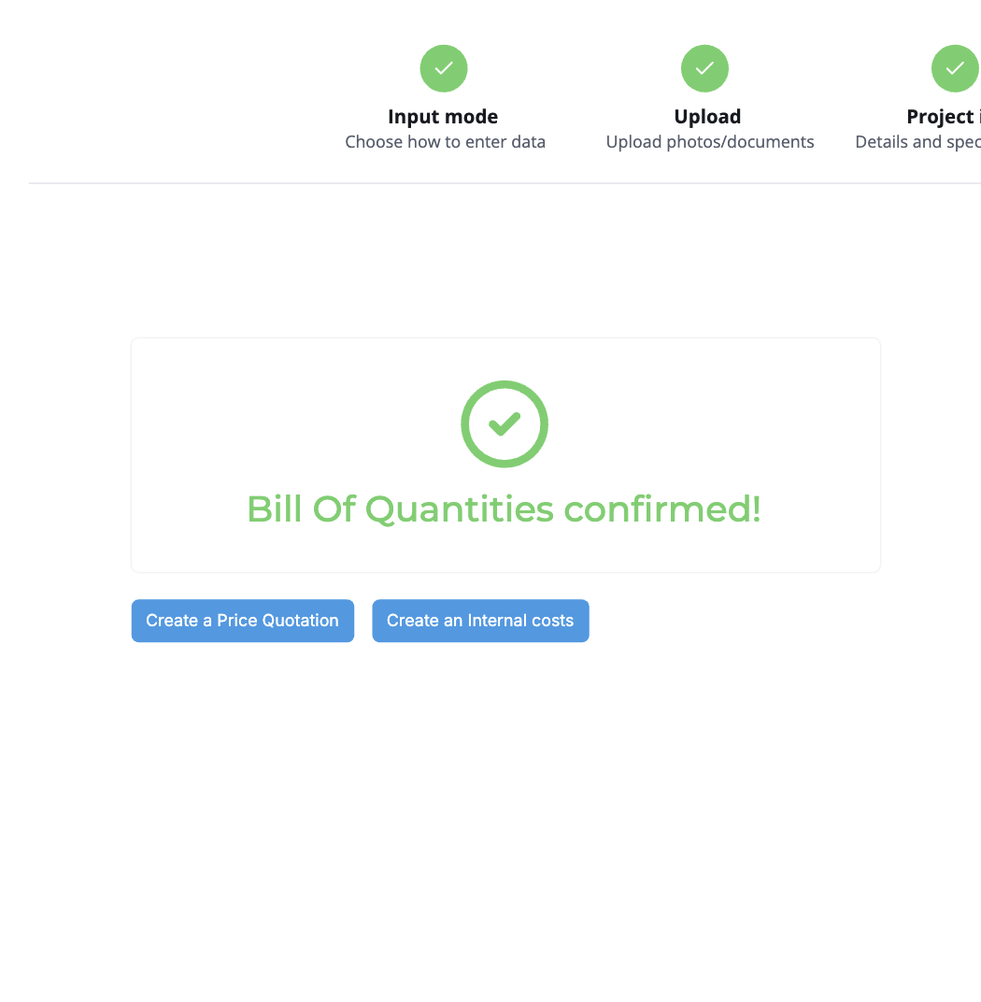

Computo Metrico Confirmation when the changes are done. Value is confirmation about the activities and prices. Button to Create a Price Quotation editable

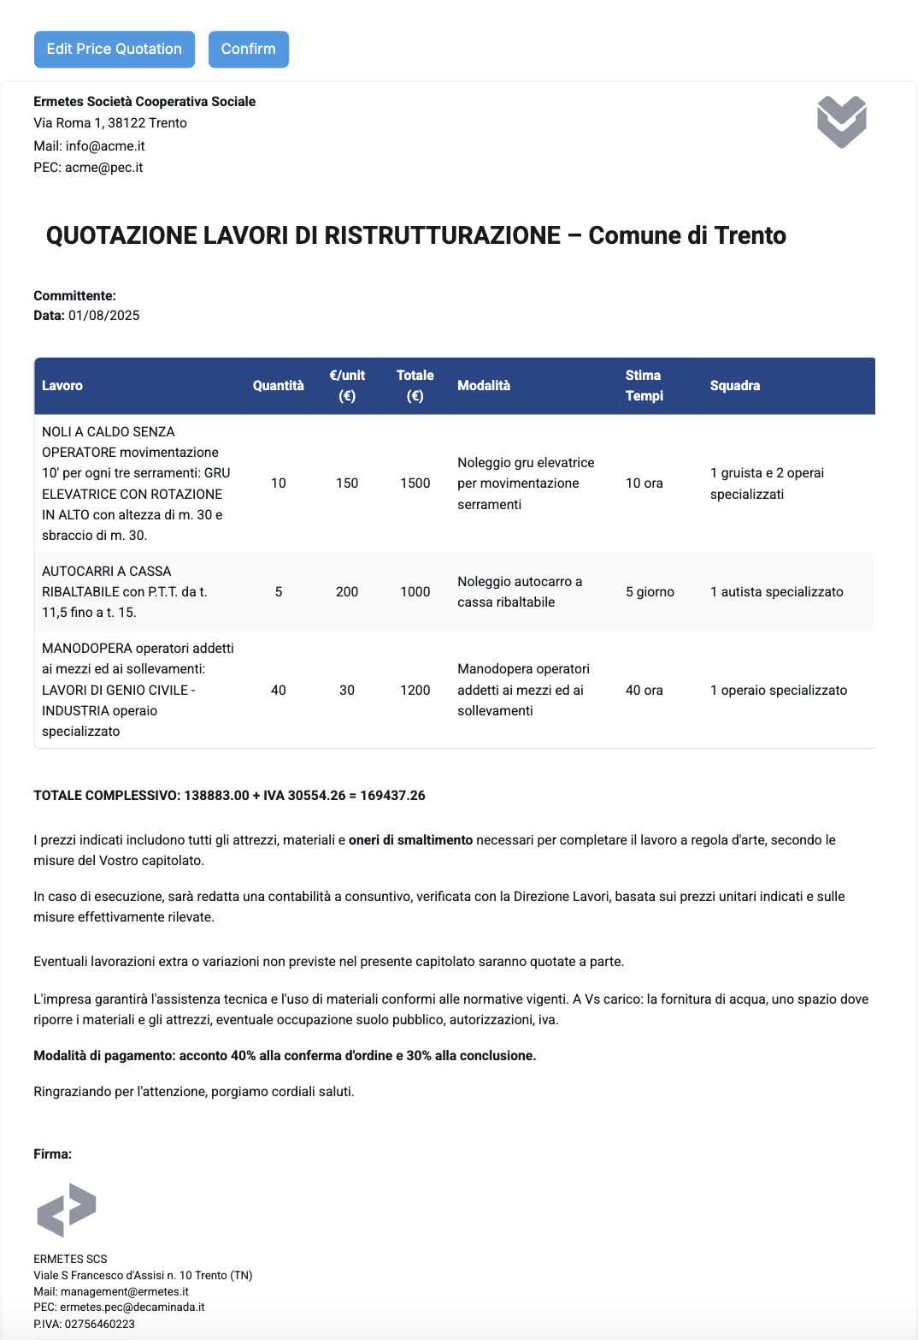

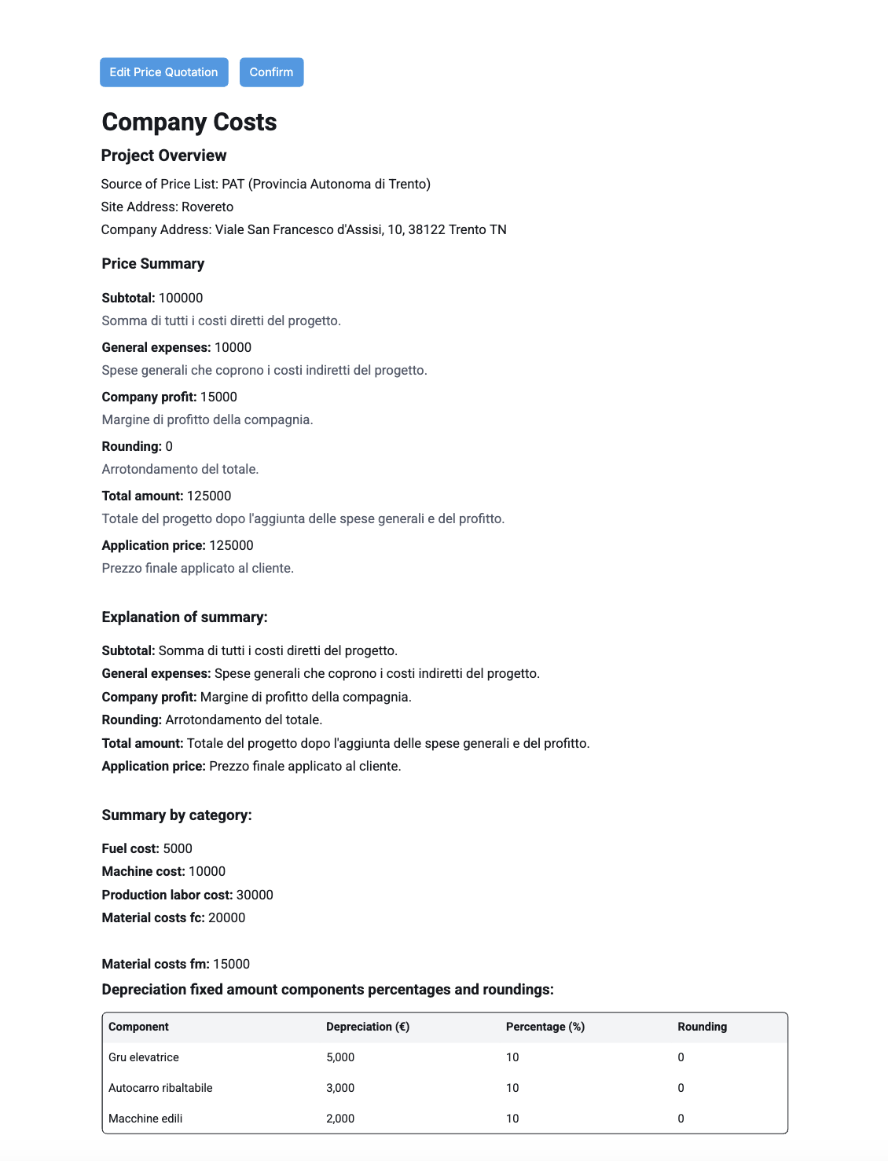

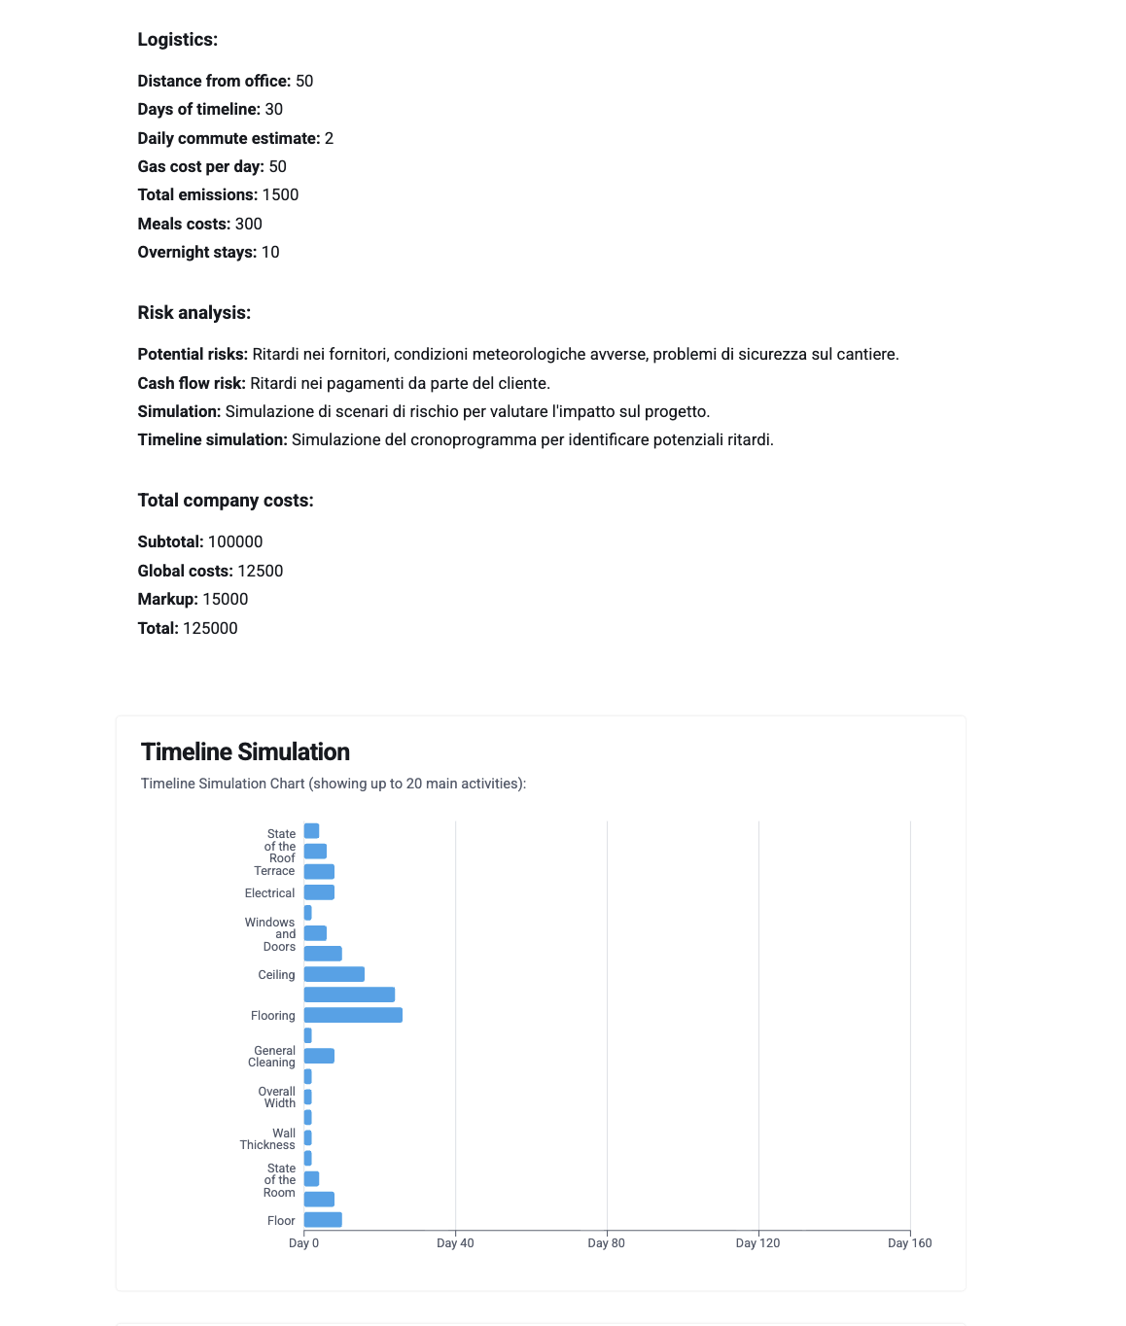

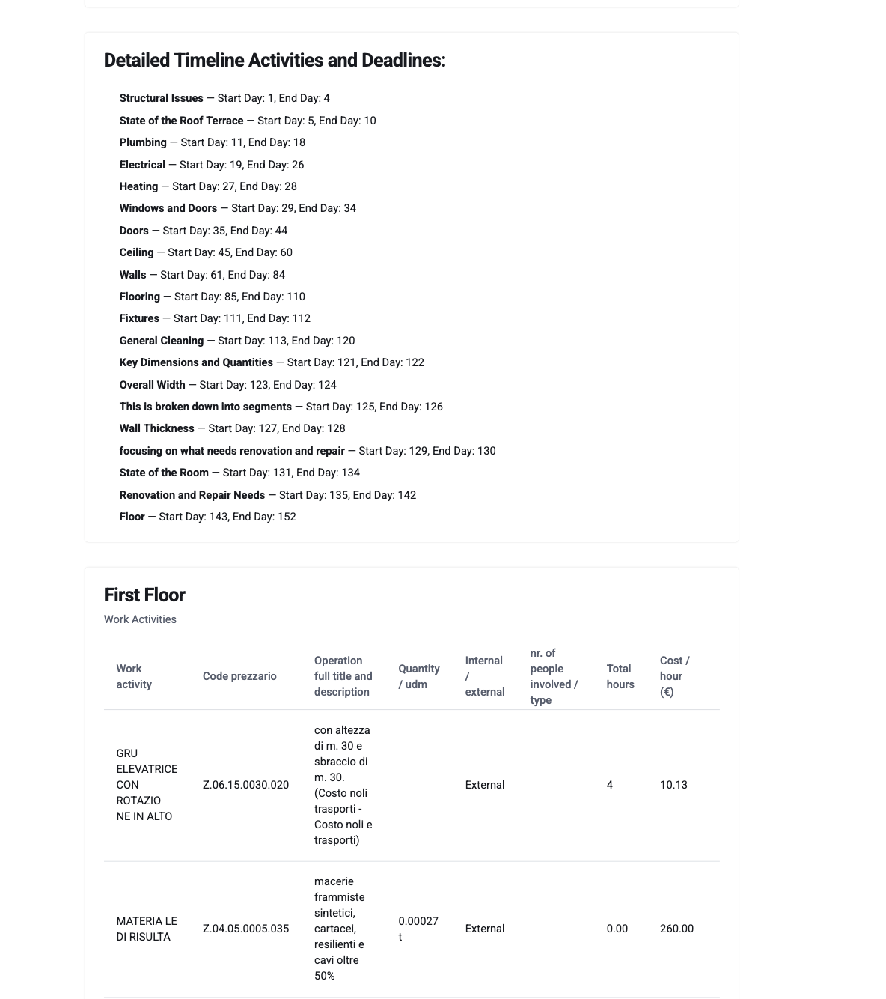

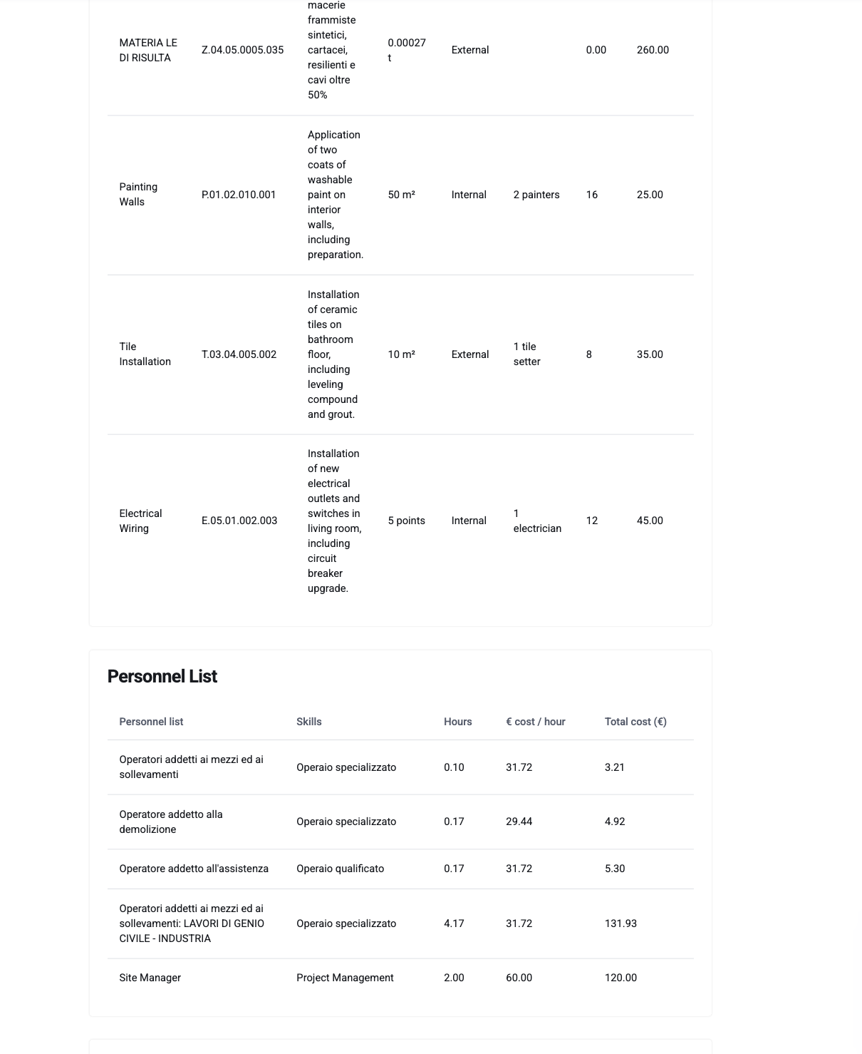

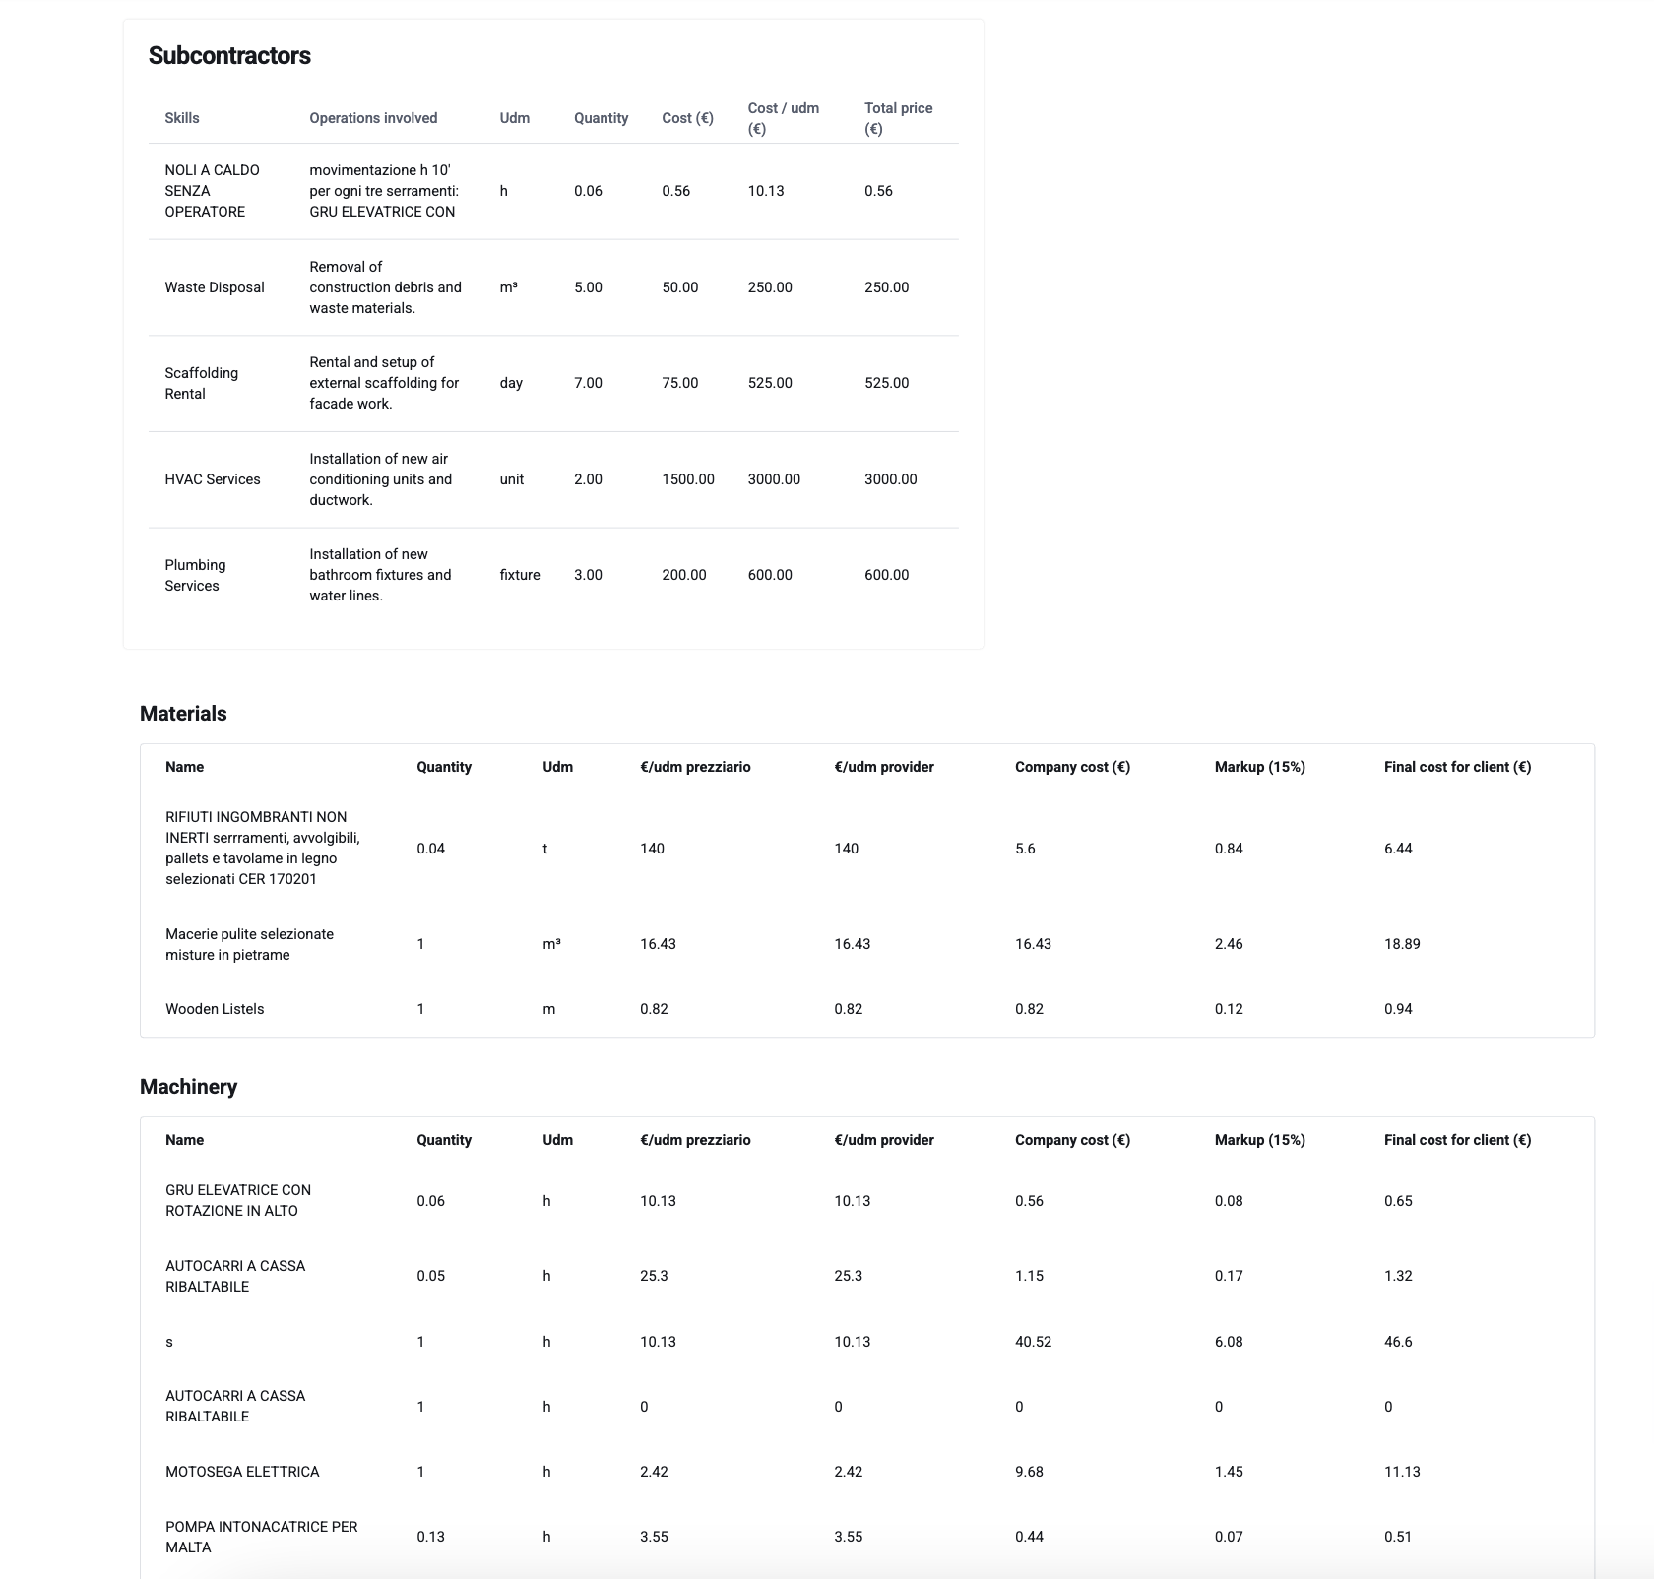

Make internal costs editable with all text and tables, value for the client: final overview and edit the internal costs before exporting, sending to the email or sharing.

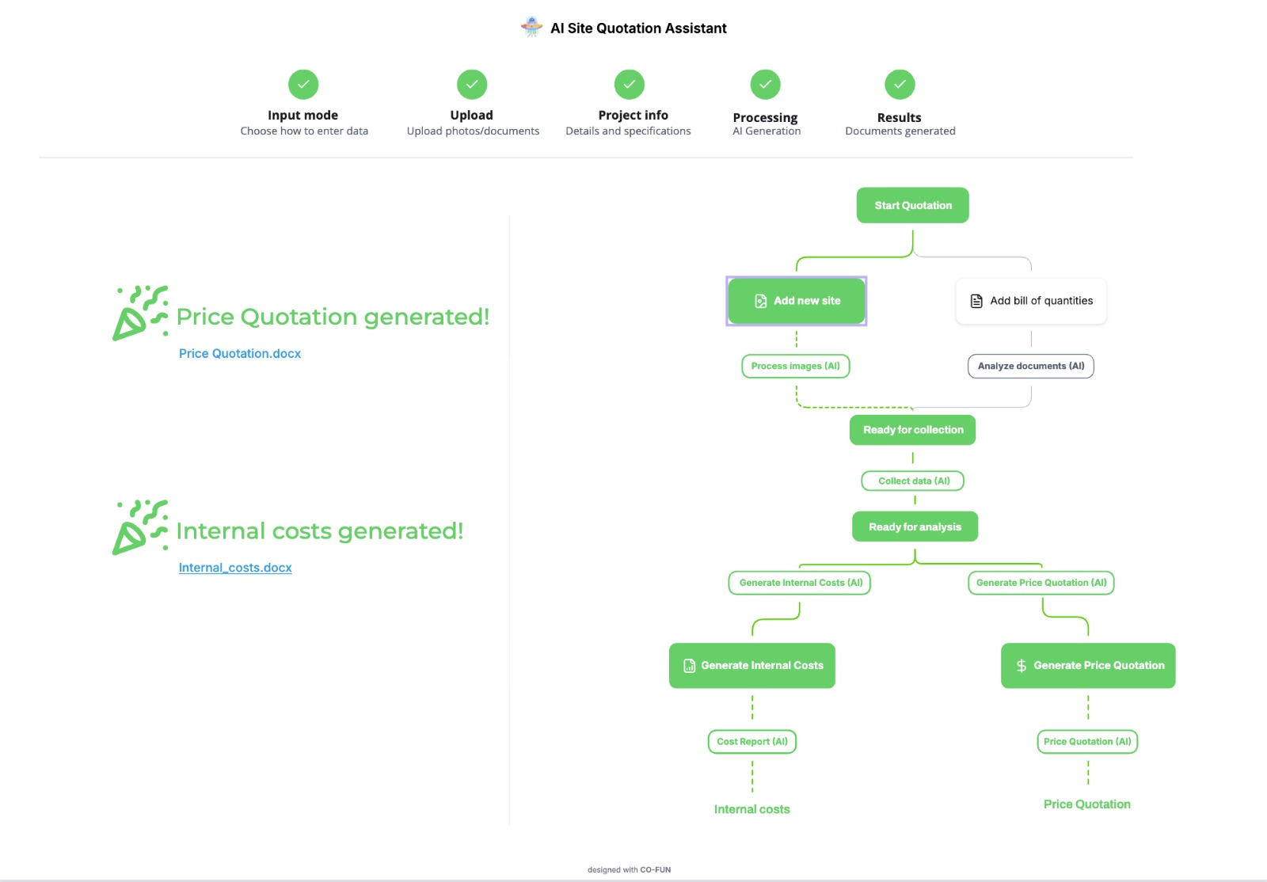

Price Quotation and internal costs is ready to download. Value: documents are generated and exportable from templates.