Definition
- Legal framework (set of rules) related to information technology, digital transformation and the Internet
- Not only one type of law, IT is everywhere
Laws
- General Data Protection Regulation (GDPR): protect all private data from being processed without consent -> all company that offer something to Europeans have to comply with it
  - Does not really apply for tax/goverments
- AI Act: rules for AI-developers and -runners
  - Does not really apply for tax/goverments
- E-Commerce Law: important part of economy
- NIS Directive: Cybersecurity
- Anti-Money Launndering Directive
- …
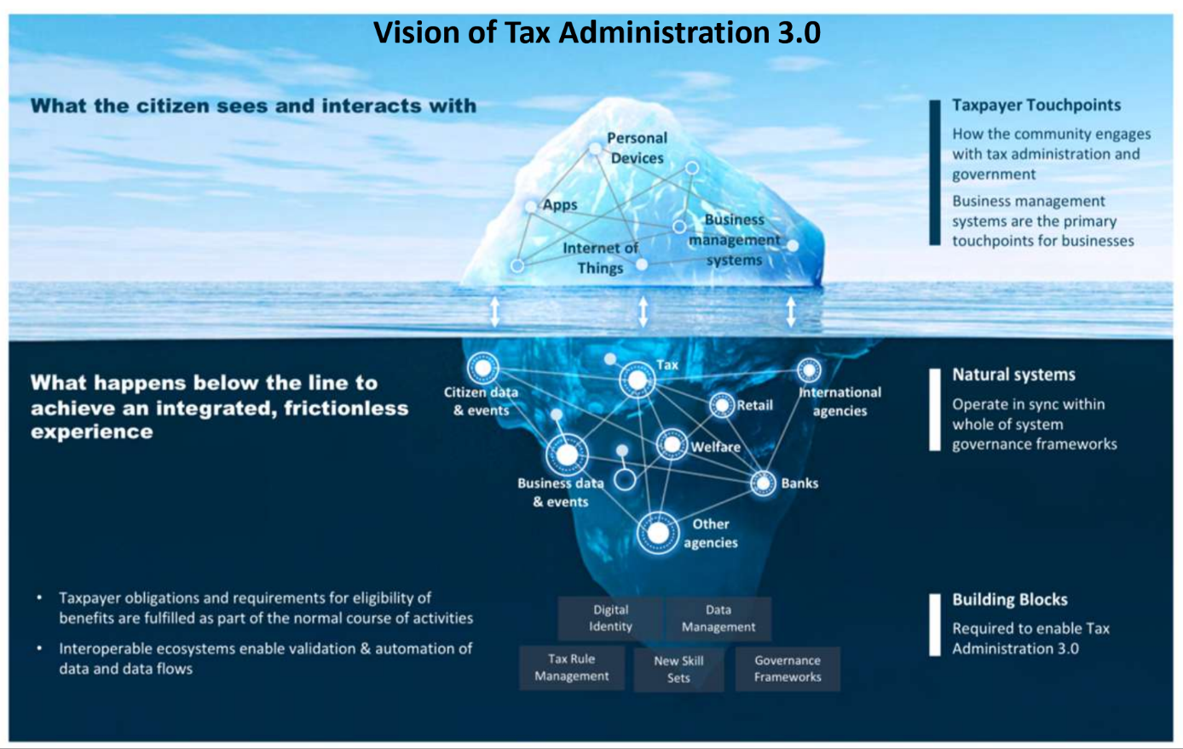

Definition Law
- Rules adopted by European Legislative body, national parlaments, certain extent by national governments
- Serve to: coordinate relationships between state/citizens, relationship between citizens, order citizens behaviour (no risk to harm others, to frame)
Hierarchy of norms (strongest to weakest)
- Fundamental principles of liberal democracies
  - Rule of law
  - Separation of powers (judiciary, legislation, executive)
- European Law
  - Founding treaties of the European Union
  - European Charter of fundamental rights
  - Secondary EU Law (Regulations and Directives such as GDPR)
- National Constitutional Law
- National “Simple” Laws
- National Regulations
- National State Acts that are contingent upon the individual
Economic foundations of the European Union
- Social market economy
- Right to property, individual seeks personal wellbeing (cost minimizing), rational persons
- Law provides grounding for (capitalist) economy
- Law frames economy and tries to mitigate shortcoming of free play of powers
- Idea: Welfare grows with wealth
Protection of Personal Data as a fundamental right in the EU (Art 8 European Charter of Fundamental Rights)
- Everyone has right to data protection concerning him-/herself
- Data processing is only possible if given consent (exception: public interest)
- The law sometimes also protects formal persons (corporates, etc.), if they are strongly connected with the natural person
- Also companies located outside of EU must comply
- Sometimes the individual is not allowed to know the processing (because of national security)
Primary law and secondary law
- Primary law: Law in the classical (official) sense, stated by government, EU, etc.
- Secondary law: Information combined by lawers, … (sources to talk about primary law)
- Legistaltive: giving law
- Judicative: speaking law
- Executive: doing law
Innovation, Regulation and Responsibility
- Innovation: Research, investments, business models, Hype cycles (=what to expect when in which expectation intensity)
- Regulation: legal instruments, standardization, deregulation
  - Objection is protection (health, privacy, property, etc.)
  - AI Act: precautionary principle, risk-based approach (risk – combination of occurrence of harm, severity of that harm)
  - Instruments: Binding rules (self regulation, code of conduct), standardization (certification), adaptation on “level 2” (detailed acts about general topics, implementing acts), soft law (guidelines, no legal consequences), prohibition (+taxation/subsidies alias Subventionen), general rules, legal certainty/flexibility), trust in technology
  - Deregulation: simplification
- Responsibility: liability (“Risiko”), Attribution, sanctions, fees
  - Who is accountable for an AI system?
  - Can the actions/knowledge of AI be attributed to a natural or legal person?
  - Should AI itself be recognized as a legal person?
  - Make Responsibility (Verantwortung) imply Accountability (Rechenschaftspflicht)?
  - Legal consequences/sanctions
  - Responsibility of AI: legal person?
  - Responsibility for AI: When to use?
  - Machine-to-machine Contracts in IoT (f.e. Smart Fridge)?
  - AI as Liability (copyright, data protection law, burden of proof)
Industriy 1.0 – 4.0
- 4.0 (now): IoT, AI
- 3.0 (20th century): computer, internet
- 2.0 (19th century): assembly lines starting
- 1.0 (18th century): steam engine starting
- Legal rules have to keep up to date and adapt
AI Act: Risk levels for AI systems
- Forbidden (unacceptable risk): contradicting EU values (social scoring, predictive policing, etc.)
- Conformity assessment (high risk): requirements for AI on market and in service (infrastructure, biometrics, etc.)
- Transparency obligation (limited risk): chatbots, text/audio/image/video creation
- No obligation (no/minimal risk): other AI systems (video games, spam filters, …)
Intellectual property
- Trademarks (“Marken”), Patents, Copyrights (geistige Schöpfungen), Designs (ästhetische Schöpfungen)
- intangible (=nicht-materielle) goods: often characterized as public goods (non-rivalrous -> many can consume at the same time, non-excludable -> hard to exclude someone from using), therefore need for special rules
- IP is expression of creator’s personality, an incentive (=Anreiz), a reward
- General: exclusive rights, registration/formal requirements, term of protection, exhaustion (first sale) doctrine, moral rights, territoriality (law for IP should be law of country where protection is claimed)
Eu Infosoc Directive (Copyright and Information Society Directive 2001)
- Autonomous concept of EU law: referring to authors and works
- Computer Programs, Databases and Photographs, sec. law refers to authors own intellectual creation
- Work = original in the sense that it is the authors own intellectual creation or expression of such a creation
Austrian Justice System
- 1 Supreme Court (oberster Gerichtshof)
- 1 Specialized Commercial Court (Handelsgericht Wien)
- 1 Specialized District Court for Commercial Matters (Bezirksgericht für Handelssachen Wien)
- 1 Specialized District Court for labour and social security law (Arbeits- und Sozialgericht Wien)
- 4 Court of Appeals (Oberlandesgerichte) in Vienna, Linz, Graz and Innsbruck
- 20 Circuit Courts (Landesgerichte)
Average time for civil case: 12 months
- 113 District Courts (Bezirksgerichte)
Average time for civil case: 6 months
Austrian Justice System – General
- ~2.3 billion expenses (55% generated by income like court fees, etc.)
- ~59.2 million IT
Legal Tech in Austria
- 1970ies: Intro of electronic cadaster
- 1980: Digitisation of land register (no archive, “Elektronisches Grundbuch”)
- 1983: Mandatory and automated injunction proceedings (“automationsunterstütztes Mahnverfahren”)
- 1980ies: start of automatization of civil and commercial proceedings
- 1990: start of digital commercial register (“Elektronisches Firmenbuch”)
- 1990ies: Start of the use of legal data bases (“Rechtsinformationssystem Justiz”)
- 2000: Start of electronic publications in insolvency matters (“Ediktsdatei”, “Gerichtliche Bekanntmachungen”)
- 2004: Electronic Register of certified experts and interpreters (“Sachverständigen- und Dolmetschliste”)
- 2005: Electronic Archive of documents (“Urkundenarchiv”)
- 2007: state of mandatory use of electronic communication by lawyers and public notaries (“Elektronischer Rechtsverkehr”)
- 2008: start of European Injunction Proceedings (“Europäisches Mahnverfahren”)
- Since 2014: Justice 3.0 Initiative
- 2020: COVID19 and wider use of video-conferencing applications
Electronic Land Register, Eletronic Company Register
- Via Electronic Legal Communication (EVR) has to be filled by lawyers and public notaries
- Accesible by anyone for fee
- Company register: published by anyone for fee
Mandatory digital communication systems
- duty to be represented by lawyer in all matters before district courts above EUR 5,000 and before all higher courts -> § 27 Abs. 1 ZPO („Zivilprozessordnung“)
- duty of lawyers, public notaries, banks, insurance companies, social security administrations, etc., to communicate with the court via the electronic communication system established by the court („Elektronischer Rechtsverkehr“, “Gerichtsorganisationsgesetz”)
- Payment of court feeds: collected by lawyer, deposited on escrow account (available on day of filing of request, lawyer is liable), court has access to the escrow account (“Einzugsermächtigung”) and transfers it to own account
- Exorbitant court fees in Austria, no ceiling
- duty to start injunction proceedings in all matters relating to payment of amounts below 75,000 EUR (einstweilige Verfügungen, ausnahmen wie unschlüssige Aktionen, unjustified, not yet payable, …)
- Case is assigned to Court Clerk operating under supervision of judge
  - Checks whether application meets legal requirements
  - Payment injunction processed automatically, printed in paper and served by courier
  - Below 15 000 (District Court Proceedings): Opposition within 4 weeks, no lawyer nor reasons required – in 2022 only 8% oppositioned
  - Above 15 000 (Circuit Court Proceedings): Opposition within 4 weeks, lawyer and reasons required
  - No Opposition: Payment injunction final and binding, can be used for enforcement, applicant automatically receives enforceable instrument (vollstreckbarer Zahlungsbefehl, 6-7 weeks from start to that)
Enforcement Proceedings
- automatic identification of the debtor‘s employer, provided that the birth date of the debtor is indicated; investigation in the data stored by the central organisation of all social security bodies („Dachverband der Sozialversicherungsträger“)
- (Social Media)
- Amount below 50€: simplified procedure for enforcement against movable property
- Lawyers have to use standard form and submit via ERV
- enforceable instrument is lacking or does not cover enforcement: the debtor may file „opposition“ within 14 days
Videoconferencing in civil and commercial cases pre- and post-pandemic
- Since 2005: court may order that remote witnesses be examined by videoconference rather than by delegated judge
- Since 2019: Videoconference to hold first hearing, examine parties or discuss written reports, parties may object, parties can only suggest remote hearing
Use of AI
- “Nobody shall be deprived from his/her legal judge”
- “Everyone is entitled to a fair and public hearing within reasonable time by an independent and impartial tribunal established by law”
- “In the exercise of their judicial mandate, judges are independent”
- Barriers against the use of AI rooted in European Law
- Not materially influencing outcome of decision making (intended for narrow procedural tasks, improve result of previously completed human activity, detect decision-making pattern or deviations from prior decision-making patterns, preparatory tasks)
- Ethical considerations
  - Human dignity, volume and nature of training data, inherent bias of training data and perpetuation of bias, lack of legal reasoning and sham reasoning, leal realism vs development of law, equity in decision-making, no sense of human morality
- Possible future developments:
  - Decrease of case numbers, faster proceedings, cost savings (?), new skills required for judges and lawyers, reorganisation of courts and law firms, challenges for education of new generation of lawyers
- s

