Record Deletion Application Manual
Record Deletion application is a web application created for deleting records from the production environments of Europeana Solr and Mongo servers.

Features
Dynamic feature configuration
Dynamic user management
Record deletion:
- single record deletion either by europeana_id or any other field
- batch record deletion through file upload either by europeana_id or any other field
- batch record deletion through the collection name

Prerequisites
Servlet container as Apache Tomcat
Postgres version >=9.1

Installation
- Get the db dump with the initial user and import it on the target Postgres DB. Postgres should be running in the same server as tomcat is running. This can be configured to be different by modifying persistence.xml file located in src/main/resources of the source code but a re-compile is required.
- Copy the target/management-xxx.war file to the Apache Tomcat webapps folder

User Manual
The application supports 3 kinds of user roles:
- USER – A user can login, modify his user information (name, surname, password), view his log files as well as every other log entries generated by any user, remove a single record, remove multiple records, remove an entire dataset according to Europeana SOLR fields, view the available users and view the systems the application connects to to remove the records
- USERADMIN – A user admin can perform all of the above operations plus modify any of the available users (name, surname, password, role)
- GOD – A God user can perform all of the above plus modify any of the available systems

Login Page
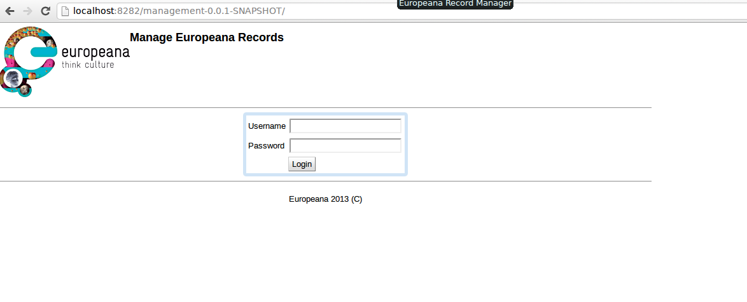
Figure 1. Login Page
The initial screen of the application is the login screen. The user is prompted to supply his username and password prior to continuing to the rest of the application.
If the username does not exist or the password is wrong the application will throw a popup notifying the user.
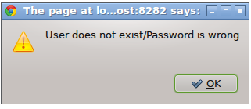

Figure 2. Wrong Username or Password
If the operation is successful, then the user is shown with the available tabs that form the application, that defaults to the first tab (“My Information”, Figure 3).
The available tabs are:
- My Information tab – Preview your information and modify some of the credentials
- Logs tab – Preview your logs or all the logs
- Record Management tab – Delete records functionality
- System Management tab – Manage Solr and Mongo servers
- User Management tab – Manage users
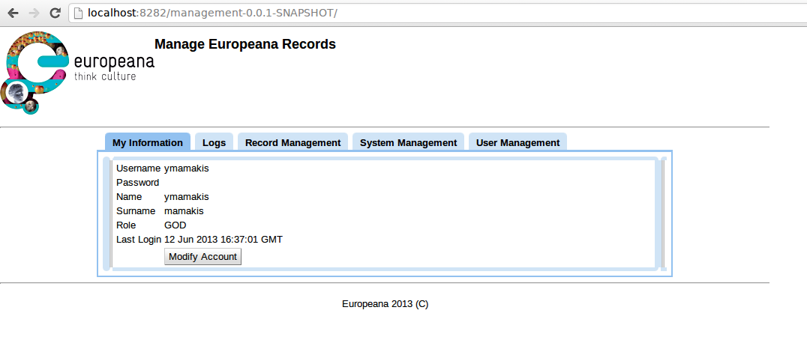
Figure 3. My Information tab

My Information
Through the My Information the user can preview some of his information as username, name, surname, role and when the user last logged in. By pressing modify account the user is prompted whether they want to modify information as his name, surname and password.
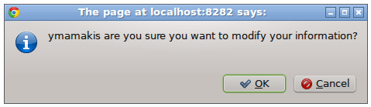

Figure 4 Prompt to modify account
If the user presses OK then the tab changes and the user can modify his information.
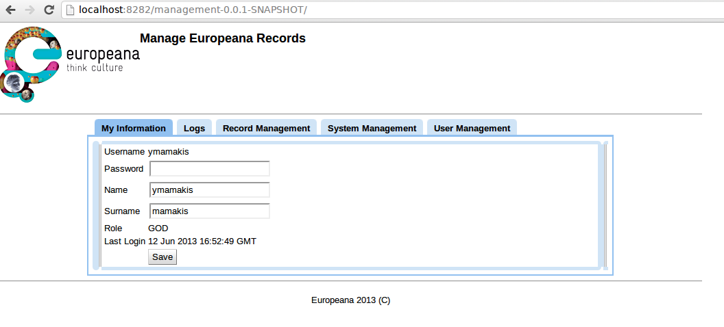
Figure 5 Modify My Information
When the user is satisfied pressing “Save” button, will notify him that the user has been saved successfully.
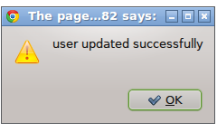

Figure 6. User saved ok

Logs Tab
In this tablet the user can preview the logs generated by his action or by any user. The user can select from the drop down on the top right corner the desired user and the blank space will be filled in with the retrieved actions
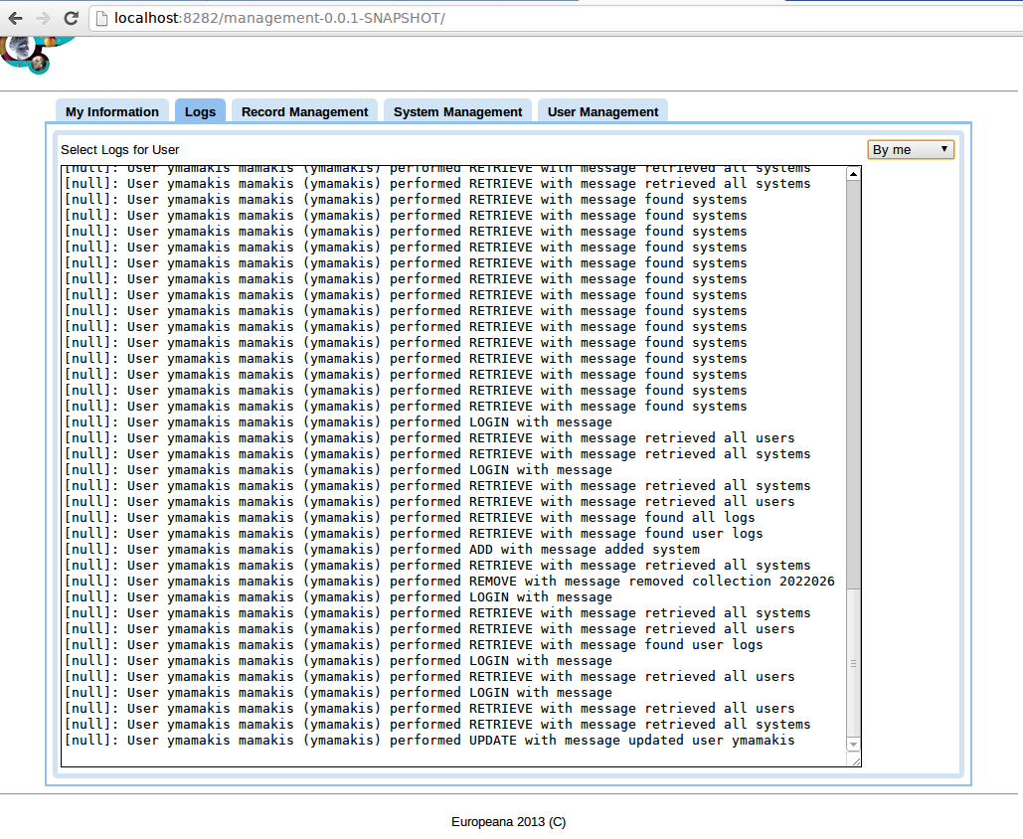
Figure 7. Show logs by user

Record Management
Record Management holds the main functionality of the record deletion application. It is comprised by 3 areas. The top area handles the record deletion functionality, the middle area is a preview area where the user can preview and manage which records are going to be deleted, while the bottom area is for collection removal. In the top area the user can specify which field is the one that the application will search on to find the record, e.g. europeana_id, provider_aggregation_edm_isShownAt etc. If the record is not unique the user will be notified that the operation cannot proceed because of ambiguous filters. In that case the user should supply a unique identification field value upon which record deletion will be performed.
Following setting the field the user can select the Value radio button, or the Batch Remove radio button, depending on the desired action. When the Value radio button is pressed then the Add Record(s) button will create a record based on what the user has entered on the textbox next to the Value label. If the Batch Remove radio button is selected then the Add Record(s) will created records according to a user supplied file. The user can provide the file using the Choose File button. Upon pressing Add Record(s) the user would then be notified that the file is uploaded for processing in the server, while upon completion the table will be populated with the selected records.
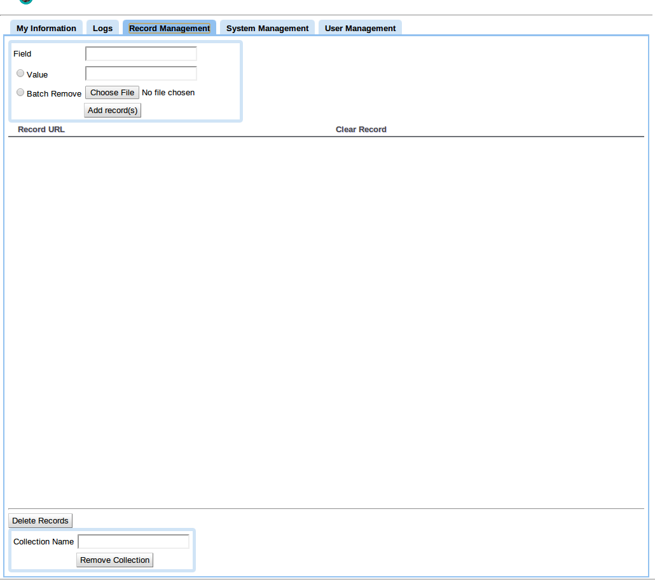
Figure 8. Record Management tab
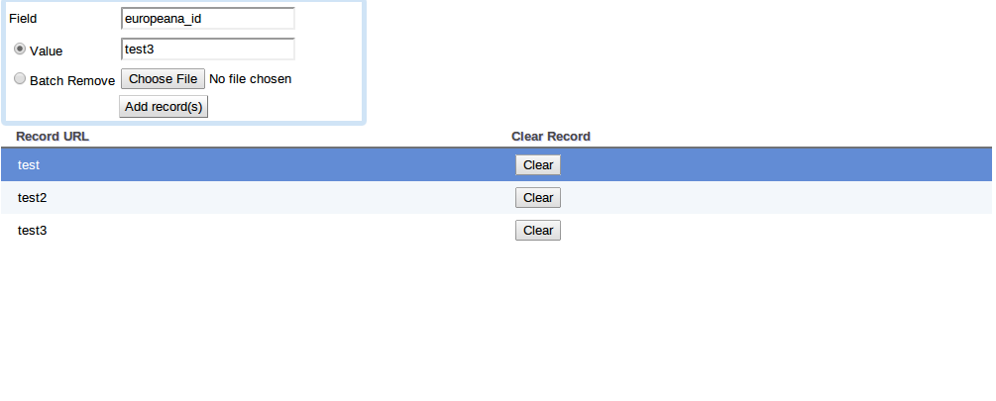
Figure 9. Added records using the value option
The records in the file should be provided in a simple text file with one record per line.
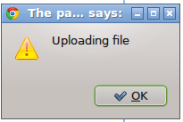

Figure 10. Uploading file for processing
When the file is processed the table looks like Figure 11.
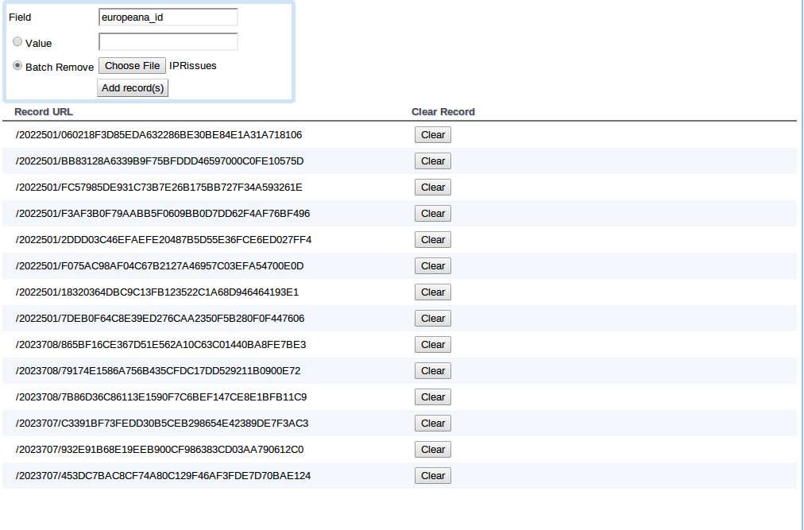
Figure 11. Batch Record Removal
The user always has the opportunity to modify the list of records to be removed by pressing the clear button next the each record.
When the user is finished, they can press the Delete Records button, that will prompt the user to verify that they want to delete the specified number of records.

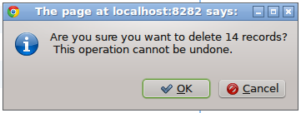

Figure 12. Record Removal prompt
The last operation that can be performed from this tab is the collection removal based on the collection name. The user can provide the Collection ID of the collection they want to remove and pressiong the Remove collection button will result in a prompt that asks them to verify whether they actually want to remove the collection
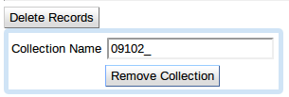

Figure 13. Remove Collection
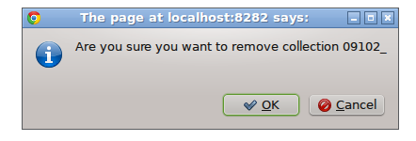

Figure 14. Remove Collection Prompt

System Management tab
From this tab the user can preview (or if they have the necessary Role) modify the available systems.
The operation is very simple as the user on the left hand side can create a system by providing the URL of the system, and the type of system (SOLR or MONGO). For the cases of solr a full URL is required as shown in Figure 15 while, for Mongo default port is considered
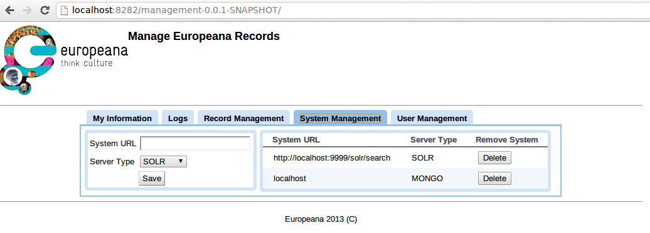
Figure 15. System Management tab
Selecting a system from the right hand side will result in its information being automatically filled in on the right hand side, where the user can update its information. The user can delete any of the systems by pressing the Delete Button in the Remove System column on the right hand side table.

User Management tab
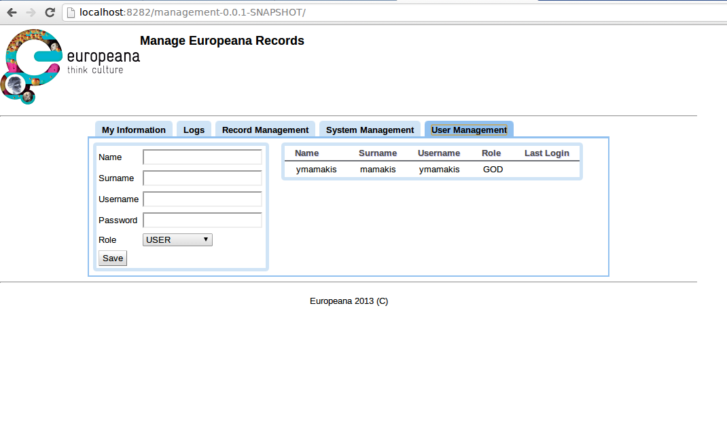
Figure 16. User Management
In this tab the user can add and update users (user deleting is not supported in this version of the application due to constraints on the Logs functionality). In order for the user to create another user, they just have to fill in all the necessary information in the right hand side, specify one of the 3 roles and press the Saved button. Alternatively, they can modify a user by selecting them from the right hand side and updating their information on the left-hand side table

