Entrar en https://my.hcltechsw.com/downloads/dx/compose

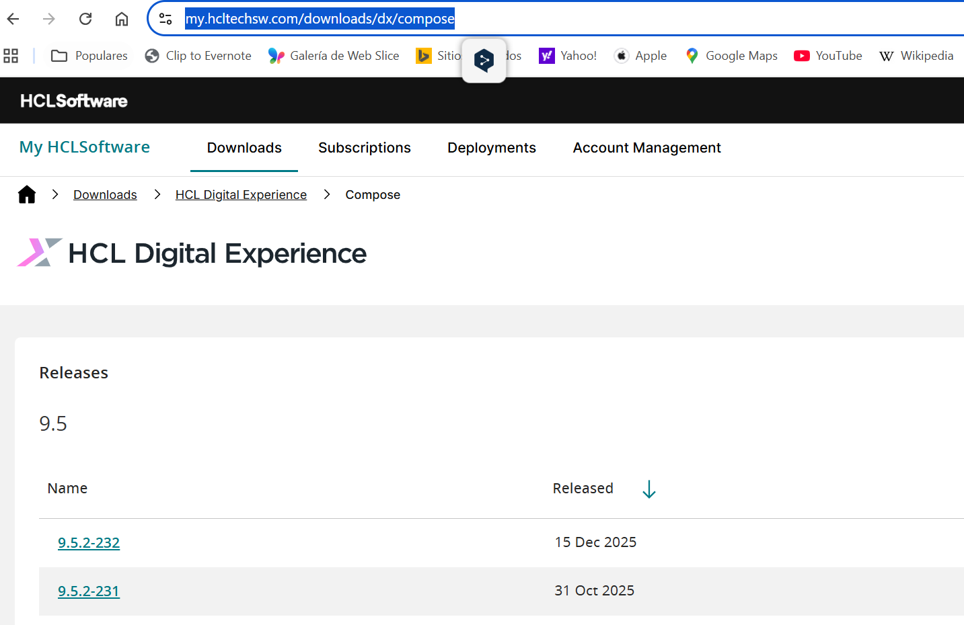

Selección la ultima versión (en este caso 9.5.2-232)

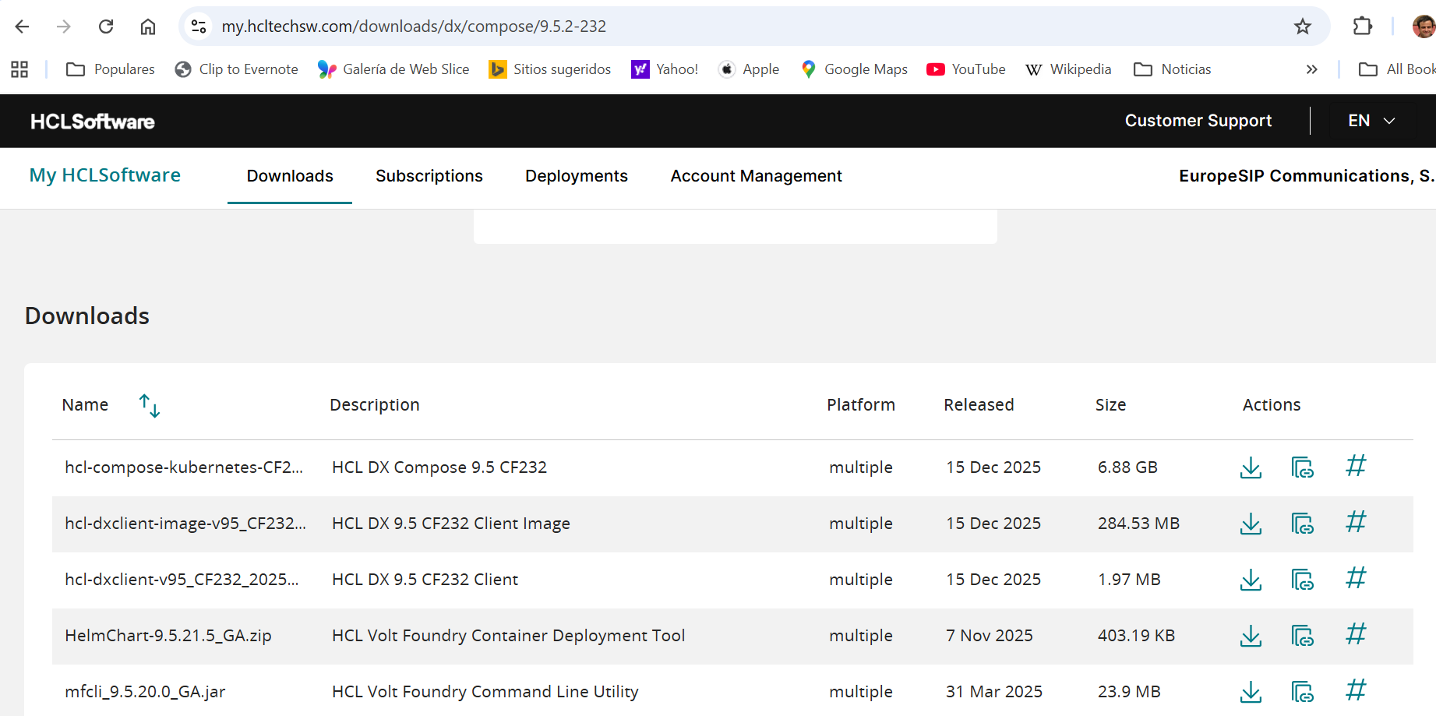

Copy temporary link

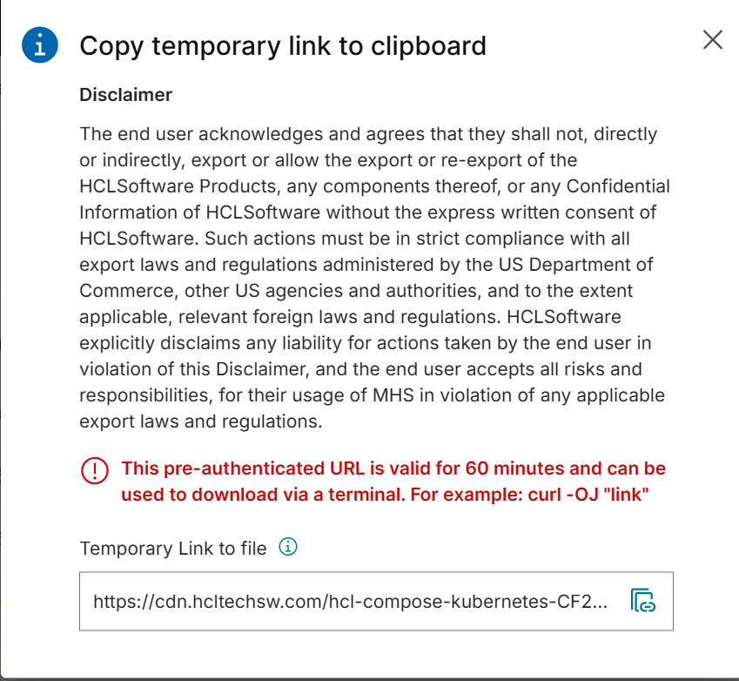

Ejemplo: $ wget -O hcl-cf232.zip "https://cdn.hcltechsw.com/hcl-compose-kubernetes-CF232.zip?Object=99632f97d71a8475ef4b917df56b4c7f7de8104a8f91c1d63b91ecb39d2595f7&ContextId=BBIk42lf4ilaxWLoMafN0&Expires=1769351303&Key-Pair-Id=K1ASQ40EC0AWQP&Signature=qR2-xxLdXzwlDH-qMdlKKmaH0Vw5vuiZ5FE6ToerQ-WYq0kjepCfhcgc8byh-9yrovWCYZD7~oXrHmpj5~H9r5lX1Caj8iKzI0T2mL~movophgXwdxoG4cpU16oF49w90bdylZHqXKGYGcojz24h8PsTuec~r3UGmM89J0E-CuYiXtFUSKhH~-dViUjtj03I0KywVAmV8eDJtHPDILxRZTR3Ad-DGNdirE2wxWmtulU-aIdd2fk0ei9gB928V3uSPgBnymgp1C6dYjmUxZhHrZQ7nsdf6260zBhqkVwPs9qiptpkS7J7E5LrqSLDRQMyx73TiP-JqdrQ2fjkdHy9cQ__"
--2026-01-25 14:46:35-- https://cdn.hcltechsw.com/hcl-compose-kubernetes-CF232.zip?Object=99632f97d71a8475ef4b917df56b4c7f7de8104a8f91c1d63b91ecb39d2595f7&ContextId=BBIk42lf4ilaxWLoMafN0&Expires=1769351303&Key-Pair-Id=K1ASQ40EC0AWQP&Signature=qR2-xxLdXzwlDH-qMdlKKmaH0Vw5vuiZ5FE6ToerQ-WYq0kjepCfhcgc8byh-9yrovWCYZD7~oXrHmpj5~H9r5lX1Caj8iKzI0T2mL~movophgXwdxoG4cpU16oF49w90bdylZHqXKGYGcojz24h8PsTuec~r3UGmM89J0E-CuYiXtFUSKhH~-dViUjtj03I0KywVAmV8eDJtHPDILxRZTR3Ad-DGNdirE2wxWmtulU-aIdd2fk0ei9gB928V3uSPgBnymgp1C6dYjmUxZhHrZQ7nsdf6260zBhqkVwPs9qiptpkS7J7E5LrqSLDRQMyx73TiP-JqdrQ2fjkdHy9cQ__
Resolving cdn.hcltechsw.com (cdn.hcltechsw.com)... 13.224.83.32, 13.224.83.77, 13.224.83.37, ...
Connecting to cdn.hcltechsw.com (cdn.hcltechsw.com)|13.224.83.32|:443... connected.
HTTP request sent, awaiting response... 200 OK
Length: 7382755217 (6.9G) [binary/octet-stream]
Saving to: ‘hcl-cf232.zip’
Lo descomprimimos en el Directorio images con el commando unzip hcl-cf232.zip -d images

Para subir las imágenes:
../upload_harbor.sh p32810yz.gra7.container-registry.ovh.net 'robot$dx+dxuser' XdNaDjuuTjUd3IphHESzfDaoX0IHCZ8F dx

