MERGE_DTA Application
Installation
Just copy the downloaded MERGE_DTA.EXE file where you want (by convention, with the dta files you want to Merge)
Run the application.
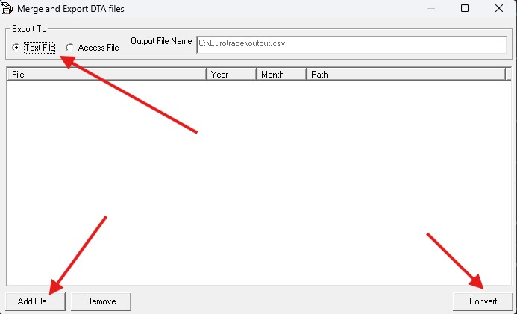
The interface allows you to choose TEXT or ACCESS output format and lets you know the output path and filename. If the folder where the application is copied contains some usable dta files, they would be displayed in the current File list.
When you click on Add Files, you can select some DTA file:
- You can Filter by Year_Month dta files or Month_Year dta
- Multiselect is enabled (use Shift/Ctrl + Click like in Windows App)
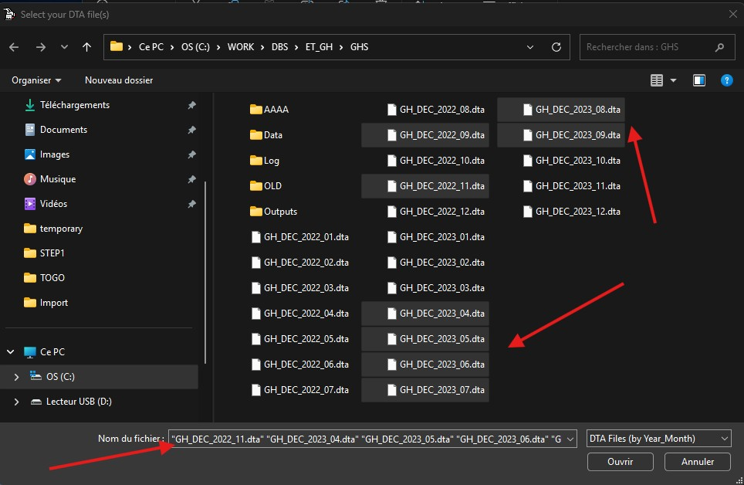
You can add multiple files, multiple times. You can unselect some of them or remove them from the List.
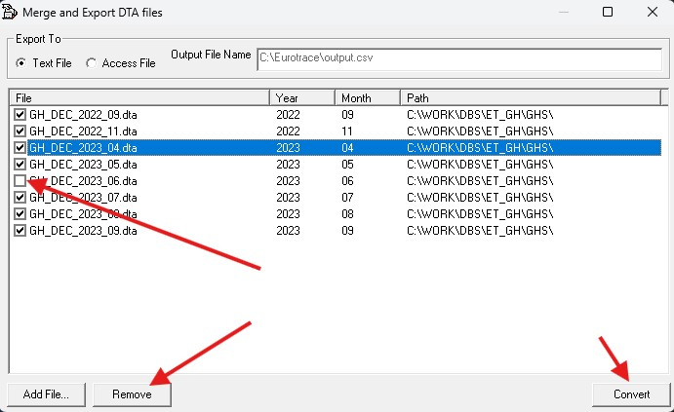
Press Convert when ready and wait some seconds to get the defined output.
Benchmark:
- 2/3 seconds for a 300MB Access result of 3 monthly files
- 10/20 seconds for the equivalent Text files

