A map of Europe population by age

# Introduction

On the 16th June 2024, Eurostat released the 1km resolution population grid of the 2021 population and housing census as laid down in Regulation (EU) 1799/2018. This dataset describes the population of Europe through several harmonised statistical indicators including the total resident population in 2021 and its decomposition into three age groups :

* Population under 15 ;
* Population from 15 to 64 ;
* Population aged 65 and over ;

This document presents this information as a map. This map shows around 1 800 000 populated cells within the European Union and around 75 000 in the three EFTA countries providing data (Liechtenstein, Norway, Switzerland). On this map, each grid cell is represented as a circle, whose size depends on the grid cell total population and colour hue depends on the composition of this population by age group. Since three age groups are available, a ternary classification is used. It allows representing when a grid cell population composition deviates from the dataset average value. The map thus provides a representation of population composition by age changes over the European space, revealing disparities and patterns.

# Map specifications

Scale : 1:1 200 000 (1cm for 12km).

Projection: European Lambert azimuthal equal-area (EPSG 3035).

Input datasets:

* Population grid: Eurostat 1km resolution grid of the 2021 population and housing census.
* Administrative boundaries: Eurostat NUTS 2024 dataset, Eurostat Country 2024 dataset. ©EuroGeographics, ©UN-FAO, ©Turkstat.
* Geographical names: Eurostat Euronym, ©EuroGeographics.
* Water bodies: Copernicus Land Monitoring, Corine Land Cover 2018.  
  <https://doi.org/10.2909/71c95a07-e296-44fc-b22b-415f42acfdf0>

Cartography: Eurostat – GISCO, 10/2024

Online interactive version of the map:



# Legend

### Total population

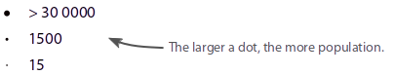

### Age group

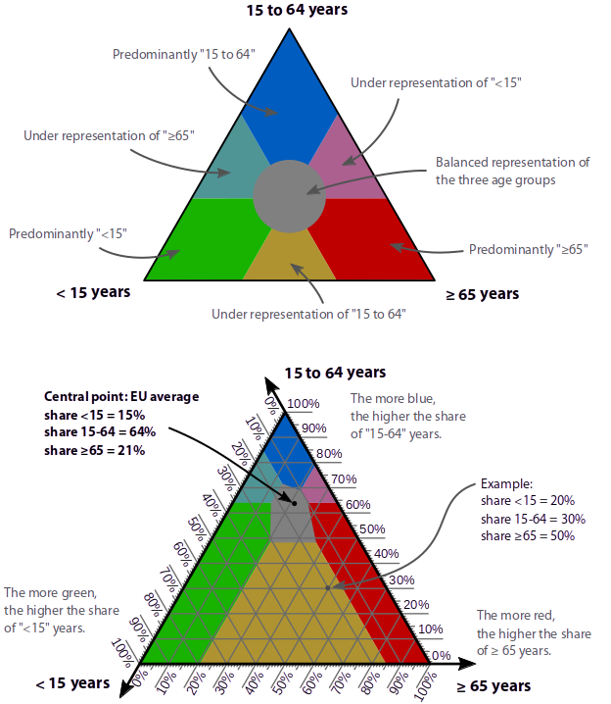

# Example

