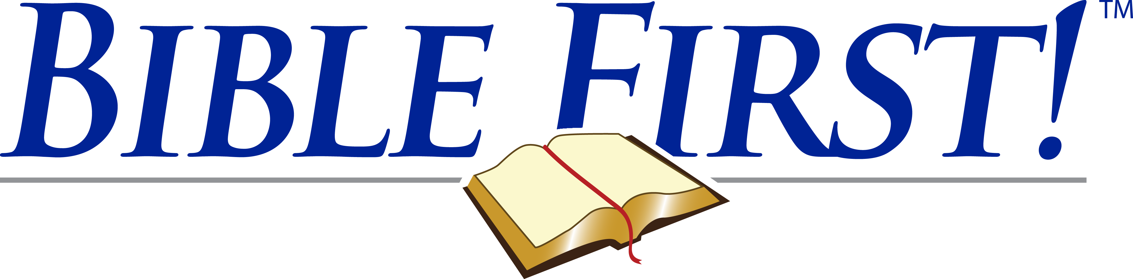

Certificate of Achievement

in recognition of their successful completion of the Bible First! course of study.

This certificate is awarded to

“Then said Jesus…, If ye continue in my word, then are ye my disciples indeed; And ye shall know the truth, and the truth shall make you free.”

John 8:31-32

Coach

Coach

Date

Name