**PONDICHERRY UNIVERSITY**

**(A Central university)**



**DEPARTMENT OF COMPUTER SCIENCE**

**MASTER OF COMPUTER APPLICATION**

**MINI PROJECT REPORT**

**FIRST INTERNAL REVIEW**

**NAME: TINGKU EUSIBIOUS N SANGMA**

**REG. NO: 24MCA00PY0007**

**TITLE OF THE PROJECT: PERSONALIZED EXPENSE TRACKING & ANALYSIS APPLICATION**

**UNDER THE GUIDANCE OF: Dr. M. NANDHINI**

**COURSE: MCA II - YEAR**

.

**ABSTRACT**

**BudgetLens**, a personal finance management and analysis software designed to help users make informed financial decisions. The application will provide a streamlined platform for users to manage their finances through key features such as manual expense entry, categorization, budget creation, and debt/lend tracking. Furthermore, BudgetLens will offer powerful data visualization tools, including graphs and charts, to help users understand their spending trends, alongside a notification system to alert them when they approach their budget limits.

**FEASIBILITY ANALYSIS**

* **Technical Feasibility:**

**"Technical feasibility is a study of the function, performance, and constraints that may affect the ability to achieve an acceptable system."**

The technologies needed to build the application are widely available and well documented.

* **Economic Feasibility:**

**"A project is economically feasible if the projected benefits of the proposed system outweigh the estimated costs."**

The project is economically feasible as the tools and software’s required to build the application are freely available. There may be small subscription charges associated with a few services such as hosting, but the amount is nominal, thus can be neglected. Furthermore, the project is being built as partial fulfillment of the course. So, there are no monetary gains estimated.

**OBJECT/STRUCTURE ORIENTED DESIGN**

* **User**: Represents the application user.
  + Attributes: UserID, Name, Email, Password.
  + Methods: login(), logout()
* **Transaction**: Represents a single expense entry.
  + Attributes: TransactionID, Amount, Date, Description, CategoryID.
  + Methods: addExpense(), deleteExpense().
* **Category**: Represents an expense category
  + Attributes: CategoryID, Name.
  + Methods: createCategory(), deleteCategory().
* **Budget**: Represents a user-defined budget.
  + Attributes: BudgetID, Amount, Month, Year, CategoryID (optional).
  + Methods: setBudget(), checkStatus(), sendAlert().
* **DebtLend**: Represents a debt or lending record.
  + Attributes: RecordID, Type (Debt/Lend), Amount, PersonName, DueDate.
  + Methods: addRecord(), updateRecord(), markAsPaid().

**SOFTWARE REQUIREMENT SPECIFICATION**

SRS is a comprehensive document that describes what a software system should do, how it should perform, and the constraints under which it must operate..

**Functional Requirements (FR):**

* **User Management**: The system shall allow users to sign up, log in, and manage their profile information.
* **Expense Tracking**: Users must be able to manually add, and delete expense entries. The system will display a comprehensive list of all transactions.
* **Category Management**: The system shall provide default expense categories and allow users to create, rename, and delete custom categories.
* **Debt/Lend Tracking**: The system shall provide a module to track money borrowed or lent.
* **Reporting & Visualization**: The system must generate monthly reports. Financial data shall be visualized using pie charts for category breakdowns and bar charts for trends

**Non-Functional Requirements (NFR):**

* **Usability**: The application interface must be intuitive, clean, and easy to navigate for a seamless user experience.
* **Performance**: The application must load quickly and process transactions without noticeable delay. Data visualizations should render efficiently.
* **Reliability**: The application must ensure data integrity. All financial entries must be stored accurately using database, with an option for future cloud backup.
* **Security**: User credentials and financial data must be stored securely to prevent unauthorized access.

**PARTIAL IMPLEMENTATION**

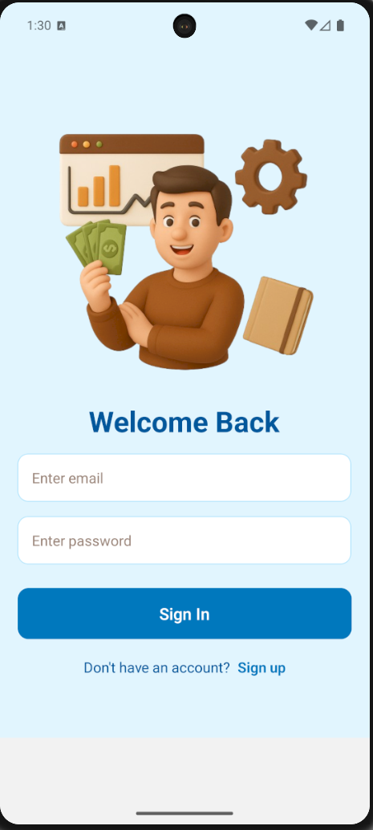

**SIGN-UP PAGE**

**LOG-IN PAGE**

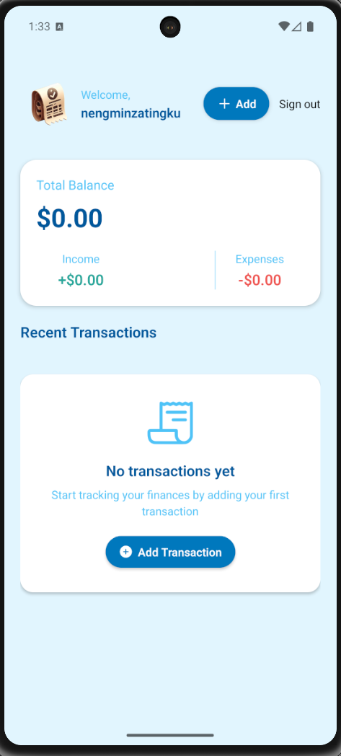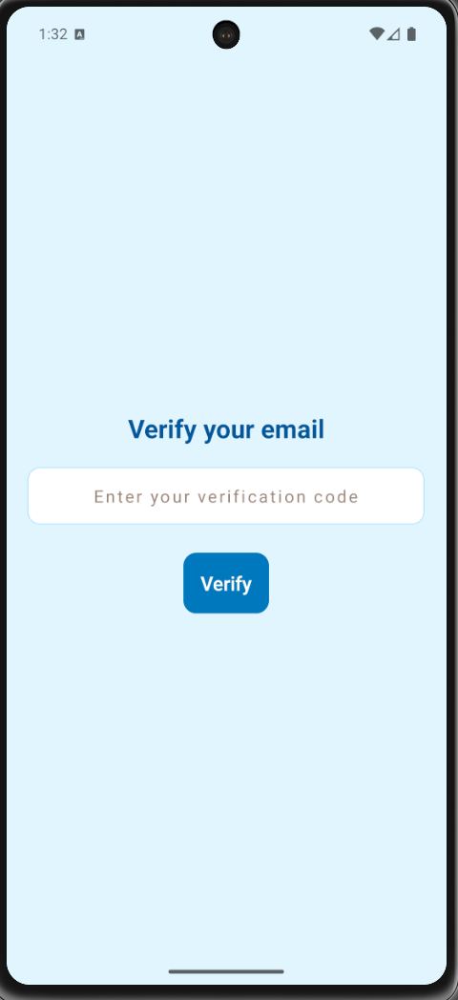

**HOME PAGE**

**EMAIL VERIFICATION**