**REPORT OF ADVANCED JAVA PROGRAMMING PROJECTS**

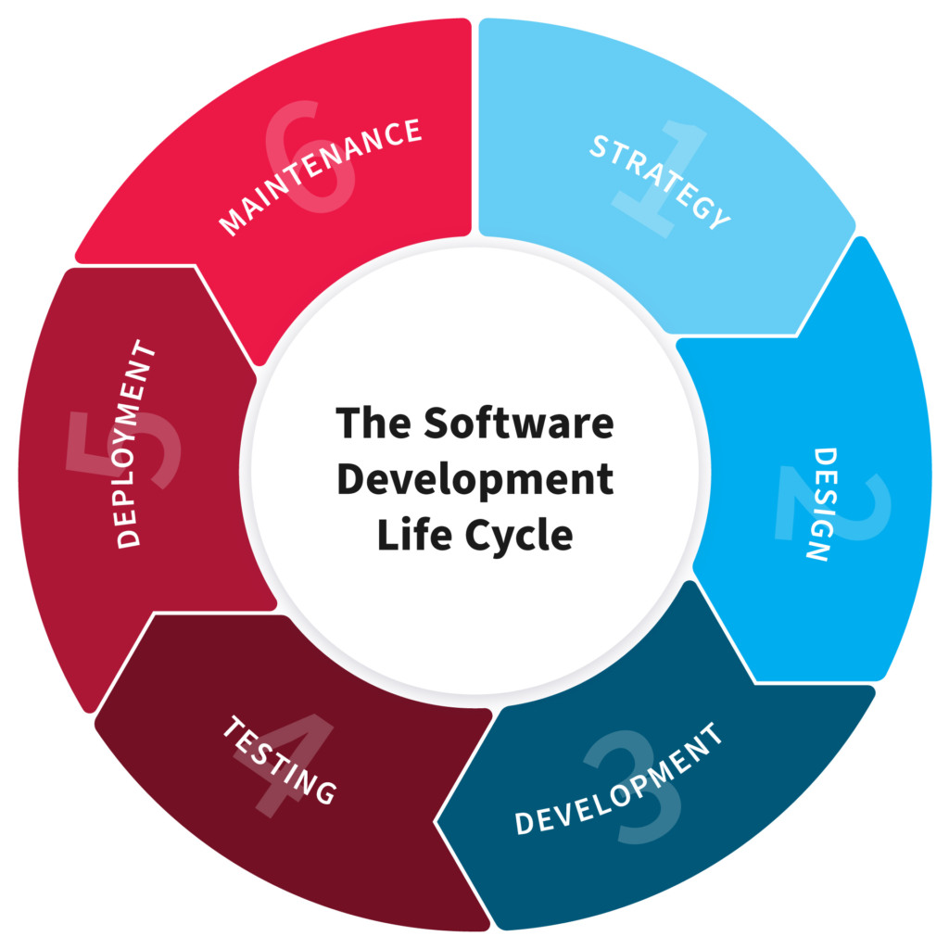

**NAME: NIYONIZERA Eustache**

**REG NO: 221005196**

**CLASS NO: 01 (in Grp III)**

**PROJECT NAME: BOOK STOTE**

**1.PLANNING**

*Book store is system for collecting and managing books which are stored for used. Goals and Objectives of Book store system is to collect many kinds of books which are costed then save its information it in database, Future Problems This system it solve is to maintain the book and to avoid shortage books to Readers.*

**2. Design**

*How Book store work by Design, it have Form which allows users to fill books information such as book name, book price, numbers of books costed. Then by Technically after User Enter Book information,System take book price costed and number of books costed then Show Total cost of All book costed and make book invoice costed(report), Functional requirements of Book store system include: System rules, Administrative requirements, Adjustments and Cancellation, Authentication requirements, Authorization, and How User interact System, On Book store system Only Admin has Authorized to Add user, then User use Log in Form to Access inside in System then start to perform his/her Tasks.*

**3. Development**

*In Build the entire system( Front end- back end technologies), Book Store System was programed by using Some Software Known as Programming Language those include JAVA Coded in NetBean as Code Reader and Form creation and Runned with Jdk which much including in NetBean and Also system Database was created by using Software called Xammp as DBMS(Database Management System) and Here Programer need to connect Java code and Database.*

**4.Testing**

*During Programer Coding need toTry Execute and Run system For Purpose of Debugging errors where are necessary, for this Stage Programer ensure that System work well or it Perform what is asked to do.*

**5.Deployment**

*After Designing Forms, Coding all, Creat database and connect all, Testing and Debugging errors, Project need to be implemented as System , Here System can started to be accessed by users who are Authorized, System need to be installed into User Laptop or Desktop, System need to be Deployed*