# Research Methods and Statistics with R 3

# Week 7 – Coke Energy (Mock Exam II)

## Introduction to the session

In this session, you will have another opportunity to practice all that you have learned thus far in this course. Below is another **exam-style question** that you are to attempt during the in-person session. Use this opportunity to become familiar with how questions will be asked on the exam and develop strategies to deconstruct and ultimately tackle the question.

This session, however, will be complemented by some ONLINE MCQs that will only be available during the practical time-window. These are designed to get you thinking about the types of questions you will receive in the *short answer* section of the final exam.

You are free to consult your lecture material and previous R scripts. **Do NOT use generative AI (not permitted during the exam). Also, it is recommended that you attempt this exercise on your own (rather than working with other students / relying on assistance from the teaching staff).**

## Learning Outcomes

By the end of this session, you will:

1. Be familiar with how questions will appear on the final exam
2. Apply one or more statistical methods *largely unprompted* to a noveldataset

## The Setup

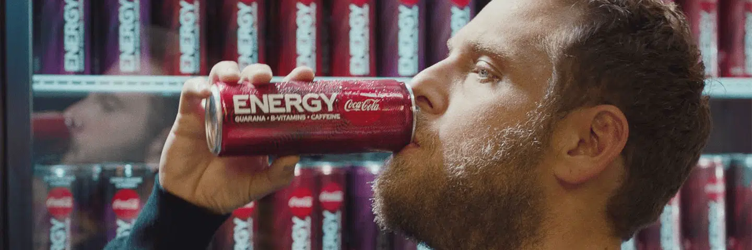Coca-Cola has approached you, an expert neuroscientist and psychologist, to help them develop a new energy drink called “**Coca-Cola Energy**”.

They wish to market this as “scientifically proven” to increase **neuroexcitability in the brain**, thereby leading to higher cognitive function throughout the day.

You have designed a study to measure neuroexcitability following administration of **Coca-Cola Energy** by applying transcranial magnetic stimulation (TMS) to two different regions of the brain, primary motor cortex (M1) and a control area (vertex).

You will recruit 60 participants and split them into three groups. **Group 1** will receive TMS to the M1 and the vertex (in separate trials) after consuming 500 mL of Coca-Cola Energy. **Group 2** will receive TMS after consuming 500 mL of Coca-Cola Classic. **Group 3** will receive TMS after consuming 500 mL of sparkling water.

You will quantify neuroexcitability as the threshold for a motor evoked potential (MEP) assessed by concurrent electromyography (EMG). A MEP is detected as a muscle twitch. The threshold is measured in mV.

## Procedure

1. **List research question, hypotheses, and analysis plan appropriate for this dataset and objective. This section can be in bullet-point form or complete sentences**

Research Question: *What is a sensible research question given these data?*

Hypotheses: *What are some reasonable hypotheses given these data? How many hypotheses do you need to identify? Are these guided by your particular analysis strategy?*

Analysis Plan: *Of the tools you have learned thus far, what is/are the most appropriate method(s) to analyse these data?*

1. **Using R, write a program to produce:**

* At least one figure displaying the data in a manner appropriate for the analysis and the research question
* Relevant descriptive statistics
* An analysis appropriate to the data and research question
* Your code should be annotated to be understood by an R-coder naïve to the study

*Have you properly annotated your code?*

*What is an appropriate figure(s) to visualise these data? Is it/are they properly labelled?*

1. **Summarise your findings as if for a results section of a paper. Include any figures or tables in this section. Bullet-point form is not acceptable for this section.**

*What information must you include in this section?*

*Have you presented your results in proper APA format?*