Assessment: Style a Social Network Page

A web developer will often start with a **sketch**, **mockup**, or **wireframe** showing what the page is supposed to look like. This could be as simple as a hand-drawn sketch on a piece of paper, or it could be a detailed diagram drawn by a designer. In either case, the developer will use this mockup as a guide, and write HTML and CSS to produce the desired layout.

For this assessment, you will create a layout for a social networking site.

Create a header using what you have learned about the box model and how to position elements using CSS. The header should be exactly 850 pixels wide (including borders), and centered within the full width of the screen.

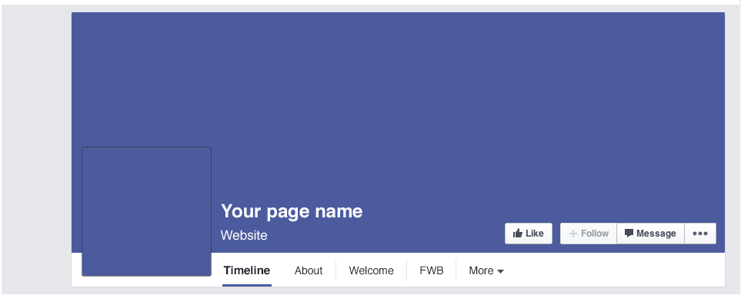

Below the header, create a two-column layout. The left column should be 328 pixels wide (including borders), the right column should be 512 pixels wide (including borders), and the space separating them should be 10 pixels wide. This should exactly match the 850 pixel wide header you previously created.

You don't have to reproduce the entire layout below, however your prototype must show at least one appropriately sized box (with content) in both the left and the right column.

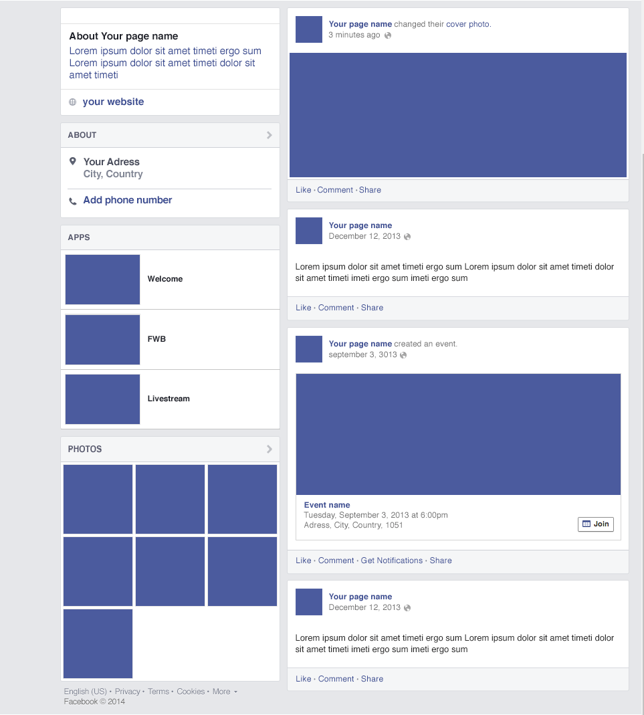

Before the start of our course I tried 'The Kenzie Prework' project. I can say that it's a great resource:

- for exploring a new area

- for learning a new subject.  
I appreciate the structure of this course:  
- Information -> Quiz -> Practice

Such structure help to get to know material, organize this material in head and use this material in right professional way.

For our current course:

* Maybe it’s not bad idea to have Quizzes - at the end of theory topics? Like in ‘The Kenzie Prework' project?
* Such Quizzes help to organize information and help to use this information in practice.