Project 5: Multinomial hurricane damage

Overview: In this project, we will implement a multinomial model to assess forest damage following a hurricane. Hurricane Hugo hit Puerto Rico in 1989, causing severe damage to many of the island’s tropical forests. In particular, the eye of the hurricane passed over the 16-hectare Luquillo Forest Dynamics Plot (LFDP), a large area devoted to research on tropical forests. We will evaluate the probabilities of different damage categories based on tree species and post-hurricane survival status.
The data: Immediately after the hurricane, forest ecologists surveyed the entire plot and assessed every tree larger than a certain size (excluding small seedlings) for the degree of damage it sustained. Damage was classified as low (D1), medium (D2), or severe (D3). A year or more later, ecologists revisited the plot and recorded each tree's survival status, where S = 1 denotes trees that died from the hurricane and S = 2 denotes trees that survived. You are provided with the dataset hurricane_damage_data.csv containing data on four "important" tree species (referred to as species 1, 2, 3, and 4). The data file includes the species code (Spp), the number of trees in each damage category (D1, D2, D3), and is grouped by survival status (Surv, equivalent to S = 1 or S = 2).
The model: You should assume a multinomial likelihood for the damage category count vectors, D, such that for observation i,
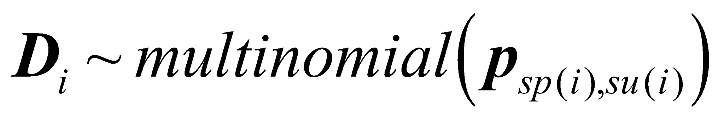
Notice that the vector (length 3) of probabilities (p) varies by species sp (“Spp” in the data file) and survival status su (“Surv” in the data file) associated with observation i, where each p vector indicates the probability of a tree belonging to each of the 3 damage categories. You will have 8 probability vectors (4 species × 2 survival categories). Use a conjugate Dirichlet prior for each damage probability vector such that:
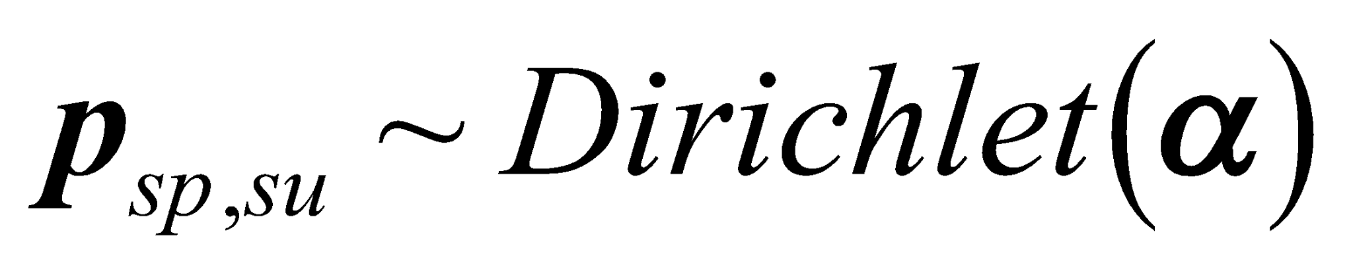
Select numerical values for the Dirichlet hyperparmeter α (also a vector of length 3) that are equivalent to contributing a total count of 3, with 1 count per each damage category; i.e., set 𝝰 = (1,1,1).
Code this model in R/JAGS; within the model code, compute pairwise differences between the damage probabilities for trees that survived versus died, for each species and each damage category (i.e., compute survived damage probability – dead damage probability). When you code the prior for the probability vectors, p_{sp,su}, you will want to put this inside a nested loop, looping through 4 species and looping through 2 survival categories.
Implement the model via R and rjags using jags.model with n.chains = 3, and provide the appropriate model file and data list to the jags.model function. Allow JAGS to generate initials in this problem. Then, update the jags model object (e.g., “jm”) using coda.samples and monitor (via variable.names) the probability vectors (p), the pairwise differences in damage probabilities, and deviance; run coda.samples for n.iter = 10000.
Just focusing on the results for the probability of severe damage (3rd damage category), we might expect trees that experienced severe damage to be more likely to die (versus survive) following the hurricane. Or, alternatively, we would expect higher damage probabilities for trees that subsequently died. We might have also expected some tree species to have been more negatively impacted by the hurricane. Is there any evidence for differences in damage responses among species?

