Inline: Out of Time Achievements
by Salem Richie
Ach. Icon | Ach. Name | Ach. Description | Ach. Unlock
 | Minimum Wage | Complete any delivery route with minimal efficacy. | Get exactly 0.5 stars on completion of any level.
 | Mid-Shift Crisis | Complete any delivery route with average efficacy. | Get exactly 1.5 stars on completion of any level.
 | Dreaming of Labor | Complete any delivery route with optimal efficacy. | Get exactly 3 stars on completion of any level.
 | Onboarding | Complete the tutorial route. | Complete the tutorial route.
 | Dynamics of the Future | Complete the tutorial route with a 3-star rating. | Complete the tutorial route with a 3-star rating.
 | Beginner’s Luck | Complete delivery route 1. | Complete delivery route 1.
 | Employee of the Week | Complete delivery route 1 with a 3-star rating. | Complete delivery route 1 with a 3-star rating.
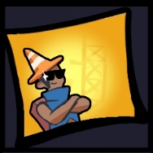 | 2 Legit 2 Quit | Complete delivery route 2. | Complete delivery route 2.
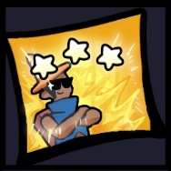 | Determined 2 Succeed | Complete delivery route 2 with a 3-star rating. | Complete delivery route 2 with a 3-star rating.
 | Anything is Pawsible | Complete delivery route 3. | Complete delivery route 3.
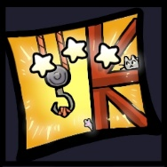 | Construction Zones May Break My Bones, But Purrs Will Never Hurt Me | Complete delivery route 3 with a 3-star rating. | Complete delivery route 3 with a 3-star rating.
 | Above and Beyond (Your Pay Grade) | Complete each delivery route with a 3-star rating. | Complete each delivery route with a 3-star rating.
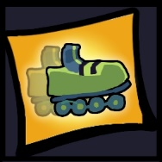 | Roster Derby | Thank you for participating  in this Parcel Dynamics enrichment activity. | View the credits.
 | Late Night Skate Life | Skate down memory lane. | Access the secret rave room in the level select menu.
 | Slacking Off | Stop and smell the asphalt. | Let the character idle long enough to flip their hat 3 times.
 | Little Dipper | Go where not even the stars can reach. | Climb to the top of the building at the beginning of delivery route 2.
 | Inline Initiative | Complete all other achievements. | Complete all other achievements.

